**Healthy Spiced Pumpkin, Yogurt & Granola Parfait***www.cookincanuck.com*

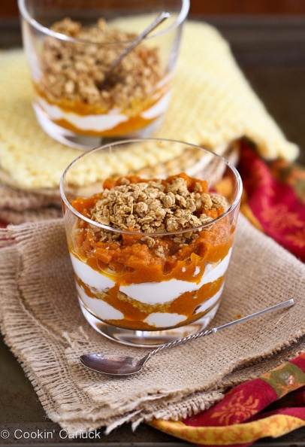**Directions:** In a medium-sized bowl, mix together the pumpkin, agave nectar, ground ginger, cinnamon and nutmeg until combined. In two small glasses or bowls, scoop some of the pumpkin mixture into the bottom. Layer with the Greek yogurt, granola, agave nectar, and more of the pumpkin mixture. Sweeten with additional agave nectar, if you wish.

**Ingredients:**

* 3/4 cup canned pumpkin (not pumpkin pie mix)
* 1 tsp agave nectar
* 1/2 tsp ground ginger
* 1/4 tsp ground cinnamon
* 1/4 tsp ground nutmeg
* 3/4 cup nonfat plain Greek yogurt
* 1 cup granola (your favorite kind)
* Additional agave nectar, if desired

**No-Bake Carrot Cake Granola Bites Recipe**

These healthy no-bake granola bites have the flavor of carrot cake, without the calories, fat or sugar. They’re ridiculously good (& also

**Ingredients:**

* 1 1/2 cups old-fashioned oats
* 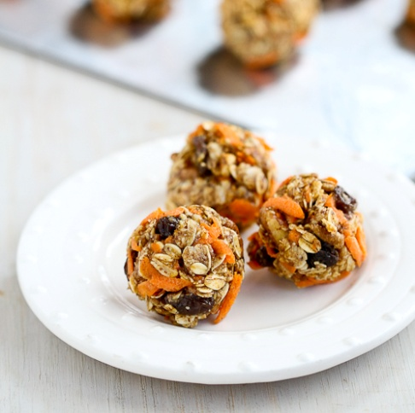1/3 cups unroasted pecans, chopped
* 1 tbsp ground flax seed
* 3/4 cup almond butter
* 3 tbsp agave nectar or honey
* 1/4 tsp ground cinnamon
* 3/4 cup (packed) grated carrot
* 1/3 cup raisins

**Directions:**

* In a large bowl, mix together the oats, pecans and flax seed.
* Stir in the almond butter, agave nectar and cinnamon until well combined.
* Stir in the grated carrot and raisins.
* Using 2 tablespoons (packed) of the mixture for each bite, roll the mixture into bite-sized balls. Using a medium-sized cookie scoop makes this process easier. Also, spray your hands with cooking spray to stop the mixture from sticking.
* Place the granola bites on a baking sheet, cover and refrigerate for 1 hour. Serve.
* Store the remaining granola bites in an airtight container in the refrigerator for up to 1 week.