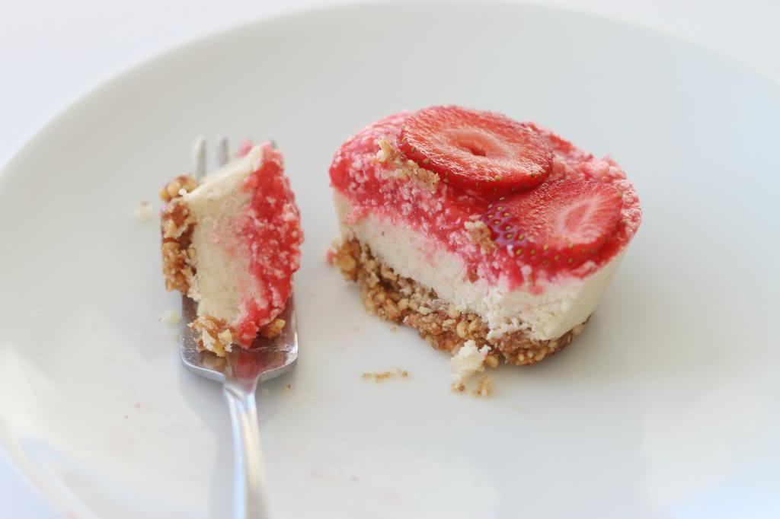Raw Strawberry Cheesecake Bites (Paleo)

**What you will need for the crust:**

2 cups of almonds

1 cup of pitted dates

1/2 cup of shredded unsweetened coconut

Juice from 1/2 of a lemon

**What you will need for the filling:**

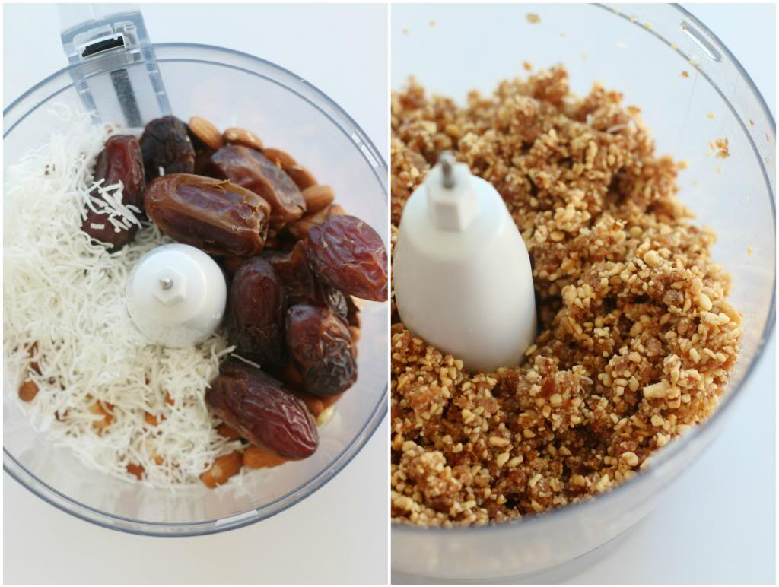3 cups of raw cashews

3/4 cup of lemon juice (fresh is best)

1/2 cup of honey

3/4 cup of coconut oil

1tbs of vanilla

**What you will need for the topping:**

8-9 medium to large strawberries

1/4 cup of coconut oil

1 tbs honey

**Directions:**

1. 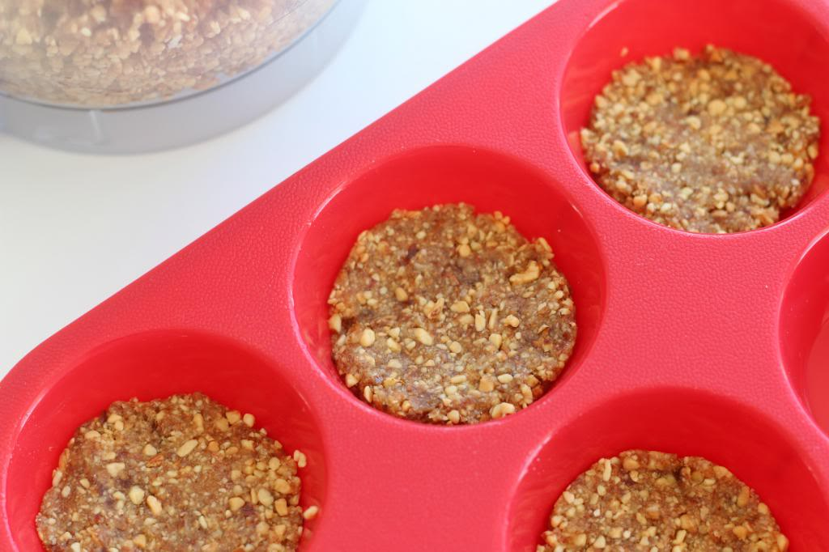Place all of the ingredients for the crust in a food processor. Process until you have a sticky dough consistency.
2. Take a small amount of crust and roll it into a ball. Then place it on the bottom of your muffin tin and press down firmly so it holds together.
3. Clean your food processor (the only annoying part of this process) and place all the ingredients for the filling inside. Process until you have a smooth cheesecake filling consistency
4. Layer the filling on top of the crust, leaving just a little bit of room for the topping.
5. Place all of the strawberry topping ingredients into the food process and blend until you have a sauce like consistency
6. Add the topping on top of each mini cheesecake.
7. Place in the freezer for about an hour or until they are set.
8. Enjoy!

http://www.delightedmomma.com/2014/01/raw-strawberry-cheesecake-bites-paleo.html

**Raw Cheesecake Recipe**

**Recipe Directions**

1. Throw the macadamia nuts, salt and dates into your food processor. (Don't add the coconut!!) Process nuts and dates until well processed but still airy.

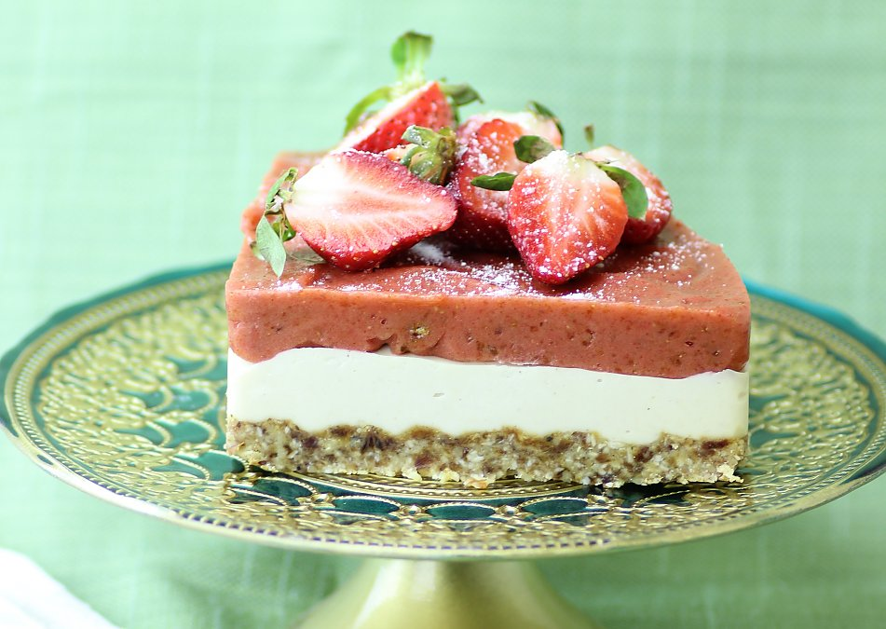2. Next, get our your cheesecake pan (or just a basic glass brownie pan if you're like me and don't have fancy cookware) and sprinkle the coconut on the bottom as your very first layer. The point of doing this is to make it so it's easier to remove the cheesecake and the coconut stops the crust from sticking to the bottom of the pan. Then press the macadamia nuts and date mixture down into the pan to form the crust.

3. Throw all cream-cheese filling ingredients into your high-speed blender and blend! Add as little water as necessary to facilitate blending. (Try to add as little water as possible.) Pour mixture on top of crust.

4. Place the above in freezer for an hour or so (so that it will firm up).

5. Meanwhile, throw your strawberries and dates in your high-speed blender. Blend until nice and smooth. Pour this mixture on top of the crust/creamcheese, which was just in the freezer for about an hour. Place the raw cheesecake recipe back in freezer. Freeze until this raw cheesecake recipe reaches the desired consistency (5 hours or so!).

6. Defrost this raw cheesecake recipe for about a half-hour before eating (or just slice from freezer and enjoy this delicious raw cheesecake)!

**Crust ingredients:**

1 1/2 cups macadamia nuts (or a combination of walnuts and/or macadamia nuts)

1/2 cup dates

1/4 cup dried, unsweetened coconut

1 pinch sea salt

**White cheesecake filling ingredients:**

3 cups cashews

3/4 cup lemon juice

3/4 cup agave or honey

3/4 cup coconut oil

1 tablespoon pure vanilla extract

1/4 cup of water, if necessary to facilitate blending. use as little as possible. (optional)

**Fruit topping ingredients:**

2 cups frozen strawberries

1/2 cup dates

http://www.therawtarian.com/raw-cheesecake-recipe

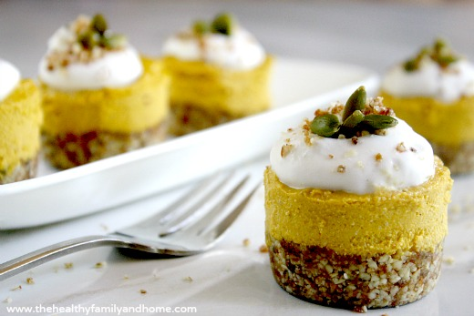**Raw Vegan Pumpkin Cheesecake:** (Raw, Vegan, Gluten-Free, Grain-Free, Dairy-Free, Paleo-Friendly, No Bake, No Refined Sugar)

**Ingredients**

**For the crust**

* 2 cups organic pecans
* 7 organic medjool dates
* 2 tablespoons organic coconut oil (melted/liquid)
* 1/2 teaspoon pink himalayan salt

**For the filling**

* 1 can organic pumpkin (Farmer's Market with BPA-free can)
* 2 cups organic cashews
* 4 tablespoons organic coconut oil (melted/liquid)
* 1/4 cup organic liquid sweetener (ex. maple syrup, raw honey, etc)
* 1/2 teaspoon organic vanilla extract
* 2 teaspoons organic ginger
* 1 1/4 teaspoon organic nutmeg
* 1/ 1/4 teaspoon pink himalayan salt

**Directions**

**Prepare the crust**

* Step 1- Put all ingredients for the crust in a food processor and process until well combined and crumbly.
* Put (2) tablespoons of the crust mixture into each of the mini-cheesecake holders and save any remaining crumbs for garnish. Press the crumb mixture very firmly into the mini-cheesecake holders and put in the freezer while you prepare the filling.

**Prepare the filling**

* Step 2-Put all ingredients for the filling into a Vitamix and blend well until smooth and creamy. Fill each mini-cheesecake holder to the top with the filling mixture. Return to the freezer for approximately (1) hour or until hard and firm.

**Assemble**

* Step 3-Remove from the freezer about 10 -15 minutes before serving so they can thaw slightly. Store in freezer because they will get soft and lose their shape if left out at room temperature.   
  Optional: Add a dollop of homemade whipped coconut cream and/or sprinkle leftover crust mixture on the top.

www.thehealthyfamilyandhome.com The Healthy Family and Home