**Black Bean Brownies**

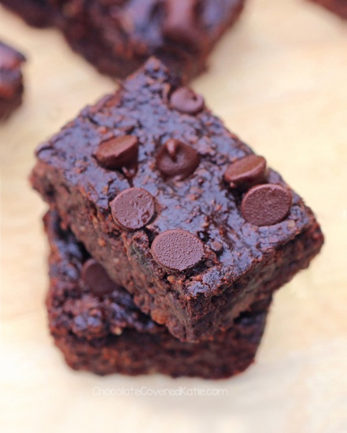

**Ingredients**

* 1 1/2 cups black beans (1 15-oz can, drained and rinsed very well)
* 2 tbsp cocoa powder
* 1/2 cup quick oats
* 1/4 tsp salt
* 1/3 cup pure maple syrup (use agave or honey as a substitution)
* 1/4 cup coconut oil (use avocado or olive oil as a substitution)
* 2 tsp pure vanilla extract
* 1/2 tsp baking powder
* 1/2 cup to 2/3 cup dark chocolate chips

**Instructions**

1. Black Bean Brownies Recipe: Preheat oven to 350 F.
2. Combine all ingredients except chips in a good food processor, and blend until completely smooth. Really blend well. (A blender can work if you absolutely must, but the texture—and even the taste—will be much better in a food processor.)
3. Stir in the chips, then pour into a greased 8×8 pan. Optional: sprinkle extra chocolate chips over the top.
4. Cook the black bean brownies 15-18 minutes, then let cool at least 10 minutes before trying to cut. If they still look a bit undercooked, you can place them in the fridge overnight and they will magically firm up! Makes 9-12 brownies.

http://chocolatecoveredkatie.com/black-bean-brownies-calories-and-nutrition-facts/#zCt5IxlGlgUSdDEu.99