**Chicken Vegetable Soup with Ginger Meatballs**

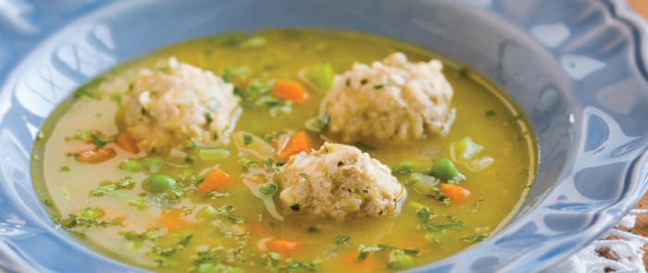

If ever there was a dish that proved I wasn’t Italian, it’s meatballs. And that’s kind of embarrassing, because not only do I love to make Italian food, I even studied (okay, suffered, but it amounted to the same thing) under an Italian signora on the Isle of Elba. But no matter how hard I tried, I could never figure out how to keep my meatballs from falling apart, until I tried basmati rice. Now my meatballs not only taste great, they also don’t disintegrate on the fork. These are actually mini meatballs, closer to the Latin-American version known as albondiguitas, with the ginger providing a little zing. If timing is an issue, the meatballs can be prepared ahead of time and refrigerated until you’re ready to cook them. Also, this recipe makes twice as many meatballs as you’ll need for the soup. To save the remainder for later, place them in the freezer for 1 hour to firm up, then transfer to an airtight container and refrigerate for up to 5 days or freeze for up to 3 months.

**Serves 4**

**Meatballs**

1 pound ground organic dark-meat turkey or chicken  
2 teaspoons grated fresh ginger  
1 teaspoon minced garlic  
1/4 cup fresh parsley, finely chopped  
1/2 teaspoon sea salt  
pinch of cayenne  
1 egg, beaten  
1/3 cup uncooked white basmati or jasmine rice

**Soup**

2 tablespoons extra-virgin olive oil  
1 yellow onion, diced small  
sea salt  
1 large carrot, peeled and diced small  
1 large celery stalk, diced small 2 cloves garlic, minced1 teaspoon grated fresh ginger  
8 cups Chicken magic mineral Broth or store-bought organic chicken broth  
1/2 cup fresh or frozen sweet peas  
1/4 cup fresh parsley, finely chopped  
1/4 cup fresh basil, finely chopped  
1 lime, cut into quarters, for garnish

To make the meatballs, line a sheet pan with wax paper. Combine the turkey, ginger, garlic, parsley, salt, cayenne, egg, and rice in a bowl and mix with your hands or a spatula until well combined. Don’t overwork the mixture or the meatballs will be tough.

Wet the palms of your hands so the mixture doesn’t stick, roll it into 1-inch balls, and place them on the prepared pan.

To make the soup, heat the olive oil in a soup pot over medium heat, then add the onion and a pinch of salt and sauté until translucent, about 4 minutes. Add the carrot, celery, garlic, ginger, and 1/4 tea- spoon of salt and continue sautéing for about 3 minutes.

Pour in 1/2 cup of the broth to deglaze the pot and cook until the liquid is reduced by half. Add the remaining 71/2 cups broth and another 1/4 teaspoon of salt and bring to a boil. Lower the heat to maintain a vigorous simmer, then gently transfer half of the meatballs into the simmering broth. (Refrigerate or freeze the remainder to use later.) Cover and allow the meatballs to simmer for 15 minutes.

Add the peas and cook for 3 minutes more, then stir in the pars- ley and basil. Serve each bowl garnished with a wedge of lime.

Variation: If you aren’t a pea person, use this recipe as an opportunity to get some dark leafy greens into your life. Simply replace the peas with 1 cup of baby spinach leaves.

Prep time: 20 minutes  
Cook time: 35 minutes  
Storage: Store in an airtight container in the refrigerator for up to 5 days or in the freezer for up to 2 months

[***The Cancer-Fighting Kitchen: Nourishing, Big-Flavor Recipes for Cancer Treatment and Recovery***](http://www.rebeccakatz.com/the-cancer-fighting-kitchen).