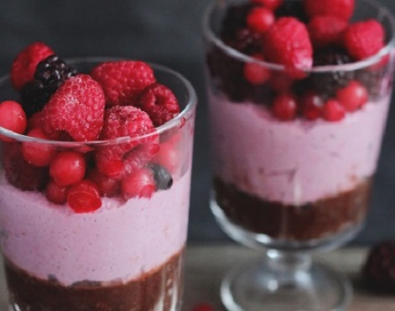**Chocolate Raspberry Mousse**

Makes 4 1/2-cup servings

* 1 pound soft silken tofu
* 2 tablespoons cocoa powder
* 1/3 - 1/2 cup maple syrup (to taste)
* 1 teaspoon vanilla or raspberry extract (optional)
* 1/2 cup fresh raspberries

Place all ingredients in a blender and process until completely smooth. Spoon into small bowls and chill well before serving.

|  |
| --- |
| **AMBROSIA** |
| Makes about 4 1-cup servings   * 2 oranges, peeled and chopped * 2 cups pineapple chunks * 1 banana, sliced * 1/4 cup shredded coconut * 2 to 4 tablespoons dried cranberries * 1 tablespoon orange juice concentrate * 1/2 teaspoon almond extract * 1 tablespoon water   Place oranges, pineapple, banana, coconut, and cranberries in a medium bowl. In a small bowl, mix orange juice concentrate, almond extract, and water. Pour over fruit and toss to mix. |

**BLUEBERRY PALEO MUFFINS**

INGREDIENTS

* 200 grams [almond flour](http://amzn.to/1RwadjY) (about 2 cups)
* ½ teaspoon baking soda
* ⅛ teaspoon salt
* 3 eggs
* ¼ cup honey
* 2 tablespoons [ghee](http://amzn.to/1Rwa3sR), melted
* 1 tablespoon lemon juice
* 1 teaspoon [organic vanilla extract](http://amzn.to/22gEsiF)
* 1 cup fresh blueberries

1. Preheat oven to 325 degrees and grease or line muffin tin.
2. Combine dry ingredients in large bowl. Combine wet ingredients in medium bowl. Stir wet ingredients into dry ingredients, then fold in blueberries. Using a large ice cream or cookie scoop, fill muffin cups ¾ full.
3. Bake for 20 - 25 minutes, until golden brown and toothpick inserted in center comes out clean. Cool on wire rack.