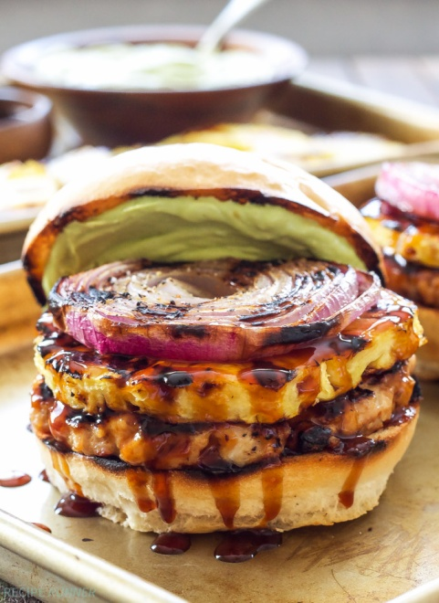**GRILLING**

**JUNE, 2017**

***TERIYAKI TURKEY BURGERS WITH GRILLED PINEAPPLE AND ONIONS***

*Ingredients*

**Teriyaki Sauce**

* 1/3 cup low sodium soy sauce
* 3 tablespoons water
* 3 tablespoons honey
* 2 tablespoons rice vinegar
* 1 clove of garlic, grated
* 1/2 teaspoon grated fresh ginger
* 1/2 teaspoon sriracha
* 2 teaspoons cornstarch + 2 teaspoons water, whisked together to make a slurry.

**Teriyaki Turkey Burger**

* 1 pound lean ground turkey
* 1/4 cup grated onion
* 2 tablespoons teriyaki sauce
* 1/2 teaspoon grated fresh ginger
* Kosher salt and black pepper to taste
* 4 buns
* 4 fresh pineapple rings
* 1 red onion cut into 1/2 inch thick slices

***Teriyaki Sauce***

1. In a small saucepan whisk together all of the ingredients except the cornstarch water slurry.
2. Bring the mixture to a boil and boil for 2 minutes.
3. Whisk in the cornstarch slurry and boil for another minute or until it has thickened.
4. Remove from the heat and refrigerate in an airtight container until ready to use.

***Teriyaki Turkey Burgers***

1. In a large bowl mix together the ground turkey, onion, teriyaki sauce, ginger, salt and pepper with your hands being careful not to overwork the meat. Form into 4 patties and set aside.
2. Heat the grill to medium high heat and oil the grates.
3. Brush the pineapple rings and red onion slices with a little oil and sprinkle with salt and pepper.
4. Place them on the prepared grill and grill the pineapple for approximately 3 minutes per side and the onions for 4-6 minutes per side.
5. While the pineapple and onions are grilling add the turkey burgers to the grill and grill for approximately 3-4 minutes per side.
6. Toast the buns on the grill for about 1 minute if desired.

***Grilled Margherita Portobella Mushrooms***

*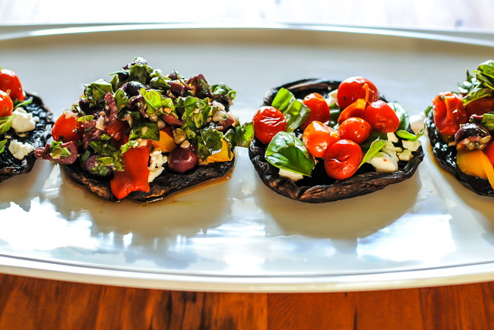Ingredients*

* 4 item(s) portobello mushroom(s), stems removed, wiped clean
* 1 spray(s) olive oil
* 1/2 cup(s) fresh mozzarella cheese
* 1/4 tsp garlic powder
* 1 tsp dried oregano
* 2 medium plum tomato(es), sliced into 1/4-inch-thick slices
* 8 leaf/leaves basil, fresh

*Instructions*

1. Heat a grill or grill pan to medium-high heat.
2. Coat mushrooms with olive oil; place on grill, stem-side down, and cook, covered, 4 minutes. Uncover and using tongs, flip mushrooms; cook for 4 minutes more.
3. After mushrooms have cooked for 8 minutes, remove them to a tray and reduce grill heat to medium-low. Fill each mushroom cap sliced tomatoes sprinkled with garlic and oregano, then fresh basil and fresh mozzarella Place mushrooms back on grill and cook, covered, until cheese melts, about 2 minutes.
4. Remove mushrooms to a serving plate and top with more fresh basil. Yields 1 mushroom per serving.

***Grilled Vegetables and Pork Tenderloin***

*Ingredients*

* Olive oil
* Salt and pepper
* Cooking spray

1. Coat vegetables and pork tenderloin with olive oil, salt and pepper.
2. Spray grill with cooking spray grill pork 4 minutes, turn and 4 minutes and turn, remove and cover to rest for 5 minutes.
3. To Grill vegetable place on hot grill sear for 3 minutes or till start to show grill marks. Turn and grill the other side remove and serve
4. Top pork and vegetables with the Teriyaki Sauce from the previous recipe.