KEY LIME PIE ENERGY BARS

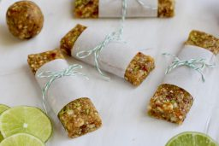

The bars are a knockoff of the fruit and nut bars everyone loves. Feel free to roll them into balls for a bite-sized treat or add a scoop or two of collagen a little protein boost.

Serves: 12 bars or 24 balls

**INGREDIENTS**

* 20 pitted [deglet dates](http://amzn.to/2mcqpew" \t "_blank) (or 10 [medjool dates](http://amzn.to/2lUTnP9" \t "_blank), pitted)
* ¾ cup [whole almonds](http://amzn.to/2mxQxU1)
* ¾ cup [raw cashews](http://amzn.to/2mfqeB6)
* ¼ cup [unsweetened shredded coconut](http://amzn.to/2mxQszw)
* Zest of 2 limes
* Juice of 1 lime
* Pinch of sea salt

**INSTRUCTIONS**

1. Place all ingredients into the bowl of a food processor.
2. Process until mixture is crumbly yet still holds together well when pinched between your fingers. If mixture is too dry, add another date and process again or add a splash of water. If mixture is too wet, add a few more nuts and process again until crumbly.
3. Press mixture onto a parchment paper-lined baking sheet forming a square about 9 x 9 inches (or roll them between your hands to form them into 16 balls). Place bars in the fridge to chill if they seem sticky.
4. Cut into 8 bars. Wrap in parchment paper and store in a covered container in the fridge for up to 1 week.

http://therealfoodrds.com/key-lime-pie-energy-bars/