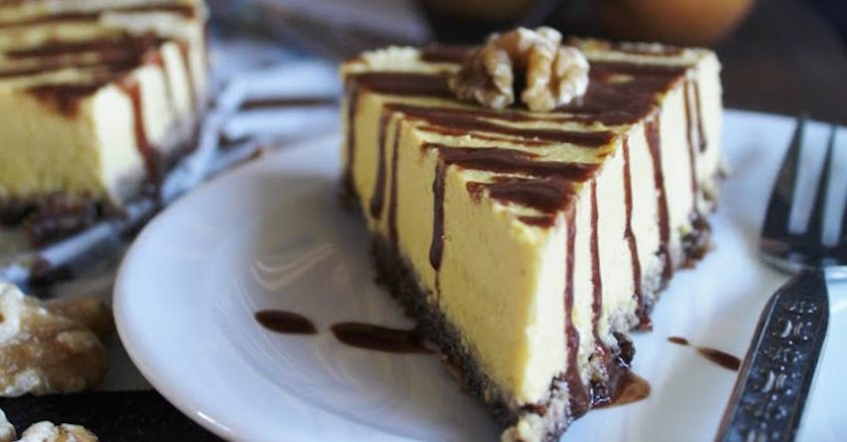**Pumpkin Cashew Cream Cake**

**For the crust:**

* 1 cup oats or walnuts
* 1 cup raisins or dates

**For the cheesecake:**

* 2 cups cashews (preferably soaked for 3-4 hours)
* 1/3 cup lemon juice
* 1/3 cup coconut nectar
* 1/2 cup melted coconut oil
* 1/2 teaspoon Himalayan crystal salt
* 1 teaspoon vanilla extract
* 1 sugar pumpkin (about 6 cups) peeled, cubed and deseeded

1. To make the crust: pulse the oats or nuts in your food processor until they become crumbs. Add the raisins or dates and process until it all sticks together. Press into the bottom of a lined spring form pan and set in the fridge.

2. To make the cheesecake: blend all the ingredients in a high speed blender until thick and smooth.

3. Spread evenly into your spring form pan (on top of your crust) and put in the fridge for about 24 hours.

4. Slice and serve with a chocolate or caramel sauce, and perhaps some vegan ice cream.

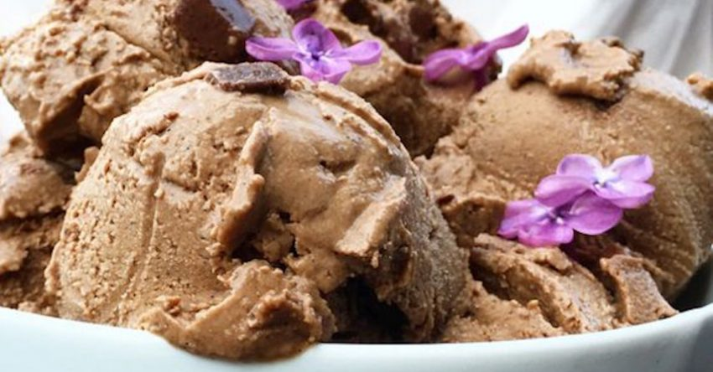**Raw Chocolate Coconut Ice Cream**

* 2 cups raw cashews (soaked for a few hours, then rinsed and drained)
* 2 cups young coconut meat
* 1 cup water or coconut water
* 10 pitted Medjool dates
* 4 tablespoons raw cacao powder
* 1 teaspoon raw vanilla bean powder
* Optional: 1/3 cup coconut sugar or maple syrup
* Optional: 1/3 cup (raw) dairy-free chocolate chips

1. Place all of your ingredients (except chocolate chips) in a high speed blender.

2. Blend until you get a thick and smooth batter. I recommend starting with just 1/2 cup of water, and then adding more as you go. The thicker the batter is, the better it tastes.

3. Stir in chocolate chips by hand and pour mixture into a medium-sized container.

4. Freeze for at least six hours before serving. Let the ice cream defrost for about 15 minutes before scooping into balls and serving it. The ice cream will keep for at least a month in the freezer.

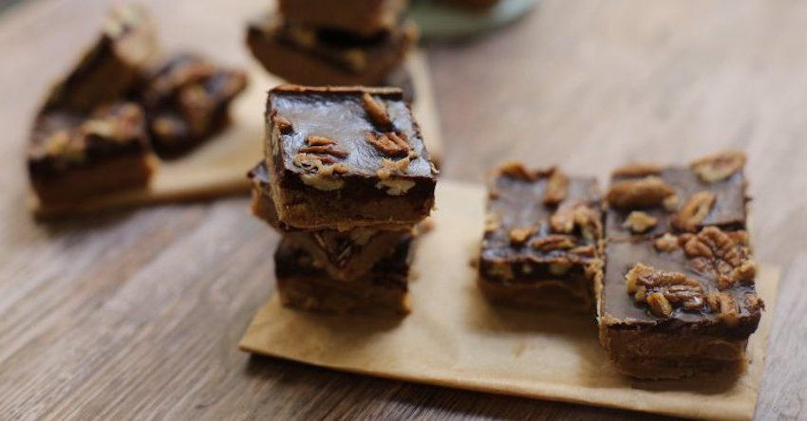**Caramel Fudge with Chocolate-Pecan Ganache**

**For the fudge:**

* 1.5 cups of almond butter
* 1/2 cup of melted coconut oil
* 1/3-1/2 cup agave/maple syrup (how sweet you like it)
* Pinch of salt

**For the chocolate ganache:**

* 1/4 cup melted coconut oil
* 1/4 cup agave/maple syrup
* 1 cup cacao/cocoa powder
* 1/3 cup pecans (+ a pinch of salt)

1. Preheat the oven to 375 degrees Fahrenheit.

2. Start by making the fudge. Melt the coconut oil and add the almond butter, coconut oil, sweetener and a pinch of salt to a mixing bowl. Mix really well until it’s a smooth silky mixture. Pour into a medium-high sided baking dish, lined with parchment paper. Place in a freezer for around 20 minutes to set, or until the top is solid.

3. Meanwhile, make the chocolate ganache. Put the pecans on a tray and add a pinch of salt. Roast them in the oven for around 10 minutes (checking after 5 minutes to make sure they don’t burn). To make the chocolate, add the melted coconut oil in a bowl with the sweetener and cacao/cocoa powder. Mix quickly until totally smooth.

4. When the fudge is set, add the chocolate on top, spreading evenly. Scatter the pecans on top and place back in the freezer for at least 30 minutes. An hour is ideal, to make sure it really sets. Store in the freezer.

5. Enjoy!

http://kriscarr.com/blog/recipes/dessert/