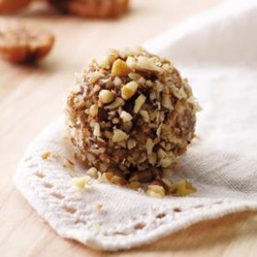**No-Bake Energy Bites Recipe**

**Ingredients**

* 1 cup (dry) oatmeal (I used old-fashioned oats)
* 1 cup toasted coconut flakes
* 1/2 cup chocolate chips
* 1/2 cup peanut butter
* 1/2 cup ground flaxseed
* 1/3 cup honey
* 1 Tbsp chia seeds
* 1 tsp. vanilla

**Preparation**

Mix all ingredients together and let sit in refrigerator for approximately ½ hour. Roll into small balls, about 1 inch in diameter. Store in air tight container in refrigerator.

**No-Bake Date Bran Balls**

**Ingredients**

* 2 cups bran flakes cereal
* 3/4 cup whole pitted dates
* 1/2 cup pecans, toasted
* 3 tablespoons honey
* 2 tablespoons cream cheese, softened
* 2 teaspoons brandy, orange liqueur or orange juice
* 1/2 cup finely chopped nuts, date sugar, coconut or toasted wheat germ

**Preparation**-Place cereal dates and pecans in a food processor and process until finely chopped. Add honey, cream cheese and brandy (or orange liqueur or orange juice) and pulse until a stiff dough forms.

Scoop tablespoon-size portions and shape with greased hands into balls. Roll each ball in chopped nuts (or date sugar or coconut or wheat germ). Place on wax paper. Let stand at room temperature for 30 minutes before serving or storing.

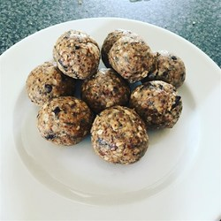**Chocolate Protein Balls**

* 1 cup rolled oats
* 1/2 cup natural peanut butter
* 1/3 cup honey
* 1/4 cup chopped dark chocolate
* 2 tablespoons flax seeds
* 2 tablespoons chia seeds
* 1 tablespoon chocolate-flavored protein powder, or to taste

**Directions**

1. Stir oats, peanut butter, honey, chocolate, flax seeds, chia seeds, and protein powder together in a bowl until evenly mixed.
2. Cover bowl with plastic wrap and refrigerate for 30 minutes.
3. Scoop chilled mixture into balls. Keep cold until serving.