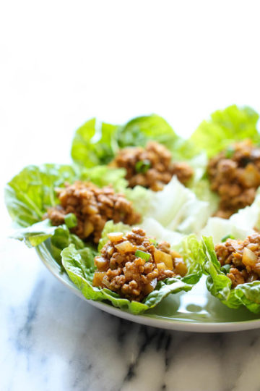[**PF CHANG’S CHICKEN LETTUCE WRAPS**](https://damndelicious.net/2014/05/30/pf-changs-chicken-lettuce-wraps/)

### INGREDIENTS:

* 1 tablespoon olive oil
* 1 pound ground chicken
* 2 cloves garlic, minced
* 1 onion, diced
* 1/4 cup hoisin sauce
* 2 tablespoons soy sauce
* 1 tablespoon rice wine vinegar
* 1 tablespoon freshly grated ginger
* 1 tablespoon Sriracha, optional
* 1 (8-ounce) can whole water chestnuts, drained and diced
* 2 green onions, thinly sliced
* Kosher salt and freshly ground black pepper, to taste
* 1 head butter lettuce

### DIRECTIONS:

1. Heat olive oil in a saucepan over medium high heat. Add ground chicken and cook until browned, about 3-5 minutes, making sure to crumble the chicken as it cooks; drain excess fat.
2. Stir in garlic, onion, hoisin sauce, soy sauce, rice wine vinegar, ginger and Sriracha until onions have become translucent, about 1-2 minutes.
3. Stir in chestnuts and green onions until tender, about 1-2 minutes; season with salt and pepper, to taste.
4. To serve, spoon several tablespoons of the chicken mixture into the center of a lettuce leaf, taco-style.

https://damndelicious.net/2014/05/30/pf-changs-chicken-lettuce-wraps/