FLOURLESS BROWNIE BITES

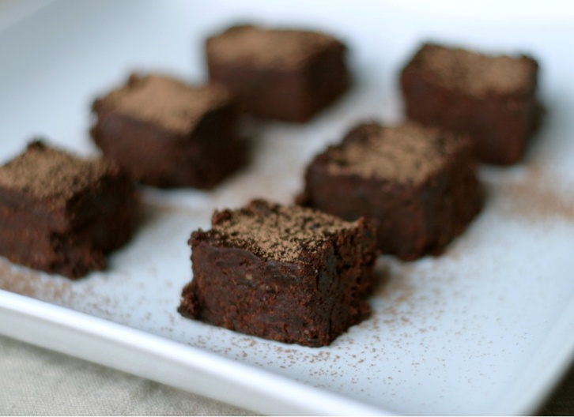

**Ingredients**

* **1 1/2 cups walnuts, ground**
* **1/4 cup cocoa powder**
* **1 teaspoon vanilla extract**
* **1/4 teaspoon sea salt, fine**
* **1 cup dates, softened**
* **1 tablespoon water**

**Directions**

**1**.   In a large food processor fitted with an "S" blade, grind the walnuts into a fine meal. Add in the rest of the ingredients, and process again until a sticky, uniform dough is formed.

2. Scoop the batter by heaping tablespoons onto a plate or baking sheet lined with parchment paper, to prevent sticking. Roll the balls between your hands, and roll them in cocoa powder, if desired.

**2**.  Store the balls in the fridge or freezer, and serve them chilled for the moist firm texture.