### Veggie Stir-Fry

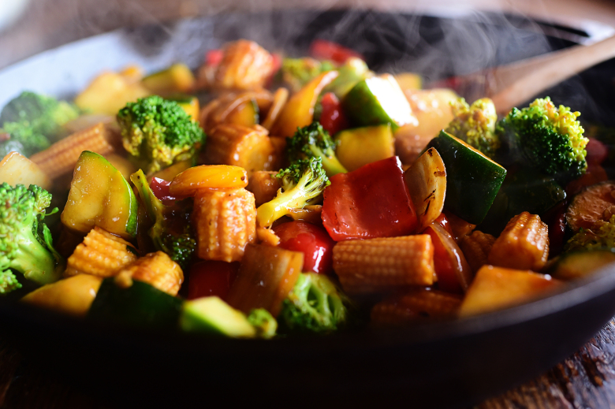

Ingredients:

* 1/2 cup Low Sodium Soy Sauce
* 2 Tablespoons Sherry (or Low-sodium Vegetable Broth)
* 2 Tablespoons Packed Brown Sugar
* 2 Tablespoons Cornstarch
* 2 Tablespoons Sriracha (more Or Less To Taste)
* 1 Tablespoon Minced Fresh Ginger
* 3 Tablespoons Peanut Oil
* 1 whole Yellow Onion, Cut Into Large Chunks
* 1 whole Red Bell Pepper, Seeded And Cut Into Large Chunks
* 1 whole Yellow Bell Pepper, Seeded And Cut Into Large Chunks
* 2 whole Garlic Cloves, Minced
* 2 whole Medium Zucchini, Cut Into Large Wedges
* 1 can (15-ounce) Baby Corn, Drained And Halved Crosswise
* 1 head Broccoli Cut Into Florets
* Cooked Noodles Or Rice, For Serving
* Sesame Seeds, For Serving

**[INSTRUCTIONS](http://thepioneerwoman.com/cooking/veggie-stir-fry/" \l "recipe-instructions-5a9211a2ad190)**

1. In a bowl, mix together the soy sauce, sherry, brown sugar, cornstarch, sriracha, and ginger. Set aside.
2. Heat the oil in a large skillet over medium-high heat. Add the onion and peppers, and stir, cooking for 2 to 3 minutes.
3. Add the garlic and cook for 30 seconds to 1 minute more, stirring continuously. Add the zucchini and stir it around, cooking it for 2 minutes more.
4. Add the baby corn and broccoli and cook for a couple of minutes, then, while the veggies are still firm, pour in the sauce.
5. Stir the veggies in the sauce, cooking for 1 to 2 minutes more, or until the sauce is very thick. If it needs to be a little saucier, pour in 1/4 to 1/2 cup hot water and splash in a little more soy sauce. Serve over noodles or rice, with a sprinkling of sesame seeds.
6. Tip: Prep all the veggies and make the sauce up to 24 hours ahead of time. Keep in separate containers in the fridge.

http://thepioneerwoman.com/cooking/veggie-stir-fry/