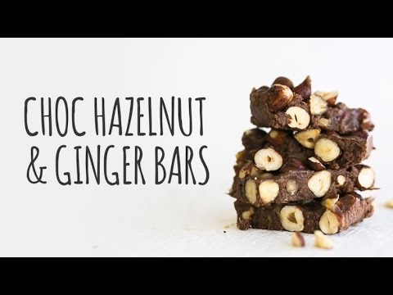

These are no ordinary chocolate bars.  They’re guilt-free with a ginger kick that will give you the afternoon pick-me-up you’re looking for. Hazelnuts for protein combined with the good fats of coconut oil and cream make this not only a healthy treat but a complete snack!

INGREDIENTS

* 1 cup roasted hazelnuts
* ¼ cup peeled and chopped ginger
* 3 tsp honey
* ½ cup [Food Matters Superfood Chocolate](http://store.foodmatters.com/product/superfood-chocolate) or raw cacao
* ½ cup coconut cream
* ¼ cup coconut oil + 1 tsp of coconut oil
* ½ cup Medjool dates

Optional extras:

* LSA (Linseed, Sunflower, Almond Mix)
* Chia seeds
* [Shredded coconut](http://amzn.to/2diCLAC)

METHOD

1. In a small saucepan over medium heat, add coconut oil and ginger, stirring until ginger begins to soften. Add honey and continue to stir until crystalized. Remove from heat and stir through the roasted hazelnuts, coating well.
2. In a food processor or high-powered blender, add Superfood chocolate or raw cacao, coconut cream, coconut oil and dates (plus any extra optionals you wish to add) and process or blend until smooth. Add a tablespoon of water if mixture isn’t smooth enough. Transfer to large mixing bowl.
3. Mix through hazelnut ginger mix until well combined. Spread mixture evenly over a lined tray in a thin layer and place in the freezer to set for 30 minutes. To serve, break or slice.

http://www.foodmatters.com/recipe/chocolate-hazelnut-ginger-bars