**TAXES:**

In this program the user inserts his/her first name, his/her last name, his/her incomes and the program show’s the taxes which he/she will pay.

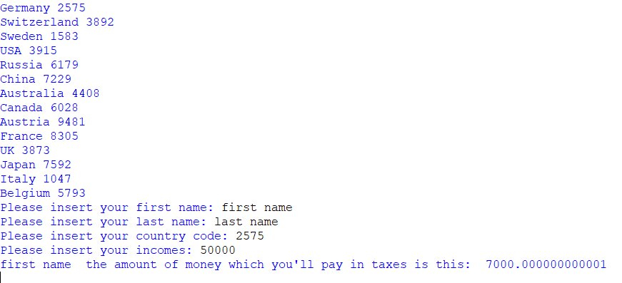

The program offers the possibility of choosing between 14 countries.