***Temperature:***

In this program which is being executed in Python 3 the user inserts the season where he/she is and the temperature of the house and the program show’s a message like “high” or “low temperature”.

**Summer:**

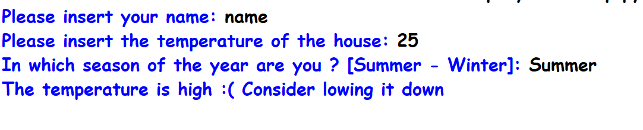

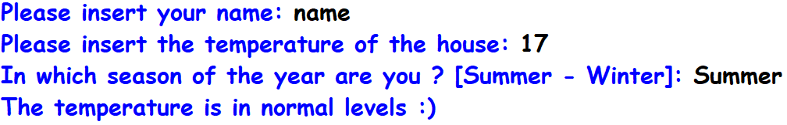

**Winter:**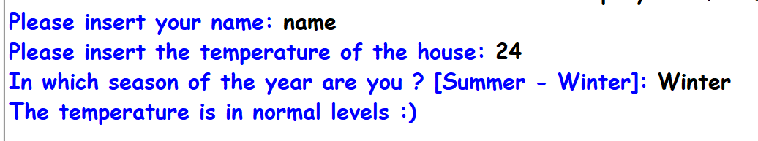

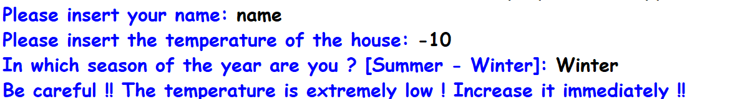

The program offers the possibility to insert temperature from -10 to 28+.