SJ Procedural Room
End-user guide for Unreal Engine 5.7. Last verified 2026-06-01.
What this plugin does
SJ Procedural Room creates editable room shells from a closed spline. It generates walls, wall finish surfaces, floors, ceilings, roof variants, door and window openings, and editor baked StaticMesh output.

Quick Start
Step | Action
1 | Enable the SJ Procedural Room plugin in your Unreal Engine project. GeometryScripting is required and is declared by the plugin.
2 | In the Content Browser, enable plugin content visibility and open /SJProceduralRoom/DemoLevel to review the included room examples.
3 | Place an ASJProceduralRoomActor in your level, or duplicate one from the demo map.
4 | Edit RoomOutlineSpline points to define the footprint. Keep the outline closed, planar, and at least three points.
5 | Use the Details panel to set room height, wall thickness, floor, ceiling, roof, materials, and bake options.
6 | Use RebuildRoom after major edits if the construction script has not already refreshed the generated geometry.
7 | Use Bake Generated Room when you want StaticMesh assets and optional StaticMeshActor replacements.

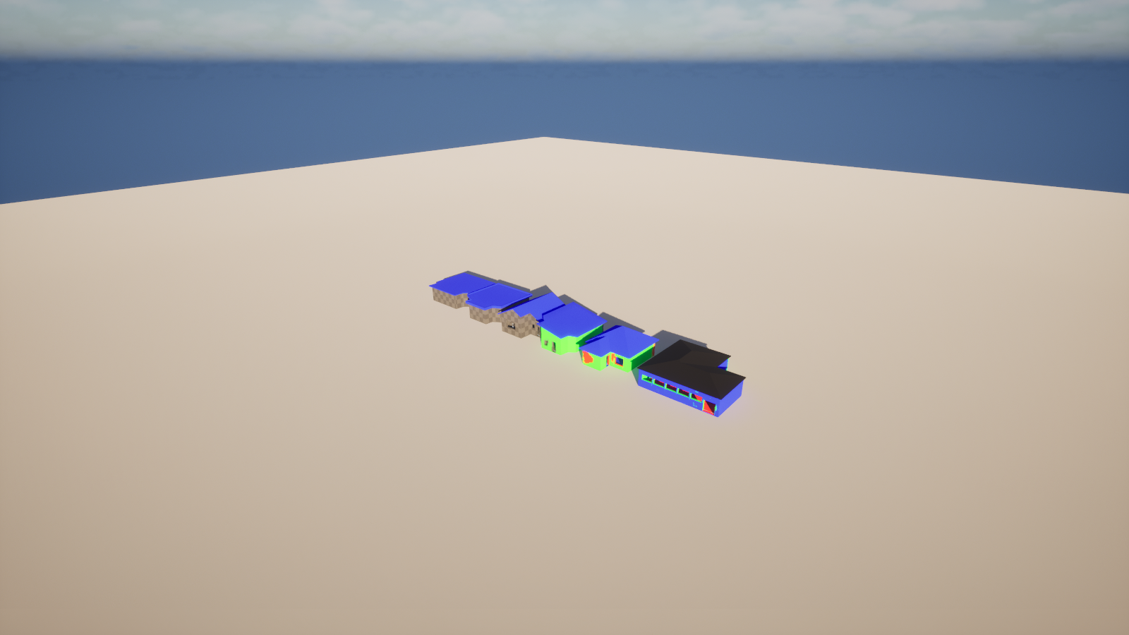
Plugin demo map loaded from /SJProceduralRoom/DemoLevel with six procedural room examples.

Opening the Sample Map
The plugin now contains a sample map under the plugin mount point:
- Asset path: /SJProceduralRoom/DemoLevel
- Source folder: Plugins/SJProceduralRoom/Content/DemoLevel.umap
- World Partition external actors are stored under Plugins/SJProceduralRoom/Content/__ExternalActors__/DemoLevel.
- The sample map was duplicated with Unreal's WorldPartitionRenameDuplicateBuilder so the external actors belong to the plugin map package.
- The current sample map contains six room actors covering flat, depressed flat, single-direction sloped, inward sloped, large inward sloped, and two-sided roof examples.
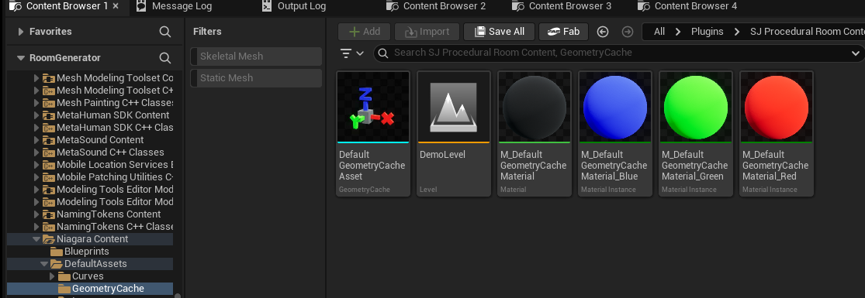
Use the Content Browser's plugin content view to open the included DemoLevel.

Actor Workflow
The main editor-facing class is ASJProceduralRoomActor. It is BlueprintType and Blueprintable, but it is designed to be placed and edited directly in the level.
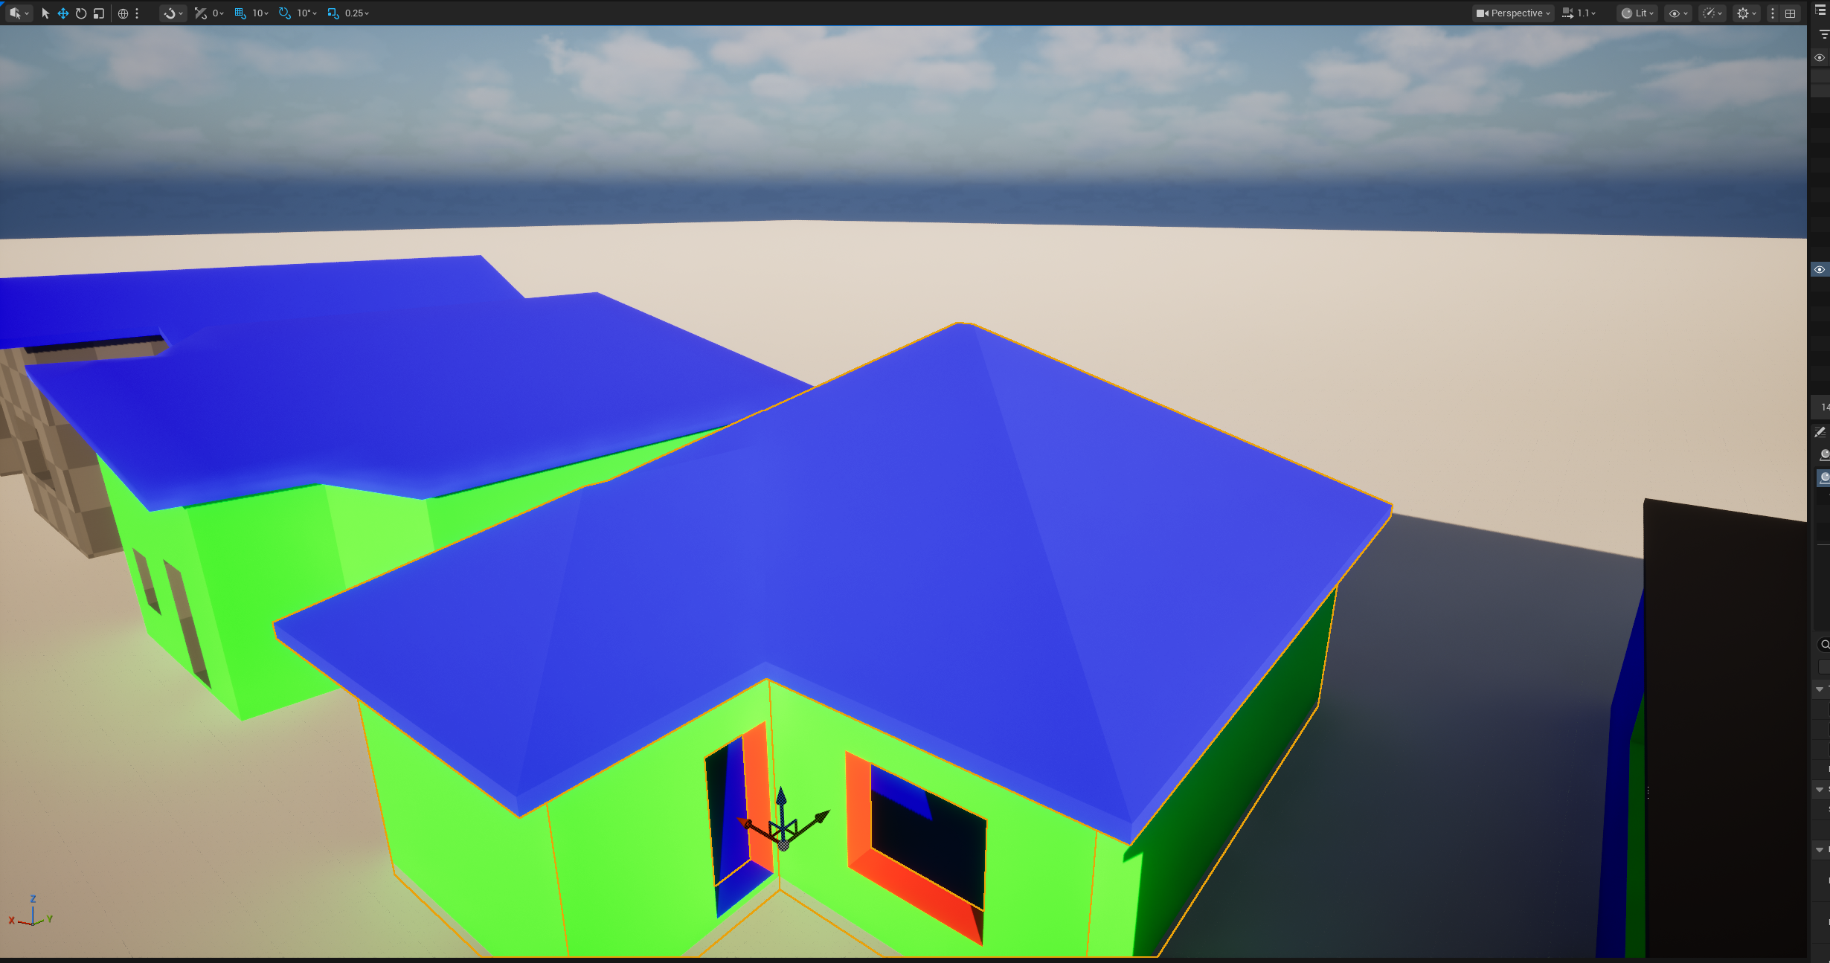
A selected procedural room actor in the plugin demo map. The actor owns the room spline and generated components.

Actor Editing Areas
Area | What to edit
Room outline | Edit RoomOutlineSpline points. The generator flattens spline points to Z=0 and expects a closed planar outline.
Room dimensions | Set RoomHeight, WallThickness, FloorThickness, and CeilingThickness from the actor Details panel.
Generated parts | Toggle floor, ceiling, and roof generation as needed. The actor does not tick; it rebuilds from construction and explicit calls.
Per-wall settings | Use SelectedWallIndex and EditableWallSettings, or edit the WallSettings array directly.
Baking | Use the Bake Generated Room editor action to create StaticMesh assets in the configured /Game folder.

Key Controls
The highlighted sections below show the selected actor/component list, material and roof assignments, and bake controls.
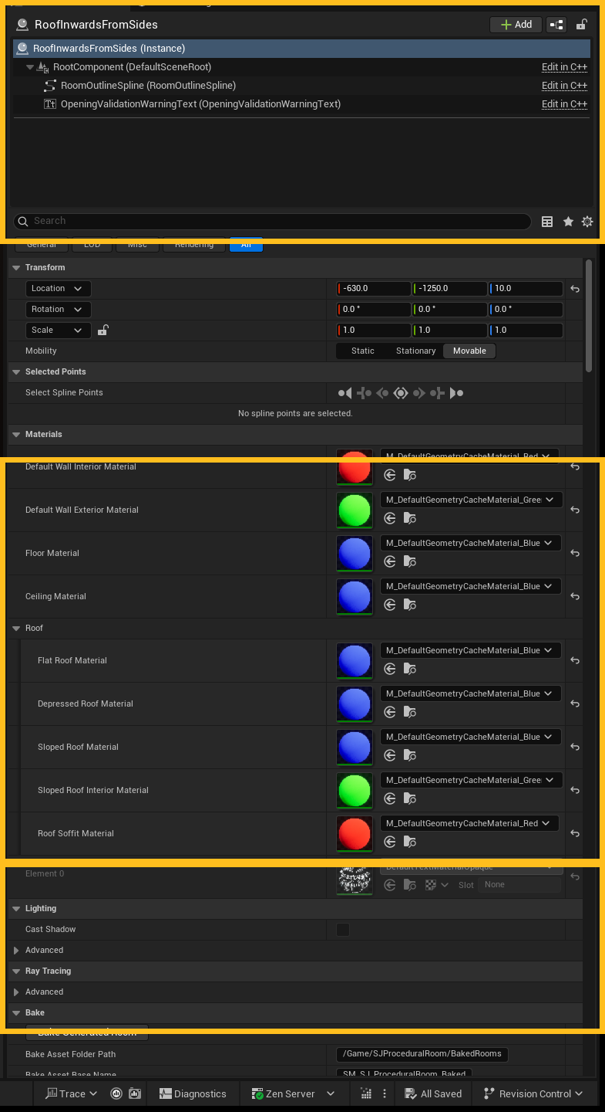
Details panel controls for an ASJProceduralRoomActor.
- Materials: set default interior/exterior wall materials, floor material, ceiling material, and roof material slots.
- Roof: assign separate flat, depressed, sloped, interior, and soffit materials.
- Openings: use actor defaults for new door/window slot sizes, plus validation settings for corner clearance and gap checks.
- Bake: choose the output folder, base asset name, separate roof option, replacement behavior, ground clearance, and geometry mode.

Walls, Doors, and Windows
Each spline side maps to one FSJProceduralWallSettings entry. Enabled walls spawn child ASJProceduralWallSegment actors unless the generator can use the simple continuous wall shell path.
Setting | Behavior
bWallEnabled | Disables or enables a wall side. Disabled walls can still receive floor or ceiling opening-face infill.
WallHeightOverride | Optional per-wall height override. If unused, height is derived from room height and ceiling/roof settings.
DefaultDoorWidth / DefaultDoorHeight | Defaults applied to newly enabled door slots before the wall is rebuilt.
DefaultWindowWidth / DefaultWindowHeight / DefaultWindowSillHeight | Defaults applied to newly enabled window slots before the wall is rebuilt.
DoorSlots | Doors use DistanceAlongWall as the opening start distance. Doors are resolved first; invalid, out-of-bounds, or conflicting slots are skipped.
WindowSlots | Windows use DistanceAlongWall as the opening center. Windows are checked against accepted doors and earlier accepted windows.
MinCornerClearance / MinOpeningGap | Validation settings for wall-end clearance and required spacing between accepted openings.

Opening validation
Conflicting openings are skipped and reported through the editor-only OpeningValidationWarningText component. Check the red warning text in the level before baking complex wall layouts.

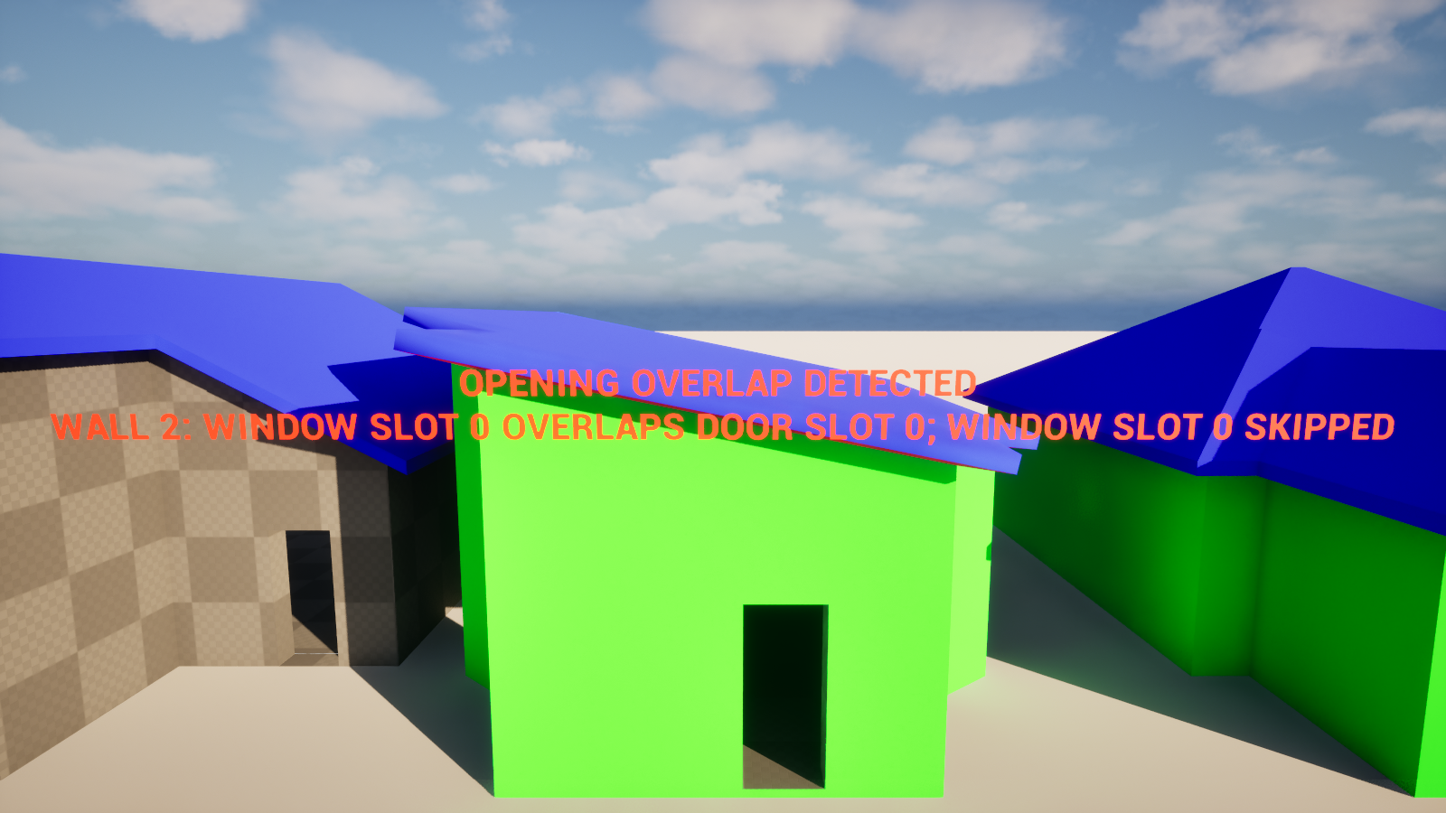
An overlapping window slot skipped by the resolver, with a visible editor warning in the demo level.

Roof Modes
The current plugin supports flat roofs, flat roofs with depression/parapet-style surfaces, and sloped roofs.
Roof type or mode | Use it for
Flat | Simple horizontal roof slabs with optional underside and soffit where extensions exist.
Flat With Depression | Depressed roof/parapet style using RoofDepressionDepth and RoofDepressionWallThickness.
Sloped - SingleDirection | A one-direction roof plane controlled by yaw and pitch settings.
Sloped - InwardFromSides | Multi-side inward sloping roof behavior using the straight-skeleton solver.
Sloped - TwoSidesOnly | Two-sided gable-style slope selection with generated gable wall infill.

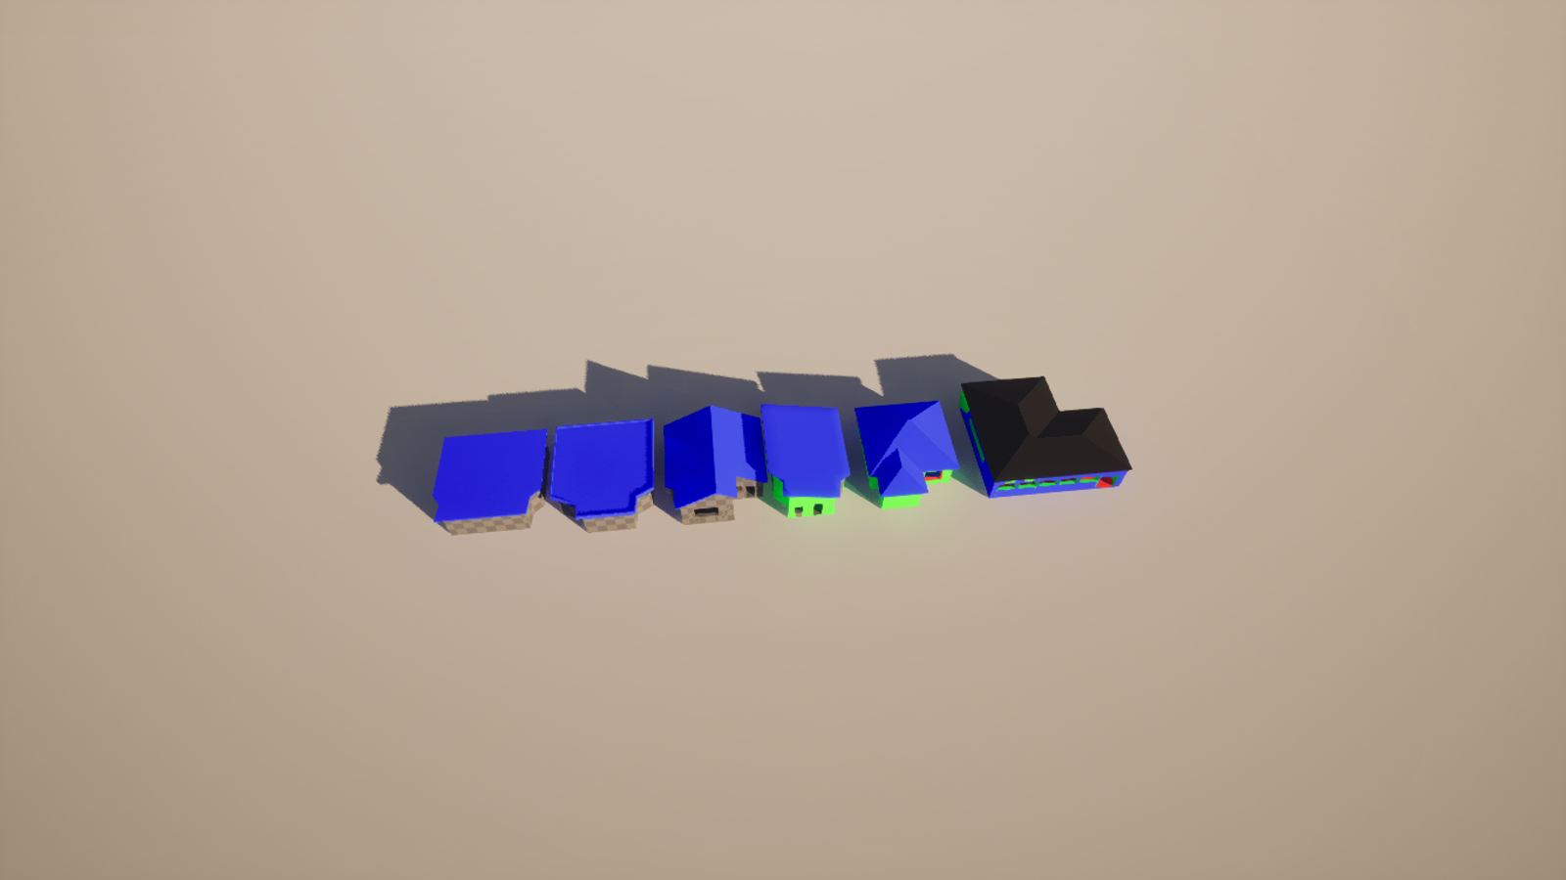
The sample map includes several roof configurations for comparison.

Lighting and Shadows
Generated DynamicMesh components are configured for normal editor lighting use, including static and dynamic shadow casting, contact shadows, two-sided shadows, and visibility for distance-field and ray-tracing paths where the project uses those systems.
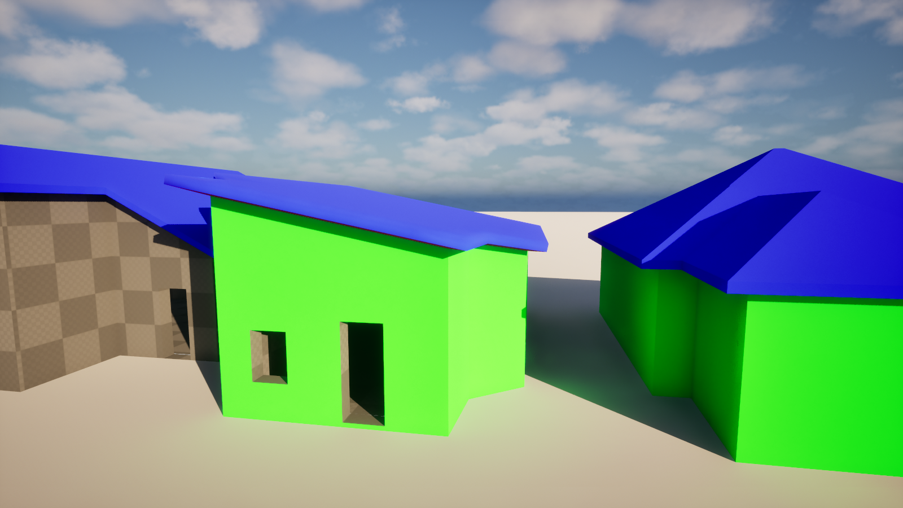
Generated opening and wall surfaces casting shadows in the refreshed demo validation scene.

Baking Static Meshes
Bake Generated Room is editor-only and creates StaticMesh assets from the live generated DynamicMesh components.
- Default bake path: /Game/SJProceduralRoom/BakedRooms.
- BakeGeometryMode defaults to SemanticMesh. VoxelMerge exists but is experimental and should be tested before production use.
- Baked assets use material slots gathered from the generated components, ray tracing support, collision, and Nanite settings.
- Spawned baked actors are lifted by BakedActorGroundClearance, currently 2.0 cm by default, to reduce floor/ground Z-fighting.
- If bBakeRoofAsSeparateAsset is enabled, the roof is saved as a separate StaticMesh asset.

Blueprint and C++ Entry Points
Callable function | Purpose
SyncWallSettingsForEditor | Keeps per-wall settings aligned with the spline side count.
RebuildRoom | Full procedural rebuild for walls, floor, ceiling, and roof.
RebuildWallSegments | Rebuilds child wall segment actors.
RebuildFloor / RebuildCeiling / RebuildRoof | Rebuilds specific generated parts.
BakeGeneratedRoomToStaticMeshAssets | Editor-only call-in-editor bake action.

Known Limitations
- Spline points are flattened to Z=0; multi-level or non-planar outlines are not supported.
- The outline should be closed and should not self-intersect.
- Invalid or conflicting opening slots are skipped instead of being partially generated; overlap conflicts are reported in the editor warning text.
- The editor module is currently scaffolding and does not add custom detail panels or visualizers.
- Door/window module spawning enums and fit data exist for future workflows, but no runtime module spawning path is currently implemented.
- Baked asset replacement applies to spawned baked actors in the level, not to manually placed StaticMesh assets.

Validation Performed for This Guide
- Compiled RoomGeneratorEditor Win64 Development with Unreal Engine 5.7.
- Refreshed /SJProceduralRoom/DemoLevel from the updated project DemoLevel using WorldPartitionRenameDuplicateBuilder.
- Loaded /SJProceduralRoom/DemoLevel and found 6 ASJProceduralRoomActor instances: RoofInwardsFromSides, RoofInwardsFromSidesLarge, RoofFlatWithDepression, RoofSingleDirection, RoofFlat, and RoofTwoSidesOnly.
- Reapplied the neutral /Game/SJProceduralRoom/BakedRooms bake path to the six demo room actors.
- Captured and inspected wide, roof, close, opening warning, shadow, editor UI, Details panel, and Content Browser screenshots.
- Checked RoomGenerator.log for plugin demo map errors; map checks reported 0 errors and 0 warnings for the validation run.

