**Summer Assignment: World History**

**Objective:** The student understands the impact of Mahatma Gandhi on the political resistance to British Rule in India in the 20th Century.

**TEKS Alignment:**

* WH.20(B) describe the rights and responsibilities of citizens and noncitizens in civic participation throughout history
* WH.21(E) identify examples of individuals who led resistance to political oppression such as Mohandas Gandhi

**Instructions:** Read through the following documents carefully. Respond to the following prompts:

1. With reference to its origin, purpose and content, analyze the value and limitations of Document 4 to historians studying Gandhi’s resistance to British rule in India. *Please respond in one full and complete paragraph.* (10 Points)
2. Use the sources to evaluate the impact of Gandhi’s resistance against the British government in India. In other words, do these sources indicate that Gandhi’s resistance was successful or unsuccessful? If he was successful, what do these sources tell you about why? If not, what do these sources tell you about why not? *Please respond to this prompt in an essay 1-2 double spaced pages in length. Be sure to create a strong thesis statement directly answering the prompt and refer to at least half of the documents to support your claim.*  (20 Points)

**Document 1**

**Source:** "Gandhi." *Gale In Context Online Collection*, Gale, 2017. *Gale In Context: High School*, Accessed 27 Apr. 2021

Mahatma [Gandhi](https://go.gale.com/ps/retrieve.do?resultListType=RELATED_DOCUMENT&searchType=ts&userGroupName=j057803&inPS=true&contentSegment=&prodId=SUIC&docId=GALE%7CMPBVDY903552274&it=r#) (1869–1948) was an Indian [civil rights](https://go.gale.com/ps/retrieve.do?resultListType=RELATED_DOCUMENT&searchType=ts&userGroupName=j057803&inPS=true&contentSegment=&prodId=SUIC&docId=GALE%7CMPBVDY903552274&it=r#) activist who led the movement to free [India](https://go.gale.com/ps/retrieve.do?resultListType=RELATED_DOCUMENT&searchType=ts&userGroupName=j057803&inPS=true&contentSegment=&prodId=SUIC&docId=GALE%7CMPBVDY903552274&it=r#) from British colonial rule throughout the first half of the twentieth century. A notable supporter of nonviolent [civil disobedience](https://go.gale.com/ps/retrieve.do?resultListType=RELATED_DOCUMENT&searchType=ts&userGroupName=j057803&inPS=true&contentSegment=&prodId=SUIC&docId=GALE%7CMPBVDY903552274&it=r#), Gandhi staged several hunger [strikes](https://go.gale.com/ps/retrieve.do?resultListType=RELATED_DOCUMENT&searchType=ts&userGroupName=j057803&inPS=true&contentSegment=&prodId=SUIC&docId=GALE%7CMPBVDY903552274&it=r#) and other peaceful [demonstrations](https://go.gale.com/ps/retrieve.do?resultListType=RELATED_DOCUMENT&searchType=ts&userGroupName=j057803&inPS=true&contentSegment=&prodId=SUIC&docId=GALE%7CMPBVDY903552274&it=r#) throughout his life to protest British control of India. He strongly opposed the [United Kingdom](https://go.gale.com/ps/retrieve.do?resultListType=RELATED_DOCUMENT&searchType=ts&userGroupName=j057803&inPS=true&contentSegment=&prodId=SUIC&docId=GALE%7CMPBVDY903552274&it=r#)’s 1947 partition (division) of India into the two nations of India and [Pakistan](https://go.gale.com/ps/retrieve.do?resultListType=RELATED_DOCUMENT&searchType=ts&userGroupName=j057803&inPS=true&contentSegment=&prodId=SUIC&docId=GALE%7CMPBVDY903552274&it=r#). His attempts to negotiate with Pakistan’s [Muslims](https://go.gale.com/ps/retrieve.do?resultListType=RELATED_DOCUMENT&searchType=ts&userGroupName=j057803&inPS=true&contentSegment=&prodId=SUIC&docId=GALE%7CMPBVDY903552274&it=r#) led to his [assassination](https://go.gale.com/ps/retrieve.do?resultListType=RELATED_DOCUMENT&searchType=ts&userGroupName=j057803&inPS=true&contentSegment=&prodId=SUIC&docId=GALE%7CMPBVDY903552274&it=r#) in 1948 by a Hindu extremist. After his [death](https://go.gale.com/ps/retrieve.do?resultListType=RELATED_DOCUMENT&searchType=ts&userGroupName=j057803&inPS=true&contentSegment=&prodId=SUIC&docId=GALE%7CMPBVDY903552274&it=r#), Gandhi was remembered around the world for his support for peace as a means of producing change.

**Document 2**

**Source:** Studio photograph of Mohandas K. Gandhi, London, 1931

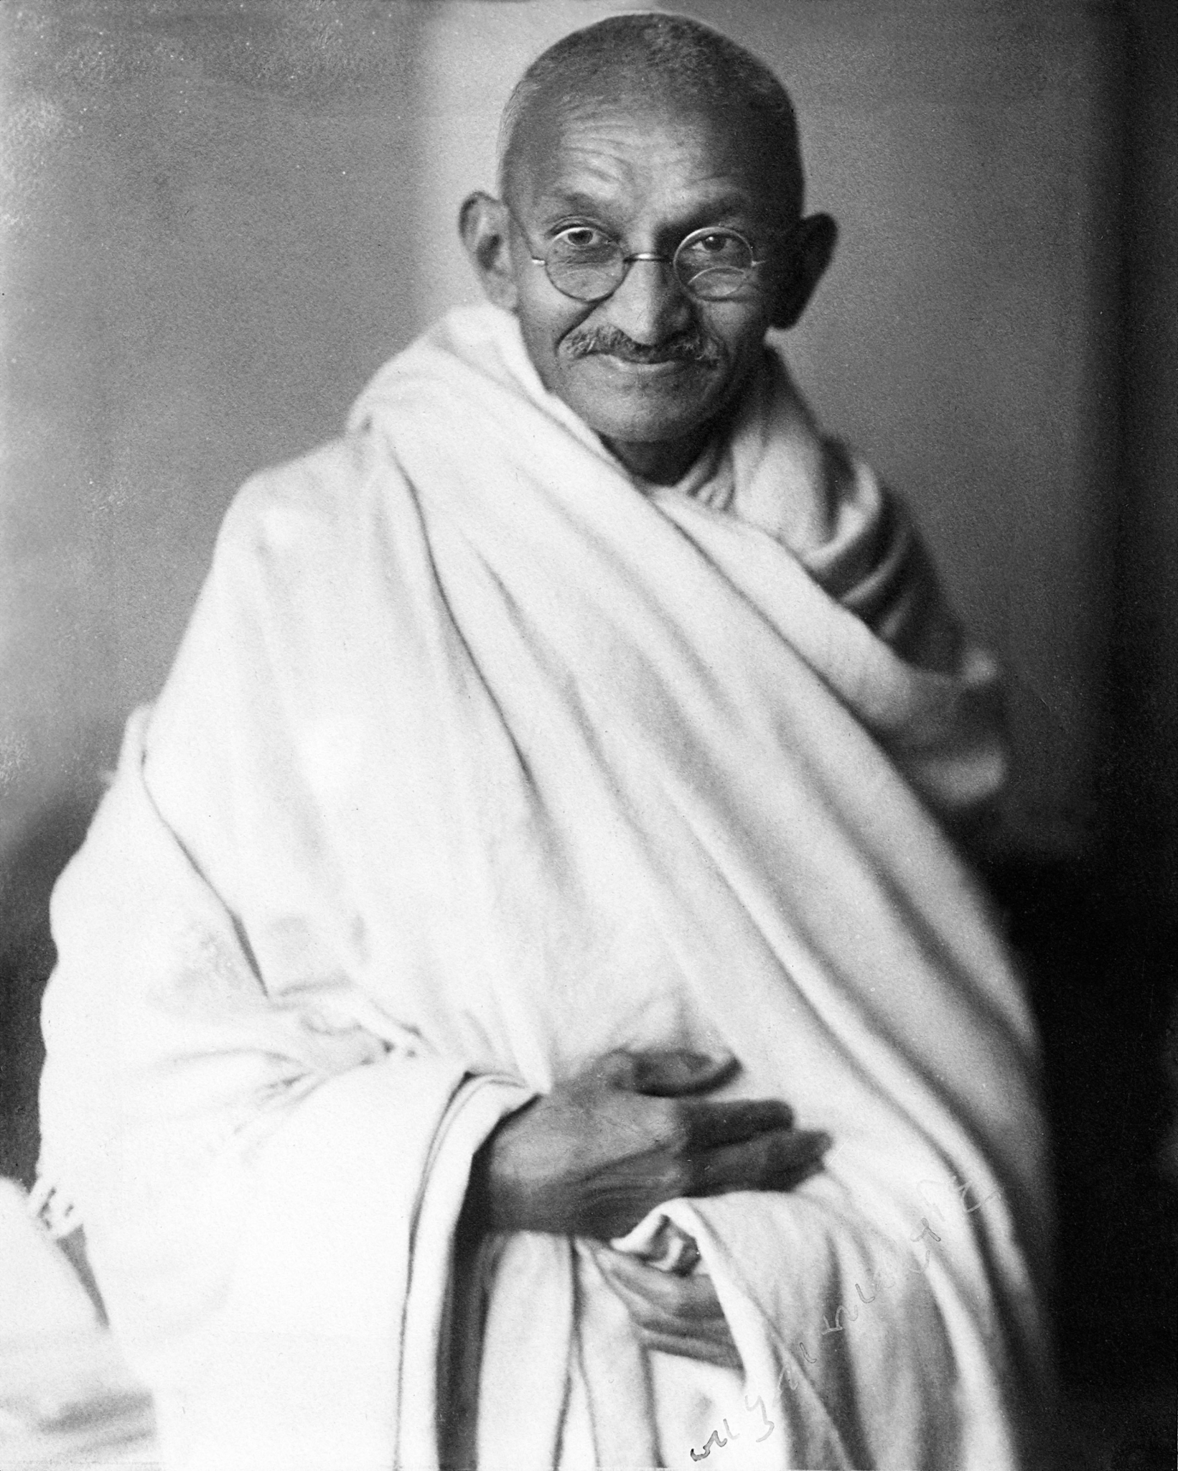

**Document 3**

**Source:** "In A Way, Gandhi Also Won 2014's Nobel Peace Prize." *Weekend Edition Saturday*, 11 Oct. 2014. *Gale In Context: High School*, Accessed 27 Apr. 2021

Mahatma Gandhi never won the Nobel Peace Prize. A lot of people who've dropped bombs, launched missiles and made war have made the Nobel, but not the man whose very silhouette - baldheaded, wrapped in cloth and walking in sandals across a perilous world - is taken to be a symbol of peace across the globe.

Historians have suggested Gandhi's selection would have riled too many people while he was alive.

Before Mahatma Gandhi was a beloved symbol, he rattled the world - India and Pakistan especially. He thought India's caste system was cruel, especially for those classified as untouchables and went on hunger strikes against it. He fought against separating Hindu and Muslim political parties and assemblies. He called on Indians to abolish child marriage and to keep young women in schools. Gandhi wanted women to be part of his movement. They joined him on boycotts, long marches and in the leadership of his Congress Party.

Gandhi did not celebrate when India gained independence in August 1947 because it divided the country along religious lines - Hindu and Muslim, India and Pakistan. He went on a last hunger strike in January 1948 to convince the new Indian government to pay cash owed to Pakistan. And then he was assassinated by a Hindu extremist who felt the mahatma had betrayed his faith.

[In 2014] Malala Yousafzai won the Nobel Peace Prize. She was a 17-year-old from Pakistan who survived the shot of an assassin to campaign for the rights of young women in her country. Mahatma Gandhi never won the Nobel Peace Prize, but in a way, [in 2014] he did.

**Document 4**

**Source:**  In August of 1942, Gandhi launched the Quit India Movement to call for an end to the British rule. The Quit India Resolution was passed on August 8, 1942. The resolution stated, "On the declaration of India's independence a provisional government will be formed and free India will become an ally of the [United Nations](https://go.gale.com/ps/retrieve.do?tabID=Reference&resultListType=RESULT_LIST&searchResultsType=MultiTab&hitCount=19&searchType=BasicSearchForm&currentPosition=1&docId=GALE%7CFNWIOE662788601&docType=Event+overview&sort=Relevance&contentSegment=ZXBK-MOD1&prodId=SUIC&pageNum=1&contentSet=GALE%7CFNWIOE662788601&searchId=R1&userGroupName=j057803&inPS=true#)." The following is the concluding portion of Gandhi's “Quit India” speeches. He gave it in Bombay, India on August 8 1942.

I have taken such an inordinately long time over pouring out what was agitating my soul, to those whom I had just now the privilege of serving. I have been called their leader or, in the military language, their commander. But I do not look at my position in that light. I have no weapon but love to wield my authority over any one. I do sport a stick which you can break into bits without the slightest exertion. It is simply my staff with the help of which I walk. Such a cripple is not elated, when he has been called upon to bear the greatest burden. You can share that burden only when I appear before you not as your commander but as a humble servant. And he who serves best is the chief among equals.

**Document 5**

**Source:** Illustration by Paulo Garretto:The Graphic, May 24, 1930

This cartoon shows Gandhi salting the tail of the British lion. It is based on an old folk belief that if you put salt on a bird’s tail you will then be able to catch it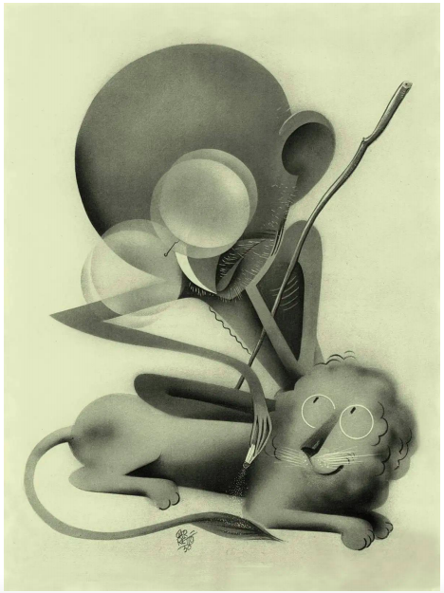

|  |  |
| --- | --- |
| ***Question 1 Rubric*** | |
| *Failing (0-2 Points)* | The response does not reach a standard described by the descriptors below. |
| *Approaching (3-5 Points)* | The origin and purpose of the document is stated but may be missing two or more of the following; the author’s name, the date of publication, the type of document or intended audience and purpose.  Explanation of value of the document with respect to the origin, purpose, and content is attempted but requires clarity.  Explanation of limitations of the document with respect to  origin, purpose, and content is attempted but requires clarity. |
| *Passing (6-7 Points)* | The origin and purpose of the document is stated but may be missing one of the following; the author’s name, the date of publication, the type of document or intended audience and purpose.  Value of the document with respect to the origin, purpose, and content is clearly explained but requires elaboration.  Limitations of the document with respect to  origin, purpose, and content is explained but requires elaboration. |
| *Masterful (8-10 Points)* | The origin and purpose of the document is clearly and accurately stated and includes the author’s name, the date of publication, the type of document and intended audience and purpose.  Value of the document with respect to the origin, purpose, and content is relevant, insightful and clearly explained.  Limitations of the document with respect to  origin, purpose, and content are relevant, insightful and clearly explained, |

|  |  |
| --- | --- |
| ***Question 2 Rubric*** | |
| *Failing (0-5 Points)* | The response does not reach a standard described by the descriptors below. |
| *Approaching (6-12 Points)* | The response lacks focus on the question.  References to the sources are made but at this level these references are likely to consist of descriptions of the content of the sources rather than the sources being used as evidence to support analysis. |
| *Passing (13-16 Points)* | The response is generally focused on the question.  Clear references are made to at least two of the sources, and these references are used as evidence to support the analysis. |
| *Masterful (17-20 Points)* | The response is focused on the question.  Clear references are made to at least two of the sources, and these references are used effectively as evidence to support the analysis. |