block_small_gap

block_length

board_length

board_height

board_start_x

board_start_y

button_start_x

button_start_y

button_height

button_gap

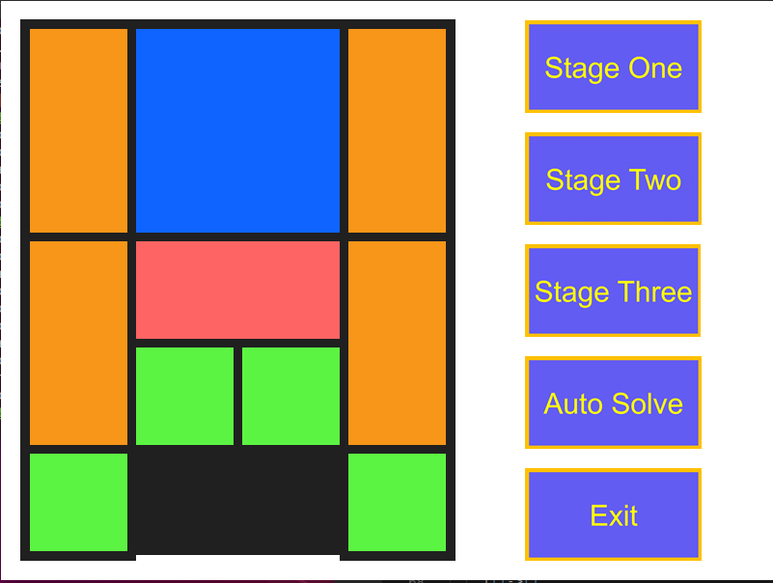

block_gap