Klotski Puzzle and Klotski Solver

Introduction:

Klotski is a sliding block puzzle which was invented around 20th century. The purpose of this game is to move the biggest square to an exit via sliding blocks. The players can only move blocks in vertical or horizontal direction, and cannot remove any block from the game board. Through many years of development, Klotski has many variants and different openings (Figure 1).

Exit

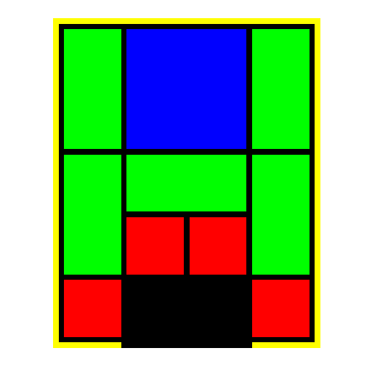

Figure 1: the most basic opening of Klotski

Although Klotski’s rules are very simple, it actually is not an easy puzzle. For example, the Klotski in Figure 1 requires at least 81 steps to win. Many people give up midway and no longer want to play Klotski anymore. Therefore, I write this Ocaml program, which allows users to

1. play Klotski with three different openings
2. get help from the computer to automatically solve the puzzle at any time, and watch the solution.

Design:

1. **Playing Klotski with three different openings**

The game board itself can be represented as a 4X5 table (Figure 2). Each cell in this table can be described by its x coordinate and y coordinate (named as box_number in the actual program). For example, the cell marked X in Figure 2 is described as (1, 2).

There are total ten blocks in Klotski. Each of them is assigned with a name and color (Table 1).

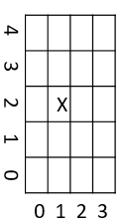

|  |  |  |
| --- | --- | --- |
| Description | Assigned Name | Assigned Color |
| 2X2 square | A | Blue |
| 1X2 rectangle | B1 | Orange |
| 1X2 rectangle | B2 | Orange |
| 1X2 rectangle | B3 | Orange |
| 1X2 rectangle | B4 | Orange |
| 2X1 rectangle | C | Red |
| 1X1 square | D1 | Green |
| 1X1 square | D2 | Green |
| 1X1 square | D3 | Green |
| 1X1 square | D4 | Green |

Figure 2: A graphic representation of the gaming board

Table 1: Blocks name and color assignment

Each block can then be described as a tuple. The first element of the tuple is the name of the block, and the second element is a variant type which contains 5 integer values: x, y, w, h and c. x and y indicate the location of the block. w and h are the width and height of the block, and c is the color of the block. For example, a block named “D1”, whose color is green, height is 1, width is 1 and location is at position (0, 0), is represented as ("D1", {x=0; y=0; w=1; h=1; c=0x5cf442}).

Thus, the game board can be easily represented as a list of tuples (Figure 3). For some blocks which occupy more than one cell, e.g. block A, the x and y indicate the lower-left corner of the block. However, the program still knows they occupy more than one cell, because their width and/or height are larger than 1. 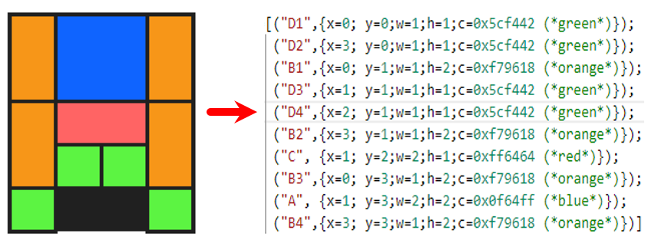

Figure 3: Use a list of tuples to represent Klotski

Through this method, the game board can be understood by the computer. The three different openings is achieved easily via using different lists of tuples.

Once a user makes a click on the screen, the program will determine which item it clicks. If it clicks

* 1. a button, the program will perform this button’s action.
  2. a block, the program will check this block’s neighboring cells.
     1. If this block is movable and can only be moved toward one direction, the program will move the block, generate a new list of tuples and refresh the screen.
     2. If this block is movable but can be moved toward two different directions, the program will ask for the user to determine which direction the block should go, then move the block, generate a new list of tuples and refresh the screen.
     3. If this block is not movable, the program will not do anything but refresh the screen with the original list of tuples.
  3. anything else, the program will not do anything but refresh the screen with the original list of tuples.

Every time the screen is refreshed, the program will check the list of tuples. If the list of tuples is in a victory stage, i.e. block A’s x =1 and y=0, the program will generate a victory screen to congratulate the user and end the game.

There is a special case when the mouse clicks at the cross section, horizontal aisle or vertical aisle between cells. If this happens, the program will think this click does not hit on any block. However, this judgement is not correct, sometimes. Thus, an additional check function is added - if the mouse clicks at cross section, horizontal aisle or vertical aisle, the program will check the neighboring cells. If they are belongs to the same block, the mouse actually hits a block!

1. **Auto solve**

When a user clicks the “Auto Solve” button, the program will take the current list of tuples as an input, and use breadth-first search (BFS) to generate a solution tree. The program tries to move every block in the input to generate all possible lists of tuples. All the different lists of tuples generated will be stored as “leaves” and then are used as new inputs to generate more “leaves”. This BFS will continue until one of the many “leaves” is in victory state (Figure 4). If a “leaf” is encountered before, e.g. the “leaf” marked with a red cross in the figure 4, will be ignored to save calculation. No new “leaf” will be generated from it.

After the solution tree is generated, a backtrack function is called to backtrack the solution tree to get a path from the victory state to the original input. This path is our solution. A small animation is made to display the solution to the user.

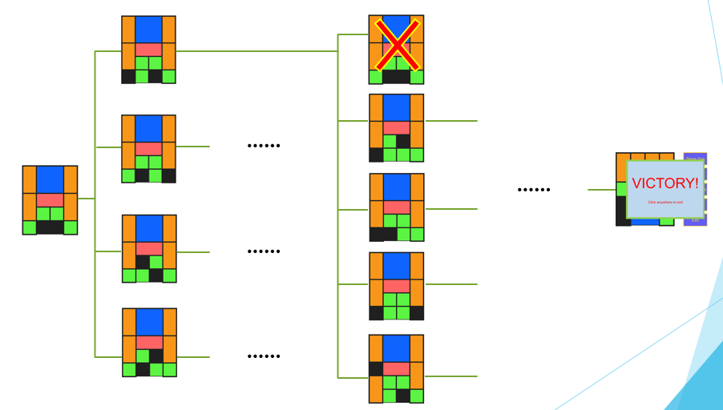

Figure 4: The BFS of the auto solve function