Contents

Getting Started

Designs

Wireframes

This is wireframe of my home page

This is wireframe of my CV page

This is wireframe of my biography page

This is wireframe of my Contact page

Sketches

Here is sketch for my home page

Here is sketch for my CV page

Here is sketch for my biography page

Here is sketch for my contact page

Final design of my website

Home page

CV page

Biography page

Contact page

Evidence of how I have used models of good practice

Page load speed

Visual appeal

Navigation

Reference

Conclusion

# Getting Started

To make my portfolio, first of all I had looked over the other different peoples portfolios and had collect some ideas on how they had style their portfolio like designing part, color combination part, navigation bar etc and finally I had generated my portfolio too.I had generated my website using HTML5 and CSS.It gives me some confidence on developing the website.Now I am able to change the all forms of website and could create as own.To generate my website,I had looked up following peoples website:

* Christine Bell
* Robert Smith
* Rachel Smith

# Designs

# Wireframes

### This is wireframe of my Home pagehomewifr.jpg

## This is wireframe of my CV page

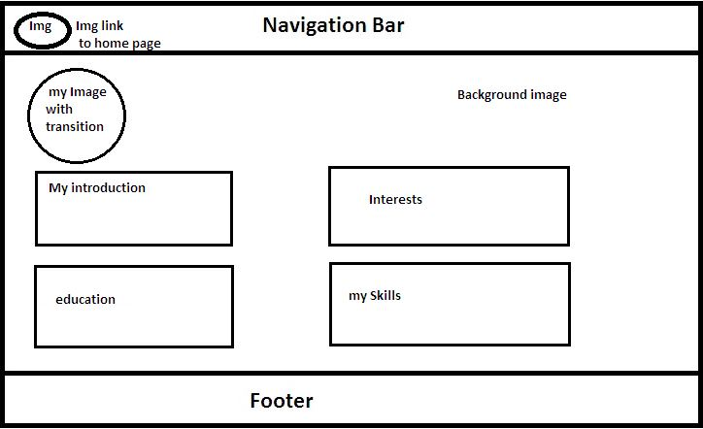

## This is wireframe of my about page

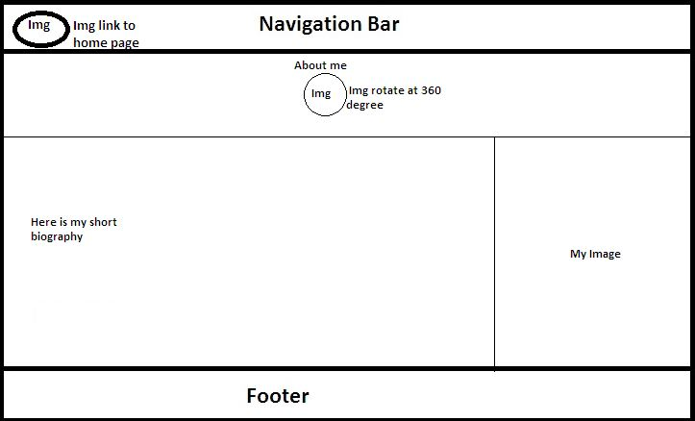

## This is wireframe of my Contact page

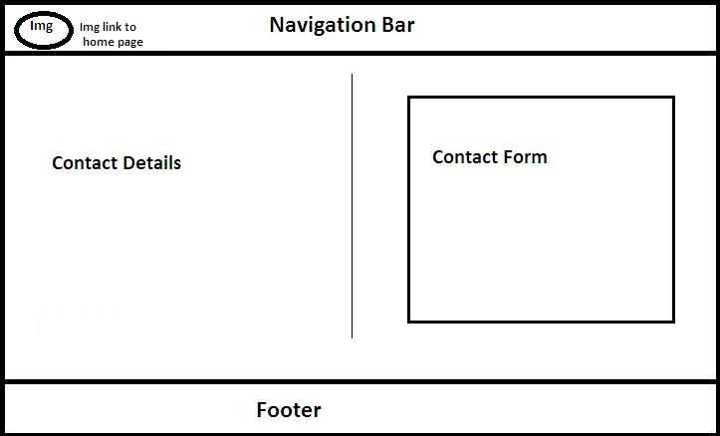

# Sketches

## Here is sketch for my home page

To make website as a user friendly, I made my website simle and all user can navigate it easily. At the top of the website, there is navigation bar and left part of this bar there is my image. At middle part, there is fixed background image, welcome notice.One rectangular box is fixed and inside it there is my image at left part and at right side, there is short information about me and below there is link to the CV page.And there is footer at the end of the page.There is white color in the navigation bar and light gray color in the footer part.

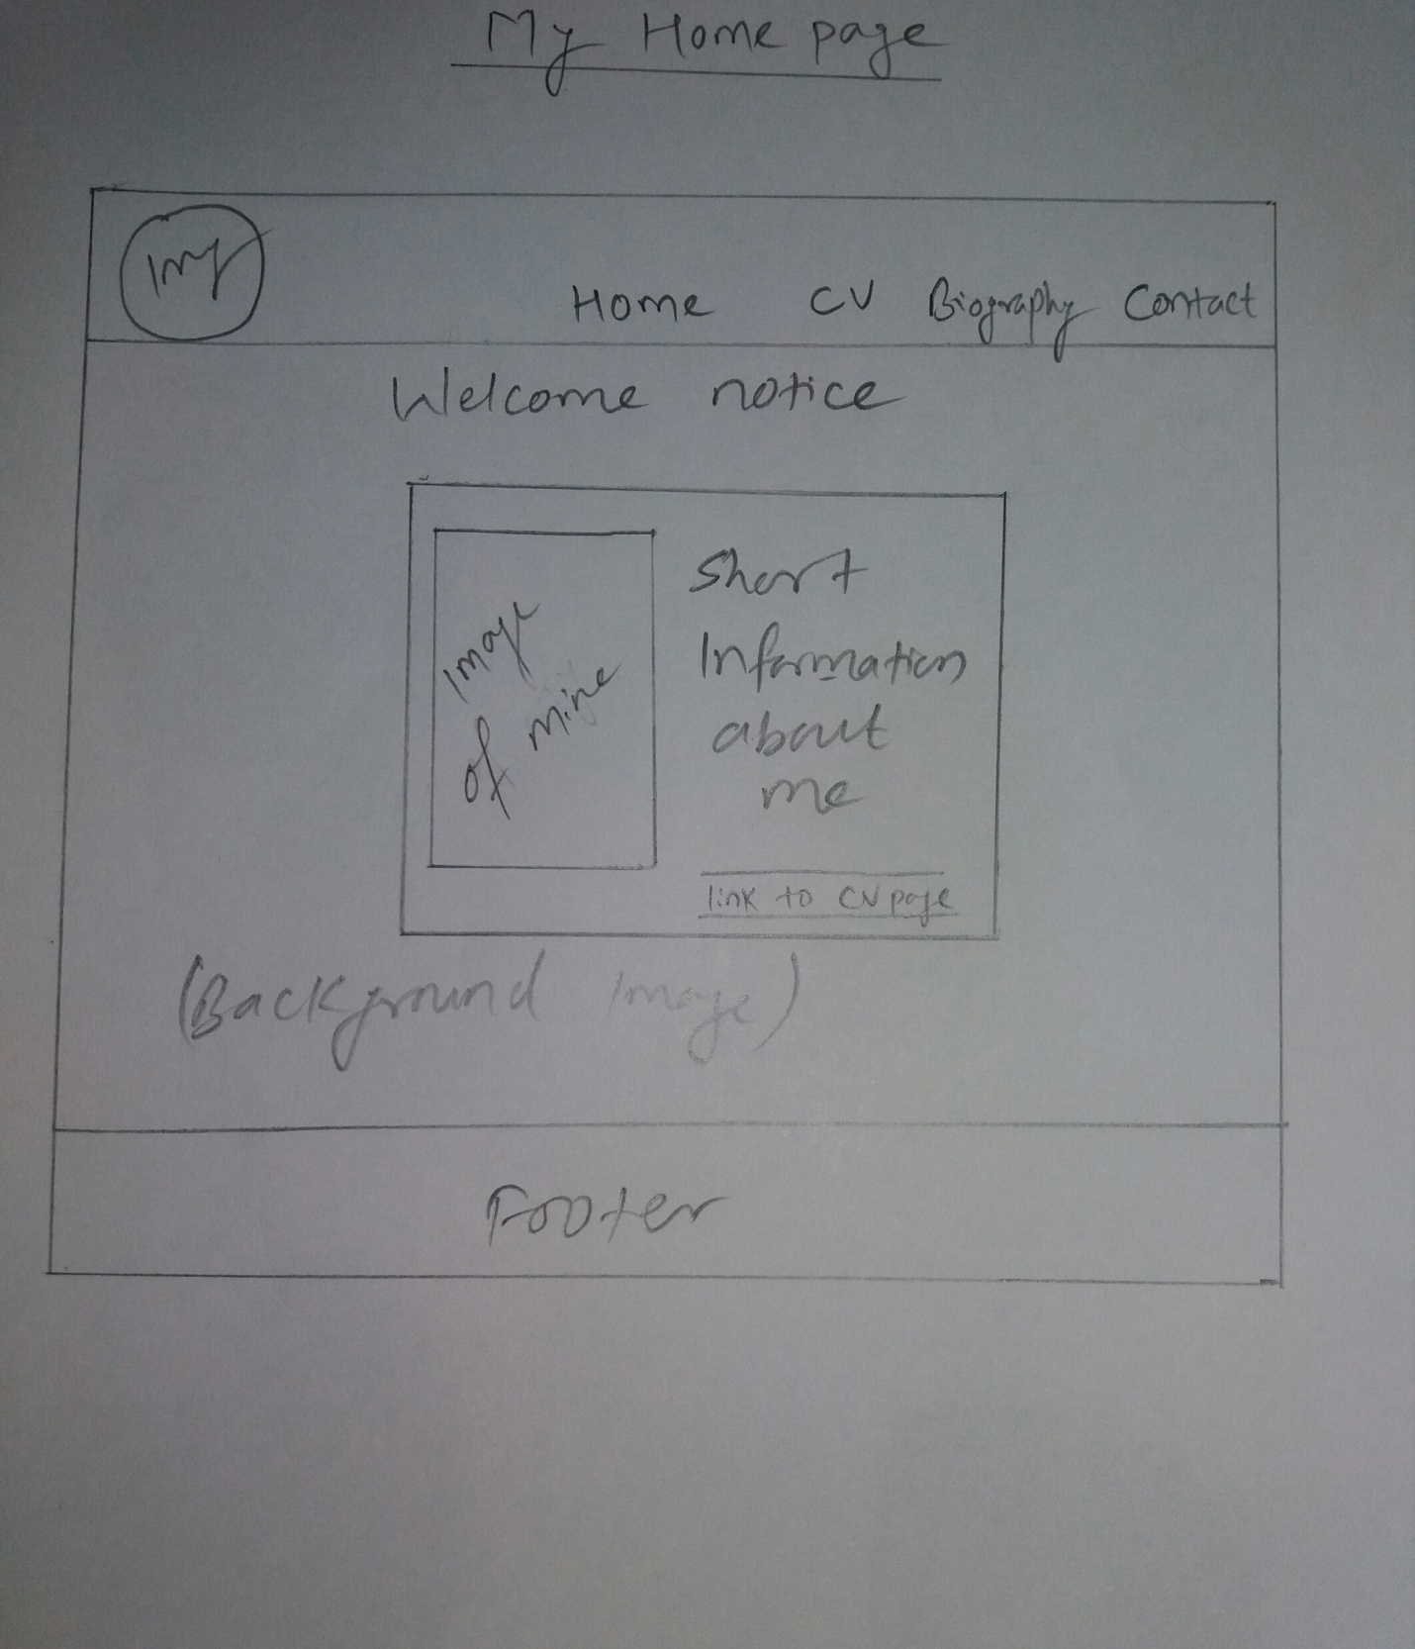

## Here is sketch for my CV page

Here in this CV page, there is same navigation bar and footer as in home page and the image on click in navigation bar is linked with CV page directly.At the middle part, background image is fixed and in left part of it there is my image with transition duration 1second on touch in it.There is four rectangular box, two in row and other two in column.Here these boxes includes my introduction, educational background, my interests, my skills.

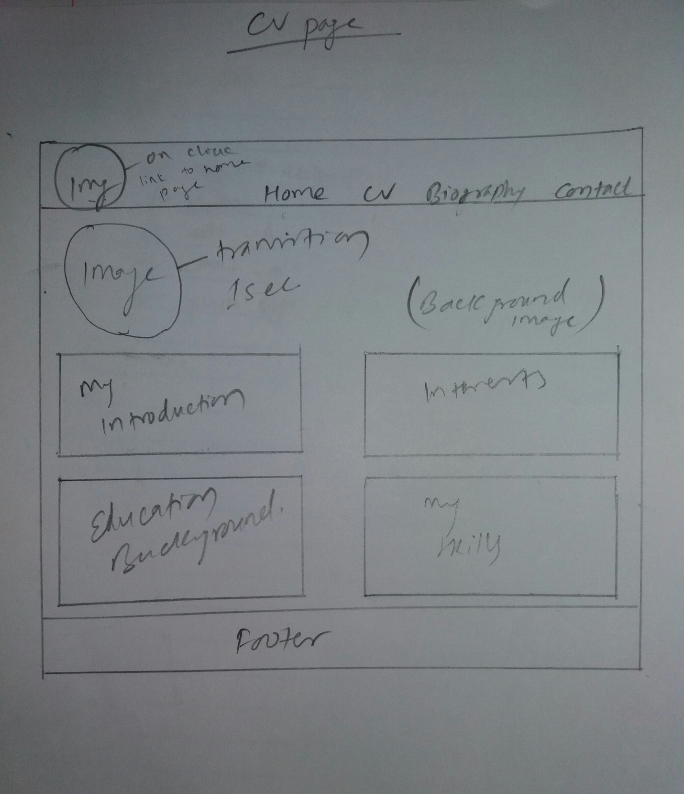

## Here is sketch for my biography page

Here in this biography page, there is also same navigation bar and footer as in home page and image in left side of navigation bar is linked directly with home page too.At the middle part, there is two images.One image is small at the top part and it rotates at 360 degree on touch in it and below it at the left side there is short biography about me and in right side there is my image.

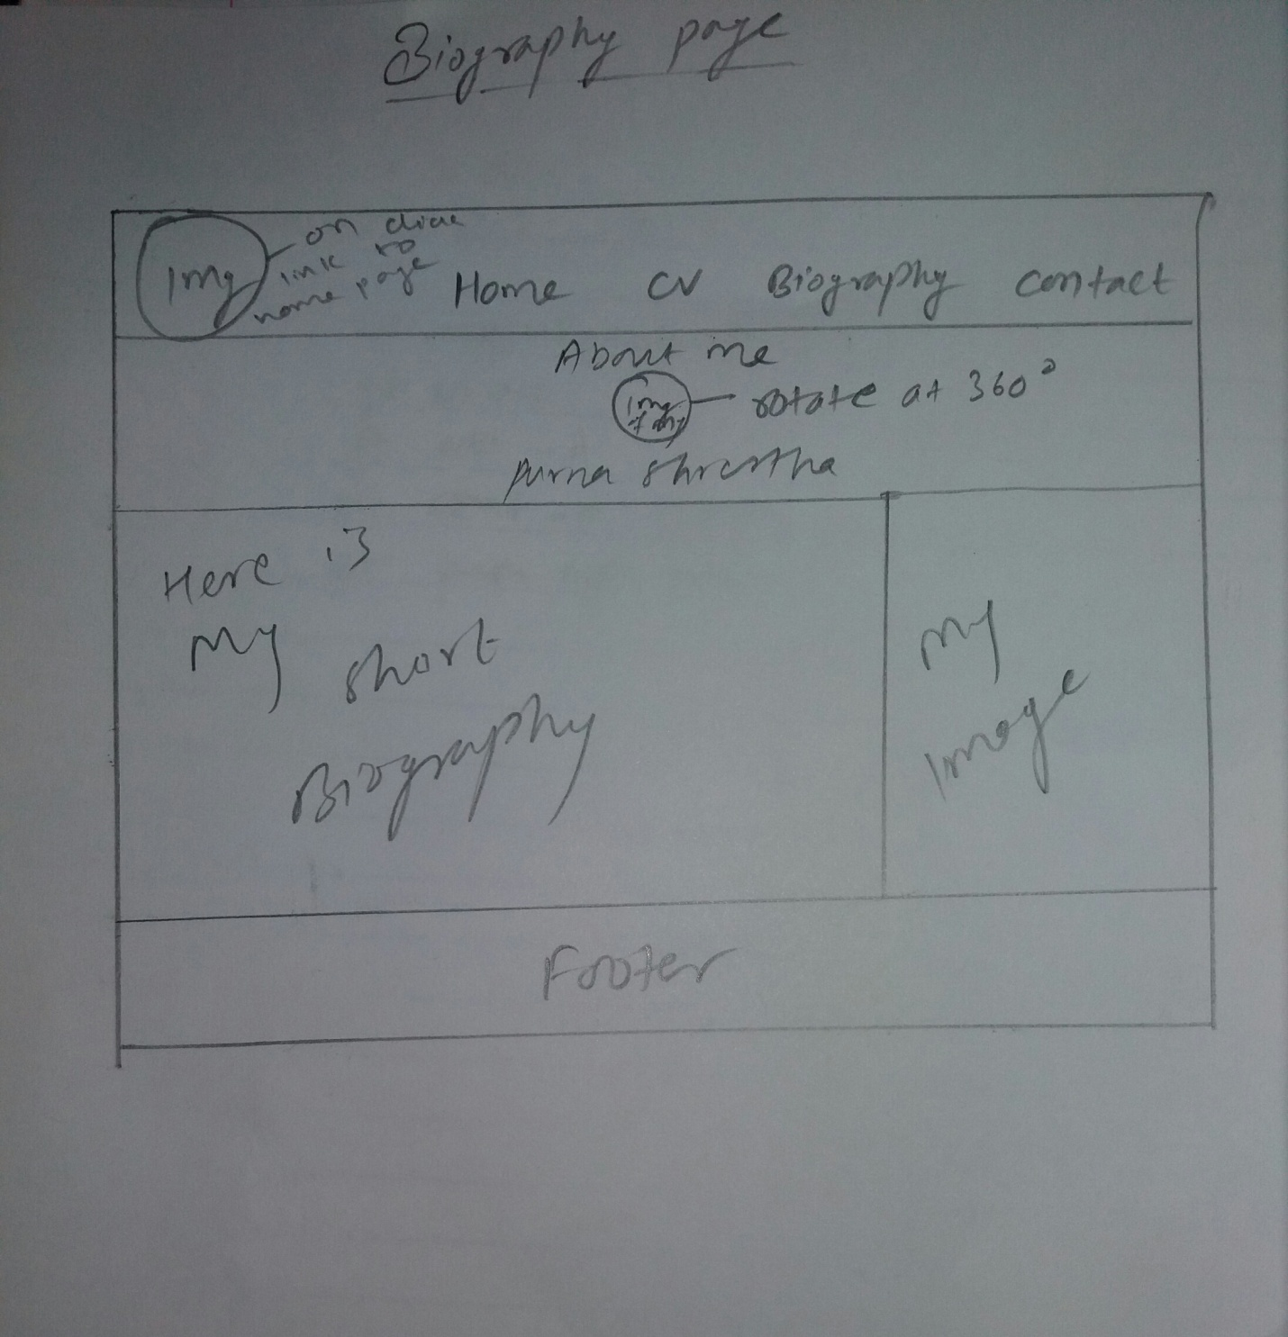

### Here is sketch for my contact page

Here in this contact page, there is also same navigation bar as in home page and also left part of image in this navigation bar is linked directly to the home page.At the middle part the background color is gery.Here it includes my contact details at left side and at there is contact form at the right side.If the visitors of my website wants to contact me they can fill up the form and send me an email directly.Here in form fill up box there is white color so that it shows some attractiveness in contact page.

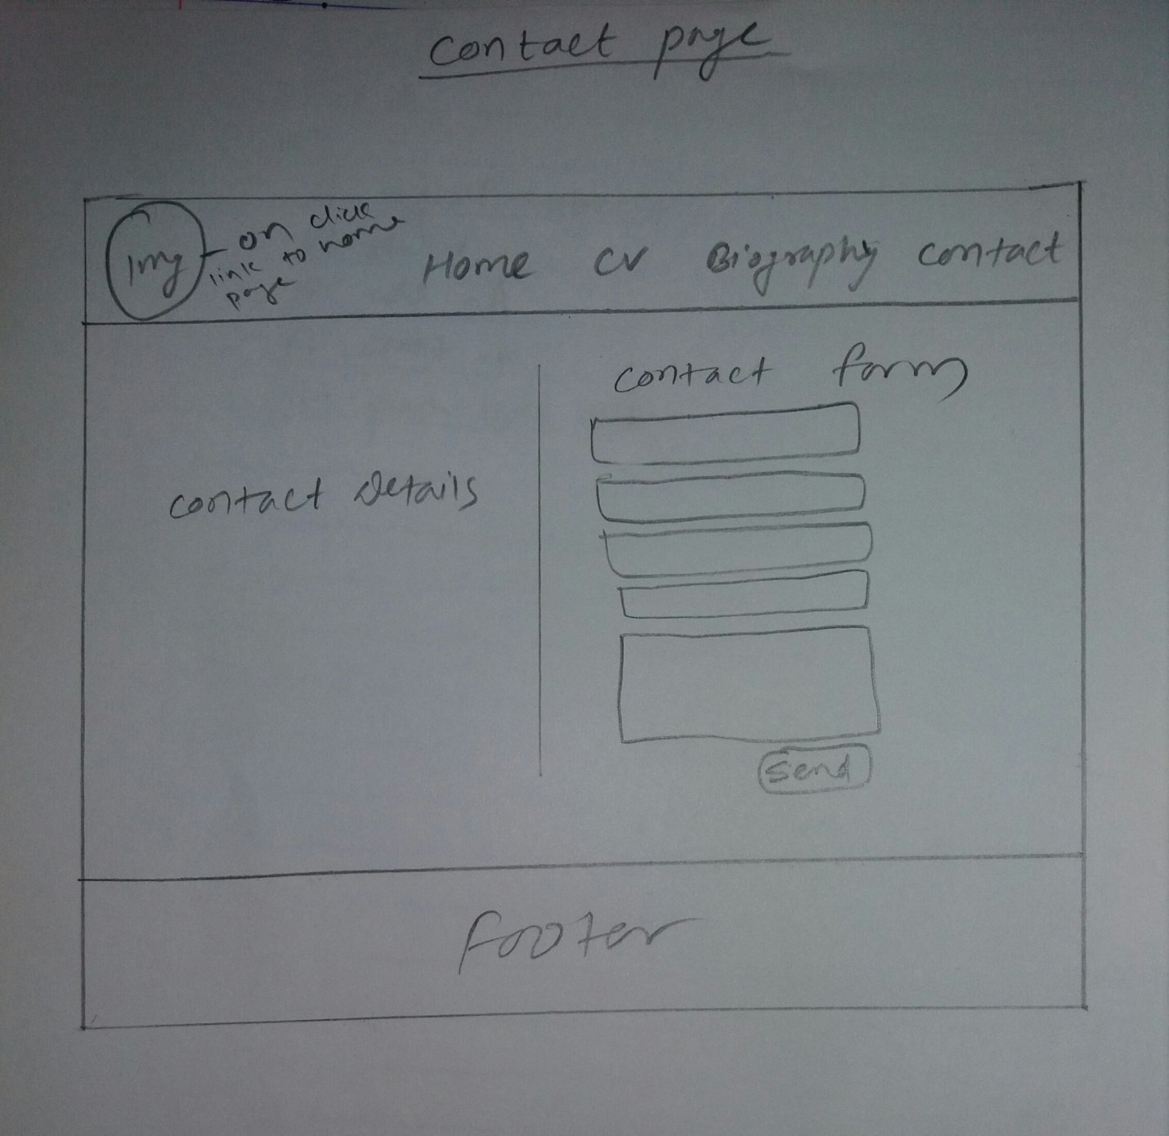

### Final design of my website

### Home page

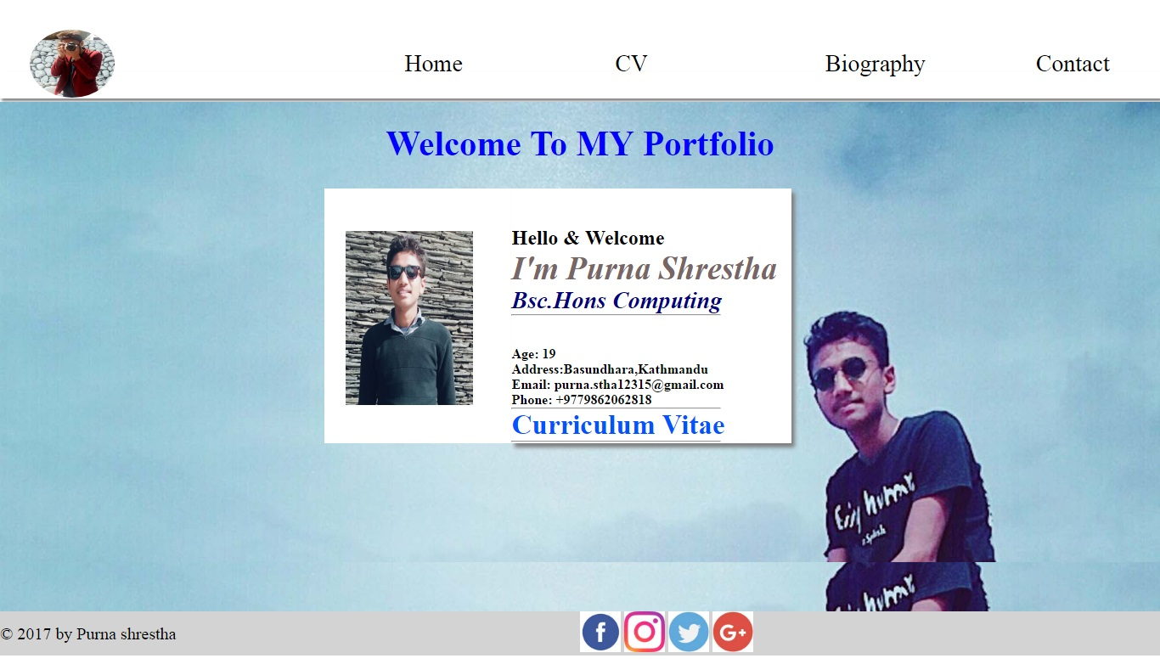

Finally, above picture is my final home page.In navigation bar, there is my picture in the left part and some of the contents in right side, and it is white in color.And at middle part, there is welcome notice to the visitor and background image fixed here.And one rectangular box is made where it contains my image and short description about me.Footer is placed at end of the page which is gray in color.To make this, I used HTML5 and CSS and code used to design is my own.

### CV page

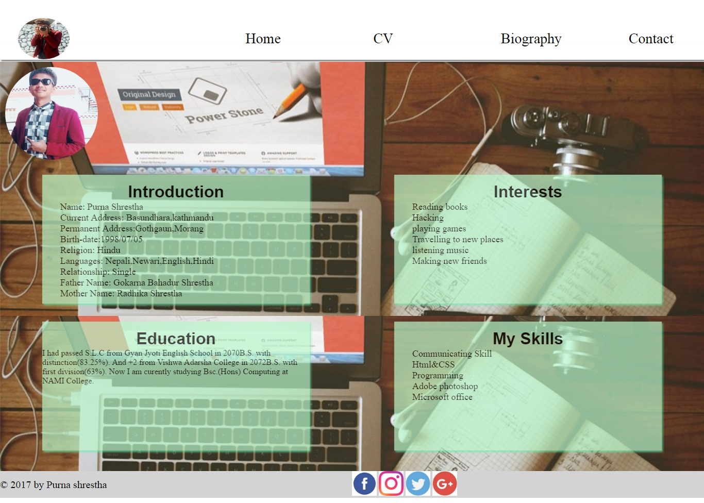

Here above picture is my CV page where it contains same navigation bar and footer as in the home page and image of navigation bar on touch placed the visitor to the home page.At middle, there is image on left part with transistion 1 second.There is four rectangular boxes including my introduction, Education background, my interests and my skills.The boxes are light gray in color with opacity 0.7.Here background image is fixed.I used HTML5 and CSS to desin this page and code is my own.

### Biography page

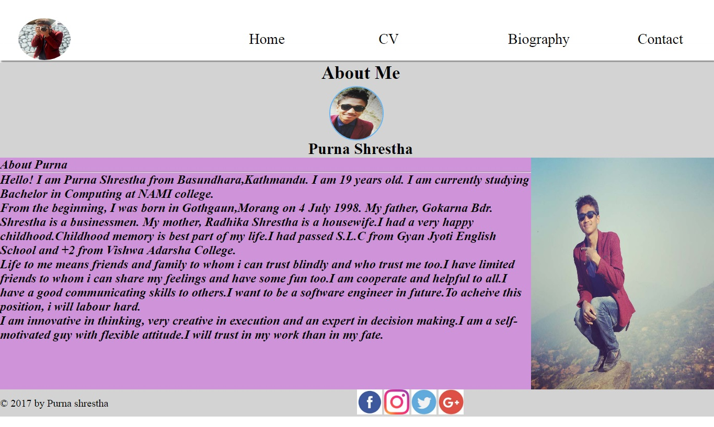

Here is my biography page where it includes same navigation bar and footer as in home page and also picture in navigation bar on touch placed the visitor to home page on touch in it.At middle, there is small image of mine with rotating at 360 degree on touch in it and its background color is light gray.And below there is my short biography at left part and image at the right side.All the image which I have used is of jpeg.Text font about my short biography is in itallic.And background color on this text is light purple(hex triplet).

### Contact page

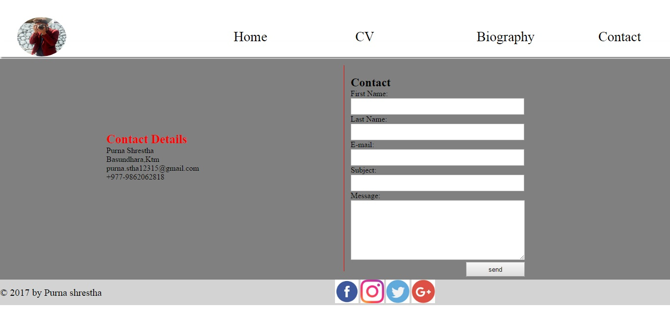

Here is my contact page including same navigation bar and footer as in home page and image o right side of the navegation bar moves to home page.At middle, there background color is gray.On its left part there is my contact details and at right side there is contact form.When the users fill up the form,message is directlu sends to me.Here I used HTML5 an CSS to design the website and code is my own.

## Evidence of how I have used models of good practice

### Page load speed

At present context, everybody wants their internet speed fast.To make the website standard, the page load speed of the website should be very fast which is one of the best models of good practice to implement in the website.As you can see below that I have tested my wensite from [www.pingdom.com](http://www.pingdom.com). My website page load time is 895ms and it is 91% faster than other websites.As it as small image file so it is easy to load the page of my website.

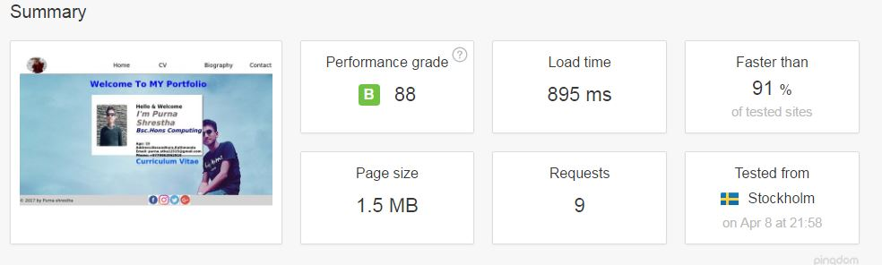

## Visual appeal

I have developed my website very simple and attractive looks while seeing for the first time by the user.I am not the perfect in it but I have try my best to make it as simpler in other view.I havent used all the properties.I have looked others website too and get hints and apply in my website too to make it simple.

## Navigation

Navigation bar is one of the most part of the good practice.It is the first look of the visitor so that it should be most attractive and easy to use.If the navigation bar is complicated to use, the user get in trouble so they cant find us.So it should be simple, easy to use for the others and at the top of website so visitors can get easily what they want.

### Reference

W3Schools Online Web Tutorials. 2017. W3Schools Online Web Tutorials. [ONLINE] Available at: [http://www.w3schools.com](http://www.w3schools.com/). [Accessed 09 April 2017].

Wix.com. 2017. Free Website Builder | Create a Free Website | WIX.com. [ONLINE] Available at: [http://www.wix.com](http://www.wix.com/). [Accessed 09 April 2017].

freshDesignweb. 2017. freshDesignweb - Web Design Blog. [ONLINE] Available at: [https://www.freshdesignweb.com](https://www.freshdesignweb.com/). [Accessed 09 April 2017].

## Conclusion

Here in the conclusion, I had made my website using HTML5 and CSS.I include all my wireframe sketches and final design of my website in above page.I include the evidence that how I had made the good practice to develop my website.In my website, there is possible to add some videos, animations to make my website more attractive but due to time limited I am unsuccessful to developed that kind in further assignment I will include it all.

<https://newaanrup.github.io/csy1018-assignment1/> (This is my github link.)