NAE-CW340-OTKIT Quick start Guide


Finding Quick Start Details Online
https://rtfm.newae.com/Targets/CW340%20OT%20Quickstart/ has the latest Quick Start details.
You can also find this page by going to https://rtfm.newae.com and find the “CW340 OpenTitan Edition Quickstart” page under “Targets” in the left-hand menu.
The QR code at the right will also take you to this webpage directly.

About this CW340 Board
Your board has been prepared as an “OpenTitan®” edition, which comes preloaded with the HyperDebug board. This simplifies your OpenTitan® “getting started” work. The “HyperDebug” board is the white ST Nucleo board plugged onto the CW340 baseboard. These together are shown here:
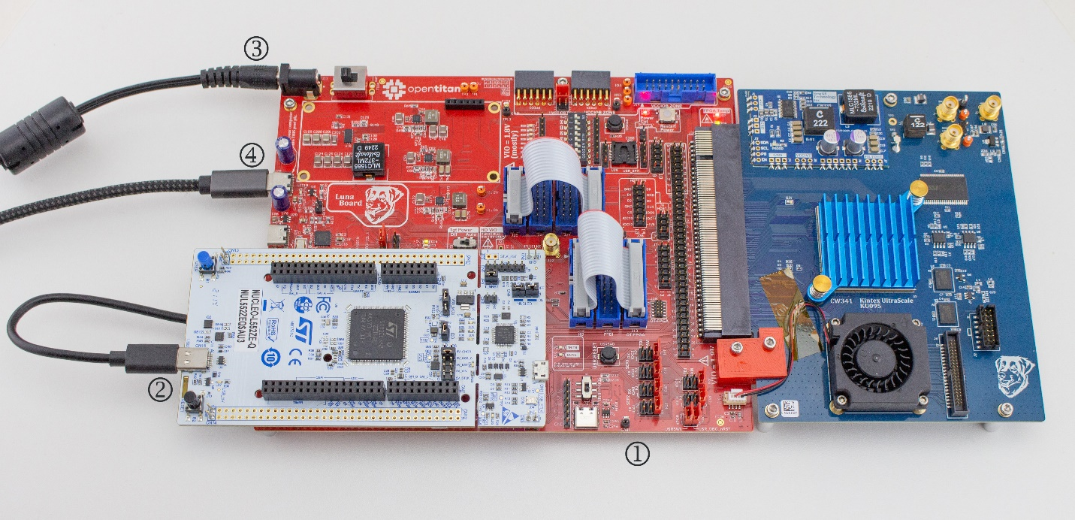
To get started with OpenTitan® using the HyperDebug interface, you’ll need to:
- Place the board on your desk.
- Plug the short 6-inch USB-C cable between the USB-C port on the CW340 and the USB-C port on the ST Nucleo board, which has been preloaded with the HyperDebug firmware.
- Connect power to the DC power jack.
- Connect the USB-C cable to your computer using J28.
These steps are shown in the image above. Details of the USB-C cable from step 2 are shown below as well:
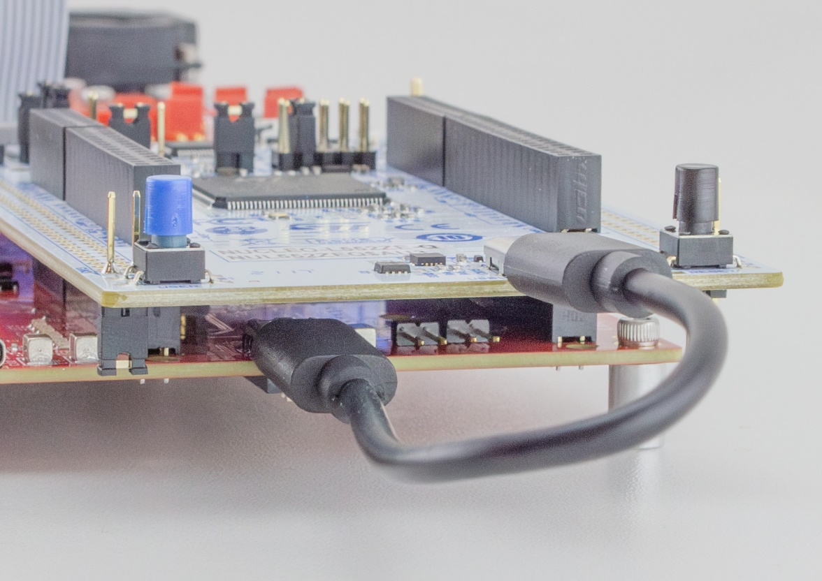
The 6-inch USB cable connected to the HyperDebug board.
The jumper settings on this board have been set up to route the serial, SPI, and JTAG ports to the HyperDebug board. If you wish to use additional OpenTitan® or HyperDebug features, additional DIP switch or cable settings may be needed. See the Getting Started link above for those details.
If you are using this board without the HyperDebug features, you will need to adjust jumper or connection settings. You can remove the ST Nucleo board (HyperDebug board) from the CW340 baseboard by gently rocking it back and forth while pulling up.
You may need to update the HyperDebug firmware on first usage. See the full online quick start guide, linked above.

More Documentation
You can find documentation for the CW340 Board at https://rtfm.newae.com . This includes usage of the CW340 as a general-purpose side-channel analysis and fault injection FPGA development platform.
You can find documentation on the OpenTitan project, which includes using this board with the OpenTitan project at https://opentitan.org .

OpenTitan trademark is controlled by the OpenTitan project, and is a registered trademark of lowRISC CIC, in the US and/or other countries.
This document last updated: August 7, 2024

