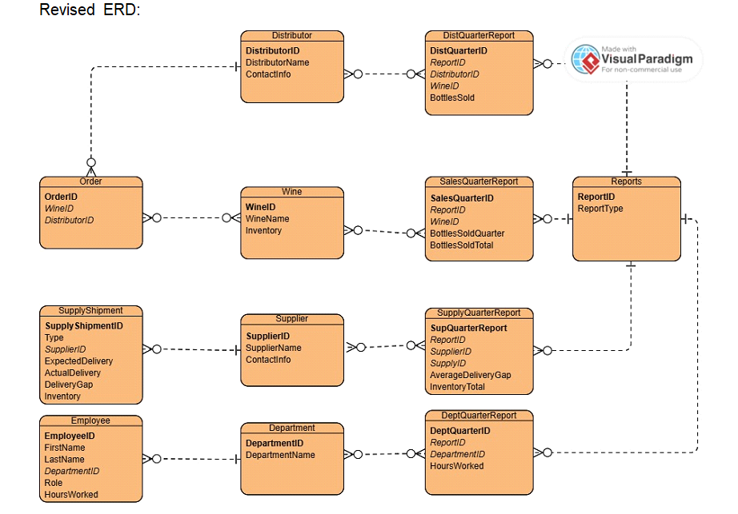

Show Tables:

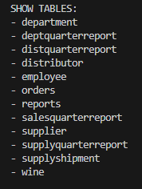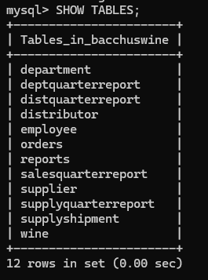

Distributor Table:

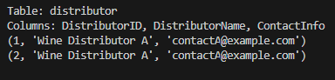

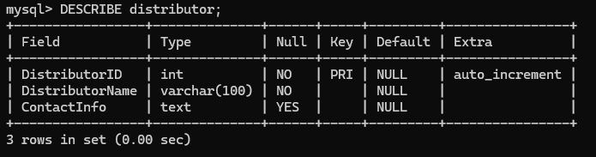

Wine Table:

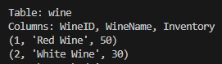

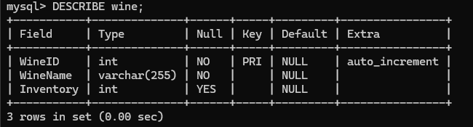

Orders Table:

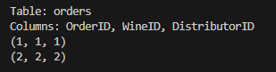

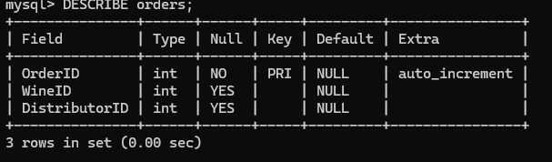

Reports Table:

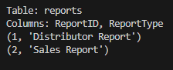

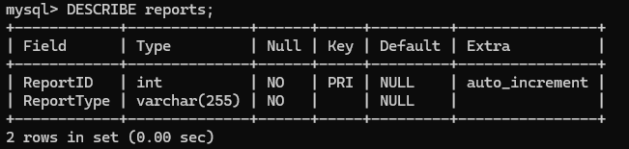

DistQuarterReport Table:

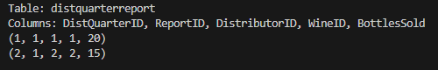

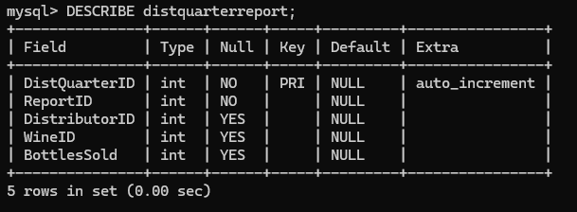

SalesQuarterReport Table:

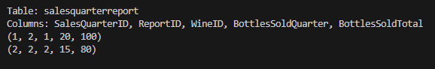

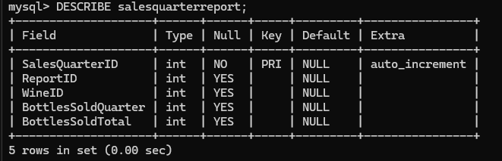

Supplier Table:

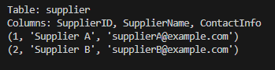

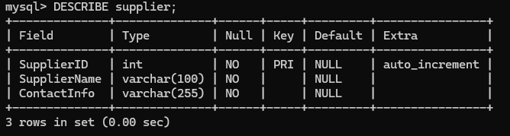

SupplyShipment Table:

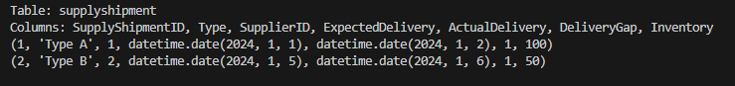

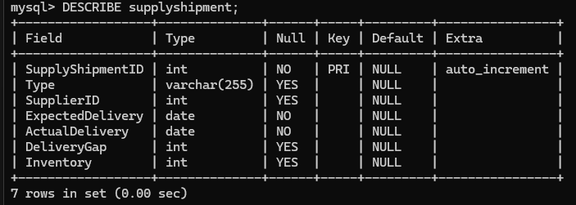

SupplyQuarterReport Table:

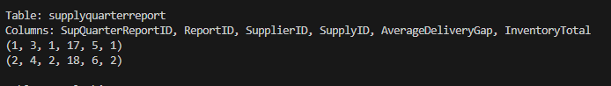

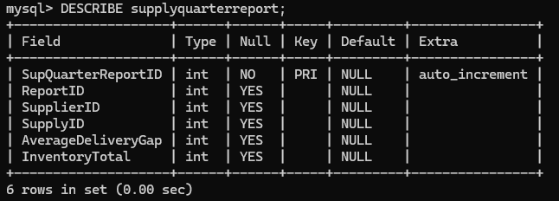

Department Table:

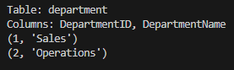

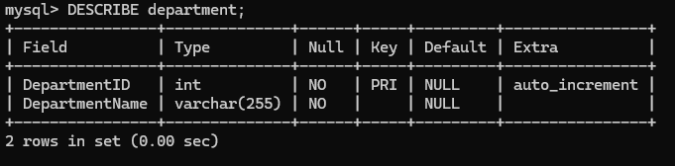

Employee Table:

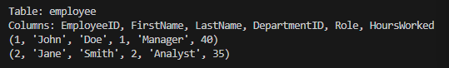

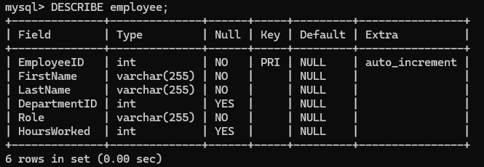

DeptQuarterReport Table:

