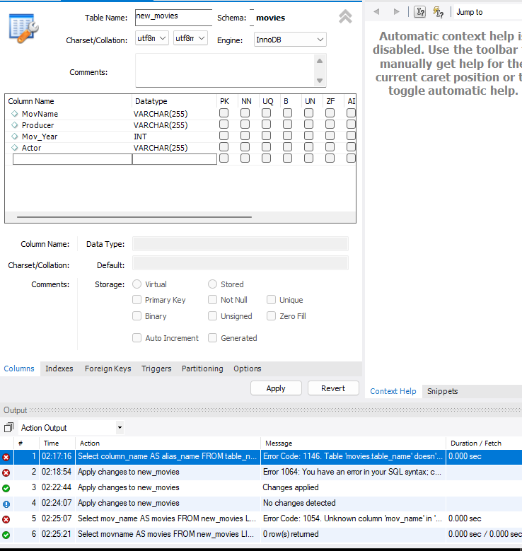

*** Creating table for examples***

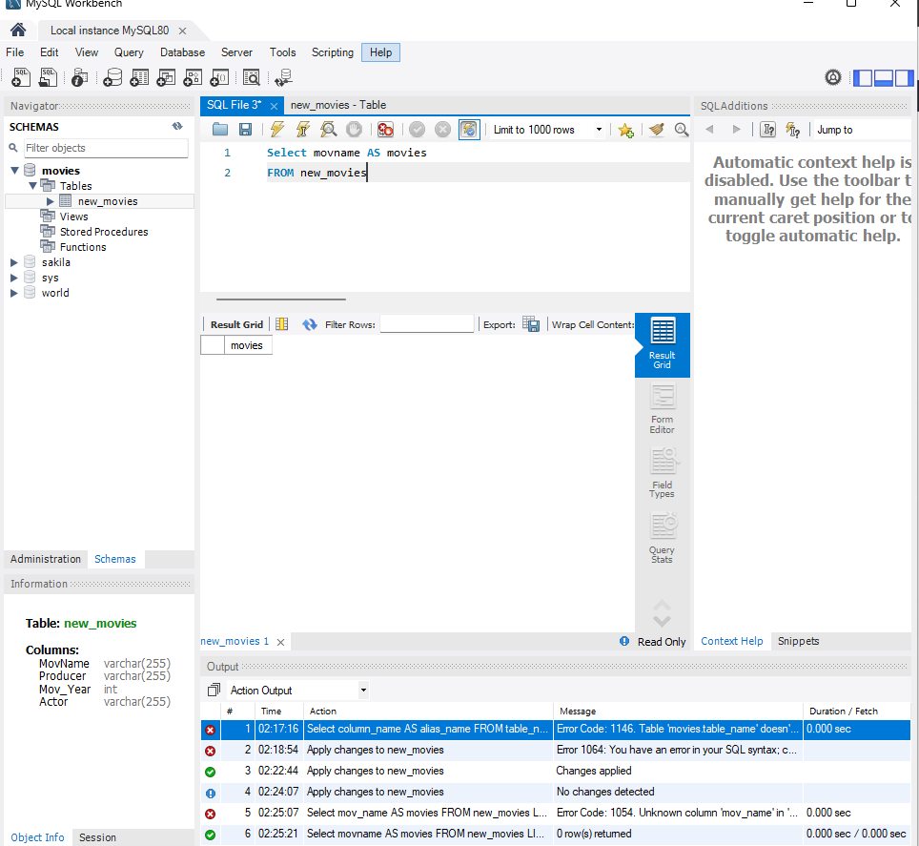Select movname AS movies

FROM new_movies;

This would be used to take a selection/column from the table (movname) and label it as something else (movies), FROM is to select which table you want to take the column from

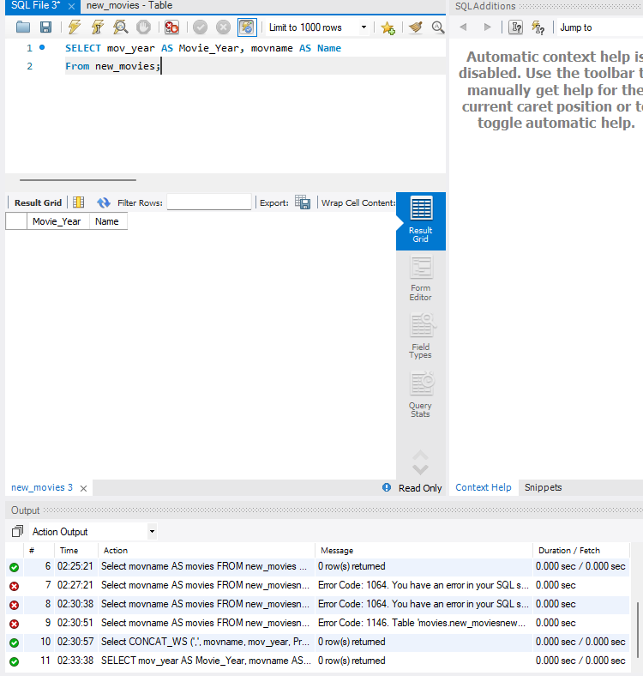

SELECT mov_year AS Movie_Year, movname AS Name

From new_movies;

Similar to the last example, this would be used when wanting to take a column from a previously created table, and re-name/label it as something else, but this way allows you to do it to more than one column at a time.

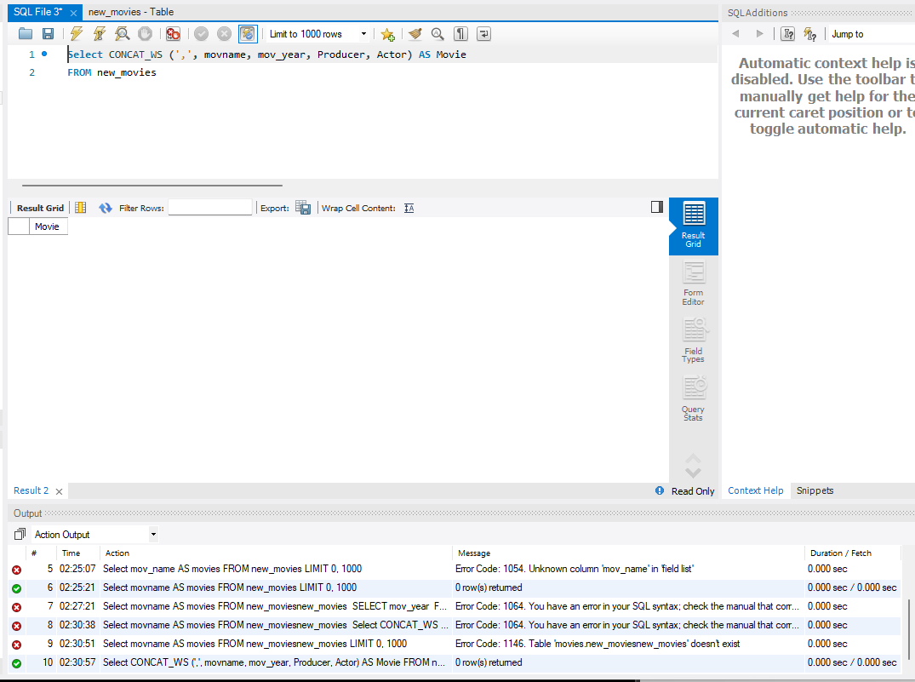SELECT CONCAT_WS (’,’, movname, mov_year, Producer, Actor) AS Movie

FROM new_movies;

This version of SELECT allows you to group columns (movname, mov_year, etc,.) and label it under one alias (Movie)