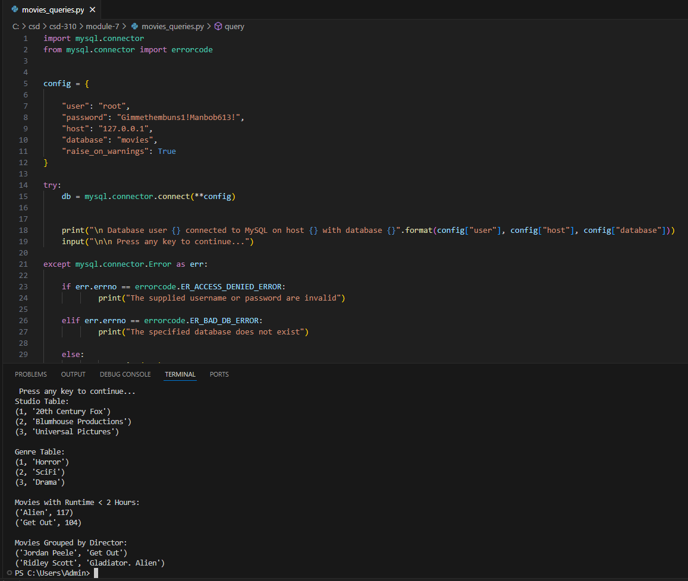[newamanda/csd-310: CSD-310 GitHub](https://github.com/newamanda/csd-310)