Katie Hilliard

Keanu Foltz

Amanda New

Amit Rizal

Module 9.1 Assignment

Business Rules

Supply:

⦁ Each supplier provides specific items regularly (bottles, corks, labels, vats, tubing)

⦁ Track delivery schedules including actual vs expected dates

⦁ Orders should be placed and tracked online

Distribution:

⦁ Order and track shipments online

⦁ Track sale statistics and compare to sale goals

Employees:

⦁ Track employee work performance

⦁ Roles to include finance, marketing, production, and distribution

⦁ Provide monthly reports and compare to performance goals

Wines:

⦁ Merlot, Cabernet, Chablis, and Chardonnay

⦁ Track distribution & sales for each wine type

Inventory:

⦁ Track by type, quantity, and age

⦁ Flag to review items over 5 years old

Marketing:

⦁ Track new offers and compare to sales

⦁ Provide a monthly/quarterly review to determine effectiveness

Assumptions:

⦁ Suppliers have unique company name and provide different supplies

⦁ Each wine type has many distributors

⦁ All reports will contribute to Stan and Davis’ EOY report

⦁ Goals are already set for production and delivery

Initial ERD:

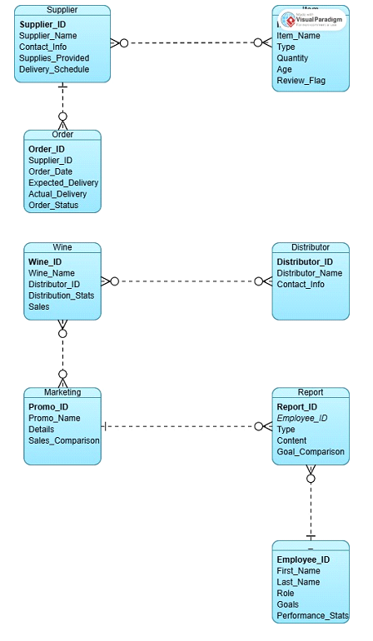

My ERD:

