Gunner orders: DETACHMENT, ATTENTION POST ON THE LIMBER, MARCH

[Gunner orders] NUMBER 6 TAKES CHARGE OF THE GUN CREW

Number 6 orders: DETACHMENT, ONE STEP FORWARD, MARCH

Number 6 reports: EQUIPMENT HAS BEEN DISTRIBUTED

Gunner orders: DETACHMENT, ATTENTION POST ON THE GUN, MARCH

Gunner orders TAKE IMPLEMENTS

Gunner orders- ATTENTION DETACHMENT, LOAD BY DETAIL, LOAD

Gunner orders: TEND, VENT

Number 3 reports: VENT STOPPED

Gunner orders: WORM

Number 2 reports: WORMED

Gunner orders: WET SPONGE

Number 1 reports: WET SPONGED

Gunner orders: DRY SPONGE

Number 2 reports: DRY SPONGED. [Sponge sequence maybe accomplished two times]

Gunner orders: LOAD, (TYPE OF ROUND), RANGE (xxx) YARDS

Number 6 repeats: LOAD (TYPE OF ROUND) RANGE (xxx) YARDS.

Gunner orders: ADVANCE THE ROUND

Number 2 reports: ROUND ADVANCED

Gunner orders: RAM

Number 1 reports: RAMMED

Gunner orders: SIGHT THE PIECE

Gunner reports: [PIECE IS CLEAR]

Gunner orders: READY

Number 4 reports: PIECE IS READY

Gunner orders: PREPARE

Gunner orders: FIRE
MISFIRE SEQUENCE

Any cannoneer reports: MISFIRE

Gunner acknowledges: THE PIECE HAS MISFIRED

Gunner orders: DO NOT ADVANCE

[Number 3 reports: THE PRIMER HAS FAILED or THE PRIMER HAS IGNITED]

[Gunner orders: DO NOT ADVANCE - THE PRIMER HAS FAILED [or THE PRIMER HAS IGNITED]

Gunner acknowledges: THREE MINUTES HAVE ELAPSED

Gunner orders: NUMBER 2, TAKE CHARGE OF THE PIECE

Number 2 reports: PRIMER EXTRACTED or THE VENT IS CLEAR

Number 2 reports: CHARGE PRICKED or THE CHARGE IS NOT SEATED
(If it is determined that the charge is not seated, removal of live charge sequence should be initiated.
If the charge has been punctured, the misfire sequence continues.)

Number 2 reports: PIECE IS READY

[Gunner states: I HAVE CHARGE OF THE PIECE]

Gunner orders: PREPARE

Gunner orders FIRE

RESEATING AND REMOVING THE CHARGE SEQUENCE.

These sequences are initiated if, during a misfire it is determined that the charge:
(1) is not seated or (2) if a second misfire occurs.

(1) When in the charge-not-seated condition,
The Chief-of-the-Piece, assume the responsibility for clearing the misfire. Cannoneers will assist as required.

It is always best to exhaust all possibilities for ignition before attempting to extract the powder charge.
Flooding the tube with water to saturate the charge or wash it out or using the bronze worm may be required.

(2) If the gun fails to fire for the second time,
"Misfire" is called as before. In this case, the steps in clearing the misfire will be repeated as described in Position D of the misfire sequence up to the primer extracted step whereupon, the Chief-of-the-Piece, or one of the officers will take command as in the charge-not-seated circumstance.

(Note: No charge should ever be reseated after a primer has fired into the chamber)
After 3 attempts to prime and fire, shut down gun and do steps to clear the tube.

SECURING THE PIECE SEQUENCE

Gunner orders: CEASE FIRING

Gunner orders: SECURE THE PIECE

Gunner orders: RIGHT ABOUT FACE

Gunner orders: FORWARD MARCH

Gunner orders: HALT

Gunner orders: POST ON THE LIMBER MARCH

[Gunner orders ] NUMBER 6 TAKES CHARGE OF THE GUN CREW

[Number 6 orders:] DETACHMENT, ONE STEP FORWARD, MARCH

Number 6 reports: IMPLEMENTS HAVE BEEN RETURNED

Gunner orders: DETACHMENT, FORM INTO FILES

This being accomplished, the Chief-of-the-Piece or the Gunner forms the detachment into a proper marching formation. The detachment is marched to their next assignment.

DANGER ZONE
WARNINGS:

The blank cartridge (powder charge), when ignited in the field piece tube, throws a cone of flame 25 feet down range from the muzzle of the field gun. An accidental discharge with an object such as the rammer, the worm or a small solid piece of debris in the tube will throw fragments down range an unpredictable distance. The spent primer is launched upward in a column of flame as the field piece is fired. It sometimes comes down outside the danger zone.

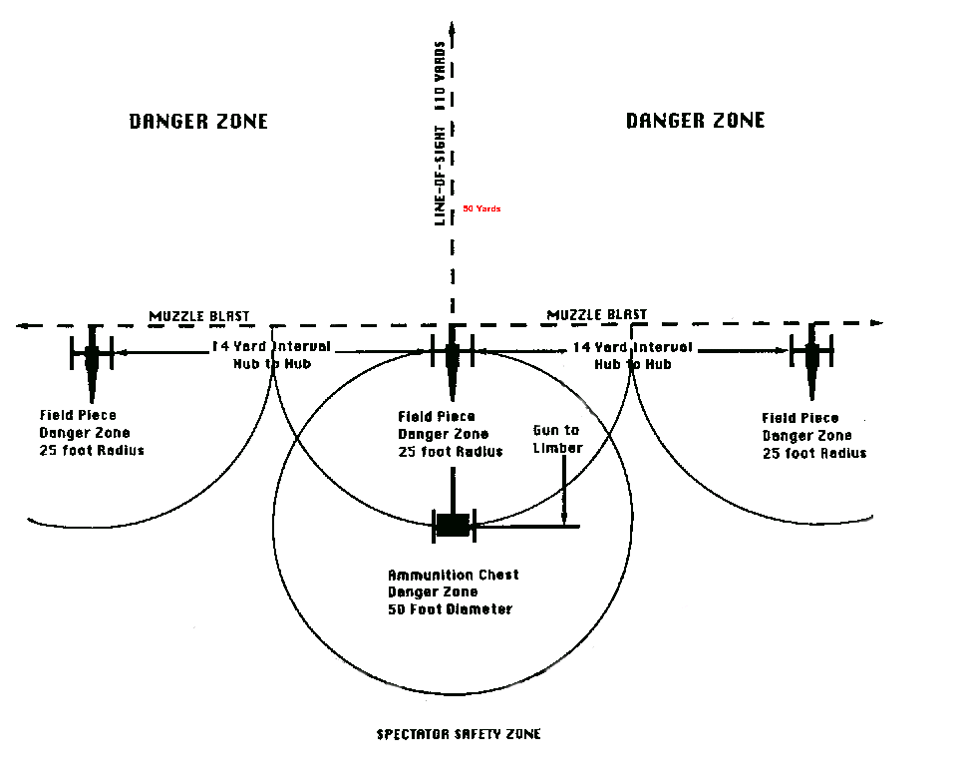

PRECAUTIONS:

During firing demonstrations, no one places anything in the Ammunition Chest or takes anything out except Cannoneers Number 6 or Number 7. The Ammunition Chest cover is closed prior to the "Ready" command and is kept closed until after all pieces are discharged or, in the case of a misfire, until the misfire is cleared.
No debris of any description is to be stored in the Ammunition Chest.

