1st Company, Richmond Howitzers

The National Civil War Artillery Association
Drill Manual

Important Notice:

The information presented in this manual is intended for use with proper instruction, other information and materials, and is not a standalone document. The drill described in this manual is not the only safe method for loading and firing artillery and may not be the best procedure under all circumstances. This manual assumes that all artillery is of modern construction and in good working order, all loads are well constructed and will not leak powder when rammed and that other safety equipment and procedures are utilized. It is also assumed that users have a good working knowledge of artillery and have received instruction in the use of this manual.

The firing of a cannon is dangerous and can cause the loss of life and limbs if done incorrectly or as the result of numerous unforeseen phenomena.

SCHOOL OF THE PIECE
(1) Limber Drill
(2) Loading
(3) Firing
(4) Misfire Sequence
(5) Securing the Piece Sequence

NOTE:
THIS MANUAL HAS BEEN ADAPTED FROM THE ORIGINAL MANUAL. WHEN OPTIONS WERE GIVING, CHOICES WERE MADE.
THIS VERSION ALSO INCLUDES THE MOUNTAIN HOWITZER DEVIATIONS WITHIN THE APPROPRIATE SECTIONS.
FOR CLEARITY, STEPS THAT ARE IMPLIED WERE ADDED.

LIMBER DRILL

The procedures and commands presented below are recommended and endorsed by the National Civil War Artillery Association, in the preparation of the gun crew at the limber prior to posting on the gun. All commands are CAPITALIZED while descriptions of the action are in normal print. When specific cannoneers are involved in the action, the individuals illustrated are darkened.

Position A:

With gun and limber previously placed, the Gunner has moved the gun crew into position to begin the manning of the piece. The detachment is at rest. The command of the detachment has been relinquished to the Gunner. The Gunner initiates the preparation sequence.

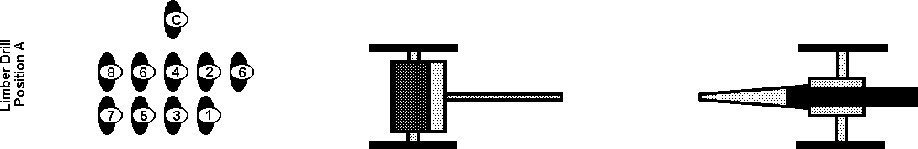

Gunner orders: DETACHMENT, ATTENTION POST ON THE LIMBER, MARCH.
(Gun crew advances to Position B)

<< MT H >> When Marching To The Piece: The box may be carried by the cannoneers at the rear of the column. At the gun line, it is advanced to the front of the column and placed in line with the other boxes and limbers.

Position B:

Numbers 1 and 2 locate themselves near the outside rear of the right and left limber wheels followed by 3, 4, and 5. The Gunner advances to a position between the limber and gun, and then faces the limber Numbers 6 and 7 locate themselves close to the rear of the limber chest. Number 6 unlocks the chest assisted by 7 who holds open and closes the chest as necessary. Number 8 locates himself so that he may observe the implement exchange and the activities of the spectators.

[Gunner orders ] NUMBER 6 TAKES CHARGE OF THE GUN CREW

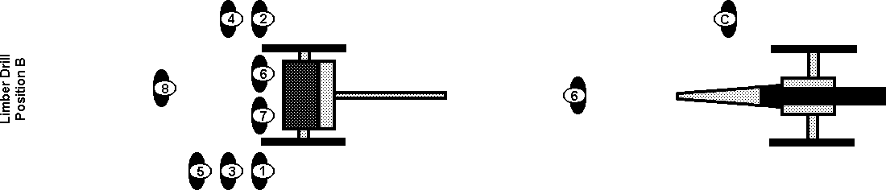

Number 6 issues gauntlets to numbers 1 and 2, when the exchange is completed.

Number 6 orders the detachment to advance.

Number 6 orders: DETACHMENT, ONE STEP FORWARD, MARCH
(Gun crew advances to Position C)

Position C:

Numbers 1 through 5 move forward one step:

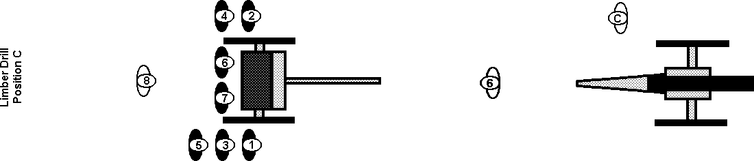

Number 6 issues a pouch (for the primers) and a lanyard to Number 4,
Number 7 issues a thumbstall and a second pouch that includes: vent prick, and vent brush to Number 3.
[Number 3 also receives the MisFire pouch that includes; spare lanyard, needle-nose pliers, gimlet and syringe.]
Numbers 5 and 7 assist Number 3 with the thumbstall and pouch adjustments.

When the exchange is completed, Number 6 orders the detachment to advance.
(Gun crew advances to Position D)

Position D:

Numbers 1 through 5 move forward one step. Number 5 stands next to Number 7.

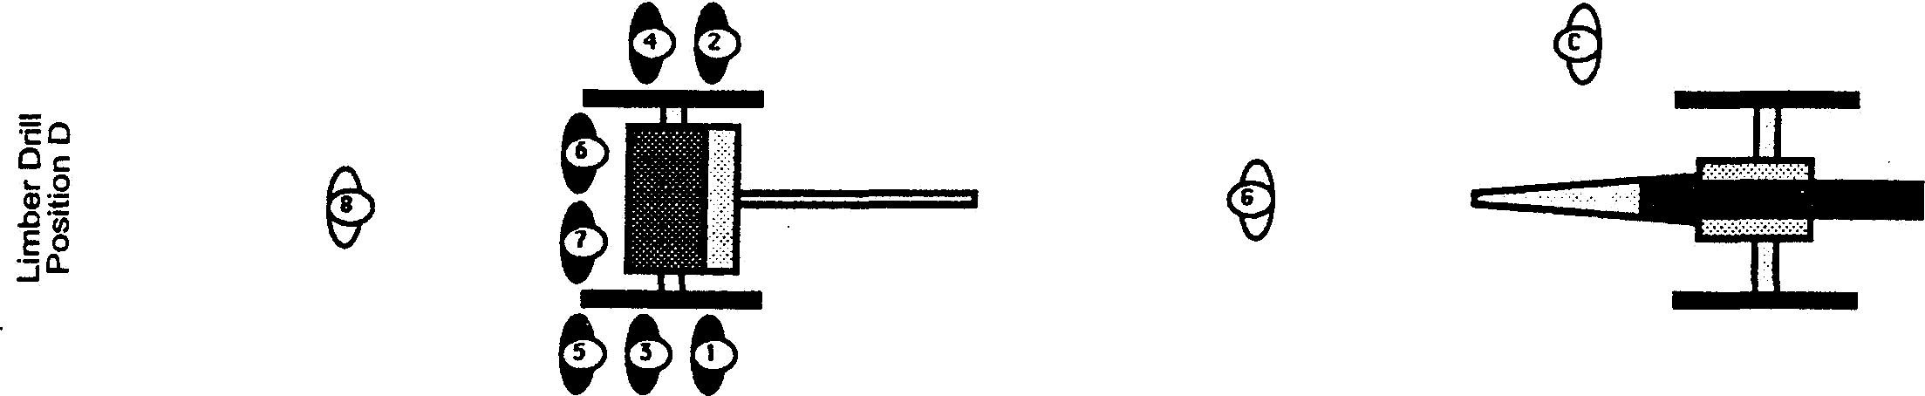

Number 6 issues the cartridge haversack to Number 5. When the exchange is completed,
Number 6 orders the chest cover closed.
Number 7 closes the cover.
Number 6 informs the Gunner that all exchanges have been accomplished.

Number 6 reports: EQUIPMENT HAS BEEN DISTRIBUTED

Satisfied that the crew has been properly outfitted, the Gunner takes command and moves the crew to the gun.

Gunner orders: DETACHMENT, ATTENTION POST ON THE GUN, MARCH
(Gun crew advances to Position E)

Position E:

Numbers 1 and 3 advance to the right side of the gun,
Numbers 2 and 4 to the left side.

<< MT H >> Numbers 1 and 2 locate themselves outside the gun wheels, in front of the axel, but behind the front edge of the wheel. Numbers 1 and 2 will be working over the wheels for all servicing of the piece. >>

Numbers 3 and 4 locate themselves outside the gun wheel aligned opposite the cascabel.
Number 5 locates himself near the front of the Limber pole.

Number 1 through 4 and 6 and 7 will perform their duties of serving the gun from these positions.

The Gunner and Number 5 will move about as necessary between the gun and the limber

Number 8 will move as required to ensure the safety of the ammunition chest and the spectators.

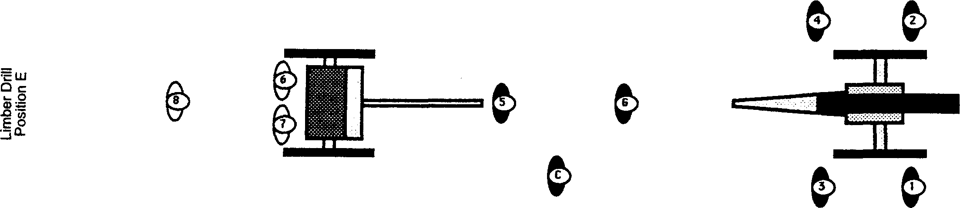

When each of the crew is in position, the Gunner will direct the loading of the piece.

The Gunner will order the further preparation of the gun and its service by the crew.

LOADING

This sequence of activities (steps) commences after the detachment has been marched into position and posted as in Position E of the Limber Drill.

Any activity may be interrupted by the command "Cease", “Halt” or “Stop” and will stop any and all gun activity. This may be ordered by any cannoneer at anytime.

The command "Commence Loading," ordered by the Gunner, reinitiates action. [CONTINUE THE DRILL]

Gunner orders TAKE IMPLEMENTS
(Cannoneers take up their implements and prepare to respond to additional orders.)

Position A:

Number 1 detaches the sponge bucket and positions it on the ground. He takes the wet sponge from its hanger, wets it in the bucket and, keeping the wet sponge in hand, returns to his post (facing forward as described in Position E above).

Number 2 takes the dry sponge and the worm from their hangers and, keeping the worm in hand, returns to his post (as described in Position E above).

Number 3 uncovers the vent and removes the handspike from its hanger, placing it in the pointing rings at the trail of the piece.

The Chief-of-the-Piece informs the Gunner of the firing order, the number of the gun and other information from the Section Officer. When implement acquisition has been completed,

Numbers 3 and 4 face front

Chief-of-the-Piece returns to a place where he can coordinate the loading and firing sequences.

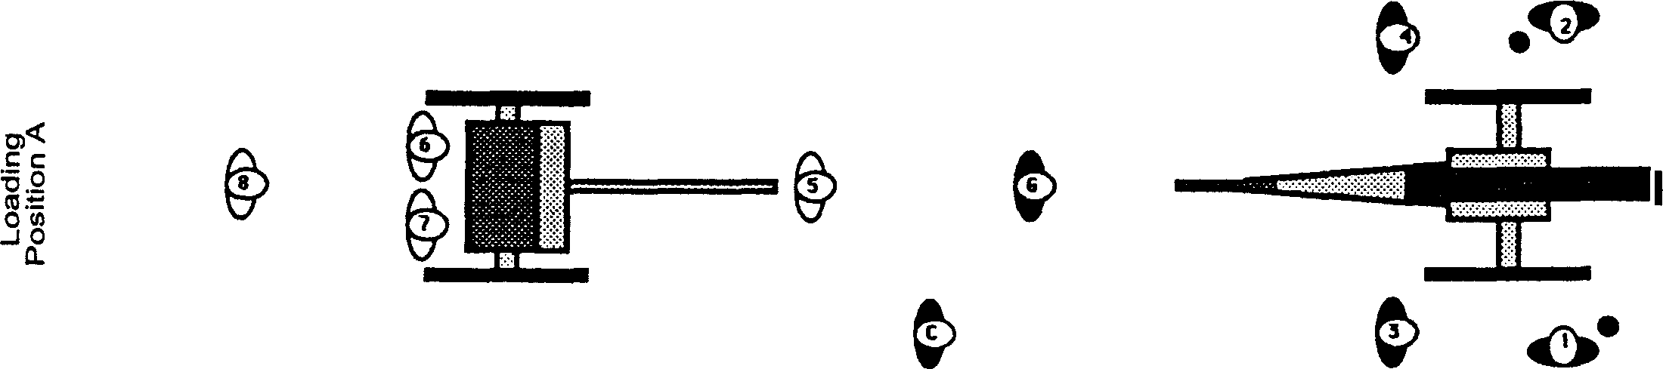

Satisfied that all implements are in hand, the cannoneers are properly posted, and that the gun has been prepared, the Gunner begins the cleaning steps in the loading sequence.

Gunner orders- ATTENTION DETACHMENT, LOAD BY DETAIL, LOAD
(All cannoneers come to attention for the first step in the loading sequence.)

Numbers 1 & 2, with their implements in hand, turn inward to face each other.
Gunner orders: TEND, VENT
(Number 3 steps well inside the wheel establishing Position B)

<< MT H >> Number 3 steps inside the wheel and kneels, resting on the right knee. Number 3 now continues with his duties, while being careful to keep his face and body away from the vent. >>

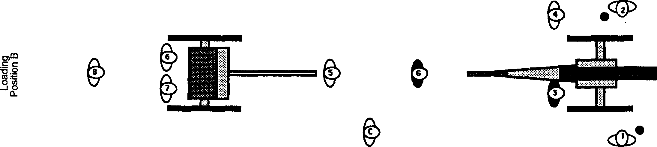
Position B:

Number 3 cleans the vent using the vent brush. Then Number 3, with the thumbstall on his left thumb, places the thumb-stall over the vent with the fingers to the left side of the gun tube and the elbow elevated to exert downward pressure to shut off the flow of air to the tube. Having accomplished this, Number 3 announces the completion of the step.

Number 3 reports: VENT STOPPED

Satisfied that the vent is properly covered and that no air can escape, the Gunner continues the cleaning steps.

Gunner orders: WORM

Position C:

<< MT H >> Number 2 steps up and works over the wheel to worm and service the piece.
While being careful not to move in front of the muzzle at any time. >>

Number 3 keeps the vent stopped.
Number 2 runs the worm down the tube seating it at the breach. He turns the worm two or more times, in order to pick up any debris, which may be in the tube. After turning the worm, number 2 withdraws the worm slowly extracting whatever the worm has picked up. He may re-worm if there is any indication that debris is left in the lube. When the task has been completed, Number 2 returns to his post, announces that the step as been accomplished, places the worm with the head upon the axle and the shaft running toward the front of the gun, parallel to the barrel

(Note: for those crews choosing to use a separate implement to "dry sponge"
Number 2 would now place the worm down and take the dry sponge).

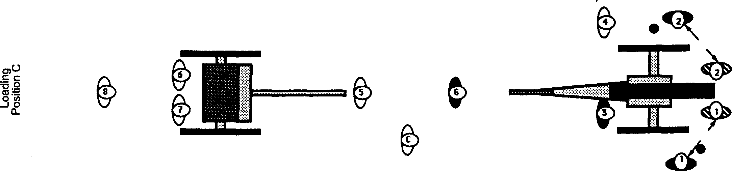
Number 2 reports: WORMED
Gunner orders: WET SPONGE

<< MT H >> sponging and all servicing of the gun is done over the wheels. >>

Number 1 places the sponge down the tube pushing it all the way to the breach.
Number 1 turns the sponge twice and then withdraws it halfway, where he turns it once, then reseats the sponge to the breach and again turns it twice The sponge is then withdrawn completely and cleared of any debris.

Number 1 reports: WET SPONGED

Gunner orders: DRY SPONGE

<< MT H >> sponging and all servicing of the gun is done over the wheels. >>

Number 2 runs the sponge down the tube pushing it all the way to the breach.
Number 2 turns the sponge twice, and then withdraws it halfway, where he turns it once, then reseats the sponge to the breach and again turns it twice. The sponge is then withdrawn completely and cleared of any debris. Having accomplished the task,

Number 2 reports: DRY SPONGED.

The Gunner will then order Number 1 and Number 2 to repeats the entire sponging step, so there will be two distinct sponging steps performed. When the second Dry Sponge is completed.

Number 1 then spins the sponge around and taps the underside of the barrel twice with the head of the rammer. He places the rammer on the edge of the muzzle, the rammer staff extending horizontally to the right side of the tube. This signals that sponging is complete and the tube and the crew are ready for the round.

(If Number 1 is used to complete both the wet and dry sponging steps, he will report SPONGED)

Satisfied that the gun tube is clean and that the vent is stopped, the Gunner initiates the loading of the cartridge.

Gunner orders: LOAD, (TYPE OF ROUND), RANGE (xxx) YARDS
(This order alerts the cannoneers and specifies the type of cartridge to be prepared.)

Number 6 repeats: LOAD (TYPE OF ROUND) RANGE (xxx) YARDS.
The gunner then issues the command to proceed.

Gunner orders: ADVANCE THE ROUND
(This order starts a series of actions at both the gun and the limber.)

Position D:

Number 5 walks from his post to the limber.
Number 6 opens the chest and selects the round then closes the chest cover.
Number 6 places the cartridge in the haversack carried by Number 5.

Number 5 advances the cartridge to the Gunner who inspects the content of the haversack

Number 5 advances to Number 2 via a route to the outside of Number 4.

While Number 5 obtains the cartridge, Number 2 places his implement upon the axle (as previously described) and positions himself:

<< MT H >> Number 2 remains outside the wheel at the same position used to worm and service the piece and works over the wheel to place the cartridge into the muzzle. >> with his back to the gun tube.

Number 5 stations himself outside the wheel opposite Number 2.
Number 5 opens the haversack and lifts it so that Number 2 may reach into it to obtain the cartridge.

Taking the cartridge, Number 2 turns to his left, counterclockwise, and inserts the cartridge into the muzzle, ensuring that it is properly placed for the rammer.

Number 5 moves to his original post after delivering the cartridge, again traveling on the outside of Number 4.

Number 2 now returns to his original post, takes up the worm and announces that the task has been completed.

(NOTE: In some areas number 2 is expected to place his implement on the hub at this time. This will signal that there is a load in the tube and ready to be seated.)

<< MT H >> If the worm is to be used to indicate “round in” it will be placed on top of the wheel. >>

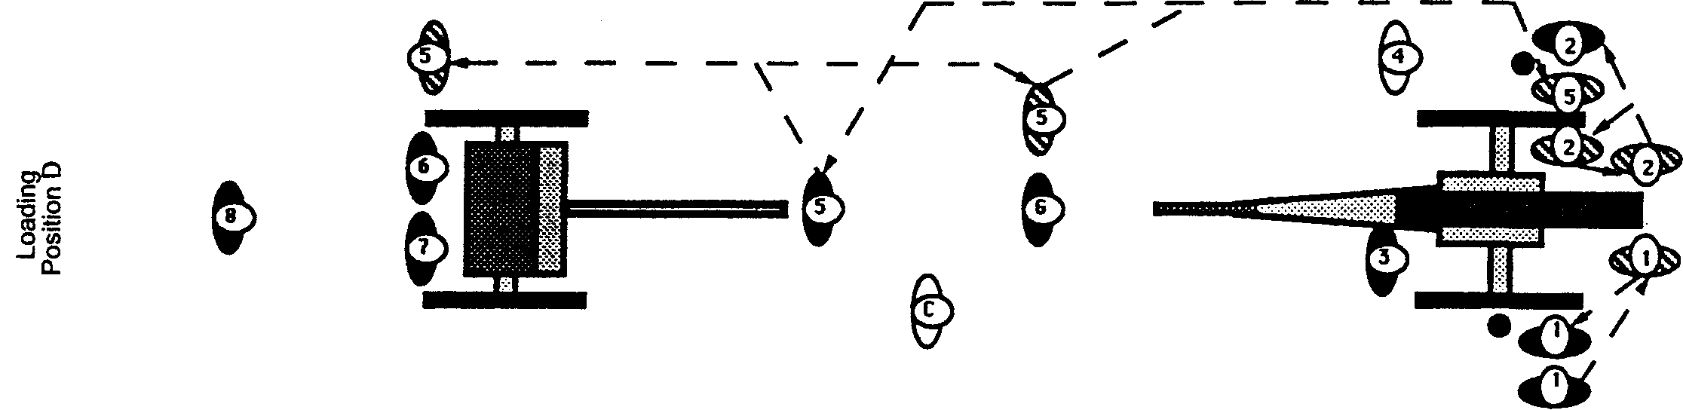

Number 2 reports: ROUND ADVANCED

Gunner orders: RAM

<< MT H >> Number 1 works over the wheel to ram the cartridge. After completing this step Number 1 places the ram on top of the wheel. >>

Number 1 runs the cartridge down the tube using one hand on the rammer shaft, keeping the thumb uninvolved, with the body behind the muzzle as much as possible. Simultaneously, Number 1 moves himself toward the axle of the carriage (being careful not to actually contact any part of the gun with his body) and his hand passes underneath the tube. (Note: After seating the round Number 1 should wait about 10 seconds before grasping the ram again. There is always increased danger as the cartridge is pressed against the breech.) Prior to seating the charge, he withdraws the rammer about 1 foot and gives a final thrust, releasing the rammer as the charge is seated at the breach. Number 1 again thrusts himself toward the axle of the carriage and his hand passes underneath the tube. After 10 seconds, the rammer is then completely removed, one-handed, thumb uninvolved. Number 1 then moves to the right wheel axle hub.

<< MT H >> After completing this step Number 1 places the ram on top of the wheel. >>

He holds the rammer shaft upright in his left hand with the sponge slightly forward. This indicates to all that the gun is loaded.

Number 1 reports: RAMMED

Gunner orders: SIGHT THE PIECE
(This action is to allow the Gunner to determine that the field of fire is clear of spectators, vehicles, etc.)

Position E:

The Gunner advances and stations himself along the left side of the trail, left foot forward, right leg extended alongside the trail. He sights along the tube or, if a slight hand is used, conducts a sighting routine. The Gunner may manipulate the elevating screw. As the Gunner approaches the piece, Number 3 uncovers the vent, steps to his original post, pauses momentarily, and then moves to the handspike. Number 3 may point the gun as indicated by the Gunner who taps on either the left or right side of the trail indicating the desired direction. Being satisfied the field of fire is clear;

Gunner stands, reports: [PIECE IS CLEAR] and returns to his post.

Satisfied that the loading is complete and that the area in front of the gun is clear, the gunner initiates the firing sequence.

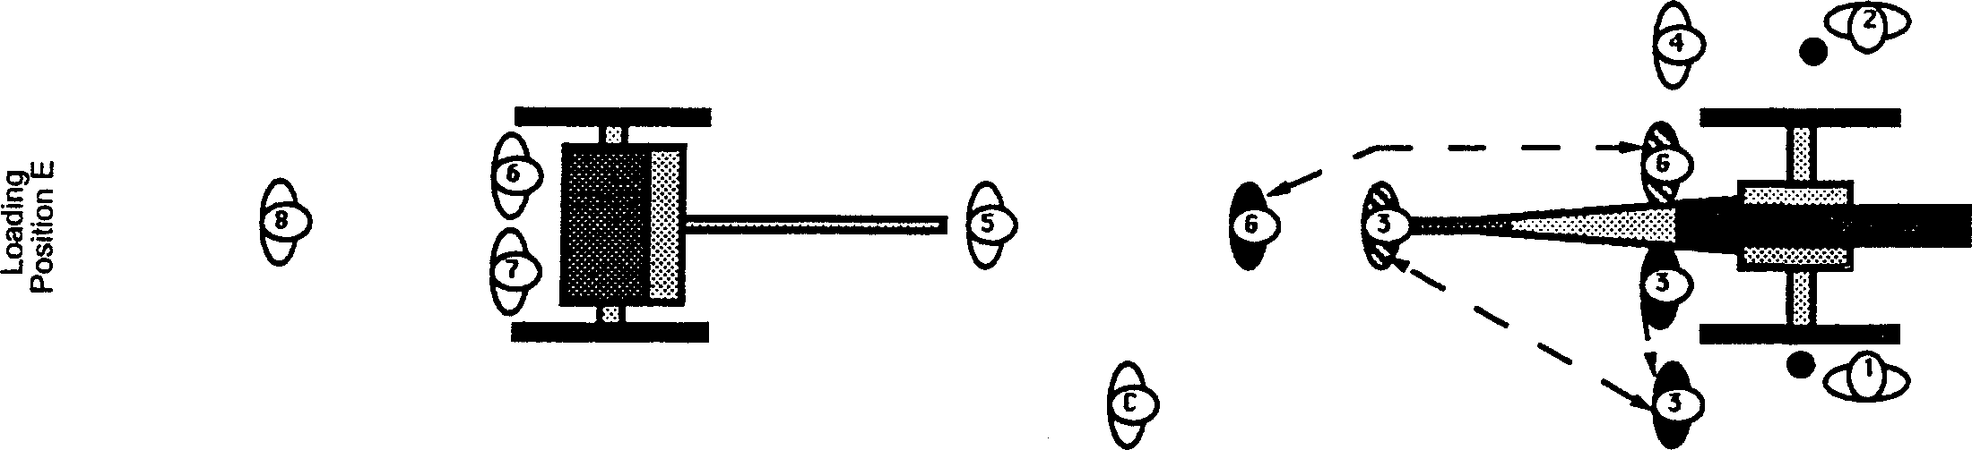

FIRING

Below are listed the commands and procedures to be followed by the National Civil War Artillery Association in the firing of artillery pieces. All verbal commands and responses are CAPITALIZED while all actions are in normal print. When specific cannoneers are involved in an action, the individuals illustrated are darkened.

This sequence of steps commences after the cannoneers have completed the loading sequence and are posted as in Position E of the loading sequence. Any of the following activities may be interrupted by the command "Cease, Stop or Halt." "Cease, Stop or Halt" may be ordered by any cannoneer at any time. The command "Commence Firing," ordered by the Gunner reinitiates the action. [CONTINUE THE DRILL]

Gunner orders: READY
(This command alerts the cannoneers that the firing sequence has begun. Numbers 3 and 4 prime the charge.)

Position A:

<< MT H >> Number 3 punctures the cartridge and continues to work from the kneeling position. With Number 4 taking extra care that he does not expose any part of his body to the vent while the primer is being placed. >>

Numbers 3 and 4 simultaneously step inside the wheels.
Number 3, while keeping his face away from the vent, inserts the vent prick holding the shaft of the vent prick between his fingers.
Number 3 punctures the powder bag and removes the vent prick.
Number 4 hands the friction primer to Number 3 who places it in the vent.
Number 4 then hands the hook end of the lanyard to Number 3 and steps outside the wheel setting himself in position so that he can see the cannoneer that will give the fire order.
Number 4 nods to Number 3 who attaches the lanyard hook to the primer.
Number 3 then steps outside the right wheel to his original post.
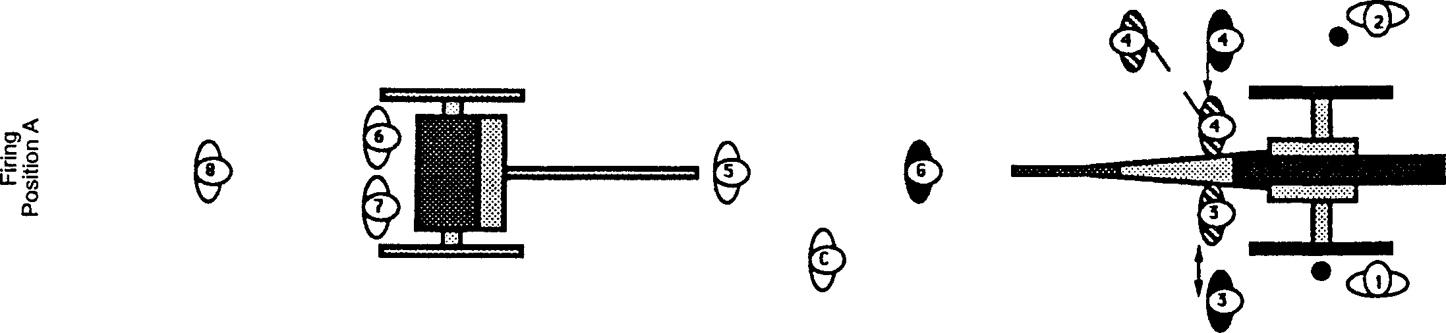
Number 4 reports: PIECE IS READY

Satisfied that the gun and the cannoneers are ready to receive the fire order, the Gunner may issue the "Prepare” command, or if other orders are standing, he may report to the Chief-of-the-Piece or the Section Officer that the piece is prepared to fire.

NOTE: Some units Number 1,2 and 3 come to the PREPARE position when Number 4 reports the piece ready.
This adds an extra measure of safety if the “Prepare” command is omitted.

Gunner orders: PREPARE or,
He may relinquish control of the fire order and report: NUMBER (x) GUN IS PREPARED

(The "Prepare” command is directed to the cannoneers. The "Gun x, is Prepared" report is directed to the Chief-of-the-Piece. When the "Prepare” order is initiated by either the Gunner or, by his proxy, another NCO or Commissioned Officer, the cannoneers respond.

(Note: it is important that the Gunner stay involved, if even as an echo to the officer giving the command. This alleviates confusion that may result in a Number 4 picking up the FIRE command from another crew. It is essential that the Number 4 has eye contact with the individual giving the command, and as such, keeping the Gunner involved, no matter what, provides that connection.)

Position B:

<< MT H >> Number 3 stands and moves back to assume the standard prepared stance.

Number 1 and 2 remove the implements from the wheel tops and move into their prepare stances.

For added protection from primer splatter, Number 1 and 2 will take position with their backs to the guns vent. They should cover the ear facing the muzzle direction, lean toward the rear of the gun and look forward as normal. >> with their eyes are on the muzzle of the gun.

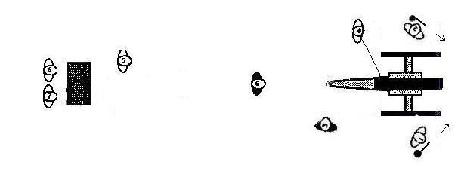

Number 3 assumes a position for firing similar to Number 1. His eyes are on the vent.

Number 4 faces the cannoneer that will give the fire command. The lanyard is extended and taunt.
Number 4, holding the handle of the lanyard at knee height, grips the handle in his right or left hand so that the back of the hand is toward the primer with the lanyard protruding between the second and third fingers close to the knuckles. The command to "Fire" or "Cease Fire" order follows immediately after the cannoneers are in the Prepare to Fire Positions.
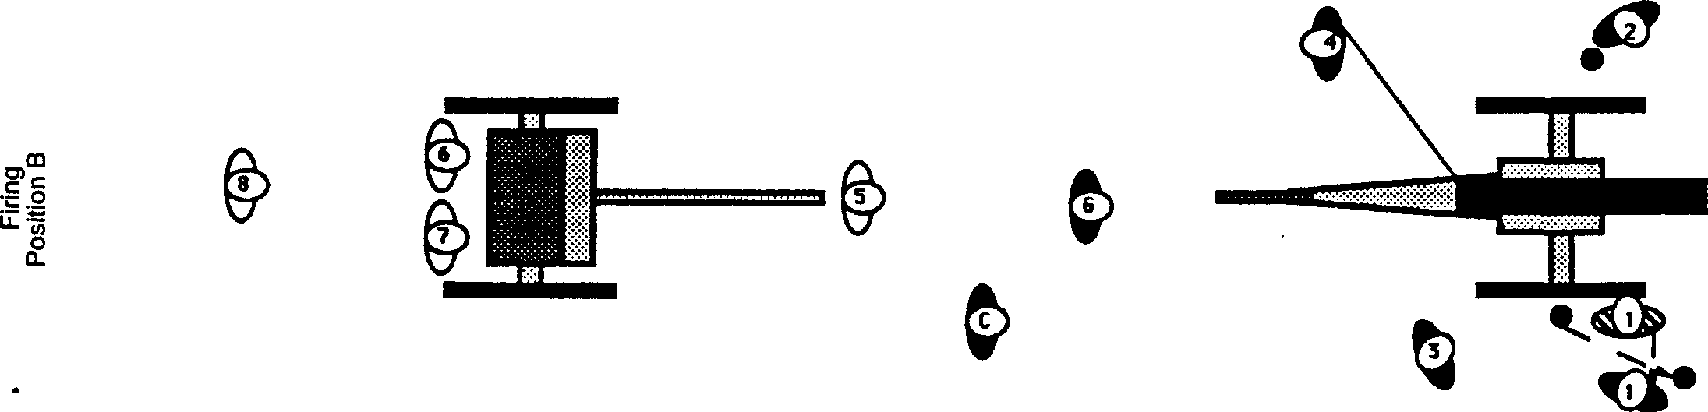

Gunner orders: FIRE

(If he relinquished control, the order to "Fire" originates from the same cannoneer as the "Prepare " command.)

Number 4 pulls the lanyard smartly. The gun discharges.

The loading sequence for the next round may now be started.

(Note: The sequence is not complete until the vent is tended, the gun wormed and sponged.)

A minimum of two minutes will be allowed to elapse between the command of "Fire, "just executed, and the introduction of a load to the bore.

A minimum of three minutes should be allowed to elapse between the “Fire” commands.

MISFIRE SEQUENCE

If the gun did not discharge or it is perceived to have not fired, any of the cannoneers may call a misfire.

Any cannoneer reports: MISFIRE

Gunner acknowledges: THE PIECE HAS MISFIRED

Gunner orders: DO NOT ADVANCE

[Gunner checks with Number 3 to determine the status of the primer]

[Number 3 reports: THE PRIMER HAS FAILED or THE PRIMER HAS IGNITED]

[Gunner orders:
DO NOT ADVANCE -- THE PRIMER HAS FAILED [or THE PRIMER HAS IGNITED]

(No further attempt is made to service the gun except Numbers 1 and 2 take alternate post.)

Position C:

Numbers 1 and 2 cross their implements high above the gun at the approximate center of the axle
The display indicates to everyone on the field that a misfire has occurred.

All cannoneers will stand clear of the gun for a three-minute interval.

The interval is timed by the Gunner and should be checked by the Chief-of-the-Piece or a commissioned officer.
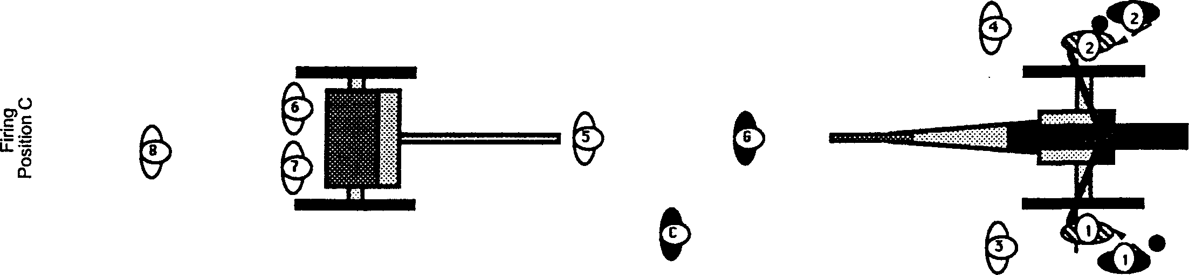

Gunner acknowledges: THREE MINUTES HAVE ELAPSED

Gunner orders: NUMBER 2, TAKE CHARGE OF THE PIECE
(Numbers 1, 2 , 3 and 4 begin the procedure to clear the misfire.)

Position D:

Number 1 and Number 2 disengage the crossed implements.
Number 1 moves into a position near the hub on the outside of the right wheel. Still holding the rammer shaft upright and tilted over the tube as if crossed,
Number 1 must make room for Number 3 to advance with the tools (either in front of or behind the position of Number 1) Units should decide for themselves on this option.

<< MT H >> Number 2 does not move inside the wheel area, but continues to work over the wheel and behind the muzzle.

Number 2 places the worm in the implement stand and steps inside the left wheel by hugging the wheel and keeping his back to the muzzle and the tube. He stations himself facing to the rear of the tube in such a manner as to use his non-dominant hand (left if you are right-handed) to work the vent.
Number 3 advances to his misfire station near Number 1 and positions himself outside the right wheel, near the axle hub.
Number 3, working above the right wheel, hands the proper tools to Number 2.
Number 2 works the vent and extracts the remains of the primer, if any.
Number 2 returns the tools to Number 3.
(Note: Number 2 and Number 3 should assess the situation and determine if the primer is protruding enough from the vent to utilize pliers or if it is set low and requires a gimlet).
???? [Number [ 1 ] would normally keep his back to the tube and work the vent with his left hand.] ?????
Number 3 position himself so that he or Number 2 does not reach over the vent during the exchange of tools.

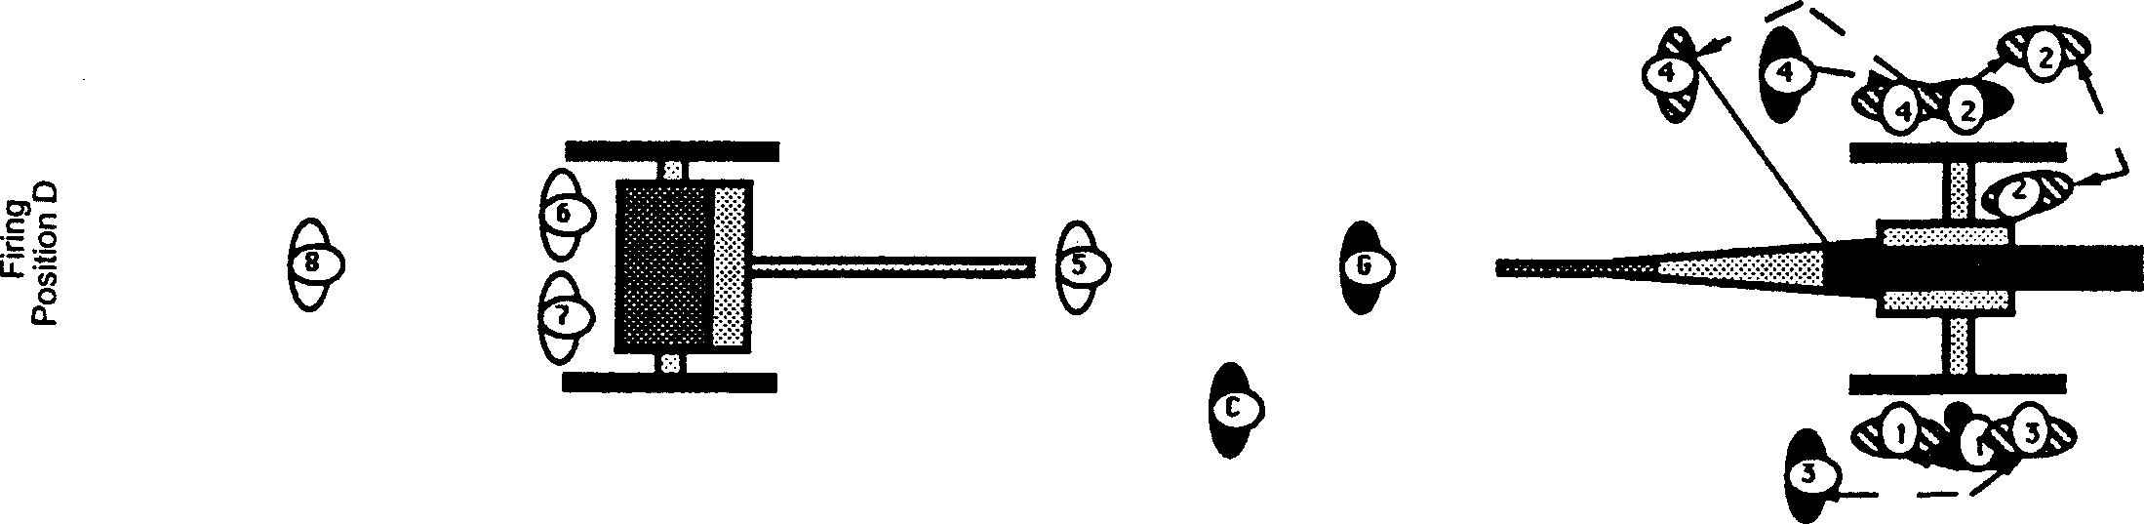

Number 2 reports: PRIMER EXTRACTED or THE VENT IS CLEAR

Number 3 hands the vent prick to Number 2,
Number 2 inserts the vent prick holding the shaft of the vent prick between his fingers (non-dominate hand).
He attempts to puncture the powder bag and removes the vent prick from the vent. [Check for powder on prick]

Number 2 returns the vent prick to Number 3 who moves to his original post.

Number 2 reports: CHARGE PRICKED or THE CHARGE IS NOT SEATED
(If it is determined that the charge is not seated, removal of live charge sequence should be initiated.
If the charge has been punctured, the misfire sequence continues.)

Number 4 advances and stations himself outside the left wheel, centered on but clear of the hub.
Number 4, working above the left wheel, hands a friction primer to Number 2.
Number 2 places the primer in the vent.
Number 4 then hands the hook end of the lanyard to Number 2 and moves to his position for firing the gun.
When in position, Number 4 nods to Number 2 who attaches the lanyard hook to the primer.
Number 2 steps outside the left wheel to his original post.

Number 2 reports: PIECE IS READY

[Gunner states: I HAVE CHARGE OF THE PIECE]

Satisfied that the cannoneers have cleared the misfire and that they and the gun are ready to receive the "Fire" order, the Gunner issues the "Prepare" command.

Gunner orders: PREPARE
(All cannoneers take the positions as described in Position B of the firing sequence.)

Gunner orders FIRE

Number 4 pulls the lanyard sharply. The gun discharges.

RESEATING AND REMOVING THE CHARGE SEQUENCE.

These sequences are initiated if, during a misfire it is determined that the charge:
(1) is not seated or
(2) if a second misfire occurs.

(1) When in the charge-not-seated condition,

The Chief-of-the-Piece, the Section Officer, the Safety Officer, or the Battery Commander may assume the responsibility for clearing the misfire. Cannoneers will assist as required.

It is always best to exhaust all possibilities for ignition before attempting to extract the powder charge.

Flooding the tube with water to saturate the charge or wash it out or using the bronze worm may be required.

(2) If the gun fails to fire for the second time,

"Misfire" is called as before. In this case, the steps in clearing the misfire will be repeated as described in Position D of the misfire sequence up to the primer extracted step whereupon, the Chief-of-the-Piece, or one of the officers will take command as in the charge-not-seated circumstance.

(Note: No charge should ever be reseated after a primer has fired into the chamber)

If the bore has been flooded and a worm is to be used, no action should be taken with anyone down range.

After 3 attempts to prime and fire,
The gun should be shut down and steps to clear the tube should be considered.

The Safety Officer should be notified at this point.
SECURING THE PIECE SEQUENCE

Once the "Fire" command has been executed, the Gunner, at order of the Chief-of-the-Piece or an officer will terminate serving of the piece.

Gunner orders: CEASE FIRING
(Cannoneers prepare to disengage)

The Gunner uses the cleaning steps as described in the loading sequence, beginning with the “clean- the- vent” procedure and continuing through dry sponge to ensure that the gun tube is clean and clear.
Dry sponge being completed by Number 2, the Gunner issues the next command.

Gunner orders: SECURE THE PIECE
(Cannoneers begin to stow the implements and secure the gun.)

Numbers 1 through 4 place the implements, acquired initially as described in Position A of the loading sequence, on their hangers. The sponge bucket, sponges, worm and handspikes are returned to their proper positions. The vent cover is installed and all debris left from the firing sequence is retrieved. When this has been accomplished, Numbers 1 through 4 return to their posts and come to attention as in Position E of the Limber Drill.

Satisfied the gun and the implements are secure the Gunner continues the sequence.

Position E:

The Gunner moves the gun crew to the limber where they will return the issued implements.

Gunner orders: RIGHT ABOUT FACE
Numbers 1 through 4 turn to face the Gunner, Number 5 faces the limber.

Gunner orders: FORWARD MARCH
Numbers 1 through 4 advance toward the Gunner. The Gunner halts the gun crew at a convenient post. Number 5 does not advance.

Gunner orders: HALT

The Gunner stations himself behind Number 2

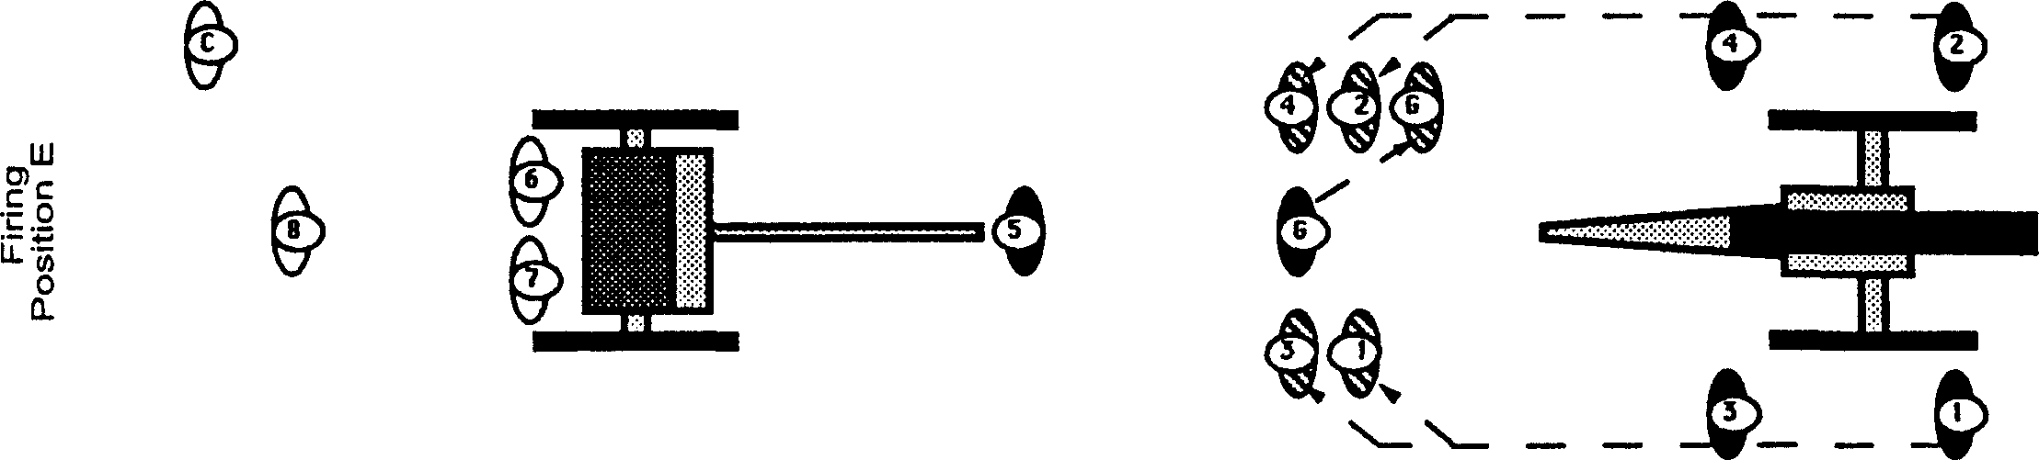

Gunner orders: POST ON THE LIMBER MARCH or other commands to position the gun crew at the limber.

Position F:

In formation, the detachment, moves to the limber and halts in a position as described in Position E of the Limber Drill except, Number 1 through 5 and the Gunner are facing toward Number 8.

[Gunner orders ] NUMBER 6 TAKES CHARGE OF THE GUN CREW

Number 6 takes charge of the detachment and reacquire the issued implements in the order described in Position D, C, and B of the Limber Drill.

[Number 6 orders:] DETACHMENT, ONE STEP FORWARD, MARCH

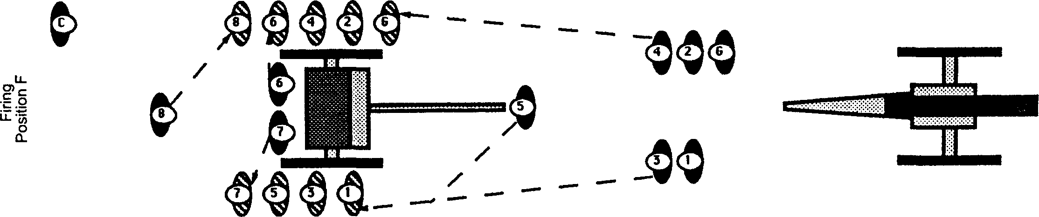

Number 8 or the Chief-of-the-Piece will inspect all implements and will open and search all tube pouches for unused friction primers and the cartridge haversack for loose powder or other debris.

Residue from firing, aluminum foil, will be deposited with Number 8. When the implement inspection and exchange has been completed, Number 6 orders the chest cover closed and locked. Number 7 closes the cover. Number 6 and 8 informs the Gunner that all implements have been retrieved.

Number 6 reports: IMPLEMENTS HAVE BEEN RETURNED

Gunner orders: DETACHMENT, FORM INTO FILES

Number 6 steps to the front of Number 4, Number 8 steps to the front of Number 6. Number 7 steps to the front of Number 5. The Gunner may advance the detachment to clear the area of the limber.

This being accomplished, the Chief-of-the-Piece or the Gunner forms the detachment into a proper marching formation. The detachment is marched to their next assignment.

DANGER ZONE
WARNINGS:

The blank cartridge (powder charge), when ignited in the field piece tube, throws a cone of flame 25 feet down range from the muzzle of the field gun. An accidental discharge with an object such as the rammer, the worm or a small solid piece of debris in the tube will throw fragments down range an unpredictable distance. The spent primer is launched upward in a column of flame as the field piece is fired. It sometimes comes down outside the danger zone.

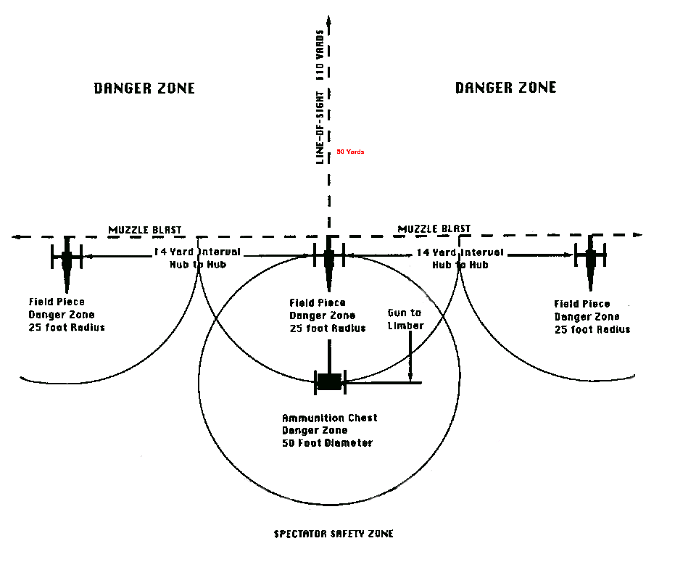

PRECAUTIONS:

During firing demonstrations, no one places anything in the Ammunition Chest or takes anything out except Cannoneers Number 6 or Number 7. The Ammunition Chest cover is closed prior to the "Ready" command and is kept closed until after all pieces are discharged or, in the case of a misfire, until the misfire is cleared.
No debris of any description is to be stored in the Ammunition Chest.

Powder

Type g or sporting powder - Cannon, Fg & FFg are suitable for blanks. Cannon and Fg may be used to fire projectiles. The potential for extremely high pressures is too great with FFFg or FFFFg for blanks or projectiles. Use of FFg is limited and requires reduced loads.

Type A Blasting Powder - (3FA-lFA) Can be used in most blank rounds. 3FA and 2FA are similar to cannon grade powder and 1FA is much coarser and has been used for projectiles fired in bores larger than 4 inches. Lifting powder is often used as cannon grade powder for making blank rounds.

Basic blank load for Fg and other cannon grade powder is 3.oz (1312.5 gr.) per inch of bore. For most blank rounds, this is a good starting point. With bores less than 2.5” the amount should be adjusted down and for bores larger than 3.75” this may be increased to the point that rounds do not butterfly down the bore. This is for blank rounds only and many other factors need to be addressed for projectiles.

Pyrodex -Pyrodex is limited to very few uses with projectiles and should never be used for blanks. This is not a suitable powder for artillery! Do not experiment!

Type B Blasting Powder - Has very unpredictable results when used in Cannon. (Should never be used)

Note: There are 7000 gr. Per pound of powder (all types Cannon, Fg, FFg, FFFg or FFFFg) Granule size does vary, cannon having the largest and FFFFg the smallest, but all have 7000 gr. (weight) per pound.

1 ounce = 437.5 gr.
1 grain = 0.002285714 ounces
1 pound = 7000 gr.

This is information is for blank rounds only ! Many other factors must be addressed for firing projectiles. Do not attempt making blank or live rounds without proper instruction and supervision.

Blank Rounds

Step 1: Start with large sheet of heavy duty aluminum foil. Fold sheet to make a rectangle large enough to wrap 3 times (6 layers) around your cartridge form. (A cartridge form can be made from tubing or a cylinder with an O.D. near the I.D. of the bore)

Step 2: Fold and roll foil around the form. Remember to keep an excess of foil at the bottom of the tube. This will be folded over and tamped to make a thick seal for the bottom end of the blank cartridge.
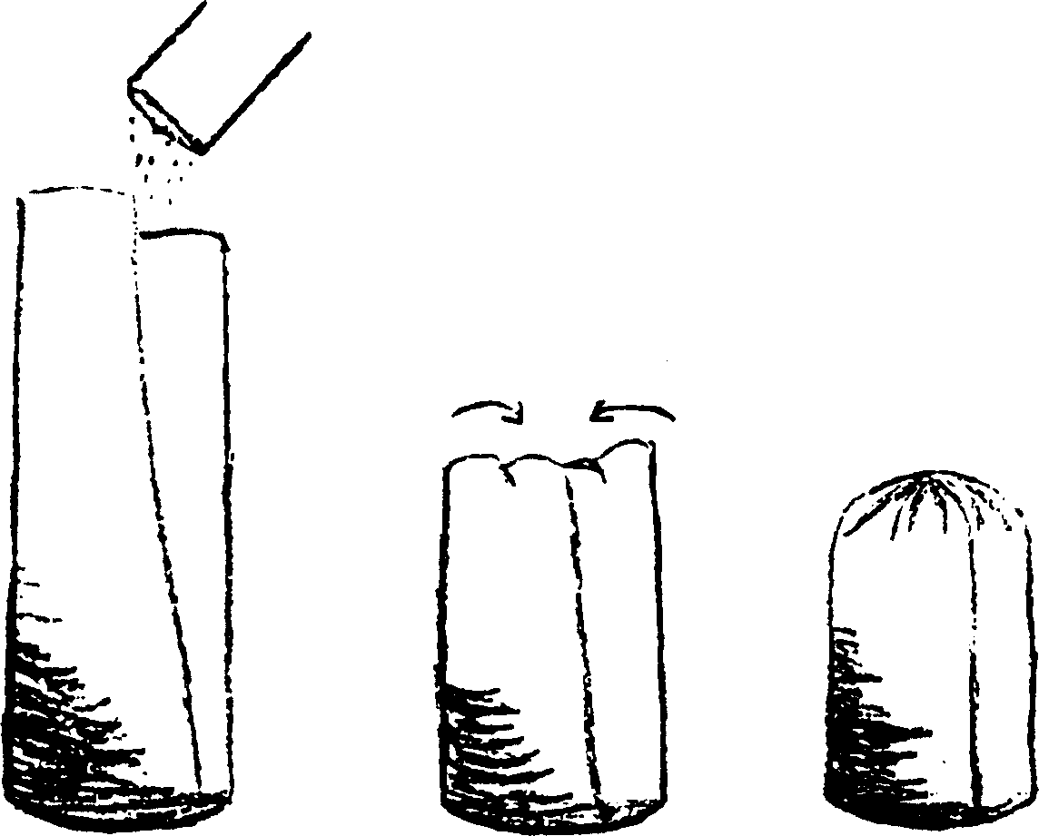
Step 3: After foil has been tamped and inspected, remove the foil cartridge from the form.
The powder charge may now be placed in the cartridge.

Step 4: Fold the foil in on itself to seal the top of the cartridge. The foil should be formed to make an extremely good seal.
The end can be color coded to mark type and load of the blank cartridge.

This is information is for blank rounds only! Many other factors must be addressed in the construction of blank rounds. Do not attempt making blank or live rounds without proper instruction and supervision.

