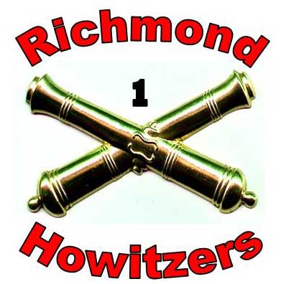
1st Company Richmond Howitzers

MONTH | DAY | EVENT | LOCATION | TYPE
March | 3 | Swap meet | Uxbridge, MA | FYI
 | 17 | St Patrick’s parade | So. Boston, MA | RH
May | 5-6 | CMD/Drill weekend | Lincoln, RI | LG
June | 2-3 | Amesbury | Amesbury, MA | LG
 | 16-17 | Borderland | Easton. MA | LG
July | 14-15 | Groton | Groton, MA | LG
August | 18-19 | Woodbury | Woodbury, CT | LG
September | 8-9 | Fort Adams | Newport, RI | RH
 | 15-16 | Lincoln | Lincoln, RI | LG
October | 6-7 | Winchendon | Winchendon, MA | FYI
 | 20-21 | Cedar Creek | Middletown, VA | ANV
November | TBD | LG’s Meeting | Sturbridge, MA | LG
 | TBD | ANV Convention< | Fredericksburg, VA | ANV
 | 17-18 | Remembrance Day | Gettysburg, PA | RH

