A Convex Hull Algorithm using Point Elimination Technique

Supervised By
Amina Khatun
Lecturer, Department of CSE
Jahangirnagar University

Submitted By
Asma Fariha, Roll - 393, Exam Roll - 090491
Md. Newaz Sharif, Roll - 420, Exam Roll -090519
Session – 2008-09

Department of Computer Science & Engineering
Jahangirnagar University
Abstract

Graham’s scan is an algorithm for computing the convex hull of a finite set of points in the 2D plane with time complexity O (nlogn). In the algorithm, points in 2D plane are sorted angle-wise and then selected as convex hull points by checking whether the points constitute right-turn or left-turn. In our project we have developed some preprocessing technique on Graham’s Scan algorithm. First, we eliminate the number of points those are not exist on the hull. To do this, we create a quadrilateral using four optimal points and then create four triangles using another four optimal points. Thus the complexity of the algorithm O (nlogn) is expected to work much faster on smaller number of points.

Acknowledgement

We would like to express our indebtedness and offer our special thanks to my supervisor Amina Khatun, department of Computer Science and Engineering, Jahangirnagar University, for her continuous effort and valuable guidance to make this thesis a success. We are especially grateful for the time she spent proofreading the details of this thesis and supporting us with comments and discussions.
We also would like to express our gratitude and offer our special thanks to Professor Dr. Md. Shorif Uddin sir, department of Computer Science and Engineering, Jahangirnagar University for his constant encouragement and endless support and also for being a very caring co-supervisor.
We also would like to offer our special thanks to all of our thesis committee members and all of our faculty members, department of Computer Science and Engineering, Jahangirnagar University, for their kind cooperation.

Table of Contents

Contents | Page Number
Table of Figures | 4
Chapter 1
1.1 Literature Review | 6
1.2 Objective and Scope of the Project | 8
1.3 Outline of the Project | 8
Chapter 2
2.1 Introduction | 10
2.2 Jarvis March (Gift Wrapping) Algorithm | 10
2.3 Graham’s Scan Algorithm | 12
2.4 Quick Hull Algorithm | 15
2.5 Divide and Conquer Algorithm | 16
2.6 Monotone chain Algorithm | 19
2.7 Conclusion | 22
Chapter 3
3.1 Introduction | 23
3.2 Making a Quadrilateral | 24
3.3 Triangulation | 24
3.4 Flow Chart | 27
3.5 Pseudo Code | 28
3.6 Complexity Analysis | 31
Chapter 4
4.1 Graphical Representation | 32
4.2 Comparison | 34
Chapter 5
5.1 Achievement | 35
5.2 Limitation | 35
5.3 Conclusion | 35
References | 36
Source Code | 38

Table of Figures

Figure Number | Figure Name | Page Number
1 | Convex polygon | 6
2 | Convex hull | 7
3 | Gift wrapping 1st step | 11
4 | Gift wrapping 2nd step | 11
5 | Graham Scan algorithm 1st step | 14
6 | Finding convex hull points | 14
7 | Quick Hull algorithm | 15
8 | Dividing into two sets | 18
9 | Merge the two sets | 19
10 | Finding lower tangent from (3,7) to (0,8) | 19
11 | Monotone chain algorithm | 19
12 | Forming a quadrilateral | 24
13 | Eliminating Points | 25
14 | Triangulation | 25
15 | Elimination of points within triangle | 26
16 | Output Image of our Implementation | 32

Chapter 1 Introduction

Introduction
In Euclidean space, an object is convex if for every pair of points within the object, every point on the straight line segment that joins the pair of points is also within the object. Let S be a vector space over the real numbers, or, more generally, some ordered field. This includes Euclidean spaces. A set C in S is said to be convex if every point on the line segment connecting x and y is in C.
A convex polygon is a simple polygon whose interior is a convex set. The following properties of a simple polygon are all equivalent to convexity:
- Every internal angle is less than or equal to 180 degrees.
- Every line segment between two vertices remains inside or on the boundary of the polygon.
A simple polygon is strictly convex if every internal angle is strictly less than 180 degrees. Equivalently, a polygon is strictly convex if every line segment between two non-adjacent vertices of the polygon is strictly interior to the polygon except at its endpoints.

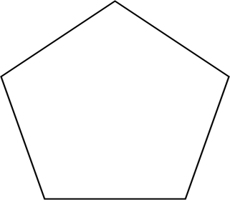

Figure 1: convex polygon

In mathematics, the convex hull or convex envelope of a set X of points in the Euclidean plane or Euclidean space is the smallest convex set that contains X. For instance, when X is a bounded subset of the plane, the convex hull may be visualized as the shape formed by a rubber band stretched around X.
Formally, the convex hull may be defined as the intersection of all convex sets containing X or as the set of all convex combinations of points in X. With the later definition, convex hulls may be extended from Euclidean spaces to arbitrary real vector spaces; they may also be generalized further, to oriented matroids.

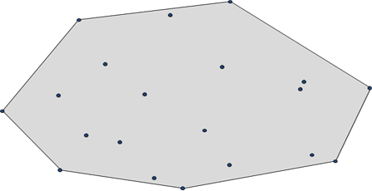

Figure 2: convex hull

Literature Review

C. Bradford Barber, David P. Dobkin, Hannu Huhdanpaa Proposed a practical convex hull algorithm that combines the two-dimensional Quickhull Algorithm with the general-dimension Beneath-Beyond Algorithm. It is similar to the randomized, incremental algorithms for convex hull and Delaunay triangulation. They provide empirical evidence that the algorithm runs faster when the input contains nonextreme points and that it uses less memory. Computational geometry algorithms have traditionally assumed that input sets are well behaved. When an algorithm is implemented with floating-point arithmetic, this assumption can lead to serious errors. They briefly describe a solution to this problem when computing the convex hull in two, three, or four dimensions. The output is a set of “thick ” facets that contain all possible exact convex hulls of the input. A variation is effective in five or more dimensions.
Per-Olof Fjällström, Jyrki Katajainen, Christos Levcopoulos, Ola Petersson presented a parallel algorithm for finding the convex hull of a sorted set of points in the plane.Their algorithm runs in O(logn/log logn) time using O(n log logn/logn) processors in theCommon crcw pram computational model, which is shown to be time and cost optimal. The algorithm is based on n ^{1/3} divide-and-conquer and uses a simple pointer-based data structure.
Kasun Ranga Wijeweera proposed a new efficient algorithm to construct the convex hull of a set of points in the plane. The proposed algorithm is able to find the points on the convex hull in boundary traversal order. When the convex hull has collinear points, the algorithm can detect all the collinear points on the hull without skipping the intermediate points. Furthermore it can deal with the data sets where coincident points appear. Two main methods have been used to make the algorithm efficient. First one is achieving parallelism which is done by partitioning the data set. Second one is data reduction which is done by removing unnecessary points at each step of processing. Further they have proved that the performance of our algorithm is better than interior points algorithm by experimental comparison.
S. G. Akl proposed a parallel algorithm that computes the convex hull of a set of n points in the plane. The algorithm uses n ^{1−ε} processors, 0<ε<1, and runs in O(n ^{ε} logh) time, where h is the number of edges on the convex hull, for a total cost of O (n logh). This performance matches that of the best currently known sequential convex hull algorithm. In addition, since h≤n, the algorithm is worst-case optimal in view of the Ω (n logn) worst-case lower bound on sequential convex hull computation. It is also shown that the convex hull algorithm leads to a parallel sorting algorithm whose total cost is O(n logn), which is optimal.
Mart M.McQUEEN and Godfried T. TOUSSIANT proposed e modification of Kirkpatrick and Seidel ‘s algorithm. Kirkpatrick and Seidel’s algorithm is capable of computing convex hull of n points in O(n log h) worst case time, where h denotes the number of points on the convex hull of the set .But M.McQUEEN and Godfried T. TOUSSIANT’s algorithm is believed to run in O(n) expected time for many reasonable distributions of points.
Herv´e Br¨onnimann, John Iacono, Jyrki Katajainen, Pat Morin, Jason Morrison, Godfried Toussaint proposed a space-efficient algorithm in which the output is given in the same location
as the input and only a small amount of additional memory is used by the algorithm.They described four space-efficient algorithms for computing the convex hull of a planarpoint set.

Gang Mei, John C.Tipper and Nengxiong Xu represent an alternate choice to compute the convex hull for planar point sets. At first they discard the interior points and then sort the remaining vertices by x and y coordinates separately. Then create a group of quadrilaterals recursively according to the sequence of sorted lists of points. Finally, the desired convex hull is built based on a simple polygon derived from all quadrilaterals.

Objective and Scope of the Project

This thesis greatly emphasize on reducing the number of points from the set of points from which the convex hull is to be computed. After applying the proposed algorithm we can reduce a huge number of points in many cases when the number of points in the set of points is large in number.
Then we can apply any of the O(nlogn) algorithm on the existing data set to compute the convex hull. The reduced number of points is expected to show better runtime. But the algorithm is based on heuristics.
The scope of this algorithm is on the point sets where number of points in very large and all points in test data are not the convex hull point. Then the processing time for computing convex hull can be reduced.

Outline of the Project

In chapter 1 we have discussed introduction, literature review of out project. Then in chapter 2 we will discuss about some convex hull algorithms and in chapter 3, we will discuss the design and implementation of our preprocessing technique. We will represent some graphical output and results in chapter 4. Then finally, our achievement and limitation will be discussed in chapter 5.

Chapter 2 Convex Hull Algorithms

2.1 Introduction

Many algorithms with O(n log n) worst case time bounds have been described recently . Several papers have proved an (n log n) lower bound for finding the convex hull. Another pair of algorithms have been proposed with a worst case time bound of O(nh) where h is the number of convex hull vertices. Graham Scan, Divide and Conquer algorithm perform worst case time complexity of O(nlogn) where some algorithms like Gift Rapping cost O(nh) complexity.

2.2 Jarvis March (Gift Wrapping) Algorithm

Introduction
One of the simplest (although not the most time efficient in the worst case) planar algorithms. Discovered independently by Chand & Kapur in 1970 and R. A. Jarvis in 1973. It has O(nh) time complexity, where n is the number of points in the set, and h is the number of points in the hull. In the worst case the complexity is O (n²).
In Gift Wrapping the idea is to use one extreme edge as an anchor for finding next one. This works because we know that the extreme edges are linked into a convex polygon. Now let’s examine how this anchored search can be accomplished. Assume general position of the points for clarity: no three points in S are collinear. Suppose the algorithm last found an extreme edge whose unlinked endpoint is ‘x’. Draw a directed line L from x to another point y of the set. ’L’ includes ‘e’ only if all other points are to the left or alternatively, only it there are no points to the right. But note that, if we check for each y whether all other points are to the left, we will be back to an n^3 calculation. For each c, for each y, check all other points.
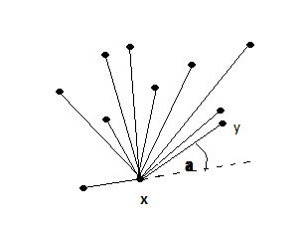
Figure 3: Gift wrapping 1st step
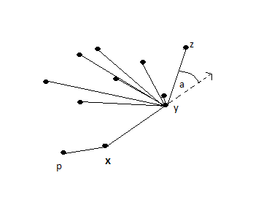
Figure 4: Gift wrapping 2nd step

The key observation to reducing the complexity is that the property of making the smallest counterclockwise angle with respect to the previous hull edge. This implies that it is not necessary to check whether all points are to the left: This can be inferred from the angle. So for each point y, compute that angle; call it 0. The point that yields the smallest ‘a’ must determine an extreme edge.

Pseudo Code 2.1: Gift Wrapping Algorithm
Find the lowest point (smallest y coordinate).
Let i₀ be its index, and set i←i₀
repeat
for each j ≠ i do
compute counterclockwise angle θ from previous hull edge.
Let k be the index of the point with the smallest θ.
Output (p_{i},p_{k}) as a hull edge.
i ← k
until i = i₀

Complexity
Since the most vertices of a polygon can have is n, the number of extreme edges is O(h). The anchored search will only explore O(n) for each hull edge. So overall time complexity will be O(nh).

2.3 Graham’s Scan Algorithm

Introduction
A slightly more sophisticated, but much more efficient algorithm, published by Ronald Graham in 1972 with time complexity O(nlogn). If the points are already sorted by one of the coordinates or by the angle to a fixed vector, then the algorithm takes O(n) time.
The first step in this algorithm is to find the point with the lowest y-coordinate. If the lowest y-coordinate exists in more than one point in the set, the point with the lowest x-coordinate out of the candidates should be chosen. Call this point P. This step takes O(n), where n is the number of points in question.
Next, the set of points must be sorted in increasing order of the angle they and the point P make with the x-axis. Any general-purpose sorting algorithm is appropriate for this, for example heapsort (which is O(n log n)).
The algorithm proceeds by considering each of the points in the sorted array in sequence. For each point, it is determined whether moving from the two previously considered points to this point is a "left turn" or a "right turn". If it is a "right turn", this means that the second-to-last point is not part of the convex hull and should be removed from consideration. This process is continued for as long as the set of the last three points is a "right turn". As soon as a "left turn" is encountered, the algorithm moves on to the next point in the sorted array. (If at any stage the three points are collinear, one may opt either to discard or to report it, since in some applications it is required to find all points on the boundary of the convex hull.)
Again, determining whether three points constitute a "left turn" or a "right turn" does not require computing the actual angle between the two line segments, and can actually be achieved with simple arithmetic only. For three points (x₁,y₁), (x₂,y₂) and (x₃,y₃), simply compute the direction of the cross product of the two vectors connecting the point (x₁,y₁) to (x₂,y₂) and the point (x₁,y₁) to (x₃,y₃), which is given by the expression (x₂-x₁)(y₃-y₁)-(y₂-y₁)(x₃-x₁). If the result is 0, the points are collinear; if it is positive, the three points constitute a "left turn" or counter-clockwise orientation, otherwise a "right turn" or clockwise orientation.
This process will eventually return to the point at which it started, at which point the algorithm is completed and the stack now contains the points on the convex hull in counterclockwise order.

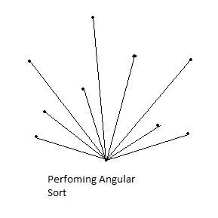
Figure 5: Graham Scan algorithm 1st step
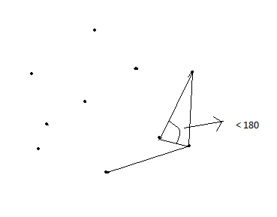
Figure 6: Finding convex hull points

Pseudo Code 2.2: Graham’s Scan Algorithm
First, define
# Three points are a counter-clockwise turn if ccw> 0, clockwise if
# ccw< 0, and collinear if ccw = 0 because ccw is a determinant that
# gives the signed area of the triangle formed by p1, p2 and p3.
Function ccw(p1, p2, p3):
return (p2.x - p1.x)*(p3.y - p1.y) - (p2.y - p1.y)*(p3.x - p1.x)

Then let the result be stored in the array points.

let N = number of points
let points[N+1] = the array of points
swap points[1] with the point with the lowest y-coordinate
sort points by polar angle with points[1]

# We want points[0] to be a sentinel point that will stop the loop.
let points[0] = points[N]

# M will denote the number of points on the convex hull.
let M = 1
for i = 2 to N:
# Find next valid point on convex hull.
While ccw(points[M-1], points[M], points[i]) <= 0:
if M > 1:
M -= 1
# All points are collinear
else if i == N:
break
else
i += 1

# Update M and swap points[i] to the correct place.
M += 1
swap points[M] with points[i]

Complexity
For sorting it takes O(nlogn) time. After that in the Stack we performed push pop operation once for all points, it takes O(n) time. So overall complexity is O(nlogn).

2.4 Quick Hull Algorithm

Introduction
Discovered independently in 1977 by W. Eddy and in 1978 by A. Bykat. Just like the quicksort algorithm, it has the expected time complexity of O(n log n), but may degenerate to O(nh) = O(n²) in the worst case.
The first step of the QuickHull algorithm is to find two distinct extreme points; we will use the rightmost lowest and leftmost highest points x and y, which are guaranteed extreme and distinct. The full hull is composed of an “upper hull” above x y and a “lower hull” below x y. QuickHull finds these through a procedure that starts with extreme points (a,b), finds a third extreme point c strictly right of ab, discards all points inside ∆abc, and operates recursively on (a,c) and (c,b).
Let S be the set of points strictly right of ab. The key idea is that a point c ϵ S that is furthest away from ab must be on the hull: It is extreme in the direction orthogonal to ab. Therefore we can discard all points on or in ∆abc and repeat the procedure on the points A right of ac and the points B right of c.
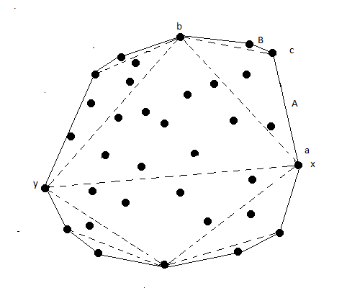

Figure 7: Quick Hull algorithm

Pseudo Code 2.3: Quick Hull Algorithm
Function QuickHull(a,b,S)
if S = ’\0’ then return ()
else
c ← index of point with max distance from ab.
A ← points strictly right of (a,c)
B ← points strictly right of (c,b)
return QuickHull(a,c,A) + (c) + QuickHull(c,b,B)

Complexity
We turn now to an analysis of the time complexity of QuickHull. Finding the initial extremes x and y, and partitioning S into S1 and S2, can be accomplished in O(n) time.
If the time complexity for calling QuickHull with |S|=n is T(n), we can express T recursively for calling QuickHull is T(n) = O(n)+T(α)+T(β).
Consider the best possible case, when each division is as balanced as possible: α = β =n/2. Then we have T(n) = 2T(n/2) +O(n). Therefore we get T(n) = O(nlogn) in the best case.
The worst case occurs when each division is as skewed as possible: α = 0 and β = n-1. Then we get T(n)=T(n-1) +O(n). Repeated expansion shows to be O(n²). So the complexity of Quick Hull is O(n²).

2.5 Divide and Conquer Algorithm

Introduction
Another O(n log n) algorithm, published in 1977 by Preparata and Hong. This algorithm is also applicable to the three dimensional case.
The idea of divide and conquer algorithm is sort the points with respect to x coordinates. After that divide the points into two sets and compute the convex hulls recursively and merge them. The sorting step guarantees the sets A and B will be separated by a vertical line which in turn guarantees that A and B will not overlap. This simplifies the merge step.
All of the work in this divide-and-conquer algorithm resides in the merge step. For this algorithm it is tricky to merge in linear time.
We will use a and b as indices of vertices of A and B respectively, with the vertices of each ordered counterclockwise and numbered from 0. All index arithmetic is modulo the number of vertices in the relevant polygon, so that expressions like a+1 and a-1 can be interpreted as the next and previous around A’s boundary, respectively. The goal is to find two tangent lines, one supporting the two hulls from below, and one supporting from above. From these tangents
conv {A U B} is easily constructed in O(n) time.
Let the lower tangent be T=ab. The idea of Prepatata and Hong is to start T connecting the rightmost point of A to the leftmost point Of B, and then to walk it downwards, first advancing on one hull, then on the other, alternating until the lower tangent is reached. Here is a important thing that a-1 is clockwise on , and b+1 is counterclockwise on B, both representing downwards movements. T = ab is a lower tangent at a if both a-1 and a+1 lie above T: this is equivalent to saying that both of these points are left or on ab. A similar definition holds for lower tangency to B.

Pseudo Code 2.4: divide and conquer Algorithm
sort the points by x coordinate.
divide the points into two sets A and B, A containing the left [n/2] points, and B the right [n/2] points.
compute the convex hulls A = H(A) and B = H(B) recursively.
merge A and B, compute conv{A U B}

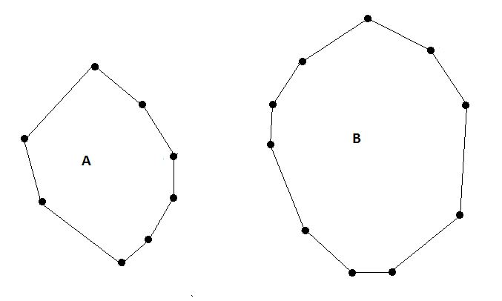

Figure 8: Dividing into two sets

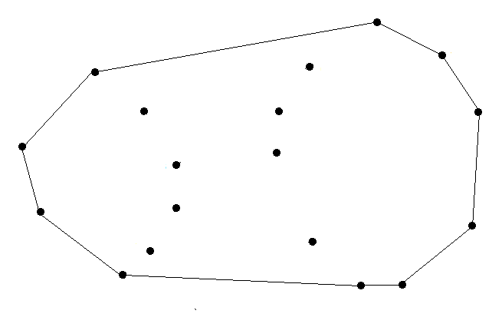

Figure 9: Merge the two sets

Pseudo Code 2.5: Lower Tangent Algorithm
a ← rightmost point of A.
b ← leftmost point of B.
while T =ab not lower tangent to both A and B do
while T not lower tangent to A do
a ← a-1
while T not lower tangent to B do
b ← b+1

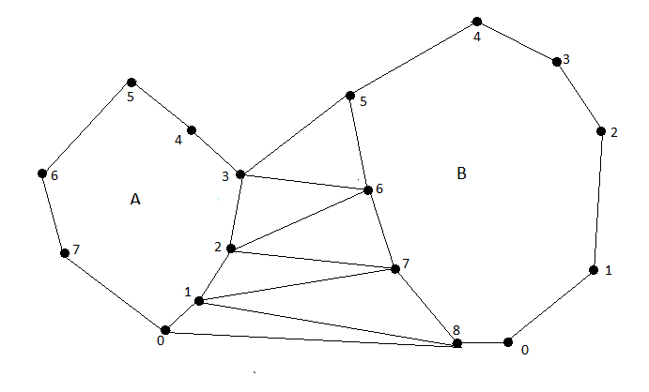

Figure 10: Finding lower tangent from (3,7) to (0,8)
Complexity
Let T(n) be the time complexity of a divide and conquer hull algorithm for n points. If the merge step can be accomplished in linear time, then we have the recurrence relation T(n) = 2T(n/2) + O(n).
The two problems of half size take 2T(n/2) time, and the merge takes O(n) time. So the worst time complexity of this algorithm is O(nlogn).

2.6 Monotone chain Algorithm

Introduction
This algorithm is published by A. M. Andrew in 1979. The Monotone Chain algorithm computes the upper and lower hulls of a monotone chain of points. That’s why it is called MONOTONE CHAIN algorithm.
This algorithm has similarities with Graham scan in using the stack manner. But it sorts the points lexicographically by their coordinates. If in some cases the ordering of points is known then that will be an advantage, because the sorting time is not required. But even if sorting is required, this is a faster sort than the angular Graham-scan sort with its more complicated comparison function.
First the algorithm sorts the point set S= {P0, P1, P2,…., Pn-1} by increasing x and then y coordinate. . Let the minimum and maximum x-coordinates be x_{min} and x_{max}. Clearly P0.x=xmin, but there may be other points with this minimum x-coordinate. Let Pminmin be a point in S with P.x=xmin first and then min y among all those points. Also, let Pminmax be the point with P.x=xmin first and then max y second. Note that Pminmin=Pminmax when there is a unique x-minimum point. Similarly define Pmaxmin and Pmaxmax as the points with P.x=xmax first, and then y min or max second. Again note that Pmaxmin=Pmaxmax when there is a unique x-maximum point(Fig1(a)). Next, join the lower two points, Pminmin and Pmaxmin to define a lower line Lmin. Then join the upper two points Pminmax and Pmaxmax to define the upper line Lmax. These points and lines are shown in the following example diagram:

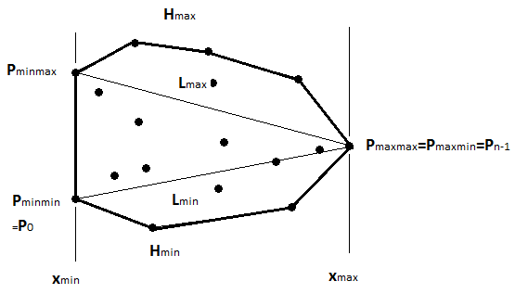 | 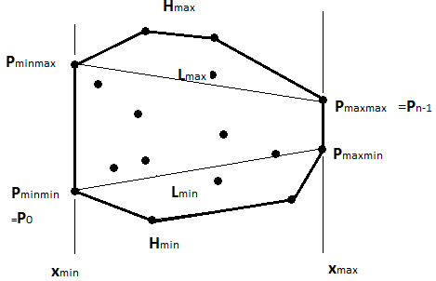
- (b)
figure 11: Monotone chain algorithm

The algorithm now proceeds to construct a lower convex vertex chain Hmin below Lmin and joining the two lower points Pminmin and Pmaxmin; and also an upper convex vertex chain Hmax above Lmax. Then the convex hull H of S is constructed by joining Hmin and Hmax together.
The lower or upper convex chain is constructed using a stack algorithm almost identical to the one used for the Graham scan. For the lower chain, start with Pminmin on the stack. Then process the points of S in sequence. For Hmin, only consider points strictly below the lower line. Suppose that at any stage, the points on the stack are the convex hull of points below Lmin that have already been processed. Now consider the next point P_{k} that is below Lmin. If the stack contains only the one point Pminmin then put P_{k} onto the stack and proceed to the next stage. Otherwise, determine whether P_{k} is strictly left of the line between the top two points on the stack. If it is, put P_{k} onto the stack and proceed. If it is not, pop the top point off the stack, and test P_{k} against the stack again. Continue until P_{k} gets pushed onto the stack. After this stage, the stack again contains the vertices of the lower hull for the points already considered. The geometric rationale is exactly the same as for the Graham scan. After all points have been processed, push Pmaxmin onto the stack to complete the lower convex chain.
The upper convex chain Hmax is constructed in an analogous manner. But, process S in decreasing order{Pn-1,Pn-1,….,P0), starting at Pmaxmax, and only considering points above Lmax. Once the two hull chains have been found, it is easy to join them.

Pseudo Code 2.6: Monotone chain Algorithm
Input: a set S = {P = (P.x,P.y)} of N points
Sort S by increasing x and then y-coordinate.
Let P[] be the sorted array of N points.
Get the points with 1st x min or max and 2nd y min or max
minmin = index of P with min x first and min y second
minmax = index of P with min x first and max y second
maxmin = index of P with max x first and min y second
maxmax = index of P with max x first and max y second
Compute the lower hull stack as follows:
(1) Let L_min be the lower line joining P[minmin] with P[maxmin].
(2) Push P[minmin] onto the stack.
(3) for i = minmax+1 to maxmin-1 (the points between xmin and xmax)
{
if (P[i] is above or on L_min)
Ignore it and continue.
while (there are at least 2 points on the stack)
{
Let PT1 = the top point on the stack.
Let PT2 = the second point on the stack.
if (P[i] is strictly left of the line from PT2 to PT1)
break out of this while loop.
Pop the top point PT1 off the stack.
(4) Push P[maxmin] onto the stack.
Similarly, compute the upper hull stack.
Let H= the join of the lower and upper hulls.
Output: H= the convex hull of S.
=

Complexity
For sorting time complexity is O(n log n).
After that, it only takes O(n) time to compute the hull.

2.7 Conclusion

The Computation of convex hull is one of the first papers in this area. There have been varieties of research to optimization of convex hull algorithms. We have discussed some algorithms above. Except these algorithm there are some algorithms like Incremental algorithm, Chan’s algorithm, Marriage Before Conquest which have the worst case time complexity of O(nlogn).

Chapter 3 Convex Hull Algorithm using Point Elimination

3.1 Introduction

To determine the convex hull of a given problem set at first we will try to minimize the points from which we will have to find the convex hull. If we will be able to remove a huge number of points then the process will be faster. Thus our concept is to try to remove a large number of points from our problem set, which are not definitely hull points. The idea is to find 4 optimal points by forming a quadrilateral, eliminate the points that lie inside quadrilateral. After that find another 4 optimal points by triangulation and do the same.

3.2 Making a Quadrilateral

At first step we will try to find four boundary points, such as:
1. Vertically lowest (bottom-most) point
2. Vertically highest (top-most) point
3. Left-most point
4. Right-most point
Then using these four points we can draw a quadrilateral. To become a convex hull, the nodes inside the quadrilateral boundary can’t be hull boundary points. So we can now avoid these points and remove from the data set to make the algorithm faster.
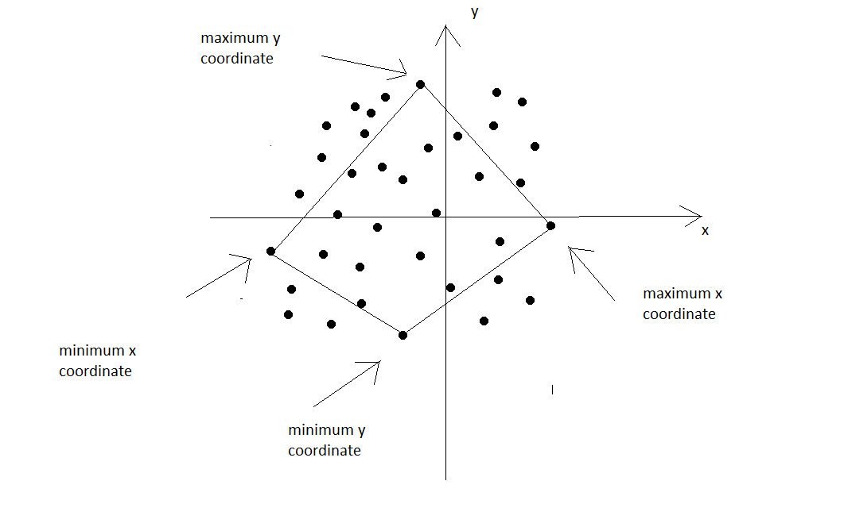

Figure 12: Forming a quadrilateral

To eliminate points in quadrilateral first we add the point to the corner of a quadrilateral. Next we calculate the areas of triangle. If the total summation of areas are not equal to the quadrilateral area then the point is not belong to the quadrilateral. We will use the following formulas-
S=a+b+c ; where a,b,c the sides of triangle.
area of a triangle = sqrt(S(S-a)(S-b)(S-c));
there will be 4 triangles, we assume that triangle areas are area1,area2,area3,area4 and area of a quadrilateral is R.
if(R != (area1+area2+area3+area4))
then the point is not in the quadrilateral.

3.3 Triangulation

We will apply another optimization using triangulation. From the quadrilateral we have got four edges. Using these edges we can draw four triangles. For clear understanding, suppose the top-most and right-most points are two end point of a triangle. Then the furthest point in the top-right side of the connecting line of two existing points is the third end point of a triangle

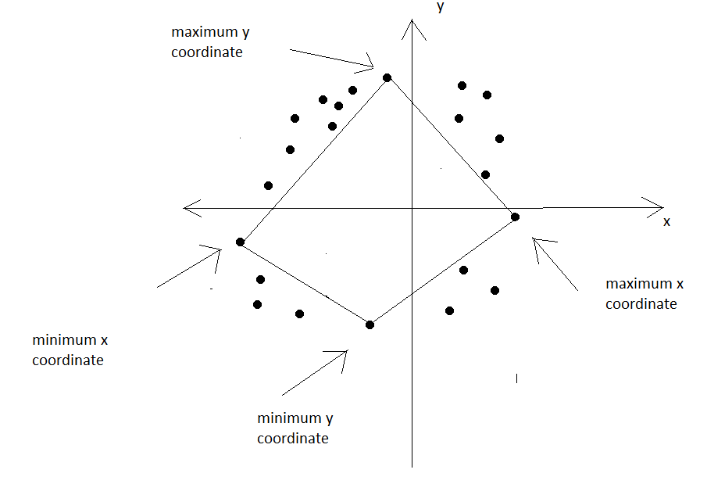

Figure 13: Eliminating Points

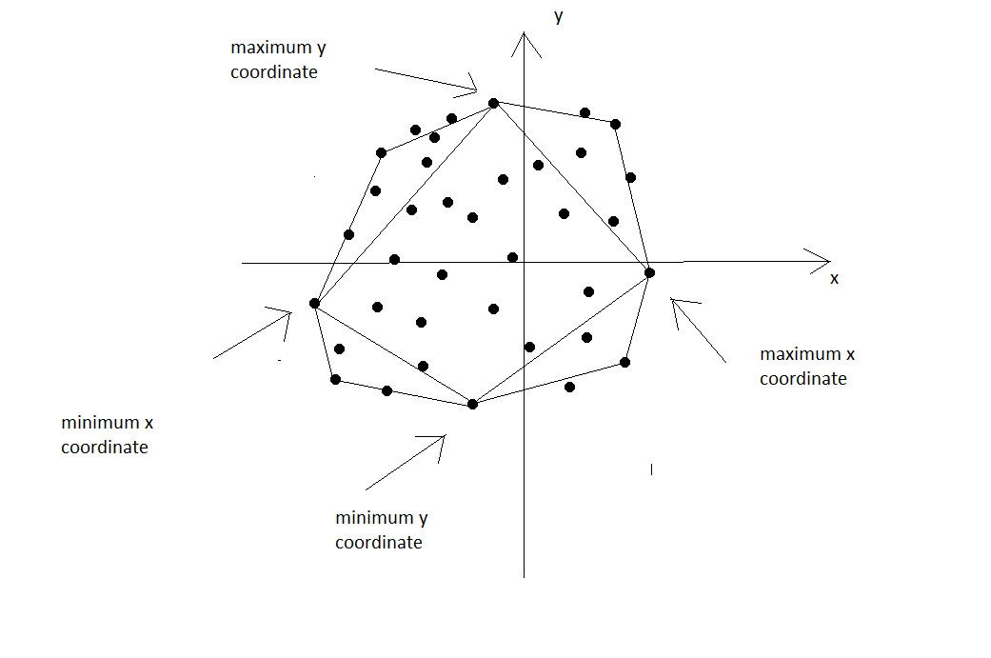
Figure 14: Triangulation

Again to find the furthest point we have calculated the length from the point to the side of the quadrilateral. In such way, from the top-right, top-left, bottom-right, bottom-left regions we will get four triangles. The point inside these four triangles can be said not to lying on hull boundary. Then we can also remove them from consideration.
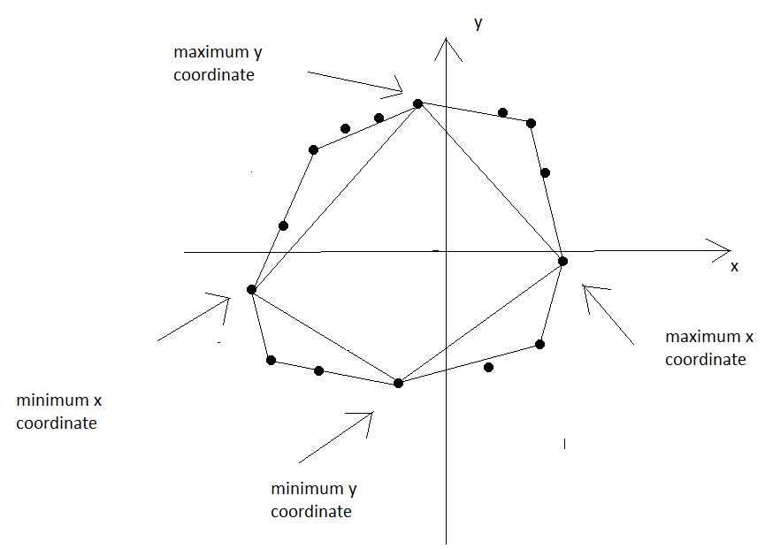

Figure 15: Elimination of points within triangle

At the end we have eight boundary points and some points on boundary or outside the quadrilateral and triangles. Now we can apply any one of the O(nlogn) algorithms for convex hull on rest of the points which should be very few in number heuristically.

3.4 Flow Chart
Start
Initialization
N →is the number of points
V[N] → container of points

Making Quadrilateral
Find Xmin (Point of minimum x co-ordinate)
Find Xmax (Point of maximum x co-ordinate)
Find Ymin (Point of minimum y co-ordinate)
Find Ymax (Point of maximum y co-ordinate)
Make the quadrilateral with these points

Check If the point is inside the quadrilateral
Yes
Eliminate

No No
If all the points are checked

Yes
Triangulation
Find top left point, top right point, bottom left point, bottom right point
Create four triangles with four sides of quadrilateral and the Peak points.

Check If the point is inside the triangles
Eliminate
Yes

No No
If all the points are checked

Yes
Performing Convex Hull Algorithm
After Eliminating those points perform any convex hull algorithm with existing points.

End

3.5 Pseudo Code

Pseudo Code 3.1: Point_Elemination()
1.N = number points
2.V[N]= container of points
3.For i=0 to N-1
Find Xmin with lowest x co-ordinate
Find Xmax with highest x co-ordinate
Find Ymin with lowest y co-ordinate
Find Ymax with highest y co-ordinate
4.quardilateral_area =cal_quardilateral_area(Xmin,Ymin,Xmax,Ymax)
5.For i=0 to N-1
6. If inside_quadrilateral(V[i])=false
7. exist_point[j]=V[i]
8. j=j+1
9.For i=0 to j
10. Find top_left_points[]
11. Find top_right_points[]
12. Find bottom_right_points[]
13. Find bottom_left_points[]
14.top_left_p = get_peak_point(top_left_points,Xmin,Ymax)
15.top_right_p = get_peak_point(top_right_points,Ymax,Xmax)
16.bottom_right_p = get_peak_point(bottom_right_points,Xmax,Ymin)
17.bottom_left_p = get_peak_point(bottom_left_points,Ymin,Xmin)
18.Final_points[p]=container of 8 peak points
19.For i=0 to top_left_points.size()
20. If top_left_points[i] is not inside triangle
21. Final_points[p]=top_left_points[i]
22. p:=p+1
23.For i=0 to top_right_points.size()
24. If top_right_points[i] is not inside triangle
25. Final_points[p]=top_right_points[i]
26. p:=p+1
27.For i=0 to bottom_right_points.size()
28. If bottom_right_points[i] is not inside triangle
29. Final_points[p]=bottom_right_points[i]
30. p:=p+1
31.For i=0 to bottom_left_points.size()
32. If bottom_left_points[i] is not inside triangle
33. Final_points[p]=bottom_left_points[i]
34. p:=p+1
35.set Ymin as Final_points[0]
36.Sort Final_points[p] with polar angle.
37.Let S be and empty stack
38.Push(final_points[0],S)
39.Push(final_points[1],S)
40.For i=2 to Final_points.size()
41. While (S.size>=2)
42. Mid=Top(S)
43. Pop(S)
44. First=Top(S)
45. If check(First,Mid,final_points[i])>=0

46. Push(Mid,S);
47. Push(final_points[i],S);
48. break;
49. End IF
50. End While loop
51.End For loop
52.return S

Pseudo Code 3.2 : Function cal_quardilateral_area(Xmin,Ymin,Xmax,Ymax)
1. top_left_side=distance(Xmin,Ymax)
2. top_right_side= distance(Xmax,Ymax)
3. bottom_right_side= distance(Xmax,Ymin)
4. bottom_left_side= distance(Xmin,Ymin)
5. corner= distance(Ymin,Ymax)
6. area1=cal_triangle_area(top_left_side,bottom_left_side,corner)
7. area2=cal_triangle_area(top_right_side,bottom_right_side,corner)
8. return area1+area2

Pseudo Code 3.3 : Function inside_quadrilateral(A)

#calculate the four triangles those are formed by four points of quadrilateral
1. area1= cal_traingle_area(A_to_Xmin,A_to_Ymax,Xmin_to_Ymax)
2. area2= cal_traingle_area(A_to_Xmax,A_to_Ymax,Xmax_to_Ymax)
3. area3= cal_traingle_area(A_to_Xmax,A_to_Ymin,Xmax_to_Ymin)
4. area4= cal_traingle_area(A_to_Xmin,A_to_Ymin,Xmin_to_Ymin) #comparing with quadrilateral area if the point inside the quadrilateral it will return true otherwise it will return false

5. If area1+area2+area3+area4 > quadrilateral_area
6. return false
7. Else
8. return true

Pseudo Code 3.4 : Function get_peak_points(top_points[],A,B)
#function of picking the top and bottom corner points
1. Line= make_straight_line (A,B)
2. Max=-1;
3. For i=1 to top_points.size()
4. Dist=distance_from_line_to_point(top_points[i],line)
5. If Dist>Max
6. Max=Dist
7. Top_point= top_points[i];
8. return Top_point

Pseudo Code 3.5 : Function inside_triangle(P,X,Y,Z,side1,side2,side3,triangle_area)
1. A=distance(X,P)
2. B=distance(Y,P)
3. C=distance(Z,P)
4. area1=cal_triangle_area(A,C,side1)
5. area2=cal_triangle_area(C,B,side2)
6. area3=cal_triangle_area(A,B,side3)
7. If area1+area2+area3 > triangle_area
8. return false
9. Else
10. return true

Pseudo Code 3.6 : Function distance_from_line_to_point(P,line)
1. return ((line.A*point.x+line.B*point.y+line.C)/line.SQ);

Pseudo Code 3.7 : Function make_straight_line(P,Q)
1. tmp.C=-(P.y-Q.y)*P.x+(P.x-Q.x)*P.y;
2. tmp.A=(P.y-Q.y);
3. tmp.B=(Q.x-P.x);
4. tmp.SQ=sqrt(tmp.A*tmp.A+tmp.B*tmp.B);
5. return tmp

Pseudo Code 3.8 : Function check(A,B,C)
1. res=A.x*B.y-A.y*B.x+B.x*C.y-B.y*C.x+C.x*A.y-C.y*A.x;
2. If res<0
3. return -1;
4. If res>0
5. return 1;
6. Else
7. return 0;

Pseudo Code 3.9 : Function compare(Point A,Point B)
1. If check(Ymin,A,B)==0
2. return dist(Ymin,A)<dist(Ymin,B);
3. dx1=A.x-Ymin.x,dy1=A.y-Ymin.y;
4. dx2=B.x-Ymin.x,dy2=B.y-Ymin.y;
5. return dy1*dx2<dy2*dx1;

3.6 Complexity Analysis

To find the four optimum /boundary points we need O(n). To eliminate the points inside quadrilateral we need O(4n).
Now, input set is reduced, n will be much less than the number of input points at the beginning . Suppose n>>m. For triangulation we need O(4*(m/4)) that means O(m). To eliminate the points inside triangle O(3m).
Again m is reduced. Suppose m>>p.
To perform graham scan or divide and conquer we need O(plgp).
Finally, overall complexity= O(5n)+O(4m)+O(plgp) which is assumed to be optimized heuristically.

Chapter 4 Result and Discussion

Introduction
We have implemented this in C/C++ both graphical and manual way. For better understanding and making a clear view we have used 2D graphics with help of graphics.h header file.
4.1 Graphical Representation
Here some images of the output of out preprocessing step. Which gives a clear view of the steps of our modification.

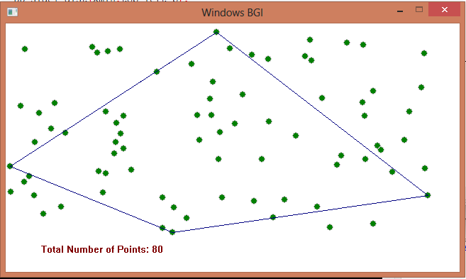
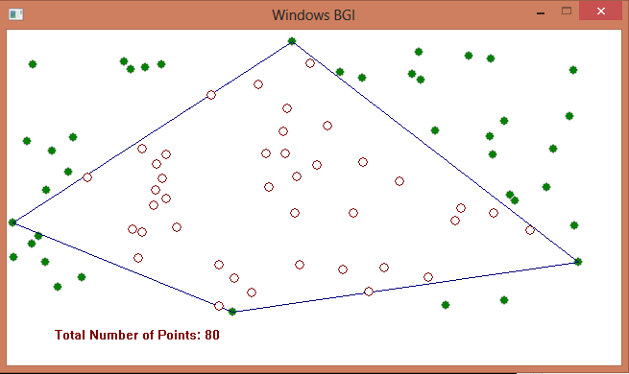
(a) (b)

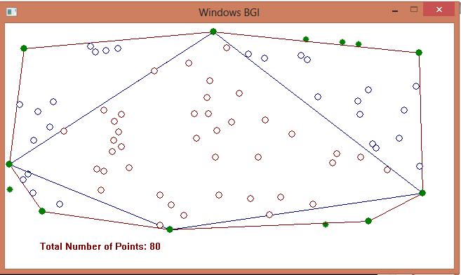
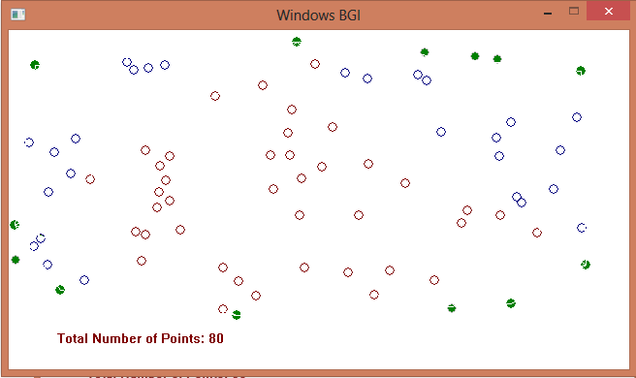
(c) (d)

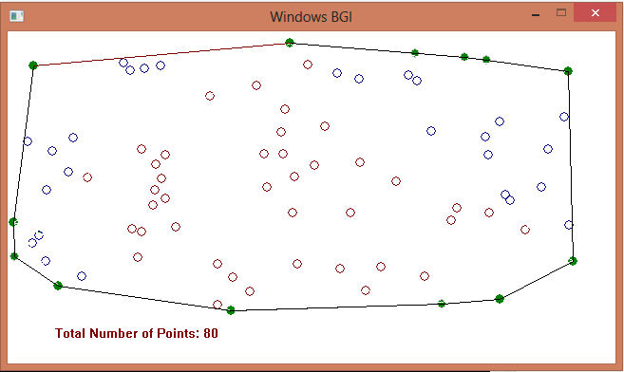
(e)

Figure 16: Output image of our Implementation

Here a point is represented by a circle. Blank circles represent the points that are eliminated. The points are generated by random number that is why it is generated uniformly.

4.2 Comparison Table
We have also prepare time comparison between our approach and Graham’s Scan. We have generated random numbers within the range of -10⁹ to 10⁹ and calculated the time for several number of inputs.
Table 1.1: Comparion Table
Input Size | Our Modification | Graham Scan’s Algorithm
100 | 0.00000 Sec | 0.00000 Sec
10000 | 0.03100 Sec | 0.04600 Sec
100000 | 0.42200 Sec | 0.67000 Sec
1000000 | 4.69600 Sec | 8.22100 Sec

Here we can see for higher input size it shows better performance. It is because the numbers are generated evenly. So there are large number of points are eliminated.

Chapter 5 Conclusion and Future Work

5.1 Achievement

If the majority of the points are lying on the quadrilateral or the triangles, our modification will reduce the complexity of any O (nlogn). Especially for number of points greater than 10⁵ it will show better performance.

5.2 Limitation

Although our solution shows better performance in larger input but it will show worse performance in input size of 100 or if the majority of points lie on the boundary of a polygon due to extra checking for point elimination.

5.3 Conclusion

Traditional Graham’s Scan Algorithm is good enough for input size about 100 or 1000 but our concern is huge input like 10^5. Our optimization totally depends on input pattern. If the points are scattered and dense it will show best performance with time complexity close to O (n) heuristically.

REFERENCES
[1] Thomas H. Cormen, Charles E. Leiserson, Ronald L.Rivest, Clifford Stein 3rd Edition (2010-2011). INTRODUCTION TO ALGORITHM. December 12,2012
[2] Joseph O’Rourke 2ND Editon. COMPUTATIONAL GEOMETRY IN C. December 17,2012
[3] Mary M. McQUEEN and Godfried T. TOUSSAINT, On the ultimate convex hull algorithm in practice. January 01, 2013
[4] Graham, R.L. (1972). An Efficient Algorithm for Determining the Convex Hull of a Finite Planar Set. Information Processing Letters 1, 132-133. January 12 2013
[5] McConnell, Jeffrey J. (2006), Computer Graphics: Theory Into Practice, p. 130, ISBN 0-7637-2250-2, December 22, 2012
[6] A. Jarvis, On the identification of the convex hull of a finite set of points in the plane, Information Processing Letters 2 (1973) 18–21. February 21, 2013
[7] F. P. Preparata, S. J. Hong, Convex hulls of finite point sets in two and three dimensions, Communications of the ACM 2 (20) (1977) 87–93.Febraury 24, 2013
[8] R. Wenger, Randomized quick hull, Algorithmica 17 (1997) 322–329. March 02, 2013
[9] Herv´e Br¨onnimann, John Iacono, Jyrki Katajainen, Pat Morin, Jason Morrison and Godfried Toussaint. Space-Efficient Planar Convex Hull Algorithms (2007-08). March 12, 2013
[10] D. G. Kirkpatrick and R. Seidel. The ultimate planar con vex hull algorithm.SIAM J. Comput., 15(1):287–299, 1986. March 16, 2013
[11] T. M. Chan. Dynamic planar convex hull operations in near-logarithmic amortized time. Journal of the ACM, 48(1):1–12. May 02, 2013.
[12] Gerth Stølting Brodal, Riko Jacob. Dynamic Planar Convex Hull. May 21, 2013
[13] K. H., R. Tarjan, and T. K. Faster kinetic heaps and their use in broadcast scheduling. In Proc. 12th ACM-SIAM Sympo-sium on Discrete Algorithms, pages 836–844, 2001. April 13, 2013
[14] A. M. Andrew. Another efficient algorithm for convex hulls in two dimensions. Information Processing Letters,9(5):216–219, 1979. April 24 2013
[15] C. Bajaj and M.-S. Kim. Convex Hulls of Objects Bounded by Algebraic Curves Algorithmica,Vol. 6, pp. 533{553, 1991. May 18, 2013
[16] M. do Carmo. Dierential Geometry of Curves and Surfaces.Prentice-Hall, 1976. April 19, 2013
[17] D. Dobkin and D. Souvaine. Computational Geometry in a Curved World.Algorith-mica,Vol. 5, No. 3, pp. 421{457, 1990. June 01, 2013
[18] D.T. Lee. On Finding the Convex Hull of a Simple Polygon. Int'l J. Computer and Information Sciences,Vol. 12, No. 2, pp. 87{98, 1983. May 29, 2013
[19] E. Sherbrooke and N. Patrikalakis. Computation of The Solutions of Nonlinear Polyno-mial Systems.Computer AidedGeometric Design,Vol 10, No 5, pp 379. April 27, 2013
[20] M. H. Overmars and J. van Leeuwen. Maintenance of con-figurations in the plane. J. Comput. System Sci., 23(2):166–204, 1981. December 30, 2012
[21] Yao, A.C. (1981). A lower bound to finding convex hulls. Journal of the ACM 28, 780-789. February 18, 2013
[22] Bentley, J.L. and M.I. Shamos (1978). Divide and conquer for linear expected time. Information Processing Letters 7, 87-91. March 10, 2013
[23] http://en.wikipedia.org/convexhull, April 18, 2013
[24] http://www.personal.kent.edu/~rmuhamma/Compgeometry, April 20, 2013
[25] http://en.wikipedia.org/grahamscan, May 11, 2013
[26] http://www.topcoder.com/tc, June 06, 2013

Source Code:
#define FOR(i,k,n) for(int i=k;i<n;i++)
#define REP(i,k,n) for(int i=k;i<=n;i++)
#define PB push_back
#define EPS 1e-9
#define MP make_pair
using namespace std;
typedef double DD;
DD quardiliteral_area;
DD top_left_side;
DD top_right_side;
DD bottom_right_side;
DD bottom_left_side;
DD corner;
int N;
struct Point
{
DD x,y;
};
struct Line_Info
{
DD A,B,C,SQ;
};
stack<Point>ST;
vector<Point>V;
vector<Point>exist_point;
vector<Point>top_left_points;
vector<Point>top_right_points;
vector<Point>bottom_left_points;
vector<Point>bottom_right_points;
vector<Point>final_points;
map<pair<int,int>,bool>M;
Point Xmin,Ymin,Xmax,Ymax;
bool operator !=(Point A,Point B)
{
if(A.x!=B.x || A.y!=B.y) return true;
return false;

}
ostream &operator <<(ostream &out,Point &P)
{
out<<P.x<<" "<<P.y;
return out;
}
istream &operator >>(istream &in,Point &P)
{
in>>P.x>>P.y;
return in;
}
DD dist(Point A,Point B)
{
return sqrt((A.x-B.x)*(A.x-B.x)+(A.y-B.y)*(A.y-B.y));
}
DD cal_triangle_area(DD a,DD b,DD c)
{
DD s=(a+b+c)/2;
return sqrt(s*(s-a)*(s-b)*(s-c));
}

bool inside_quadriliteral(Point A)
{
DD up=dist(Ymax,A);
DD down=dist(Ymin,A);
DD left=dist(Xmin,A);
DD right=dist(Xmax,A);
DD area1=cal_triangle_area(up,left,top_left_side);
DD area2=cal_triangle_area(up,right,top_right_side);
DD area3=cal_triangle_area(down,right,bottom_right_side);
DD area4=cal_triangle_area(down,left,bottom_left_side);

if((area1+area2+area3+area4)>(quardiliteral_area+EPS)) return false;
return true;
}
DD cal_quardiliteral_area(Point Xmin,Point Ymax,Point Xmax,Point Ymin)
{

top_left_side=dist(Xmin,Ymax);
top_right_side=dist(Xmax,Ymax);
bottom_right_side=dist(Xmax,Ymin);
bottom_left_side=dist(Xmin,Ymin);
corner=dist(Ymin,Ymax);

DD area1=cal_triangle_area(top_left_side,bottom_left_side,corner);
DD area2=cal_triangle_area(top_right_side,bottom_right_side,corner);

return area1+area2;

}

DD dist_from_line_to_point(Point point,Line_Info line)
{
return ((line.A*point.x+line.B*point.y+line.C)/line.SQ);
}
Line_Info make_straight_line(Point P,Point Q)
{
Line_Info tmp;
tmp.C=-(P.y-Q.y)*P.x+(P.x-Q.x)*P.y;
tmp.A=(P.y-Q.y);
tmp.B=(Q.x-P.x);
tmp.SQ=sqrt(tmp.A*tmp.A+tmp.B*tmp.B);
return tmp;
}
Point get_peak_point(vector<Point>top_points,Point A,Point B)
{
Line_Info get_line_info=make_straight_line(A,B);
DD mx=-(1<<31-1);
Point top_p;
FOR(i,0,top_points.size())
{
DD DIST=dist_from_line_to_point(top_points[i],get_line_info);
if( DIST> mx+EPS)
{ top_p=top_points[i];
mx=DIST; }

}
return top_p;
}
bool inside_triangle(Point P,Point X,Point Y,Point Z,DD side1,DD side2,DD side3,DD triangle_area)
{
DD A=dist(X,P);
DD B=dist(Y,P);
DD C=dist(Z,P);
DD area1=cal_triangle_area(A,C,side1);
DD area2=cal_triangle_area(C,B,side2);
DD area3=cal_triangle_area(A,B,side3);
if((area1+area2+area3)>(triangle_area+EPS)) return false;
return true;
}
int check(Point A,Point B,Point C)
{
DD res=A.x*B.y-A.y*B.x+B.x*C.y-B.y*C.x+C.x*A.y-C.y*A.x;
if(res<0)return -1;
if(res>0)return 1;
return 0;
}
bool compare(Point A,Point B)
{
if(check(Ymin,A,B)==0)return dist(Ymin,A)<dist(Ymin,B);
DD dx1=A.x-Ymin.x,dy1=A.y-Ymin.y;
DD dx2=B.x-Ymin.x,dy2=B.y-Ymin.y;
return dy1*dx2<dy2*dx1;}
int main()
{
Point temp,p;
Line_Info get_line_info;
int a=1,b=1;
cout<<"Enter number of points ";
cin>>N;
FOR(i,0,N)
{
temp.x=rand()%1000000000;
temp.y=rand()%1000000000;
if(M[MP(temp.x,temp.y)]==false)
{
V.PB(temp);
M[MP(temp.x,temp.y)]=true;
}

}
clock_t t1,t2;
t1=clock();
Xmin.x=1000000001;
Xmax.x=-1000000001;
Ymin.y=1000000001;
Ymax.y=-1000000001;

FOR(i,0,N)
{
if(V[i].x<Xmin.x)
{ Xmin=V[i];}
if(V[i].x>Xmax.x)
{Xmax=V[i];}
if(V[i].y<Ymin.y)
{Ymin=V[i];}
if(V[i].y>Ymax.y)
{ Ymax=V[i];}
}
final_points.PB(Ymin);
final_points.PB(Xmin);
final_points.PB(Xmax);
final_points.PB(Ymax);
quardiliteral_area=cal_quardiliteral_area(Xmin,Ymax,Xmax,Ymin);
FOR(i,0,N)
{
if(Xmin!=V[i] && Xmax!=V[i] && Ymin!=V[i] && Ymax!=V[i])
{
if(!inside_quadriliteral(V[i]))
{
exist_point.PB(V[i]);
}
}
}
FOR(i,0,exist_point.size())
{
if(exist_point[i].x<Ymax.x && exist_point[i].y>Xmin.y)
{
top_left_points.PB(exist_point[i]);
} else if(exist_point[i].x>Ymax.x && exist_point[i].y>Xmax.y)
{
top_right_points.PB(exist_point[i]);
}
else if(exist_point[i].x>Ymin.x && exist_point[i].y<Xmax.y)
{
bottom_right_points.PB(exist_point[i]);
}
else if(exist_point[i].x<Ymin.x && exist_point[i].y<Xmin.y)
{
bottom_left_points.PB(exist_point[i]);
}
}
Point top_left_p,top_right_p,bottom_right_p,bottom_left_p;
if(!top_left_points.empty())
{
top_left_p=get_peak_point(top_left_points,Xmin,Ymax);
final_points.PB(top_left_p);
}

if(!top_right_points.empty())
{ top_right_p=get_peak_point(top_right_points,Ymax,Xmax);
final_points.PB(top_right_p);
}
if(!bottom_right_points.empty())
{
bottom_right_p=get_peak_point(bottom_right_points,Xmax,Ymin);
final_points.PB(bottom_right_p);
}
if(!bottom_left_points.empty())
{
bottom_left_p=get_peak_point(bottom_left_points,Ymin,Xmin);
final_points.PB(bottom_left_p);
}
DD side1=dist(Xmin,top_left_p);
DD side2=dist(Ymax,top_left_p);
DD tri_area=cal_triangle_area(side1,side2,top_left_side);
FOR(i,0,top_left_points.size())
{
if(!inside_triangle(top_left_points[i],Xmin,Ymax,top_left_p,side1,side2,top_left_side,tri_area))
{
final_points.PB(top_left_points[i]);
}

}

//top right
side1=dist(Xmax,top_right_p);
side2=dist(Ymax,top_right_p);
tri_area=cal_triangle_area(side1,side2,top_right_side);
FOR(i,0,top_right_points.size())
{ if(!inside_triangle(top_right_points[i],Xmax,Ymax,top_right_p,side1,side2,top_right_side,tri_area))
{
final_points.PB(top_right_points[i]);
}

}
// bottom right
side1=dist(Xmax,bottom_right_p);
side2=dist(Ymin,bottom_right_p);
tri_area=cal_triangle_area(side1,side2,bottom_right_side);
FOR(i,0,bottom_right_points.size())
{ if(!inside_triangle(bottom_right_points[i],Xmax,Ymin,bottom_right_p,side1,side2,bottom_right_side,tri_area))
{
final_points.PB(bottom_right_points[i]); }}

//bottom left
side1=dist(Xmin,bottom_left_p);
side2=dist(Ymin,bottom_left_p);
tri_area=cal_triangle_area(side1,side2,bottom_left_side);
FOR(i,0,bottom_left_points.size())
{ if(!inside_triangle(bottom_left_points[i],Xmin,Ymin,bottom_left_p,side1,side2,bottom_left_side,tri_area))
{
final_points.PB(bottom_left_points[i]);
}

}
sort(++final_points.begin(),final_points.end(),compare);
Point First,Mid;
ST.push(final_points[0]);
ST.push(final_points[1]);
N=final_points.size();
FOR(i,2,N)
{
while(ST.size()>=2)
{
Mid=ST.top();
ST.pop();
First=ST.top();
if(check(First,Mid,final_points[i])>=0)
{
ST.push(Mid);
ST.push(final_points[i]);
break;
}
}
}
cout<<"Stack size "<<ST.size()<<endl;
t2=clock();
DD tm=(DD)t2-(DD)t1;
printf("%.10lf Sec",(tm/CLOCKS_PER_SEC)+EPS);
//cout<<tm/CLOCKS_PER_SEC<<" Sec"<<endl;
system("pause");
return 0;
}

