Product Design
Team 11, SSAD56
Aanshul Sadaria
Krutam Hathi
Shovan Swain

Design Model
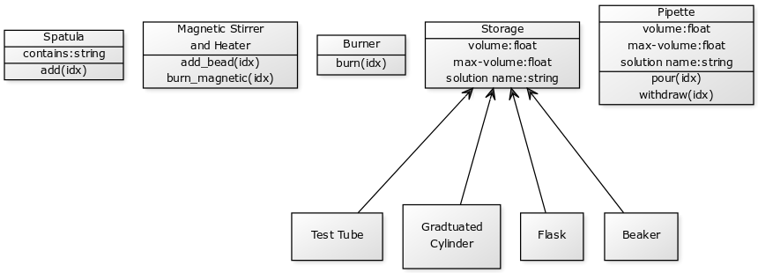
Class Name | Class State and Behaviour
draggable | Class state:  1) All HTML elements under this tag can be dragged and dropped by the user.  2) Basically all the lab apparatus come under this class.  3) It’s properties include the x and y co-ordinate of the object.  Class behaviour:  1) The ‘draggable’ elements can be dragged and dropped by the user.  2) Two or more ‘draggable’ elements can be made to interact with each other.
Pipette | Class state:  1) All different “Pipette” objects fall under this class  2) It’s properties include the solution name, max-volume, volume.  Class behavior  1)The ‘pipette’ elements can interact with ‘Storage” elements.  2) Two kind of interactions, ‘pour’ and ‘withdraw’ are possible.
Burner | Class state:  1) All different “Burner” objects fall under this class.  Class Behaviour:  1) The ‘burner’ elements can interact with “Storage” elements.  2) There is only one kind of interaction, “burn” which heats the contents of the container at a constant rate of 500kJ/s
Storage | Class State:  1) All different “Storage” apparatus falls under this class.  2) Their properties include solution name, max-volume, volume.
.

Sequence Diagram(s)
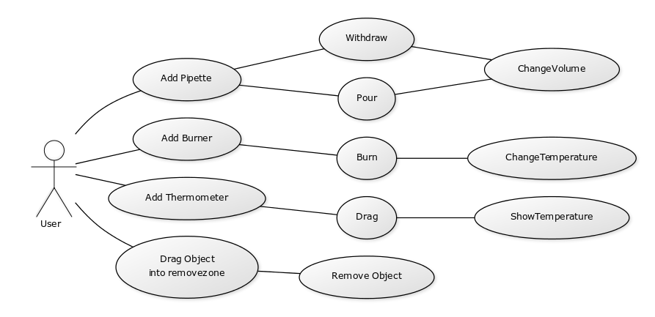

Design Rationale
1) Methods for the same class had no distinction. This caused a problem as there may be different instances of the class trying to perform the same method but with a different output.
So the solution was to send the unique “id” of the instance object as an argument to the method so that it gives different output to the different instances.
2) To maintain the apparatus’ properties, I used variables in the JS file I.e method itself. But this had the issue that another apparatus could come and overwrite the previous data.
So the solution was to maintain data-attributes within the HTML tag of the object itself so that every instance has its own separate properties.
3) On burning an apparatus, I used to immediately call the function “cool” which would simultaneously cool the apparatus. But in this approach, on heating the apparatus a second time, It would call “cool” again and cool twice as fast.
So the solution was to call an instance of “cool” the moment the object is brought onto the table. This obviously meant I had to remove the function call to “cool” I was doing right after calling “burn”
4) In the earlier stages, each object’s method file just had a bunch of methods. To call them, I wrote down function calls in the HTML div itself. This was bad design.
So to fix this, I called only one parent function from each object. This parent function takes care of calling all further functions and making basic changes in the view accordingly. This eased up the function calling and debugging process a lot.

