**GIARA B. LIM**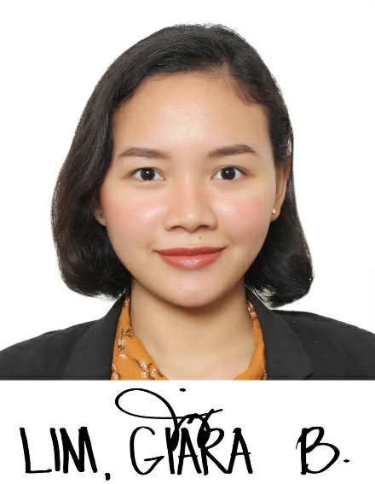

Brgy. 23 Burgos Street TACLOBAN City

Contact No. 09484578449

Email: [giaralim1501229@gmail.com](mailto:giaralim1501229@gmail.com)



**OBJECTIVE**

Goal-oriented and well organized seeking for job in field of teaching in primary or nursery education. To hone my skills, to be learn and to build a harmonious relationship with co- teachers.



**PERSONAL DATA**

Place of Birth: Tacloban City

Date of Birth: November 6,1996

Age: 25 years’ old

Sex: Female

Civil Status: Single

Nationality: Filipino

Height: 5’ ft

Weight: 49 kg

Religion: Roman Catholic



**EDUCATIONAL ATTAINMENT**

**Tertiary Education** Bachelor of Elementary Education -CONTENT

Leyte Normal University

Tacloban City, Leyte

June 2015- MAY 2019

**Secondary Education** Leyte National High School

Tacloban City

June 2011 – April 2015

**Primary Education** Kapangian Central School

Tacloban City

June 2005- March 2011



**PERSONAL QUALIFICATIONS**

* Licensure Examination for Teachers (LET PASSER 2019)
* Interpersonal skills
* Computer literate
* Good communication skills
* Excellent in handling diverese learners



**SKILLS/INTEREST**

* Superb verbal communication skills when teaching pupils.
* Excellent in adapting the changes in work place, environment and in development of others.
* Commit in recognizing and assessing workmates and supervisors’ progress.



**TEACHING EXPERIENCE**

**Teacher Adviser-** SNEC- Sto. Niño Educational Center August 2019-2021

* Teacher adviser both grade four and Kindergarten classes.
* Adviser of Grade four pupils.

Taught subjects (MATH, SCIENCE EDUKASYON sa PAGPAPAKATAO and MAPEH).

* Adviser of KINDERGARTEN with 16 pupils in class. Teaches not only skills and subjects but disciplines and self-grooming



**TRAININGS / SEMINARS**

* MELC'S Based Quarter 3 Cum Contexualization of Self- Learning Materials (March 18, 2021
* 10 Days Basic Computer Literacy Training

JE Mondejar Computer College (February 28– MARCH 12, 2020

* Diwa innovation workshop for educators

Hotel Alejandro, Tacloban City (JANUARY 25, 2020)

* Philippine Association for Teachers and Educators Region VIII

Leyte Normal University (February 23, 2019

* Seminar workshop in mother tongue based multilingual education

Leyte normal university (2017)



**CHARACTER REFERRENCES**

1. **PROF. JOCELYN BAYRANTE**

Coordinator, Student Teaching (BEED)

Leyte Normal University

Tacloban City

Tel. No. 321-2170/321-3175

1. **MARINA C. LABATOS**

Teacher- Adviser

San Fernando Central School

Tacloban City

09079920292

GIARA B. LIM

Applicant