**Software**

The following software listed in the table below plays a vital role in the development phase of the system in order to successfully build and compile all the necessary tech that will be used for the system features and management.

**Table 1.** *Software that will be used for the Insert title of the study here.*

|  |  |
| --- | --- |
| Software | Description |
| Laravel | Laravel is a PHP framework used as a Back end as a Service (BaaS) for the developed system. APIs will be created and will communicate to the database. |
| VueJS | A javascript progressive framework used to create user interface or for the front-end. |
| React Native  MySql | React Native is an open-source UI software framework created by Meta Platforms, Inc. It is used to develop applications for Android, Android TV, iOS, macOS, tvOS, Web, Windows and UWP by enabling developers to use the React framework along with native platform capabilities.  A relational database for storing systems data. |

Laravel is a free, open-source PHP web framework created by Taylor Otwell and is intended to develop web applications. This framework is used as a Back-end as a Service (BaaS) for the Imarket System. This helps us quickly create scalable and more manageable back-end APIs for the system.

*VueJS* is a progressive javascript framework for creating a user interface or front end. This lets you create components and layouts easily that can be used throughout the system. This is used to create the front end or the user interface of our system and connects to our APIs from the back-end server, the Laravel, thus returning JavaScript Object Notation (JSON) data.

*React Native* is a JavaScript framework for writing real, natively rendering mobile applications for iOS and Android. It’s based on React, Facebook’s JavaScript library for building user interfaces, but instead of targeting the browser, it targets mobile platforms. In other words: web developers can now write mobile applications that look and feel truly “native,” all from the comfort of a JavaScript library that we already know and love. Plus, because most of the code you write can be shared between platforms, React Native makes it easy to simultaneously develop for both Android and iOS.

*MySQL* is indeed not the only (R)DBMS on the market, but it is one of the most popular ones and only second to Oracle Database when scored using critical parameters like the number of mentions in search results, professional profiles on LinkedIn, and frequency of technical discussions on internet forums.

**Hardware**

The development of the system needs to meet all of the requirements. Hardware used in the development is listed in the table below; these are the primary devices to use the system and display the output.

**Table 2.** *Hardware that will be used for the Insert Title of your study here*

|  |  |
| --- | --- |
| Hardware | Description |
| Smartphone | Any mobile device to test for the development of the application for mobile platforms. |
| Personal Computer/Laptop | Hardware that would be used to build and display the system's output. |

*A smartphone* would be the hardware for testing the system's features like detecting the user's exact location as it has GPS unlike a desktop itself.

*Personal Computer/Laptop*would be the hardware for building and developing the system. This is the primary device to display the output of the system.

**Peopleware**

Everyone can use the IMarket Application. The end-users of this system can order their own set of items from the market and be delivered on their doorstep.

Specifically, these users are the following:

* *Persons* who would like to buy in the market can use the system. It displays all the available options for the user and can make its order.
* *Delivery Rider* are the ones who will deliver the order of the persons who ordered through this system.
* *Market Seller* are the ones who gets in partnership with the owner of the application and thus have the capability to sell its product on the platform.
* *The System Administrator or the Super Admin* is the one who has complete control of the system. They can manage data, users, and system permission; they are also responsible for the validation of accounts registered.

Chapter IV

**Methodology**

This chapter discusses the methods used to conduct this research. This includes the program considerations, requirements, and specifications. It also discussed the procedures done by the researchers during the pre-development and post-development process of the proposed system.

**Systems Design**

**Systems Development Life Cycle Processes**

The Iterative Waterfall Model was utilized in this research as the SDLC model. This model allows the development team to return to the previous phase and adjust requirements and, if necessary, some modifications. Developers can go back into prior phases of development to make any alterations or changes in this model. This is possible because every phase in this model has a feedback channel. The development team may always go back to prior phases and make the necessary adjustments, regardless of their working phase (Sharma, 2019). The Iterative Waterfall Model is very simple to understand and use. That is why it is one of the most widely used software development models. This model is ideal for this project because the developers can divide the project into small parts. Therefore, any errors in the current phase will be detected early on, and the team can immediately solve this problem. There may be instances that some requirements might change, and some improvements need to be made. In this case, it will not be a problem for the developers to commit these changes because this model allows that process to happen. **(Rephrase nala ini nyo kay bangn masabtan ni sir)**

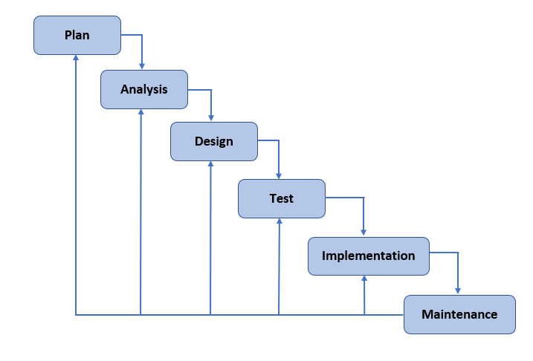

**Figure 1.** *System’s Development Life Cycle (Iterative Waterfall Model)*

Planning

In this initial phase that starts the cycle, the researchers gathered some data as to what could be possibly made to ease the problem of the persons who wakes up early in the morning to buy in the market. The researchers also created a wireframe or low fidelity prototype using Figma to visualize what could be the functions for the system.

The proposed system is an IMarket which stands for Internet Market that helps the persons who usually goes to the market to just stay and make an order on the platform and their order will be delivered right away. The group needs a computer with at least 8GB of RAM, Intel i3 8th Generation processor, and higher to start developing the system and any mobile device for testing out the mobile application. It has Windows 10 or higher operating system and a functional mobile device. There is no expenditure on the system development unless one of the said requirements is inadequate in the group because the development of the system cannot be started.

Analysis

In this phase, the proponents gathered data regarding the proposed technology, coming up with solutions that can cover the gaps presented in this paper. Information that was gathered was analyzed in order to facilitate better decision-making. In line with the suggestions given by the respondents, the proponents were able to obtain better ideas that can be implemented to the proposed system.

Design

In designing the system, the researchers converted their low fidelity prototype into a high-fidelity design considering it to be user-friendly, which the end-users can use efficiently. It is designed to use modern user interfaces, minimal and responsive design.

These system design specifications are achieved through developing it using VueJS as the front-end technology for the web application, which is used to create user interfaces because of its progressive framework, and Laravel as its backend technology which is a PHP framework. For the mobile application, React Native is used to ensure the native feature for the application developed.

Testing

In this phase, the developer will ensure the developed web application and mobile application to be as bug free. The researchers will manually test all features and write down any bugs or problems encountered during testing and will be forwarded to the developers.

Implementation

In this phase, the developers will be conducting the necessary tests to ensure the system quality before deploying it to be available for the end-users. Once the proposed system meets the expected results set by the researcher based on the respondent's feedback, the proposed system will then be available for deployment. The proposed system will be deployed in a Virtual Private Server to have a centralized database for the mobile application and web application.

Maintenance

After the system is deployed, the end-users will access it and explore the different features it can offer. Following would be the system evaluation, where the researchers will be conducting a follow-up survey to the end-users and evaluate the outcome of the system. If needed, the developers will update the system according to the end-users feedback.