四个页面效果参看：
http://www.roohl.com/free/index.html
http://www.roohl.com/free/order.html
http://www.roohl.com/free/person.html
http://www.roohl.com/free/address.html
- 链接加下a标签和样式哈
http://www.roohl.com/free/person.html
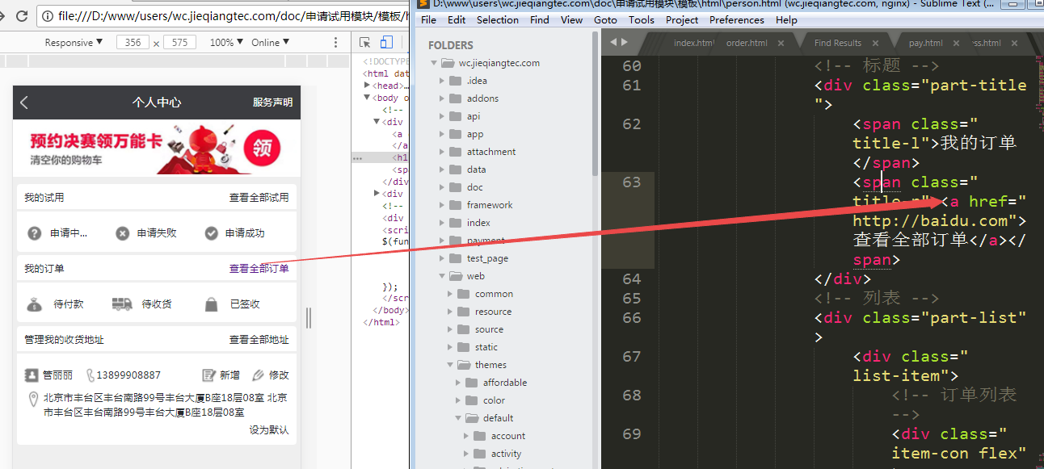

- 我的订单进入“全部订单”后，没太大必要加tab导航，不利于ajax翻页
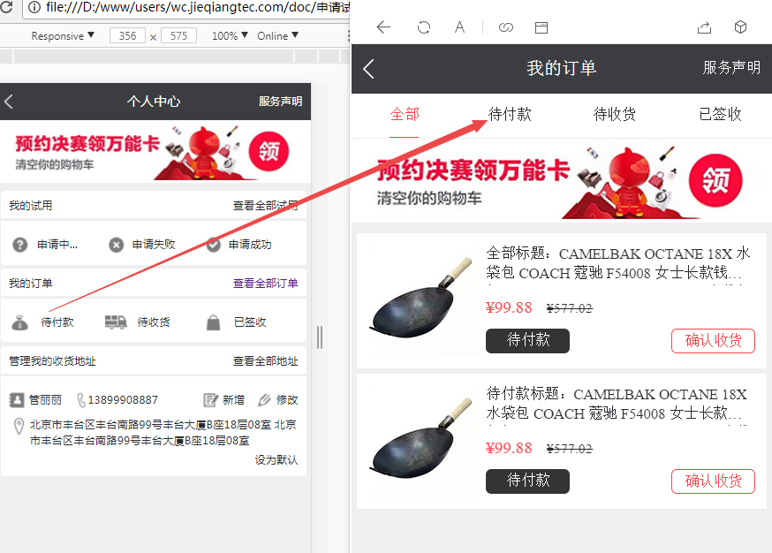

规划页面：15个页面左右
- 首页
http://shop.rongec.com/app/index.php?i=10&c=entry&do=list&m=sen_appfreeitem
  - 试用商品详情
  - 购买页面
  - 试用报告反馈
http://shop.rongec.cn/app/index.php?i=10&c=entry&orderid=14047&do=baogao&m=sen_appfreeitem

- 试用秀
http://shop.rongec.com/app/index.php?i=10&c=entry&op=jpcp&do=list2&m=sen_appfreeitem
  - 试用秀详情
http://shop.rongec.com/app/index.php?i=10&c=entry&report_id=57&do=baogao&m=sen_appfreeitem
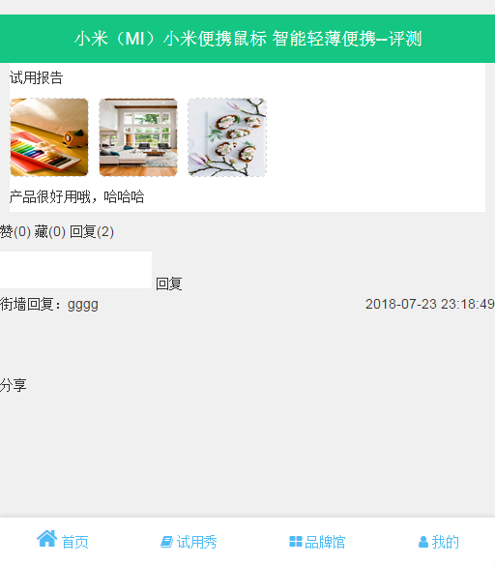
  - 分享效果
- 品牌馆
http://shop.rongec.com/app/index.php?i=10&c=entry&do=brand&m=sen_appfreeitem
  - 品牌馆列表
http://shop.rongec.com/app/index.php?i=10&c=entry&brand_id=76&brand_name=%E8%8B%B9%E6%9E%9C&do=list&m=sen_appfreeitem

- 我的首页
http://shop.rongec.com/app/index.php?i=10&c=entry&do=myorder&m=sen_appfreeitem
  - 我的试用/我的购买（我的订单）
http://shop.rongec.com/app/index.php?i=10&c=entry&state=9&do=myorder&m=sen_appfreeitem

  - 我的收藏/我的点赞
http://shop.rongec.com/app/index.php?i=10&c=entry&type=2&do=MyCenter&m=sen_appfreeitem

  - 我的评论
  - 我的地址
http://shop.rongec.cn/app/index.php?i=10&c=entry&from=confirm&returnurl=.%252Findex.php%253Fi%253D10%2526c%253Dentry%2526id%253D8%2526do%253Dconfirm%2526m%253Dsen_appfreeitem&do=address&m=sen_appfreeitem

- 试用规则
http://shop.rongec.cn/app/index.php?i=10&c=entry&do=rule&m=sen_appfreeitem

- 自助发布页面
http://shop.rongec.cn/app/index.php?i=10&c=entry&type=1&op=post1&do=publish&m=sen_appfreeitem
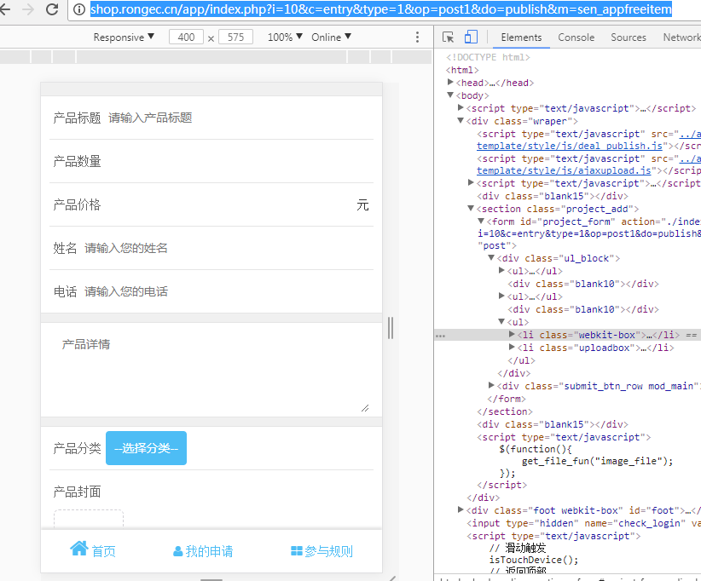
- 购物车
http://shop.rongec.cn/app/index.php?i=10&c=entry&do=MyCart&m=sen_appfreeitem

- 联系我们
http://shop.rongec.cn/app/index.php?i=10&c=entry&do=contactus&m=sen_appfreeitem
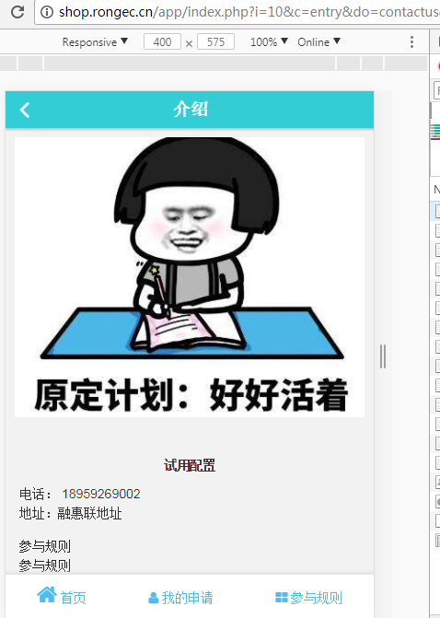
- 更多详情（包括分享和转发）
http://shop.rongec.cn/app/index.php?i=10&c=entry&do=detail_more&m=sen_appfreeitem&id=15

- 操作技巧
http://shop.rongec.cn/app/index.php?i=10&c=entry&id=9&do=tip&m=sen_appfreeitem


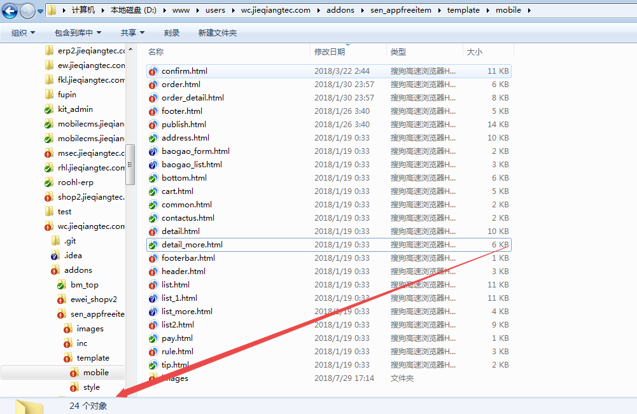
ajax翻页：
$begin_rec = 0;
$per_page_rec = 6;
if ($_GPC['rpage']) {
$begin_rec = $per_page_rec * ($_GPC['rpage'] - 1);
}
$begin_rec = $begin_rec > 0 ? $begin_rec : 0;
$condition = ' and isrecommand=1';
$rlist = pdo_fetchall("SELECT * FROM " . tablename('sen_appfreeitem_project') . " WHERE weid = '{$_W['uniacid']}' AND status >= '2' and status < '4' and isrecommand = '1' $condition ORDER BY displayorder DESC, finish_price DESC LIMIT $begin_rec , $per_page_rec");
if ($_GPC['rpage']) {
include $this->template('list_more');
} else {
include $this->template('list');
}

$(function(){
var page = 2;

var bottomOffset = 0;
var lock = false;
$(window).scroll(function(){
if(page > 100) {
$("#loading").hide();
$("#continue_jobs_more").hide();
$("#more").hide();
return;
}
var $currentWindow = $(window);
var windowHeight = $currentWindow.height()+700;
var scrollTop = $currentWindow.scrollTop();
var docHeight = $(document).height();
if ((bottomOffset + scrollTop) >= docHeight - windowHeight) {
if(lock) return;
lock = true;
$.ajax({
url:"<?php echo $this->createMobileUrl('list');?>&rpage="+page,
type:"get",
success:function(data){
if (data == 'norec') {
page = 200;
lock = true;
} else {
$('#continue_jobs').append(data);
page++;
lock = false;
}

}
});
}
});
});

