## 1、已申请右侧空白，看下你的手机显示不？

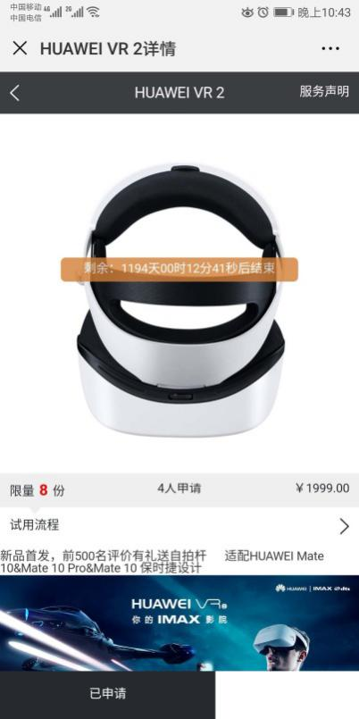

答:已修复，单个按钮只占60%宽度

## 2、暂停是不能购买但前台还继续显示么？暂停的作用是？

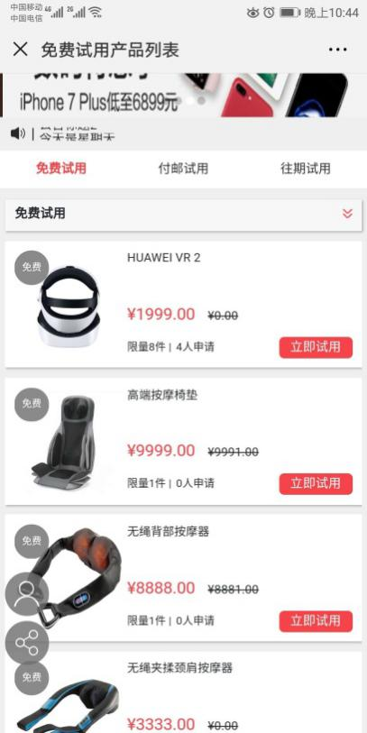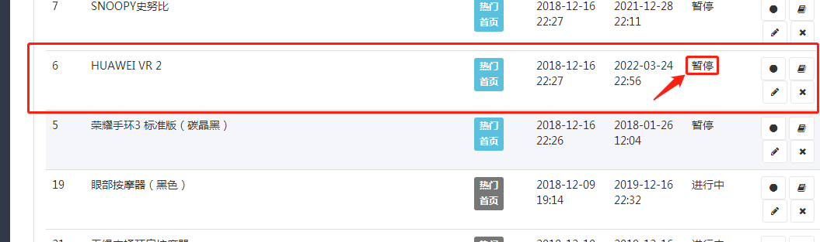

答:“暂停”暂时没作用，如果不希望在前台展示，可选在“待审核”

SELECT * FROM `ims_sen_appfreeitem_project` WHERE weid = '10' AND status >= '2' and status < '4' and deal_days > 1544366749 and freight>0 ORDER BY displayorder DESC, finish_price DESC LIMIT 0,6

<div class="form-group">

<label class="col-xs-12 col-sm-2 col-md-2 col-lg-1 control-label">状态</label>

<div class="col-xs-12 col-sm-8 col-lg-9">

<select name="status" class='form-control'>

<option value='' >全部</option>

<option value="-1" >审核不通过</option>

<option value="0" selected>编辑中</option>

<option value="1" >待审核</option>

<option value="2" >暂停</option>

<option value="3" >进行中</option>

<option value="4" >已结束</option>

</select>

</div>

</div>

## 3、热门选项在免费试用、付邮试用、往期试用和精选推荐之间是或的关系对么？精选推荐可以选择热门而独立显示在精选推荐的位置么？

|  |
| --- |
| C:\Users\ADMINI~1\AppData\Local\Temp\WeChat Files\860617a0d0904ae7a1a05d02f817ead.jpg |

答:独立的

免费试用:包邮且未过活动时间产品，按排序倒序，累计销售价格倒序展示6个

付邮试用:付邮且未过活动时间产品，按排序倒序，累计销售价格倒序展示6个

往期试用:已过活动时间产品，按排序倒序，累计销售价格倒序展示6个

精选推荐:后台配置的热门推荐且未过活动时间产品，按排序倒序，累计销售价格倒序展示4个

2018-12-17 22:38:13 TODO debug4 runtime=0.048s ：来源:

http://shop.rongec.cn/app/index.php?i=10&c=entry&id=12&do=list&m=sen_appfreeitem

------------

sql2 : SELECT * FROM `ims_sen_appfreeitem_project` WHERE weid = '10' AND status >= '2' and status < '4' and deal_days > 1545057493 and freight<=0 ORDER BY displayorder DESC, finish_price DESC LIMIT 0,6 ;

sql2 : SELECT * FROM `ims_sen_appfreeitem_project` WHERE weid = '10' AND status >= '2' and status < '4' and deal_days > 1545057493 and freight>0 ORDER BY displayorder DESC, finish_price DESC LIMIT 0,6 ;

sql2 : SELECT * FROM `ims_sen_appfreeitem_project` WHERE weid = '10' AND status >= '2' and status < '4' and deal_days < 1545057493 ORDER BY displayorder DESC, finish_price DESC LIMIT 0,6 ;

sql2 : SELECT * FROM `ims_sen_appfreeitem_project` WHERE weid = '10' AND status >= '2' and status < '4' and ishot = '1' and deal_days > 1545057493 ORDER BY displayorder DESC, id DESC, finish_price DESC LIMIT 4 ;

*// 付邮试用*$pay_list = pdo_fetchall("SELECT *\** FROM " . tablename('sen_appfreeitem_project') . " WHERE weid = '{$_W['uniacid']}' AND status >= '2' and status < '4' and deal_days > $time and freight>0 $condition ORDER BY displayorder DESC, finish_price DESC LIMIT " . ($rpindex - 1) * $rpsize . ',' . $rpsize);  
  
*// 往期试用*$discount_list = pdo_fetchall("SELECT *\** FROM " . tablename('sen_appfreeitem_project') . " WHERE weid = '{$_W['uniacid']}' AND status >= '2' and status < '4' and deal_days < $time $condition ORDER BY displayorder DESC, finish_price DESC LIMIT " . ($rpindex - 1) * $rpsize . ',' . $rpsize);  
  
  
*// 热门推荐*$hot_list = pdo_fetchall("SELECT *\** FROM " . tablename('sen_appfreeitem_project') . " WHERE weid = '{$_W['uniacid']}' AND status >= '2' and status < '4' and ishot = '1' and deal_days > $time ORDER BY displayorder DESC, id DESC, finish_price DESC LIMIT 4 ");

## 4、往期试用可以增加更多么？

答:往期试用:已过活动时间产品，按排序倒序，累计销售价格倒序展示6个

## 5、精选推荐可以增加商品的展示数量么？

答:精选推荐:后台配置的热门推荐且未过活动时间产品，按排序倒序，累计销售价格倒序展示4个

## 折扣试用开发需要多久？

答:其实我们现在所有的商品都是折扣商品，有两个价格，一个产品价格（市场价），一个折扣价（直接购买价格），

折扣率=折扣价/市场价