Hydrological response of a coastal dune aquifer to plantation clearfell and dune scraping: a BACI analysis of a 21-year manual record
M. Hollingham
2026
Abstract
Restoration of groundwater-dependent dune slack habitat increasingly relies on physical interventions — plantation removal and mechanical ground-surface lowering (“scraping”) — whose hydrological consequences are rarely tested against long monitoring records. We use a 21-year manual dipwell record (88 dipwells, 2005–2026) at Newborough Warren, Anglesey, to evaluate two interventions: a 2015 dune scraping at a single slack and an experimental ~8 ha Corsican pine clearfell in December 2017. Both are analysed within a Before–After–Control–Impact (BACI) framework using ANCOVA with a cumulative-water-balance covariate, a distance-weighted scraping term and an easting × time gradient that absorbs the coastal-retreat signal. Against an in-situ unfelled forest control, the clearfell produced a significant rise in the mean monthly water table at the felled (Impact) well of +0.120 m (95% CI [+0.050, +0.189], p < 0.001), but no significant change in summer minimum depth — the metric that governs slack viability — at any tier. Recovering the winter water table therefore does not relieve the summer drought trajectory, which continues to deepen across felled and unfelled wells alike. Scraping produced a larger, directly ecological benefit: a +0.195 m improvement in summer minimum depth at the scraped slack relative to its paired control (p = 0.005), interpreted as a permanent topographic effect rather than a change in aquifer dynamics. We show that scraping is mechanistically identical to coastal erosion in its effect on the inland water balance, raising a “chase-inland” cascade risk, and that forest-management perturbations propagate south-westward toward the coast rather than into the eastern slacks where the ecological need is greatest. The companion paper (Hollingham, 2026a) develops the aquifer-characterization framework on which this analysis draws.
Highlights
- A 2017 plantation clearfell raised the mean water table by +0.120 m but left summer minima unchanged.
- Dune scraping improved summer minimum depth by +0.195 m — an order of magnitude larger ecological gain.
- Scraping mimics coastal erosion and carries a “chase-inland” cascade risk for interior wells.
- Forest-management effects propagate seaward, not into the eastern dune slacks.
- Summer minimum depth, set by climate, is the binding restoration constraint at this site.
Keywords: dune slack; groundwater; clearfell; BACI; restoration; coastal dune hydrology

1. Introduction
Coastal dune slacks are among the most species-rich and most threatened groundwater-dependent habitats in north-west Europe. Their characteristic plant communities occupy a narrow band of water-table depth: the seasonal summer minimum must remain shallow enough to wet the rooting zone yet deep enough to avoid permanent inundation, a window of roughly 0.4 m that separates the wet-slack and dry-slack communities recognized by Curreli et al. (2013). A complementary indicator based on mean spring rather than summer water level has more recently been proposed (van Willegen et al., 2025); we frame the present analysis on the summer minimum, which is the more direct measure of the drought constraint on slack viability and the metric against which both interventions are evaluated here. Where the summer water table falls progressively, slack vegetation transitions toward dry-grassland and scrub, and the conservation interest is lost. At many British and continental sites this decline has prompted active intervention, most commonly the removal of conifer plantation established on stabilized back dunes during the twentieth century, and the mechanical lowering of the ground surface to bring the water table back into the rooting zone.
The hydrological rationale for these interventions is intuitive but rarely tested against a long record. Plantation removal is expected to recover the rainfall intercepted by the canopy and so to raise recharge; ground-surface lowering is expected to reduce the depth from the surface to the water table directly. Neither expectation, however, distinguishes a change in the mean water level from a change at the summer minimum, and neither accounts for the confounding trends — progressive climate drying and, at coastal sites, shoreline retreat — that operate over the same decades as the management. Without a control-based design and a long baseline, an apparent post-intervention improvement can reflect a wet run of years, and an apparent failure can mask a real benefit eroded by a deteriorating background.
Newborough Warren, on the south-west coast of Anglesey, offers an unusually strong setting for such a test. A continuous manual dipwell record spanning 2005–2026 covers 88 wells across a single sand body, two documented management interventions, and a coastline undergoing measurable retreat. The first intervention is a dune scraping carried out at one slack (CEH36) in April 2015; the second is an experimental clearfell of approximately 8 ha of Corsican pine (Pinus nigra var. maritima) in December 2017, undertaken on the recommendation of earlier researchers and implemented as an operational forestry action. The monitoring network includes wells inside, at the edge of, and well beyond the felled compartment, together with unfelled forest and open-dune controls, allowing the felling signal to be separated from the site-wide climate trajectory and from the coastal-retreat gradient.
This paper analyses both interventions within a Before–After–Control–Impact (BACI) framework and asks three questions. First, did either intervention raise the water table, and if so, in which season and by how much? Second, what mechanisms explain the response, and what do they imply for the durability of the gain? Third, how far do the effects of forest management reach across the site — in particular, can clearance in the forest zone benefit the eastern slacks where the ecological stakes are highest? The aquifer architecture, cluster structure and state-space model (SSM) on which the analysis rests are developed in the companion paper (Hollingham, 2026a); here we cite that framework rather than re-derive it, and concentrate on the interventions themselves.

2. Study site and interventions

2.1 Site
Newborough Warren is a calcareous coastal dune system of approximately 700 ha designated as a Special Area of Conservation for its dune slack habitats. A bedrock ridge forms the northern boundary of the study area; groundwater flows southward from this high ground across a single, highly transmissive body of clean dune sand. The drainage divides around a central dune topographic high: the forested western block discharges south-westward toward Caernarfon Bay, while the open eastern dune discharges south and south-east toward the Menai Strait. This drainage geometry is central to the reach question addressed in Section 5.4: perturbations originating in the western forest propagate seaward, not into the eastern slacks. The geomorphology, the five-cluster partition of the monitoring network and the substrate contrasts are described in full in the companion paper (Hollingham, 2026a).
The monitoring record comprises end-of-month manual dipwell readings. For the analyses reported here the network is partitioned into five hydrogeological clusters — C1 Lake Edge (n = 7), C2 Dune (n = 24), C3 Western Residual (n = 21), C4 Main Forest (n = 9) and C5 Coastal Forest (n = 5), totalling 66 reference wells — with an extended network of additional wells used in robustness checks. The forest occupies clusters C4 and C5; the two carry the same Corsican pine canopy but differ in substrate, C4 sitting on thinner sand over irregular bedrock on the elevated ridge flank and C5 on deeper, more uniform coastal sand.

2.2 The scraping intervention
In April 2015 the ground surface of one dune slack, instrumented by dipwell CEH36, was mechanically lowered to raise the summer water table toward the surface. The excavation depth was not directly surveyed; back-calculation from the observed water-table response and the open-dune specific yield (D = H₀ / Sy) implies a lowering of approximately 0.42 m. A second scraping episode in October 2023 lowered two further slacks (CEH18, CEH21). CEH36 lies approximately 340 m seaward and downslope of the later clearfell footprint, a proximity that matters when the interaction between the two interventions is considered. The unscraped slack CEH4, and CEH22 nearer the coast, serve as paired controls.

2.3 The clearfell intervention
In December 2017 approximately 8.4 ha of Corsican pine was felled. The felled compartment straddles the gradational boundary between C4 Main Forest and C5 Coastal Forest, and the wells within and adjacent to it show mixed cluster affinities spanning C3, C4 and C5 (Hollingham, 2026a). The compartment cannot, therefore, be treated as a clean single-cluster experiment; its hydrological effects propagate downslope into the coastal catchment along the continuous drainage pathway. The sole in-situ Impact well is WMC3; four edge wells (CEH31, CEH20, CEH30, CEH16) sit closer to the felling boundary, and unfelled forest, coastal and climate controls complete the five-tier design described below.

3. Methods

3.1 BACI design and control tiers
Both interventions are evaluated as monthly BACI gaps — the water level at a target tier minus the level at a control tier — with the intervention “step” estimated as a level shift at the intervention date after adjustment for climate and spatial covariates. The clearfell analysis uses a five-tier classification: Impact (the felled well WMC3), Edge (felled-margin wells), Forest control (unfelled plantation), Coastal control and Climate control. Three counterfactuals are run for the clearfell — Forest, Climate and Combined — but the Forest control is the primary test, because it compares felled wells against unfelled forest sharing the same canopy and substrate and so isolates the canopy-removal response from the coastal-retreat gradient that contaminates comparisons against open-dune controls. The combined control dilutes the felling signal because it incorporates coastal-tier wells that carry the retreat signal, and the climate control spans a wider easting range still; both are reported for completeness but are not interpreted as clearfell effects.

3.2 ANCOVA specification
The clearfell step is estimated by ANCOVA fitted to the monthly BACI gap, with covariates: a centred cumulative water-balance (CWB) term capturing climate forcing; a distance-weighted scraping dummy (exponential decay length λ = 300 m) that absorbs the 2015 scraping signal at wells near CEH36; a CWB × clearfell interaction testing whether climate sensitivity changed after felling; and an easting × time interaction that absorbs the progressive west-to-east deepening attributable to coastal erosion. Sensitivity of the clearfell coefficient to the scraping decay length was checked at λ = 200, 300 and 500 m. The scraping intervention is analysed with a two-tier CUSUM-BACI framework: a Tier 1 correction removes background drift estimated at the controls, and a Tier 2 paired comparison estimates the residual scraping signal, cross-checked by synthetic control and by an SSM forward-residual method.

3.3 Coefficient decomposition and the shared SSM
To interpret the BACI steps mechanistically we draw on the state-space model developed in the companion paper, in which the monthly change in water level is partitioned into a rainfall-recharge term (β₁), an atmospheric-draw term (β₂, scaling PET) and a head-dependent drainage term (β₃, scaling displacement above a fixed drainage datum). For the intervention wells the SSM was fitted separately to the pre- and post-felling windows, yielding per-well coefficient shifts (Δβ₁, Δβ₂, Δβ₃) and a predicted clearfell effect computed from those shifts. Canopy interception (24% of incident rainfall; Freeman, 2008) enters the forest clusters implicitly through their lower β₁ and is treated as a partition of the available PET energy budget rather than an additive loss (Hollingham, 2026a).

3.4 Scenario framework
Forward scenarios — full clearfell, 50% thinning and broadleaf conversion — were evaluated by perturbing the per-well β coefficients and computing the steady-state head response. Clearfell sets canopy interception to zero and adjusts β₂ at the forest wells using a BACI-corrected upper-bound multiplier; thinning halves the interception with a proportional adjustment; broadleaf conversion replaces the 24% pine interception with a 15% annual-mean deciduous value (Komatsu et al., 2011) and applies a seasonally varying β₂ multiplier that sits below the pine value through the leaf-off winter and above it during the growing season — Nov–Apr and May–Oct means of approximately 0.88 and 1.075 of the pine coefficient, an annual-mean effect close to unity — to reflect deciduous phenology. The framework aggregates per-well responses by inverse-distance weighting; it is a scenario aggregator, not a calibrated continuous-flow model, and applies no explicit propagation between clusters. All numerical results below are read from the live analysis pipeline.

4. Results

4.1 Dune scraping

4.1.1 Background drift
Both scraping controls show accelerating decline independent of any management action. The cumulative CUSUM at CEH4 reached −10.7 m and at CEH22 −19.1 m by early 2026, the convergent deterioration of two spatially separated wells confirming a progressive coastal-erosion signal at the western dune edge that any scraping benefit must be assessed against. The summer minimum at the CEH4 control deepened across successive management eras (era means −1.16 m at baseline, −1.18 m during 2015–17, −1.40 m post-felling), establishing the deteriorating background trajectory.

4.1.2 The CEH36 benefit
Three independent methods converge on the scraping benefit at CEH36 during the pure-scraping era (April 2015 – December 2017): a raw BACI step of +0.131 m against CEH4, a synthetic-control step of +0.135 m from eleven donor wells, and an SSM forward-residual step of +0.083 m (Figure 1). The convergence of the raw BACI and synthetic-control estimates with the near-zero SSM forward residual indicates a permanent ground-surface lowering — a step shift in the geometry — rather than a change in the aquifer’s dynamic response. The benefit diminished but was not reversed during the post-felling era, as CEH4’s own deterioration accounts for much of the apparent reduction in the BACI gap.
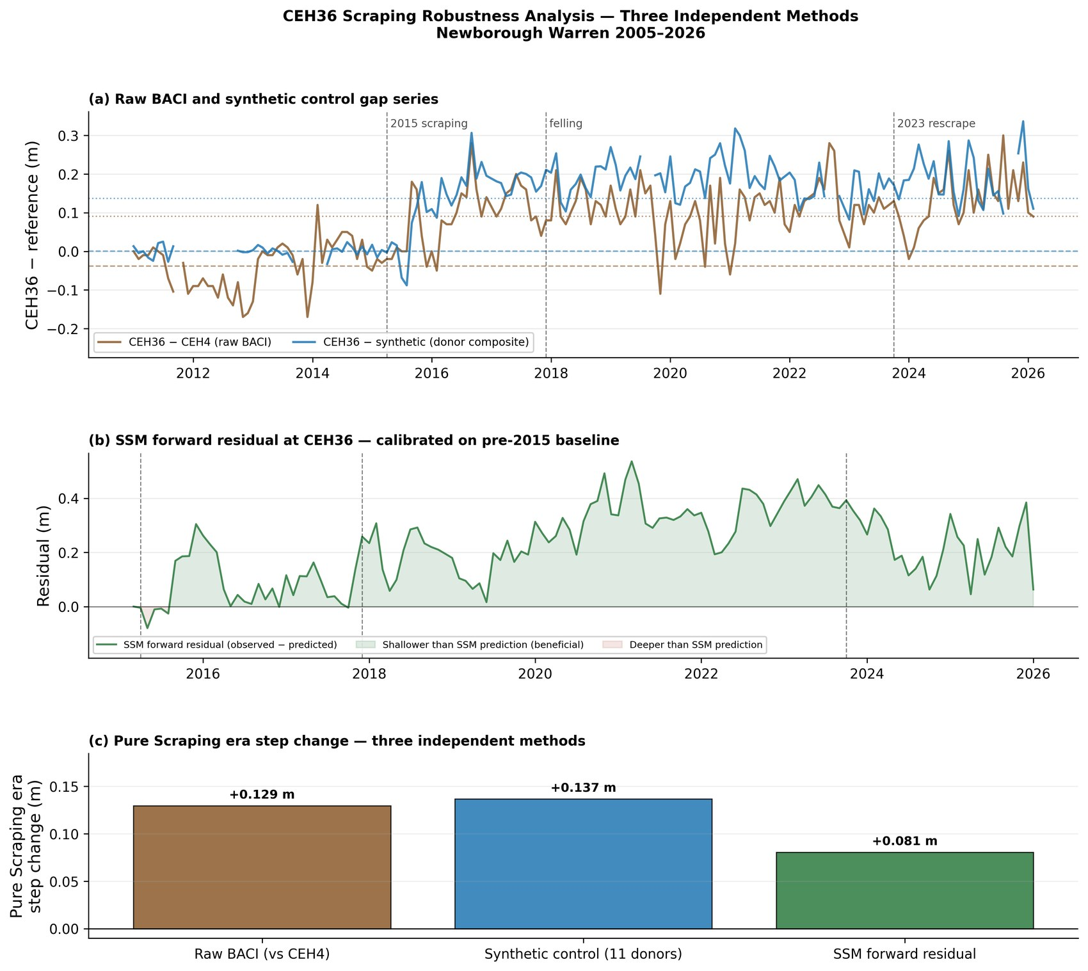
Figure 1. Three-method robustness assessment of the scraping signal at CEH36 (measured). (a) Raw BACI gap (CEH36 minus CEH4) and synthetic-control gap, with intervention dates; the persistent positive offset after April 2015 marks the step change. (b) SSM forward residual, calibrated on the pre-scraping record; the persistently positive residual indicates a water table sitting above the pre-intervention model prediction. (c) Pure-scraping-era steps from the three methods: raw BACI +0.131 m, synthetic control +0.135 m, SSM residual +0.083 m. Source: 09_scrape_08_ceh36_robustness.
The ecologically decisive result is at the summer minimum. The paired BACI summer-minimum analysis returns a significant improvement at CEH36 of +0.195 m against CEH4 (p = 0.005) and +0.159 m against the climate-control centroid (p = 0.007); the CEH4 control declined significantly against the climate centroid over the same period (Figure 2), confirming the background drying. Neither of the slacks scraped in October 2023 shows a benefit that survives background correction (CEH18 +0.056 m, p = 0.20; CEH21 −0.008 m, p = 0.89), consistent with their short two-summer post-scraping record and, at CEH21, an unreliable control on its own coastal-erosion trajectory.
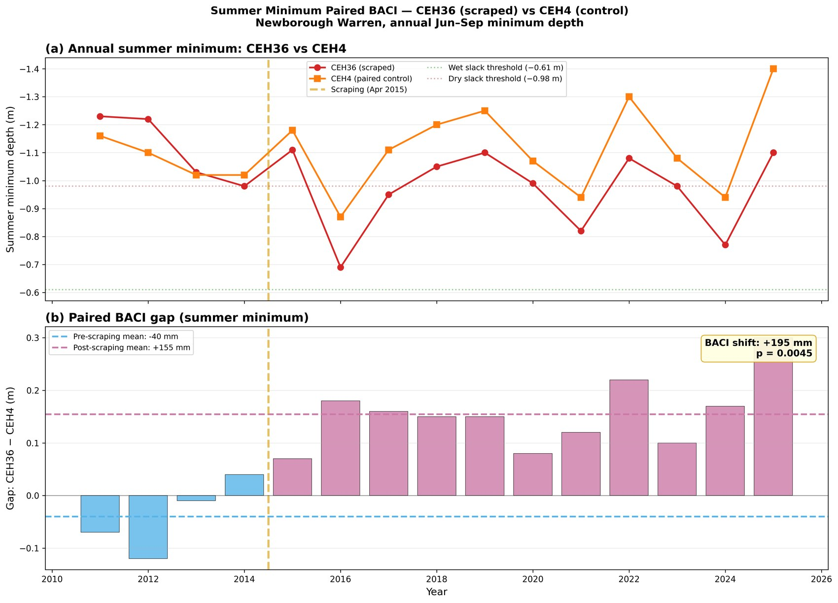
Figure 2. Paired BACI summer-minimum analysis, CEH36 (scraped) versus CEH4 (control) (measured). (a) Annual summer minimum depth with the Curreli et al. (2013) ecological thresholds. (b) BACI gap (CEH36 minus CEH4) by year, pre- and post-scraping means; the paired shift is +0.195 m (p = 0.005). Source: 09c_04_summer_minima_paired.

4.1.3 Drainage coefficient and propagation
Era-specific drainage coefficients (β₃) increased directionally at both treatment and control wells (CEH36 from 0.091 at baseline to 0.142 during pure scraping; CEH4 from 0.071 to 0.164 over the same period). Because the increase extends to unmanipulated wells, it is more consistent with SSM fitting artefacts at wells undergoing long-run erosion than with a genuine drainage response to scraping, and the per-era β₃ values should not be read as evidence of management-driven drainage change. A supplementary test for uphill propagation of the scraping signal was sensitive to the fitting method and is inconsistent with the aquifer diffusivity timescale, which at these distances exceeds the 31-month observation window; the propagation signal is best interpreted as a fitting artefact rather than a physical drainage response (Section 5.1.3).

4.1.4 Scenario context at the scraped well
To place the measured benefit in context, alternative interventions were computed at CEH36 using its own SSM coefficients. The observed scraping benefit (+45.2 mm water-equivalent per month) substantially exceeds any modelled alternative at the same well: hypothetical clearfell +13.2, 50% thinning +6.6, broadleaf +2.9, and a wet-climate scenario +7.8 mm/month, against −14.4 mm/month under a dry-climate scenario. At the summer minimum the contrast is starker — scraping +0.165 m against +0.031 m for hypothetical clearfell and −0.034 m under the dry scenario — confirming that scraping operates through a fundamentally different mechanism, creating a topographic drain rather than modifying the surface energy balance.

4.2 The December 2017 clearfell

4.2.1 ANCOVA-BACI results
Against the Forest control — the primary counterfactual — the clearfell produced a significant rise in the mean monthly water table at the Impact well of +0.120 m (95% CI [+0.050, +0.189], p < 0.001, R² = 0.27, n = 162). The Edge-tier step was small and non-significant (+0.033 m, 95% CI [−0.016, +0.082], p = 0.19). The distance-weighted scraping covariate was significant in both Forest-control models (+0.344 m at Impact, p = 0.002; +0.583 m at Edge, p < 0.001), and clearfell coefficients were identical across the three scraping decay lengths tested, confirming that the scraping and clearfell terms are temporally well separated.
The Climate- and Combined-control comparisons are reported in Table 1. The Climate-control comparison returns a null (−0.016 m, p = 0.54), which should not be read as a weaker version of the Forest-control signal: against the open-dune Climate control the felled area is statistically indistinguishable from open dune, so the forest hydrological signature has been removed and what remains is open-dune behaviour. This convergence is itself a positive finding — the Forest-control and Climate-control analyses together show what was gained (canopy removal raised the mean head +0.120 m relative to still-forested ground) and what was restored (in dynamical terms the felled ground’s mean-level behaviour now matches open dune rather than forest). The Combined-control estimate (+0.072 m) lies between the two for the same geometric reason. All three comparisons are contaminated to varying degrees by the coastal-retreat gradient, which is why the Forest control is the primary test and Table 1 reports the others for completeness rather than as independent clearfell estimates.
The CWB × clearfell interaction was non-significant in all six models, indicating that canopy removal raised the mean water table without altering the system’s sensitivity to climate forcing (Figure 3).
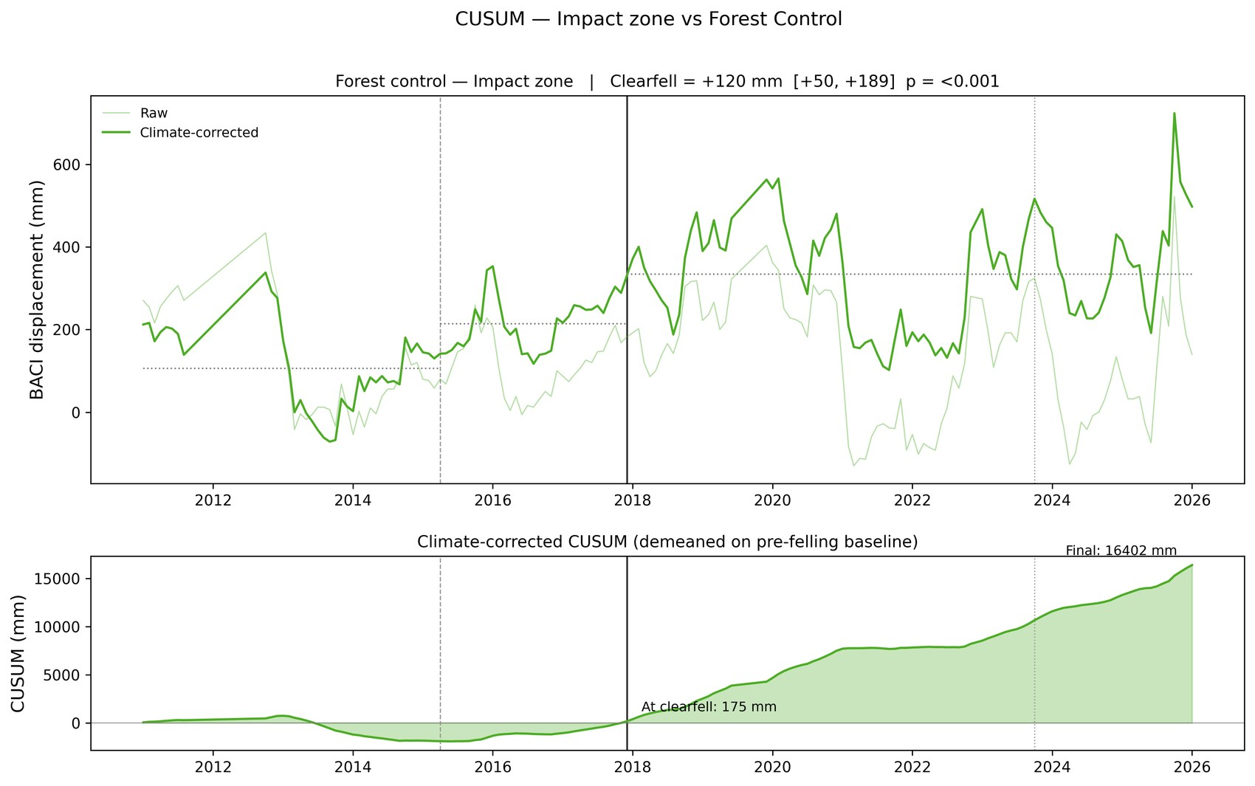
Figure 3. Forest-control BACI time series and CUSUM for the Impact tier (WMC3) (measured). Upper panel: monthly BACI gap with climate-corrected series and era means. Lower panel: cumulative sum of the climate-corrected series demeaned on the pre-felling baseline; sustained positive accumulation after December 2017 confirms the clearfell step. Vertical lines: April 2015 scraping (dashed), December 2017 clearfell (solid), October 2023 re-scraping (dotted). Source: 10a_07_cusum_impact.
The validity of the easting × time correction can be checked independently against the network-scale coastal-retreat gradient model (Hollingham, 2026a). For the headline Forest–Impact comparison the agreement is close: the BACI absorbs −12.9 ± 5.2 mm yr⁻¹ against an independent prediction of −11.1 mm yr⁻¹ (z = −0.35, consistent within sampling error), confirming that the +0.120 m Impact step is not a residual of incomplete gradient correction. The Edge comparison absorbs more drift than coastal retreat alone justifies, so any felling-attributable Edge signal is a lower bound rather than an inflated estimate.

4.2.2 Summer minima
No significant clearfell effect on summer minimum depth was detected at any tier. At the Impact well the shift was −0.007 m (p = 0.91); the pooled mixed-effects estimate at the Edge tier was −0.064 m and non-significant (p = 0.12). The distributional view by tier (Figure 4) shows the Impact and Edge tiers tracking the Forest-control trajectory in their summer extremes, with no detectable divergence after felling, while the Coastal control deepens progressively in a pattern consistent with coastal erosion rather than clearfell timing. The clearfell therefore registers in the mean monthly level but not in the summer extreme — the metric that determines slack viability — where felled and unfelled wells move together.
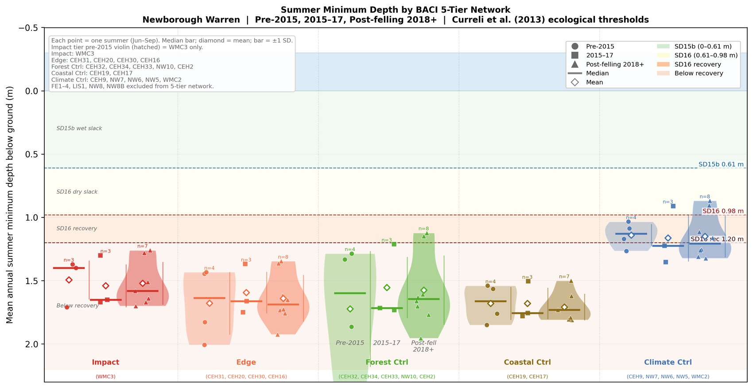
Figure 4. Summer-minimum depth distributions by BACI tier across three management phases (measured). Violin width indicates frequency; diamond = mean, bar = median. The Impact and Edge tiers track the Forest-control trajectory with no detectable divergence in summer extremes after felling, despite the significant positive shift in the monthly ANCOVA; the Coastal control deepens progressively, consistent with coastal erosion. Ecological thresholds from Curreli et al. (2013). Source: 21_forestry_04_baci_zone_violin.

4.2.3 Coefficient decomposition
Fitting the SSM separately to the pre- and post-felling windows shows that recharge sensitivity (β₁) declined at nearly all wells across all tiers — a site-wide phenomenon, visible in controls and treatment wells alike, that rules out a clearfell-specific origin and is the strongest candidate mechanism for the observed summer-minimum decline (Figure 5). Atmospheric draw (β₂) moved in the opposite direction at the unfelled Corsican-pine Forest-control wells, rising by +0.12 to +0.30 (tier mean +0.145), whereas it fell at the felled Impact well (−0.28) and at the open-dune Climate and Coastal controls, and the broadleaf well NW10 fell rather than rose; within the Forest-control tier the β₁ and β₂ shifts are strongly anti-correlated (r = −0.69), though across the full network they are not (r = −0.06). Drainage (β₃) changes were small and spatially incoherent. Because β₁ falls comparably at controls and felled wells, a per-well reading of the shifts alone would imply no positive clearfell effect, in apparent tension with the significant positive ANCOVA step.
The two analyses are reconciled rather than contradictory. The ANCOVA measures the gap between felled and control wells, so the site-wide β₁ decline — which affects both — cancels and the canopy-removal effect becomes visible. The per-well decomposition measures coefficient changes at each well individually, where the β₁ decline registers as a negative contribution everywhere and, because controls and felled wells decline comparably, no clearfell-specific signal emerges. The decomposition therefore underestimates the felling benefit; it does not refute it.
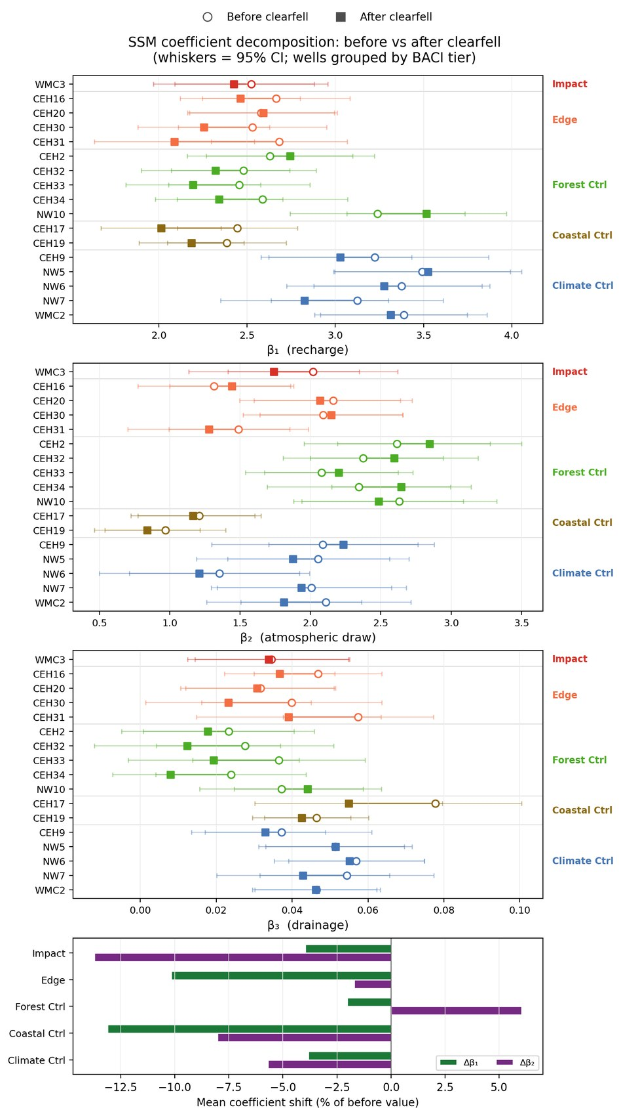
Figure 5. Before- and after-clearfell SSM coefficient estimates for the BACI-network wells, grouped and coloured by tier (measured). Open circles = before felling, filled squares = after, joined by a line; whiskers = 95% CI. β₁ recharge declines at nearly all wells across every tier — a site-wide signal. β₂ atmospheric draw rises only at the unfelled pine Forest controls while falling at the felled Impact well, the open-dune controls and the broadleaf well NW10 — an anomaly discussed in §5.3. β₃ drainage changes are small and spatially incoherent. Bottom panel: per-tier mean β₁ and β₂ shift as a percentage of the pre-felling value (β₃ omitted — its proportional swings are noise-dominated and are shown on its own panel above). Source: 10e_03_coefficient_shifts.

4.2.4 Robustness
Four independent methods relax the ANCOVA assumptions. An SSM residual normalization and a six-donor synthetic control both show a gross step of approximately +0.10 m at the Impact well (synthetic-control +0.099 m, p = 0.001) that reduces to of order +0.03 m once the upward drift of the Forest controls is removed — a small, positive, clearfell-specific component near the limit of detection. Synthetic backward extension of the within-compartment wells (WMC3 + FE1 + FE2) returns a clearfell step of +0.085 m (p < 0.001). Decomposed, FE2 — sited inside the felled footprint — diverges +0.028 m post-felling (p < 0.001), whereas FE1, some 20 m outside the boundary in standing forest, shows no significant divergence (+0.009 m, p = 0.15): exactly the spatial pattern expected of a localized felling effect. A clearfell transect from plantation interior to felling core shows no significant distance gradient, though the post-felling spread in transect hydrographs widens, suggesting a distance-dependent response that seven wells lack the power to resolve.

4.3 Forest-management scenarios
The scenario framework quantifies the seasonal trade-off at the two forest clusters; it returns no response at C1, C2 or C3 under any forest-management scenario. Full clearfell produces a small positive net annual volumetric response at both forest clusters (C4 +8.1, C5 +10.4 mm/month), driven by the winter recharge gain from interception removal marginally exceeding the summer atmospheric-draw cost. Fifty per cent thinning gives roughly half this response (C4 +4.1, C5 +5.2 mm/month). Broadleaf conversion is near-neutral and differently signed across the two clusters (C4 −0.7, C5 +1.6 mm/month): the leafless-winter recharge advantage is offset by the growing-season transpiration penalty, slightly negative on the thin high-β₂ C4 substrate and marginally positive on the deeper C5 sand (Figure 6).
C5 captures roughly twice the per-area clearfell response of C4 despite carrying the same canopy, because its higher specific yield and lower β₂ attenuate the summer cost more strongly. This is the basis of an important caveat: the same canopy treatment delivers different per-area benefit across the forest, and the model predicts the larger response at C5 — yet the observed C5 trajectory is the steepest decline in the network. The model-versus-observation discrepancy at C5 is discussed in Section 5.2.3. All three scenario magnitudes are small relative to the climate-driven response over the same horizon, where the dry-climate scenario imposes −10 to −18 mm/month across the clusters.
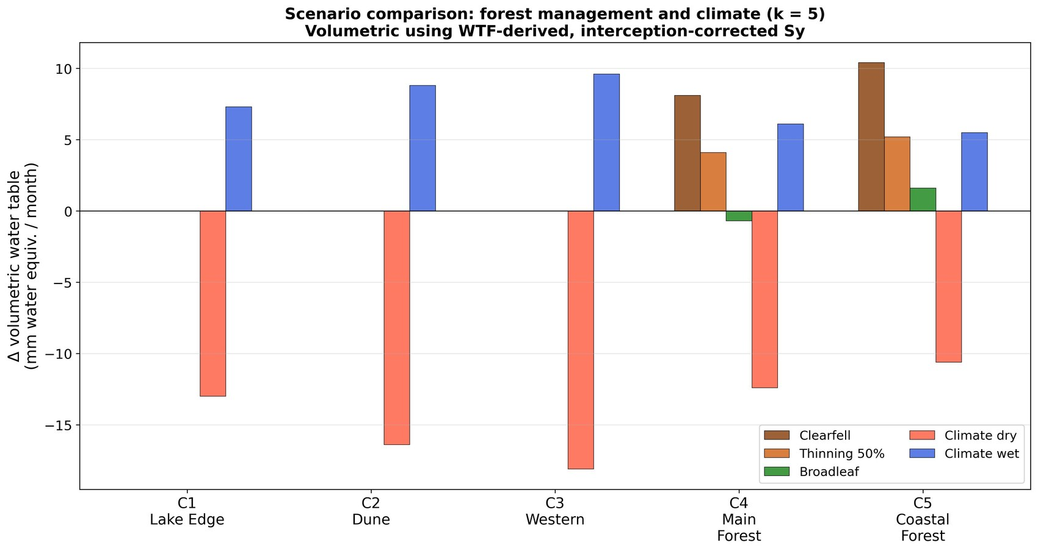
Figure 6. Forest-management and climate scenario responses by cluster, expressed as volumetric water-equivalent change (mm/month) (modelled). Forest-management scenarios produce a response only at the forested clusters C4 and C5; clearfell and thinning are small and positive, broadleaf conversion near-neutral and differently signed across C4 and C5. Climate scenarios are spatially coherent and an order of magnitude larger. Steady-state predictions from the per-well SSM coefficient structure. Source: 21_forestry_05_scenario_comparison.
Table 1. Three-counterfactual ANCOVA-BACI clearfell-step estimates (m) against each control tier, with the scraping covariate. The Forest control is the primary test. Climate- and Combined-control rows are contaminated by the coastal-retreat gradient; the Climate-control null is discussed in the text as a convergence result rather than as an independent clearfell estimate. Values read from the live pipeline (10a_report_numbers.csv).
Control | Zone | Clearfell step (m) | 95% CI | p | Scraping step (m) | Scraping p | R² | n
Forest | Impact | +0.120 | [+0.050, +0.189] | <0.001 | +0.344 | 0.002 | 0.27 | 162
Forest | Edge | +0.033 | [−0.016, +0.082] | 0.19 | +0.583 | <0.001 | 0.48 | 158
Climate | Impact | −0.013 | [−0.062, +0.036] | 0.60 | +0.014 | 0.91 | 0.18 | 146
Climate | Edge | −0.109 | [−0.172, −0.047] | <0.001 | +0.210 | 0.60 | 0.21 | 143
Combined | Impact | +0.073 | [+0.038, +0.108] | <0.001 | +0.082 | 0.27 | 0.27 | 144
Combined | Edge | −0.021 | [−0.048, +0.006] | 0.14 | +0.293 | 0.02 | 0.45 | 141

5. Discussion

5.1 Dune scraping

5.1.1 Measured benefit and durability
Scraping creates a topographic low that acts as a local drain, raising the water table at the scraped site by collecting lateral inflow. At CEH36 the benefit is unambiguous at the summer minimum — the +0.195 m paired improvement represents a shift across more than half the gradient separating the SD15b wet-slack and SD16 dry-slack community thresholds of Curreli et al. (2013) — and it persisted through the post-felling period even as the control deteriorated. Because the benefit is a geometric step rather than a change in dynamic response, the background climate-drying trend continues to operate at the scraped site as elsewhere, and the gain is slowly eroding. The two slacks scraped in 2023 have too short a record, and in one case too unreliable a control, to support any estimate; a re-scraping interval cannot yet be inferred from the record.

5.1.2 Coastal-erosion analogy and the cascade risk
The mechanism by which scraping delivers its benefit — lowering the ground surface to reduce the depth to water — is physically identical to the mechanism of coastal erosion. Both reduce ground elevation relative to a fixed absolute water-table position, both raise the displacement head at adjacent locations, and both consequently steepen drainage gradients away from the lowered zone. The accelerating CUSUM decline at the two coastal controls shows this process operating naturally at the western shoreline. The SSM drainage term operates in both directions, so a scraped zone with elevated displacement head draws water from its surroundings: scraping near the coast steepens the gradient between coast and interior and can deepen the water table at wells uphill.
This carries a management implication the physics make explicit even though the 31-month observation window cannot test it directly. If coastal scraping deepens summer minima at interior wells, those wells may in turn be identified as scraping candidates — lowering their surface, raising their displacement head, and propagating the drainage enhancement further inland. Each successive scrape addresses the local symptom while intensifying the systemic cause. This “chase-inland” dynamic is the topographic analogue of the apparent drainage acceleration that the clearfell analysis identifies as a fitting artefact: the aquifer is not gaining storage-decay capacity, but the systematic lowering of ground surfaces produces a head trajectory that the manager may read as progressive deepening requiring further intervention. On the precautionary principle, the spatial planning of any scraping programme should avoid amplifying the existing coastal drainage gradient; the most productive targets are the eastern transitional slacks (Section 5.4), not the coastal margin.

5.1.3 Timescale
The propagation timescale is governed by the aquifer’s hydraulic diffusivity and, for the relevant distances, is measured in years to decades — longer than the 31-month scraping observation window. This explains why no distance-decay in the drainage signal was detectable uphill of CEH36, accounts for the slow equilibration of any clearfell recovery, and means that the coastal-erosion signal now visible at the controls is a lagged response to earlier retreat: the present CUSUM trajectories are a leading indicator of inland conditions rather than a real-time measure of them. Monitoring programmes must be designed around this lag.

5.2 The clearfell experiment

5.2.1 A winter-recharge intervention
The clearfell is most directly tested against the in-situ Forest control, where it produced a significant +0.120 m rise in the mean monthly water table. Four independent robustness methods return steps in the same direction; they sit below the ANCOVA because they omit the easting × time correction and so represent lower bounds on the felling-specific component. Once the upward drift of the Forest controls is removed, that component is small and near the limit of detection, and the summer minima show no significant change at any tier. The honest synthesis is that canopy removal raised the mean — chiefly the winter level — without relieving the summer drought that governs slack viability. We resist a “success” or “failure” framing: the clearfell did what canopy removal mechanically can do at this site, which is recover part of the winter interception loss, and did not do what was hoped, which is lift the summer floor.
The seasonal partition follows from the canopy acting simultaneously as a hydrological sink and as a microclimatic shield (Section 5.3). Removing it recovers the interception loss, raising β₁ and winter recharge, but also raises β₂, so that a given summer PET produces a larger drawdown. The two effects operate in different seasons; their near-cancellation at the summer minimum, combined with the site-wide β₁ decline that deepens summer lows at felled and unfelled wells alike, leaves the summer floor essentially unmoved while lifting the mean. The non-significant CWB × clearfell interaction is consistent with this: the felling shifted the baseline from which the water table responds to climate, rather than the rate of that response.

5.2.2 Reinterpreting the historical baseline
Earlier attributions of water-table depression to the plantation (e.g. Betson et al., 2002) were made during the driest decade in the long RAF Valley rainfall record and without a climate-partitioned, control-based design. The present analysis shows that the canopy does suppress winter recharge — confirmed by the significant mean recovery after felling — but that its effect on summer extremes is small relative to the site-wide β₁ decline. The historical baseline is best read as a compound of forest influence and exceptional climatic dryness whose seasonal structure was not resolvable at the time.

5.2.3 The C5 model–observation discrepancy
The scenario framework predicts that clearfell raises the C5 water table more than C4’s, because C5’s lower β₂ means the interception gain outweighs the evaporative penalty there. Yet C5 shows the steepest observed decline in the network. We flag this discrepancy rather than explain it away. The reconciliation we find most plausible is mechanistic: the clearfell scenario is a vertical flux adjustment — a winter recharge gain set against a summer evaporative cost — whereas the observed C5 decline is dominated by a lateral geomorphological forcing. C5 sits on deep, freely draining sand directly against the retreating coastal boundary, and its high hydraulic diffusivity allows the lateral drawdown signal from coastal erosion to propagate inland efficiently, overriding the localized vertical interception gain that the scenario predicts. This does not rescue the prediction so much as locate the missing term: the per-cluster SSM represents vertical exchange but not the lateral coastal boundary condition, and the mixed felling zone straddling the C4/C5 transition compounds the attribution. The coastal-retreat signal is the leading candidate and the one most directly measurable in the field. The model prediction and the observation are not reconciled by the present data, and continued C5 monitoring with targeted coastal-retreat measurement is a stated research priority.

5.3 Hydrological role of the plantation
The forest functions as both a sink and a shield. As a sink it suppresses recharge through 24% canopy interception (Freeman, 2008) and draws the water table down through transpiration; as a shield it intercepts PET energy at wet canopy surfaces before that energy can act on the water table. The shield is most clearly read not from the post-felling coefficient shifts but from the cross-cluster β₂ contrast, which is dominated by substrate, not canopy. C4 carries the network’s highest β₂ not because its canopy draws hardest but because its thin sand over irregular bedrock has the lowest effective specific yield, so a given evaporative flux produces the largest head change; C5, on deeper sand, has a much lower β₂ despite identical canopy (Hollingham, 2026a). The practical consequence is that canopy-attributable changes in β₂ must be measured against a position-matched control — precisely the role of the Forest-control tier here.
That control tier, however, behaved in a way the canopy framework does not readily explain: atmospheric draw rose at the unfelled pine controls even as it fell almost everywhere else. We are cautious about reading this as a real increase in forest evaporative demand. The rise is modest — about 6% of β₂ — and at every individual well the pre- and post-felling confidence intervals overlap, so it is not significant well by well. Three considerations argue against an ecophysiological reading. The stands are already mature (~75 years), so further canopy maturation is an implausible driver of a 6–12% step in transpiration sensitivity over a single decade. The shift is also specific to the pine controls — the leaf-off broadleaf well moved the other way and the open-dune controls fell — a pattern a uniform climate-driven rise in demand would not produce. And within the pine controls the β₂ rise is mirror-imaged by the β₁ decline (r = −0.69), the signature of an ordinary-least-squares fit trading variance between two seasonally anti-correlated regressors — winter rainfall against summer evaporative demand — at wells where the canopy buffers and lags recharge enough to make the two hard to separate.
A warmer-winter increase in canopy interception, physically reasonable for an evergreen stand, is consistent with the recharge (β₁) decline but cannot account for the β₂ rise. In the Thornthwaite scheme used here winter PET is small and essentially unchanged between the two windows — the entire PET increase falls in summer — and the scheme cannot represent the wind- and humidity-driven evaporation of intercepted water at all, so increased winter interception would register as suppressed recharge, not as stronger atmospheric draw. The remaining physical possibility is a summer storage effect — as the table declines into the thinner, lower-specific-yield C4 sand, a given evaporative flux produces a larger head change, inflating apparent β₂ — but this too is a property of substrate and a falling table, not of the canopy. We therefore treat the Forest-control β₂ rise as an artefact of fitting and substrate rather than a measured change in forest water use; consistent with the companion paper’s finding that absolute β₂ values are upper bounds best read as rankings (Hollingham, 2026a), the decomposition is reliable for the direction of the β₁ decline but not for a quantitative reading of β₂.
A direct observational test of broadleaf conversion exists within the network, and it is best read as a phenological proof-of-concept rather than a spatial counterfactual. Dipwell NW10 sits in a block of mixed broadleaf established after a 1993 clearance. Its decoupled SSM coefficients capture the deciduous seasonal partition directly: a higher recharge sensitivity (β₁ = 3.53 against a C4 median of 2.34), consistent with a leaf-off canopy transmitting more winter rainfall, set against an atmospheric draw (β₂ = 2.52) comparable to adjacent pine, consistent with that winter advantage being offset by growing-season transpiration. Its climate-normalized summer minimum sits about +0.25 m shallower than the pine interior, and — the feature that most supports the scenario framework — this anomaly is diminishing as the canopy closes, converging on the near-neutral scenario prediction. The spatial reading is weak: NW10 is a single, positionally confounded well, and the spread between two pine wells in the same cluster exceeds the NW10 anomaly, so it supports an indicative reading at most — a maturing broadleaf canopy whose net annual hydrological effect approaches that of the pine it replaced, with a different seasonal partition. A robust species attribution would require several instrumented wells across the broadleaf block.
We also note a slower process that the water-table analysis cannot resolve but that bears on restoration: progressive Dothistroma needle blight is already thinning parts of the canopy, offering a natural experiment in canopy-density effects on β₂ that requires only sustained monitoring. It is flagged as a monitoring question rather than a finding.

5.4 The reach of forest management
A central management question is whether forest management in the C4/C5 zone could improve conditions in the eastern open-dune clusters (C1, C2, C3), where the ecological thresholds are most critical and the remaining wet-slack resource is concentrated. The evidence indicates it cannot. The scenario framework produces no detectable response at C1–C3 under any forest-management scenario; the BACI record shows no felling-specific response at wells outside the forest zone once common-mode climate variability is removed; and the post-felling transect is spatially uniform with no inland gradient. This isolation is not a framework artefact. The drainage geometry sends forest-zone perturbations south-westward toward Caernarfon Bay, not eastward into C1 and C2 (Figure 7), and the steady-state drawdown of the existing 75-year-old plantation is already negligible at the eastern wells despite the plantation having had its full lifetime to reach equilibrium. Any clearfell recovery would propagate outward on the same years-to-decades timescale and with a comparable, spatially limited footprint.
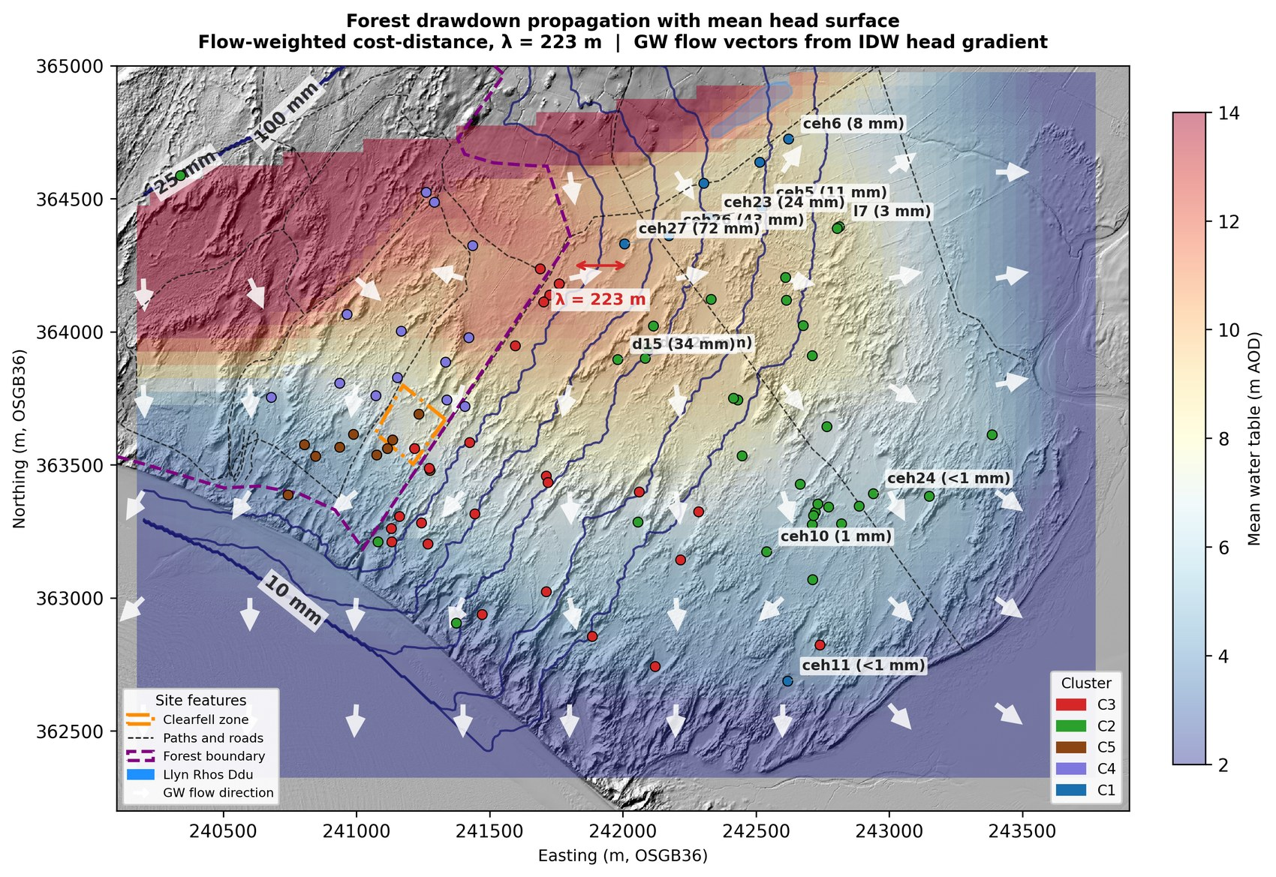
Figure 7. Steady-state drawdown field of the existing plantation, illustrating the reach of forest-zone perturbations (illustrative — computed from an assumed canopy-edge head deficit, not a measured drawdown). The perturbation is directed south-westward toward Caernarfon Bay along the drainage gradient and is negligible at the eastern C1/C2 wells. The per-well inverse-distance framework is a geometric aggregator, not a calibrated flow model. Source: 20_drawdown_propagation.
The clusters where the stakes are highest — C1 and C2, whose summer minima sit within 0.2–0.4 m of the community thresholds — therefore show no detectable response to forest management, and their summer trajectory is set by the site-wide climate signal. Because winter flooding across the western and forest clusters is controlled almost entirely by antecedent summer minimum depth rather than winter rainfall amount (Hollingham, 2026a), the primary restoration lever is summer minimum depth, over which forest management in the C4/C5 zone has no influence at C1 or C2.

5.5 Implications for restoration and monitoring
Three conclusions for management follow. First, summer minimum depth, not winter recharge, is the operative restoration target, which makes summer dipwell readings more diagnostically informative than winter peaks and reframes monitoring design accordingly. Second, topographic scraping is the most directly effective intervention in the record, but its benefit is local and its planning must respect the cascade risk by targeting the eastern C1/C2 transitional slacks — where a single scrape can bring a marginal well within reach of a mildly wet winter — rather than the coastal margin where it would amplify an existing erosion-driven gradient (Figure 8). Third, plantation clearance raises the mean winter water table but does not lift the summer floor and does not reach the eastern slacks; its hydrological case rests on winter-season and within-forest objectives, not on benefiting the wider slack resource.
Two points follow for monitoring design. First, the aquifer equilibrates to a step change over years rather than months — the lagged drainage adjustment that makes the clearfell’s mean-level gain a transition toward a new state as much as a fixed outcome — so future BACI evaluations of topographic or canopy interventions should commit to multi-decadal baselines, lest a transient state observed in a short window be read as a permanent result. Second, because scraping steepens the inland drainage gradient in the same way coastal erosion does, any future scraping should be paired with a dedicated transect of dipwells running uphill along the drainage gradient from the worked slack, so that the chase-inland acceleration can be measured directly and pre-empted rather than reconstructed after the fact.
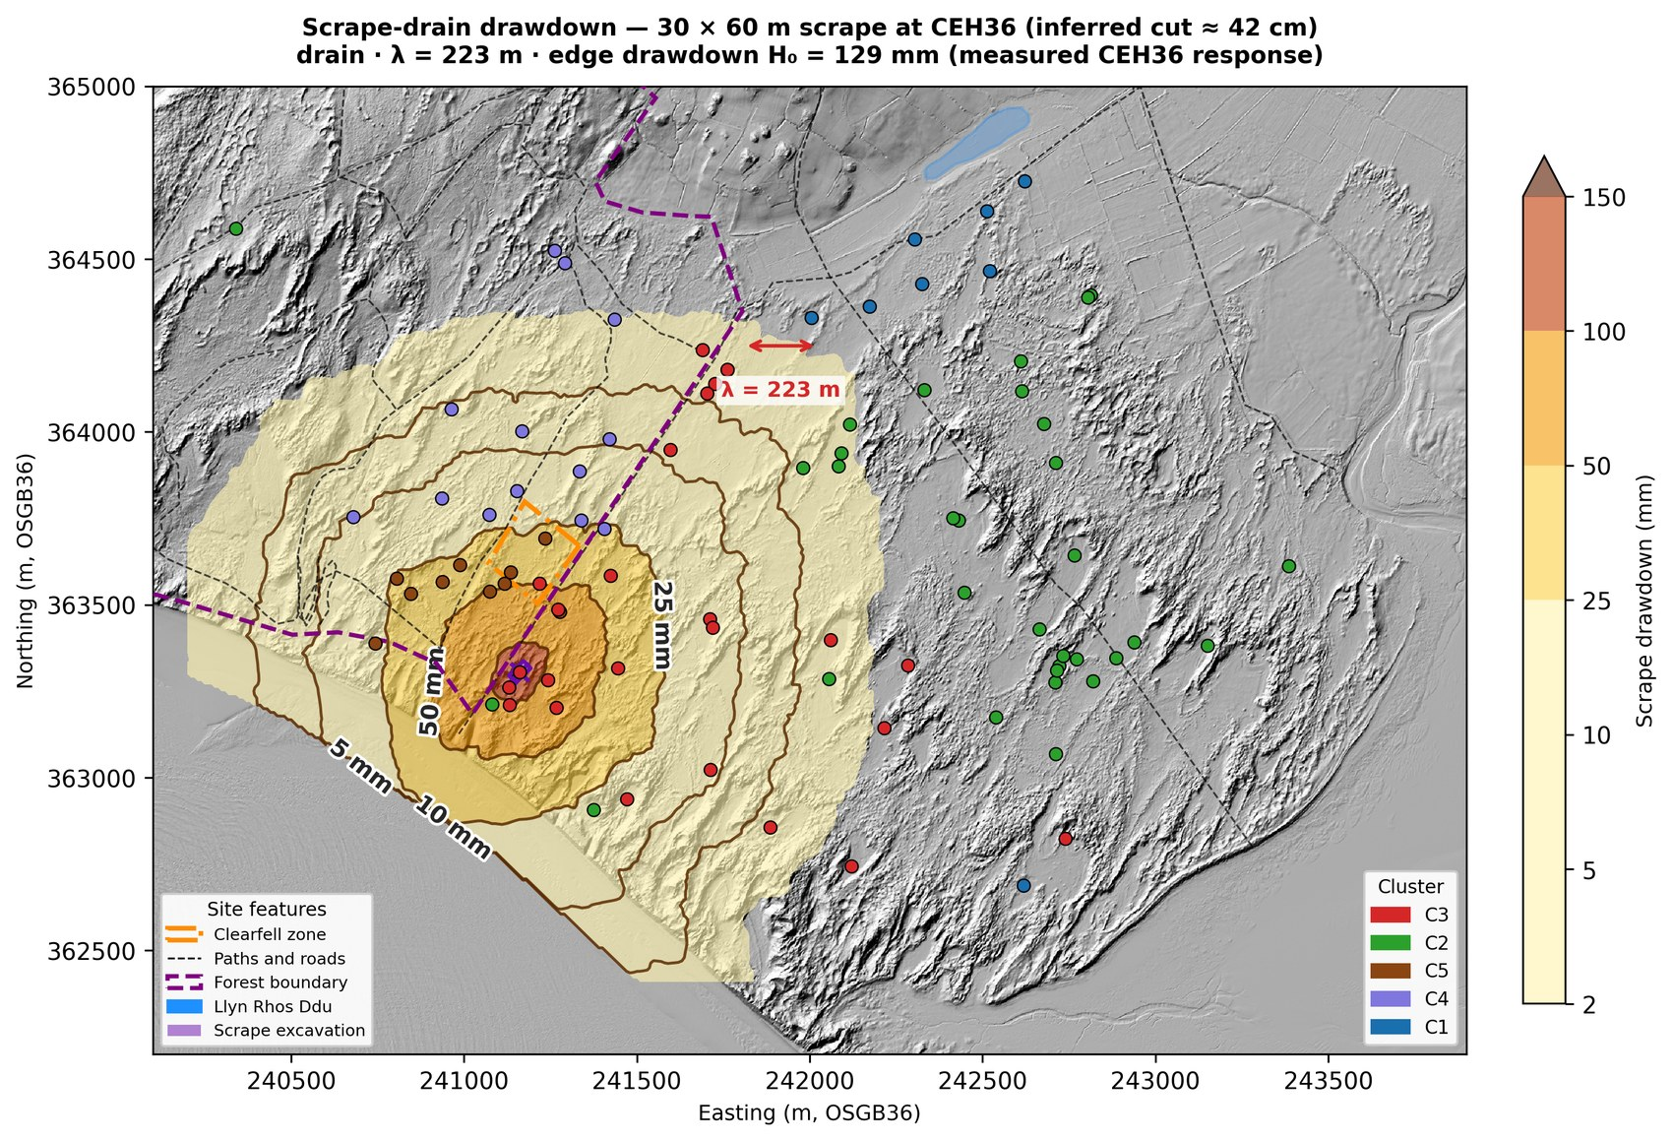
Figure 8. Modelled steady-state drawdown field around the 2015 CEH36 scrape — edge magnitude empirically anchored, reach modelled. The edge drawdown is set to the measured CEH36 scraping response (≈0.13 m; Script 09a, Pure-Scraping era vs CEH4), not an assumed value; the surrounding field is a steady-state radial-drain decay along a flow-weighted cost-distance (leaky-aquifer length λ = √(K·b/(Sy·β₃)) ≈ 220 m), with the excavation interior masked because the slack itself rises. The excavation depth (≈0.42 m) is the inferred output, D = H₀/Sy, not a survey input. The elevated displacement head at the scrape steepens drainage gradients and draws the surrounding water table down — the same mechanism as coastal erosion, underlying the chase-inland cascade. Source: 20_scrape_drawdown_nohead.
Underlying all three is the binding constraint: the summer drought trajectory, driven by a site-wide decline in recharge efficiency under a climate redistributing rainfall toward wetter winters and drier summers, is approaching the ecological viability thresholds within the next one to two decades. The management challenge at Newborough is therefore hydrological adaptation — maintaining flooding capacity in an increasingly seasonal climate — rather than restoration to a prior state. The prediction equations, threshold maps and scenario framework underpinning these conclusions are available as interactive tools (Hollingham, 2026b).

6. Limitations
Neither intervention was randomly assigned, raising the usual possibility that pre-existing site characteristics confound the signal; the monitoring network was not designed as a purpose-built propagation transect and cannot resolve a residual felling signal within 100 m of the clearfell edge. Both intervention analyses treat the coastal-erosion confound through covariates and control selection rather than through explicit time-lagged modelling: the easting × time term captures the average spatial gradient but not the multi-year propagation of erosion signals from earlier retreat, so the contemporaneous management signal cannot be fully separated from the time-integrated coastal signal. The independent corroboration of the easting × time covariate against a physics-based gradient model is reassuring at the headline Forest–Impact comparison but only partial at the Edge and Climate tiers. The Thornthwaite PET method overestimates evaporative demand in humid maritime climates, so the absolute scenario magnitudes are conservative upper bounds; the relative ranking of scenarios and the finding of structural isolation are independent of the PET method because they depend on coefficient ratios and spatial structure. The NW10 broadleaf comparison rests on a single, positionally confounded well with fewer than four years of post-canopy-closure record and should be read as indicative only. The spatial framework is a per-well scenario aggregator interpolated by inverse-distance weighting, not a calibrated continuous-flow model; resolving cluster-to-cluster coupling would require slug tests and a ground-penetrating-radar survey of aquifer thickness, identified as priority fieldwork.

7. Conclusions
A 21-year manual record and a five-tier BACI design allow the hydrological effects of two dune-restoration interventions to be separated from a deteriorating climatic and coastal background. The December 2017 clearfell raised the mean monthly water table at the felled well by +0.120 m against an in-situ forest control, but left summer minimum depth — the metric governing slack viability — unchanged at every tier; canopy removal is, at this site, a winter-recharge intervention whose effect on the summer floor is small against a site-wide decline in recharge efficiency. The 2015 dune scraping delivered a larger and directly ecological benefit, improving the summer minimum at the scraped slack by +0.195 m, but did so by permanently lowering the ground surface — mechanically identical to coastal erosion, and carrying a chase-inland cascade risk. Forest-management effects propagate seaward and do not reach the eastern slacks where the ecological need is greatest. The operative restoration lever is summer minimum depth, best addressed by carefully sited scraping in the eastern transitional zone, while the binding constraint remains the climate-driven summer drought trajectory — traceable, in the coefficient decomposition, to a site-wide decline in rainfall-recharge efficiency (β₁) as the climate redistributes rainfall toward wetter winters and drier summers. The companion paper (Hollingham, 2026a) sets out the aquifer-characterization framework on which these conclusions rest.

References
Betson, M., Robins, N.S., Hulme, P.J., 2002. Hydrogeology of the Newborough Warren dune system, Anglesey. British Geological Survey / Environment Agency.
Curreli, A., Wallace, H., Freeman, C., Hollingham, M., Stratford, C., Johnson, H., Jones, L., 2013. Eco-hydrological requirements of dune slack vegetation and the implications of climate change. Science of the Total Environment.
Freeman, C., 2008. Rainfall interception by the Newborough Warren Corsican pine plantation (site-specific measurement).
Hollingham, M., 2026a. Hydrogeological characterization of a coastal dune aquifer from a 21-year manual record: cluster structure, a state-space water-balance model, and specific yield. Companion paper (this issue).
Hollingham, M., 2026b. Newborough Warren Groundwater Research — interactive modelling suite. https://newbroman.github.io/Newborough_Hydrology/
Komatsu, H., Kume, T., Otsuki, K., 2011. Increasing annual runoff — broadleaf versus coniferous forests: a meta-analytical review. Hydrological Processes.
Pye, K., Blott, S.J., 2024. Coastal change and dune dynamics on the south-west Anglesey coast.
Ranwell, D.S., 1972. Ecology of Salt Marshes and Sand Dunes. Chapman and Hall, London.
van Willegen, L., et al., 2025. [Dune-slack indicator analysis]. Ecological Indicators 170, 113016.

