A parameter-sparse state-space framework for characterizing coastal dune-aquifer architecture from manual dipwell records
M. Hollingham
Draft — 2026

Abstract
The vegetation communities of coastal dune slacks occupy a band of water-table depth only a few tens of centimetres wide, so that small differences separate a functioning wet slack from a dry one. Characterizing the aquifer that governs that water-table depth is difficult in unconsolidated dune sand, where distributed flow models demand hydraulic-conductivity fields and aquifer-thickness surfaces that are expensive to measure and poorly constrained. Many dune systems are nonetheless monitored over decades by manual dipwell networks. We ask whether that routine record alone can resolve dune-aquifer architecture, and present a parameter-sparse framework that does so without coring, hydraulic testing or calibrated continuous-flow modelling. The framework couples hierarchical clustering of hydrograph dynamics with a three-term state-space model — recharge, atmospheric draw, and head-dependent drainage referenced to a fixed sub-surface displacement datum — fitted at each well from monthly rainfall and temperature at a single station. Around this core we derive a water-balance decomposition, an independent water-table-fluctuation estimate of specific yield, a benchmarking diagnostic against a traditional linear model, continuous coefficient and head surfaces, a residual field treated as a structural diagnostic of where the lumped balance is insufficient rather than as a quantified flux map, and a network-scale regression of long-term trend against distance from an eroding shoreline. Demonstrated at Newborough Warren (Anglesey, UK; 88 dipwells, 21 years), the framework resolves five hydrogeological clusters that are independently confirmed by the mechanistic coefficients and by a synthesis of drainage timescale, forecasting skill and specific yield. Interception-corrected specific yields converge across clusters, showing that the behavioural contrasts are surface- and land-cover-mediated rather than reflecting different subsurface storage. The displacement-formulation model closes the monthly water balance to within 1.6% of losses and raises median iterative Nash–Sutcliffe efficiency from 0.13 to 0.75 over the linear benchmark, with the spatial pattern of the gain delineating where storage dynamics govern the aquifer. A coastal-retreat gradient is resolved as a forcing distinct from climate, explaining the anomalous decline of the most coast-proximal cluster. The framework is transferable to any dune system with a monitoring network and a nearby climate station; the hydrological consequences of management interventions at the site are reported in a companion paper.
Keywords: coastal dune aquifer; dune slack; state-space model; specific yield; groundwater characterization; coastal retreat
Highlights
- Dune-aquifer architecture resolved from manual dipwells and one climate station
- State-space model with a displacement datum closes the water balance to within 1.6%
- Iterative forecast skill rises from NSE 0.13 to 0.75 over a linear benchmark
- Interception-corrected specific yields converge: storage uniform, contrasts surface-led
- Coastal retreat resolved as a forcing distinct from climate on long-term decline

1. Introduction
Coastal dune slacks are among the most hydrologically sensitive habitats in north-west Europe. The seasonally fluctuating water table that defines them sits within a narrow envelope: the wet- and dry-slack vegetation communities of conservation interest occupy a band of summer-minimum depth only a few tens of centimetres wide (Davy et al., 2006; Curreli et al., 2013). Because that envelope is set by groundwater rather than by surface management, the conservation status of a dune system cannot be understood without a quantitative account of how its aquifer fills, stores and releases water — how recharge enters the water table, how evaporative demand and lateral drainage remove it, and how these processes vary across the geomorphological range of the site.
Characterizing that architecture by conventional hydrogeological means is difficult in dune settings. Distributed groundwater models of the MODFLOW family require hydraulic conductivity fields, aquifer-thickness surfaces and boundary fluxes that are expensive to measure and poorly constrained in unconsolidated, rapidly transmissive dune sand; at Newborough Warren itself, an earlier distributed-model effort encountered exactly these calibration difficulties (Betson et al., 2002). Slug and pumping tests sample only the immediate vicinity of a borehole, and the dense borehole networks needed to interpolate a parameter field across a dune system of several square kilometres are rarely available. Yet many dune sites are monitored, often over decades, by exactly the kind of low-cost instrumentation that distributed models cannot directly exploit: networks of manual dipwells read at monthly intervals, alongside a nearby meteorological station. The methodological question this paper addresses is whether that routine monitoring record, on its own, is sufficient to resolve the hydrogeological architecture of a dune aquifer — its storage, recharge efficiency and drainage behaviour — with enough spatial detail to support conservation interpretation, and without recourse to coring, hydraulic testing or calibrated continuous-flow modelling.
We develop and demonstrate such a framework. Its core is a three-term state-space model (SSM) fitted independently at each well, in which the monthly change in water-table position is partitioned into a recharge term proportional to rainfall, an atmospheric-draw term proportional to potential evapotranspiration, and a head-dependent drainage term proportional to the water-table displacement above a fixed reference datum. The displacement formulation is the design decision that makes the framework transferable: by referencing drainage to a datum below ground rather than to the ground surface, it captures the head-dependence of lateral discharge without requiring site-specific calibration of drainage geometry, and it resolves a physically meaningful drainage coefficient at every well, including the low-gradient forest interior where a surface-referenced formulation is borderline. The three fitted coefficients are physically interpretable — recharge sensitivity, atmospheric draw and proportional drainage decay — and require only monthly rainfall and temperature from a single station as forcing.
Around this core we assemble a set of complementary, independently derived characterizations that cross-validate one another. Hierarchical clustering of hydrograph dynamics — using a correlation-based distance that isolates temporal behaviour from absolute water-table elevation — partitions the network into spatially coherent hydrogeological units before any model is fitted, providing a structure that the mechanistic coefficients must then independently reproduce. A pattern-matching affinity analysis extends the classification to wells with shorter records and identifies the gradational transition zones between units. The SSM is benchmarked against a traditional linear model under iterative simulation, and the spatial pattern of the predictive gain itself becomes a non-invasive diagnostic of where nonlinear storage dynamics govern the aquifer. A water-balance decomposition built directly from the fitted coefficients quantifies the recharge–loss partition at each cluster under identical climate forcing, and an independent water-table-fluctuation estimate of specific yield tests whether the behavioural contrasts between units reflect genuine differences in subsurface storage or boundary conditions imposed at the surface. Finally, interpolation of the per-well coefficients yields continuous maps of recharge sensitivity, atmospheric draw and drainage rate, a mean head surface with its associated flow field, and a water-balance residual field that makes explicit where the three-term model closes and where it implies an unmeasured boundary flux.
We also resolve an external forcing that conventional climate-trend analysis at a dune site can misattribute. Where a shoreline is actively eroding, the progressive landward migration of the seaward drainage boundary deepens the water table near the coast independently of climate, imposing a spatial gradient on long-term summer-minimum trends. We fit a physics-based, network-scale regression of water-table trend against distance from the eroding shoreline, and use it to partition each cluster’s summer-minimum decline into a coastal-retreat component and a climate-driven background — a distinction that matters both for interpreting the aquifer’s long-term trajectory and for any subsequent attribution of trends to climate alone.
The framework is demonstrated at Newborough Warren, a coastal dune system on Anglesey, north-west Wales, monitored over twenty-one years by a network of eighty-eight dipwells (eighty-nine monitoring points, including the Llyn Rhos-Ddu lake gauge) spanning the full geomorphological range of the site — from lake-margin and open-dune slacks to a mature coniferous plantation on the elevated landward flank. The density and length of this record make it an unusually well-suited proving ground: it is large enough to test whether the framework recovers structure that is independently visible in the raw hydrographs, and varied enough to span the contrast between a shallow, fast-cycling eastern aquifer and a deep, sluggish western and forested interior.
The objectives of this paper are therefore: (i) to set out the state-space characterization framework and its displacement formulation; (ii) to demonstrate that hydrograph-dynamics clustering, mechanistic SSM coefficients, model-benchmarking diagnostics, water-balance decomposition and specific-yield estimation converge on a single, internally consistent picture of aquifer architecture; (iii) to map that architecture continuously across the site and identify where the three-term water balance closes and where it does not; (iv) to quantify the coastal-retreat forcing on long-term water-table trends; and (v) to assess the framework’s transferability to other dune systems monitored by routine dipwell networks. The hydrological consequences of the two management interventions undertaken at the site — dune scraping and a partial plantation clearfell — are quantified separately within a before-after-control-impact design and are reported in a companion paper (Hollingham, 2026b); they are not treated here, where the plantation enters only as a land-cover boundary condition on the aquifer characterization.

2. Study site
Newborough Warren occupies the south-western tip of the Isle of Anglesey in north-west Wales (Figure 1). The modern dune system is a late-Holocene feature, the present dunes having developed over previously cleared agricultural land following storms in 1330 (Ranwell, 1958; Rhind et al., 2001). The site has no perennial surface drainage; flow lines shown on later figures are DEM-derived flow-accumulation paths included for spatial reference. The dune field is underlain by weakly permeable glacial till, which forms the effective base of the sand aquifer. A bedrock ridge, demarked by the 20 m AOD contour and trending south-south-west to north-north-east, forms the northern boundary of the study area and outcrops within the northern plantation. The hydrological study area, defined by the extent of the DEM-derived flow network, covers approximately 1,170 ha; the dipwell network spans a core zone of roughly 720 ha within it, lying entirely on the south-eastern flank of the ridge. Dune terrain on the north-western flank, draining toward the Malltraeth estuary, is hydrologically separate and is not considered here.
The aquifer south-east of the ridge is divided by its substrate into two contrasting blocks (Stratford et al., 2007). In the east, shallow sand over till and estuarine deposits constrains storage and produces a responsive, flashy water-table regime; in the west, deep aeolian sand accumulation over a broader platform permits substantial groundwater storage and strongly buffered seasonal fluctuations. Whether this east–west contrast reflects two distinct substrate bodies or a single estuarine-clay base that outcrops on the higher eastern and southern ground and dips beneath the surface toward Caernarfon Bay — thinning the sand column in the east and thickening it toward the south-west — is not resolved by the present data (Section 5.1). The aquifer discharges principally across the south-western foreshore of Caernarfon Bay and the southern and eastern coast of the Menai Strait. A small lake within the warren, Llyn Rhos-Ddu, acts as a near-fixed-head body and is the dominant local drainage sink for the immediately adjacent wells, receiving groundwater throughout the year as the regional water table maintains its head above the lake surface (Stratford et al., 2007).
The northern part of the study area is managed plantation dominated by mature Corsican pine. The plantation enters the present analysis solely as a land-cover boundary condition: its canopy intercepts a fraction of incident rainfall before it reaches the ground, and this interception is treated below as a modifier of the surface input to the forested clusters rather than as a management variable. The dune-slack communities of the open system are classified under the National Vegetation Classification as SD15b (wet slack) and SD16 (dry slack); their water-table requirements (Curreli et al., 2013) provide the ecological reference frame for the site but are not used analytically in this paper.
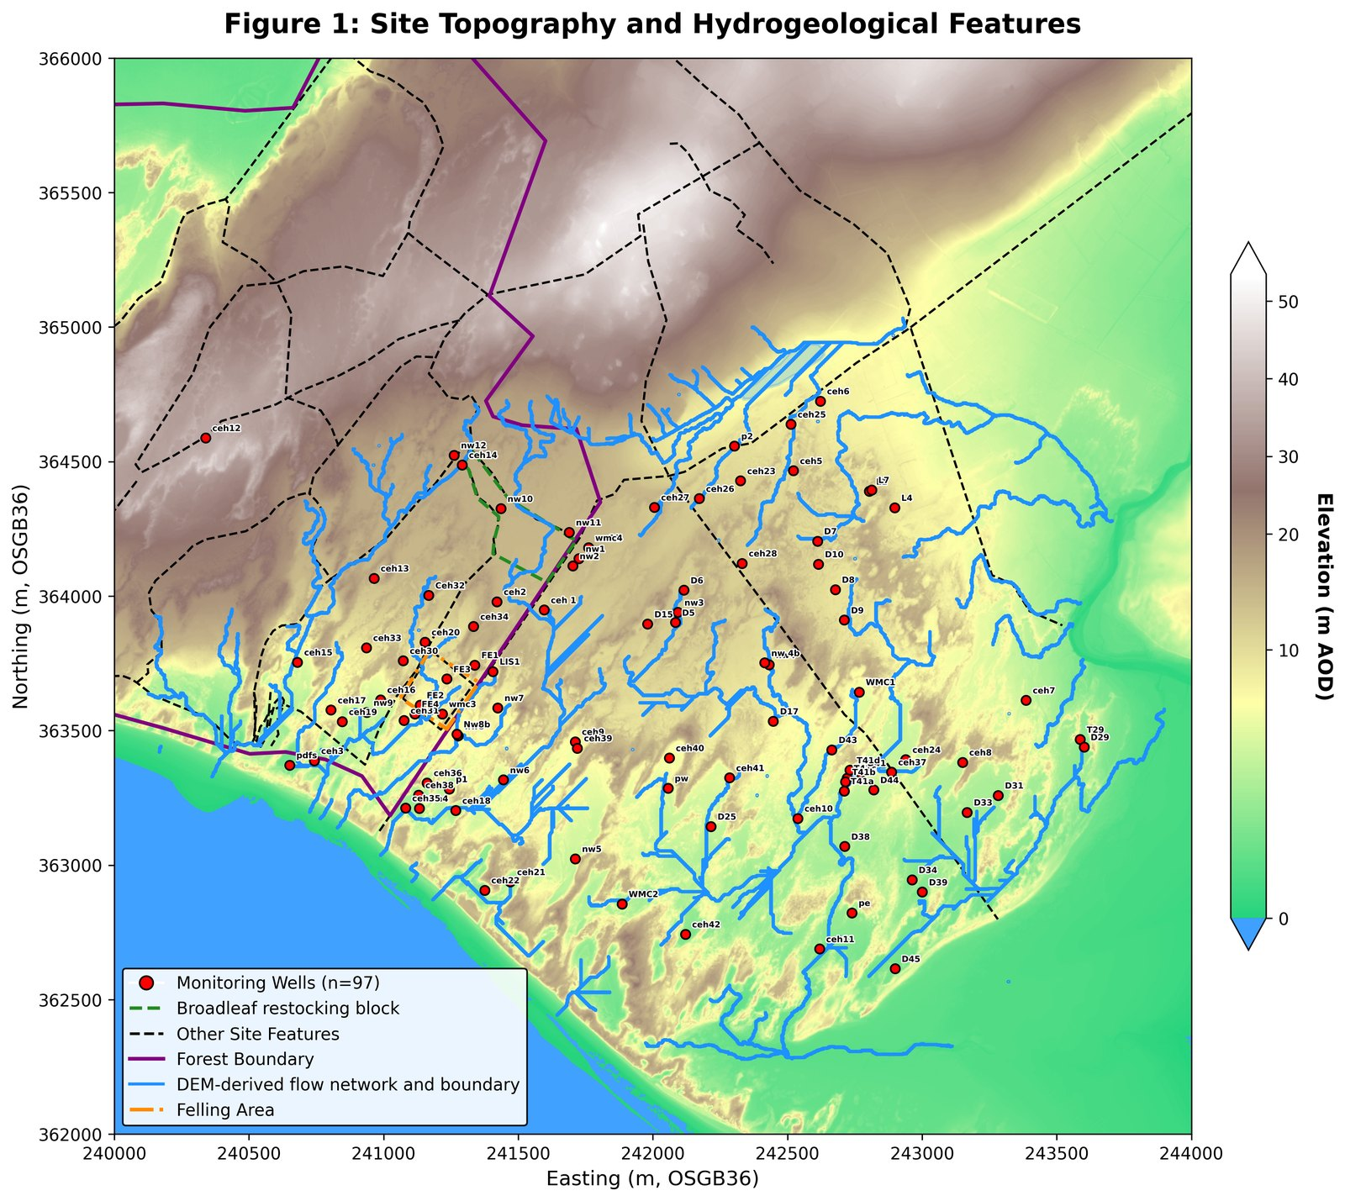
Figure 1. Site topography, geology and monitoring network at Newborough Warren. (Digital elevation model with rock ridge, forest boundary, watershed boundary, and a flow network derived algorithmically from the DEM for orientation only — no perennial surface streams are present on site. LiDAR data: © NRW & OS.)

3. Data and methods

3.1 Groundwater and climate records
The primary observational dataset is a network of manually read dipwells, with water-table elevation recorded at approximately monthly intervals. Each reading is taken at the end of the month and represents the water level for the month just ended; readings are bucketed to a monthly timestamp by field convention, with a reading on or before the fifteenth of a month assigned to the preceding month and a later reading assigned to the same month. All monthly series therefore index the month to which the reading belongs rather than the day on which it was taken. Of the full monitoring array, wells with sufficient record length form the reference network used for model fitting; the remainder, with shorter records, form an extended network classified by pattern matching (Section 3.3). Water levels are expressed both in metres above ordnance datum and, for the displacement formulation, as depth below the ground surface at each well.
Climate forcing is taken from the Royal Air Force Valley station. Monthly precipitation totals are used directly. Potential evapotranspiration is computed by the Thornthwaite method from monthly mean temperature and station latitude; this is an empirical index of atmospheric evaporative demand and does not define a specific reference surface in the manner of Penman–Monteith, a property that bears on the interpretation of the atmospheric-draw coefficient (Section 3.4). Rainfall and PET are monthly totals for the same calendar month as the water-table change they are aligned against; no rainfall lag is applied, consistent with the end-of-month measurement convention.

3.2 Hierarchical clustering of hydrograph dynamics
The reference network is partitioned into hydrogeologically distinct zones by agglomerative hierarchical clustering with Ward’s minimum-variance linkage (Ward, 1963). The distance metric is the Pearson correlation distance between standardized well hydrographs, which compares the shape of the seasonal and inter-annual water-table dynamics while discarding absolute elevation; two wells that fluctuate in synchrony are treated as similar regardless of their mean water-table depth. This isolates the dynamic hydrogeological signature — the timing and relative amplitude of filling and draining — from the topographic offset between wells.
The number of clusters is selected by a dual-metric approach combining the Ward’s merge-distance profile, which identifies the partition at which further agglomeration incurs a disproportionate increase in within-cluster variance, with the mean silhouette coefficient (Rousseeuw, 1987), which favours partitions with well-separated, internally coherent groups. Seasonal amplitude — the long-term mean difference between winter maximum and summer minimum at each cluster centroid — is retained as a secondary descriptor characterizing each unit but is not used in the clustering itself.

3.3 Network extension by Pearson affinity analysis
The primary classification, derived from the reference network, is extended to the wells with shorter records by Pearson affinity analysis. Unlike the mechanistic models, this stage operates on the raw observed time series without model fitting: each well’s hydrograph is correlated against every cluster centroid, and the well is assigned to the cluster with which it correlates most strongly. The correlation delta between the assigned and next-strongest cluster classifies membership into tiers, distinguishing core members with an unambiguous dominant affinity from wells with closely competing affinities between neighbouring clusters. A multi-cluster affinity flag identifies wells whose hydrographs are nearly equally well matched by several centroids; the spatial concentration of these flags delineates the gradational transition zones where the boundaries between hydrogeological units are diffuse rather than sharp. The extended-network wells are classified for spatial completeness and are not used in the cluster-level mechanistic fits.

3.4 State-space model and the displacement formulation
The mechanistic core of the framework is a three-term linear state-space model relating the monthly change in water-table position to climate forcing and to the antecedent head. For a given well or cluster centroid, the model is
Δh(t) = β₁·P(t) − β₂·PET(t) − β₃·h_disp(t−1)
where Δh(t) is the change in water-table position during month t, P(t) and PET(t) are the month-t precipitation and potential evapotranspiration totals, and h_disp(t−1) is the water-table displacement above the drainage datum at the end of the preceding month. The three coefficients are constrained to enter with physically correct sign and are reported as positive quantities: β₁ (recharge sensitivity) is the water-table rise per unit rainfall; β₂ (atmospheric draw) is the decline per unit PET; and β₃ (proportional drainage decay) is the fraction of antecedent displacement dissipated by lateral drainage each month.
The drainage term is referenced to a displacement above a fixed datum rather than to the absolute or ground-surface-referenced head:
h_disp = D + h_depth
where D is the drainage datum (a uniform depth below the ground surface, set at 3.7 m for the primary analysis) and h_depth is the water-table position in the negative-below-ground convention. Two features of this specification are central. First, the drainage term uses the displacement at the end of the previous month — the start of the current month — rather than the current month’s level. Using the contemporaneous level would introduce simultaneity bias, since that level is itself the result of the drainage being modelled; physically, the discharge during a month is driven by the head at the start of the month. Second, referencing drainage to a sub-surface datum rather than to the ground surface allows the head-dependent drainage response to be resolved consistently across wells of very different mean water-table depth, including the low-gradient forest interior where a surface-referenced drainage term is weak and borderline. The sensitivity of the fit to the datum choice is examined by independently optimizing D at each well over a sweep of candidate depths and comparing the resulting fit against the uniform datum (Section 4.7).
The model is fitted by ordinary least squares without an intercept at each reference well and at each cluster centroid hydrograph. The recharge-efficiency of each unit is summarized by the lumped catchment storage coefficient, LCSC = 100/β₁, expressing the depth of rainfall required to raise the water table by a fixed increment; lower LCSC denotes more efficient recharge. Because the fitted coefficients fold together vegetation effects, specific yield and soil-moisture dynamics, and because no intercept is fitted, the recharge term in an open-boundary system of this kind can absorb unmeasured boundary fluxes into β₁ (Young, 2011; Knotters and van Walsum, 1997); this is addressed explicitly through the residual-field analysis (Section 3.10) and the specific-yield estimation (Section 3.8).
A depth-dependent extension, in which β₂ is replaced by β₂·exp(−λd) to allow atmospheric draw to decline as the capillary fringe retreats from the root zone with increasing water-table depth d, was evaluated at cluster level by grid search over λ. Because the extension introduces a nonlinearity that would propagate into the closed-form analytical outputs derived elsewhere, it is retained as a diagnostic of depth-coupling rather than adopted as the operational model; the fixed-β₂ SSM is used throughout, understood as an effective depth-averaged parameterization.

3.5 Model benchmarking against a traditional linear model
The predictive value of the explicit storage-decay term is assessed by benchmarking the SSM against a traditional linear model (TLM) that omits the head-dependent drainage term, fitting the water-table change as a function of climate forcing alone. Both models are fitted at every reference well and compared in two modes. In one-step diagnostic mode, each prediction is corrected by the observed level from the previous month, and the two models are compared by coefficient of determination. In iterative simulation mode, the model is run forward from an initial condition without observational correction, propagating its own predictions, and the two models are compared by Nash–Sutcliffe efficiency. The iterative comparison is the discriminating test, because it exposes the cumulative drift that arises when storage memory is omitted. The spatial pattern of the iterative NSE gain is mapped across the network as a diagnostic of where head-dependent drainage memory is indispensable to prediction and where the aquifer approximates a linear climate response.

3.6 Spatial coefficient mapping and within-forest regression
The per-well SSM coefficients are interpolated across the site by inverse-distance weighting over a regular grid built on a LiDAR-derived digital elevation model, with ridge cells and non-aquifer areas masked. This yields continuous surfaces of recharge sensitivity, atmospheric draw and drainage rate, together with a model-fit-quality surface, providing a spatially resolved expression of aquifer behaviour that complements the cluster-level summaries.
Within the forested zone, where the canopy is broadly uniform but the per-well coefficients span much of the site-wide range, the per-well coefficients are regressed against elevation, distance from the ridge and easting to test whether the within-forest variation tracks topographic position and water-table depth or canopy differences. Because the subsurface beneath the plantation is not cored, elevation and position serve as proxies for substrate, and the regression isolates this topographic control on the mechanistic coefficients beneath a constant land cover.

3.7 Mean monthly water-balance decomposition
The fitted cluster coefficients are used to decompose the mean monthly water balance of each cluster into its component fluxes under identical climate forcing. Recharge is computed as β₁ times mean monthly precipitation, atmospheric draw as β₂ times mean monthly PET, and gravity drainage as β₃ times the mean displacement above the datum. All terms are expressed in metres of water-table change per month — the natural unit of the state-space model — and are directly comparable across clusters that receive the same climate input. Canopy interception is not added as a separate loss term: in the forested clusters it is already embedded implicitly in the lower fitted β₁ and β₂, and adding it explicitly would double-count losses. The net monthly balance — recharge minus total losses — quantifies the residual that would be required from an unmeasured boundary input to maintain long-run equilibrium.
An indicative volumetric conversion is presented alongside the head-space decomposition using assumed specific-yield values appropriate to the substrate of each cluster, with the empirical specific-yield estimates of Section 3.8 used to bracket the volumetric fluxes from above. For the forested clusters, canopy interception is applied as a reduction of the surface input following the site-specific interception fraction (Freeman, 2008), reducing the boundary input rather than being additive to losses. The evapotranspiration–drainage partition is bracketed by two independent methods — the SSM headspace ratio and a seasonal recession-curve analysis — and reported as a mid-point with an associated uncertainty range.

3.8 Specific-yield estimation by the water-table-fluctuation method
An independent estimate of specific yield is derived from the dipwell record by the water-table-fluctuation method (Healy and Cook, 2002), in which specific yield is the ratio of net recharge to the corresponding water-table rise. The method is applied to the cluster-mean hydrographs, retaining only months in which both the water table rose and net recharge was positive above defined thresholds, and constraining event-level estimates to a physically plausible range. Because monthly data cannot isolate individual storm events and the method at monthly resolution is known to conflate gravity drainage with capillary-fringe release, the resulting estimates are interpreted as upper bounds on effective storage rather than as point estimates (Healy and Cook, 2002; Scanlon et al., 2002).
For the forested clusters a canopy-interception correction is applied to the precipitation term before computing net recharge, reducing only the rainfall input and leaving the Thornthwaite PET term unchanged. PET is an energy-based atmospheric-demand index independent of land cover; reducing it to account for canopy-evaporated interception would conflate atmospheric demand with realized evapotranspiration and remove the same quantity from both sides of the balance. The corrected forest estimates are compared against the open-dune range to test whether the attenuated water-table response beneath the canopy reflects the surface boundary condition or a genuinely different subsurface storage. The per-well event-median specific yields are interpolated across the site to assess whether the spatial distribution of storage is uniform or shows discontinuities coinciding with the cluster margins.

3.9 Network-scale coastal-retreat gradient regression
Where a shoreline is actively eroding, the landward migration of the seaward drainage boundary deepens the near-coast water table over time independently of climate, imposing a spatial gradient on long-term summer-minimum trends. To partition each cluster’s observed summer-minimum decline into a coastal-retreat component and a climate-driven background, a network-scale, physics-based non-linear regression is fitted to per-well water-table trends against distance from the eroding shoreline. The perpendicular distance from each well to the eroding Caernarfon Bay high-water mark is computed once, out of pipeline, from the Ordnance Survey tidal-boundary shapefile restricted to the west-facing Newborough shoreline; the Menai Straits is excluded as non-eroding boundary. Distances are supplied to the analysis as a versioned data input with documented provenance.
Two functional forms are fitted: a Dupuit–Forchheimer steady-state strip-aquifer form, in which the coastal anomaly declines linearly to a far-field background and is capped at zero; and an exponential-decay form representing a diffusive transient response. Both are fitted by profile non-linear least squares with well and month fixed effects and a cumulative-water-balance covariate absorbed by within-well demeaning, with model selection between the two forms by the Akaike information criterion (Akaike, 1974). Three nested specifications are fitted to test robustness to forest-cover inclusion: the full network excluding the clearfell-zone wells; a forest-free network dropping all forested wells; and a single-cluster specification using only the western non-forested cluster, with the far-field background held to the network value because that cluster contains no well at the coast and an unconstrained fit on its restricted distance range would be under-identified. The forest-free linear-with-cutoff fit is taken as the headline. The headline fit is then applied to decompose each cluster’s summer-minimum slope into gradient and climate components, quantifying the contribution of coastal retreat to long-term water-table trends across the network.

3.10 Spatial interpolation, flow field and water-balance residual field
A mean water-table surface is constructed by inverse-distance interpolation of per-well mean elevations to a regular grid on the British National Grid, masked to the sea-boundary extent. No elevation mask is applied, because the water table is a continuous surface independent of the overlying topography. Normalized Darcy flow-direction vectors are computed from the head-gradient field using a single representative hydraulic conductivity (Betson et al., 2002) and an interpolated aquifer-thickness surface; these are reported as directional context for the interpolated head field rather than as the output of a calibrated continuous-flow model (Bear, 1972; Freeze and Cherry, 1979).
The water-balance residual field quantifies, at each reference well, the degree to which the three-term SSM closes the long-term water balance. The residual is computed from the fitted coefficients as the difference between modelled mean losses (atmospheric draw plus drainage) and modelled mean recharge, with the canopy-interception correction applied at forested wells. Positive residuals indicate locations where modelled losses exceed modelled recharge, implying an unmodelled input such as lateral recharge from the bedrock ridge; near-zero residuals indicate that the three-term balance closes adequately. The field is interpolated to a grid with sea-boundary anchors and ridge cells masked. It is interpreted as a structural diagnostic of where the model’s three terms are sufficient, not as a quantified map of lateral inflow, since the residual also absorbs nonlinear soil-moisture storage dynamics, coefficient sensitivity and any systematic bias in the Thornthwaite PET estimate. The mechanistic attribution of the residual pattern is tested by an independent cross-correlation lag analysis for distance-dependent transport from the ridge and a seasonal climatology analysis for unmodelled summer evaporative demand.

3.11 Computational implementation
All data pre-processing, statistical modelling and spatial mapping were implemented as a sequential, numbered Python pipeline, with time-series management in pandas and NumPy, model fitting in statsmodels, and spatial interpolation and rendering over a LiDAR DEM. The state-space alignment and displacement calculation are implemented once in a shared model-utilities module and called by every script that fits the SSM, ensuring that all downstream analyses are consistent with the cluster-level fits. The pipeline and its outputs are reproducible by running the published scripts in sequence.

4. Results

4.1 Climate and well-network characterization
The RAF Valley record establishes that Newborough Warren operates under a persistent annual water surplus, with mean annual precipitation of approximately 890 mm against mean annual Thornthwaite PET of approximately 652 mm over the monitoring period, a study-period P/PET ratio of about 1.36 (Figure 2). The surplus is strongly seasonal in its expression: winter rainfall exceeds evaporative demand by a wide margin, while summer PET exceeds rainfall, concentrating atmospheric demand on the aquifer during the period of lowest recharge. Inter-annual variability in the water balance is driven almost entirely by precipitation rather than by evaporative demand, which shows strong seasonality but negligible inter-annual trend. The post-2013 period has run warmer than the earlier summer-temperature baseline (Figure 3), intensifying the summer deficit.
The reference network comprises 66 wells with monthly water-table records over the 2005–2026 monitoring period, supplemented by 21 extended-network wells with shorter records classified by pattern matching (Section 4.3). Records run to a median length well above a decade, giving the spatial density needed to distinguish cluster-scale behaviour from site-wide climate forcing.
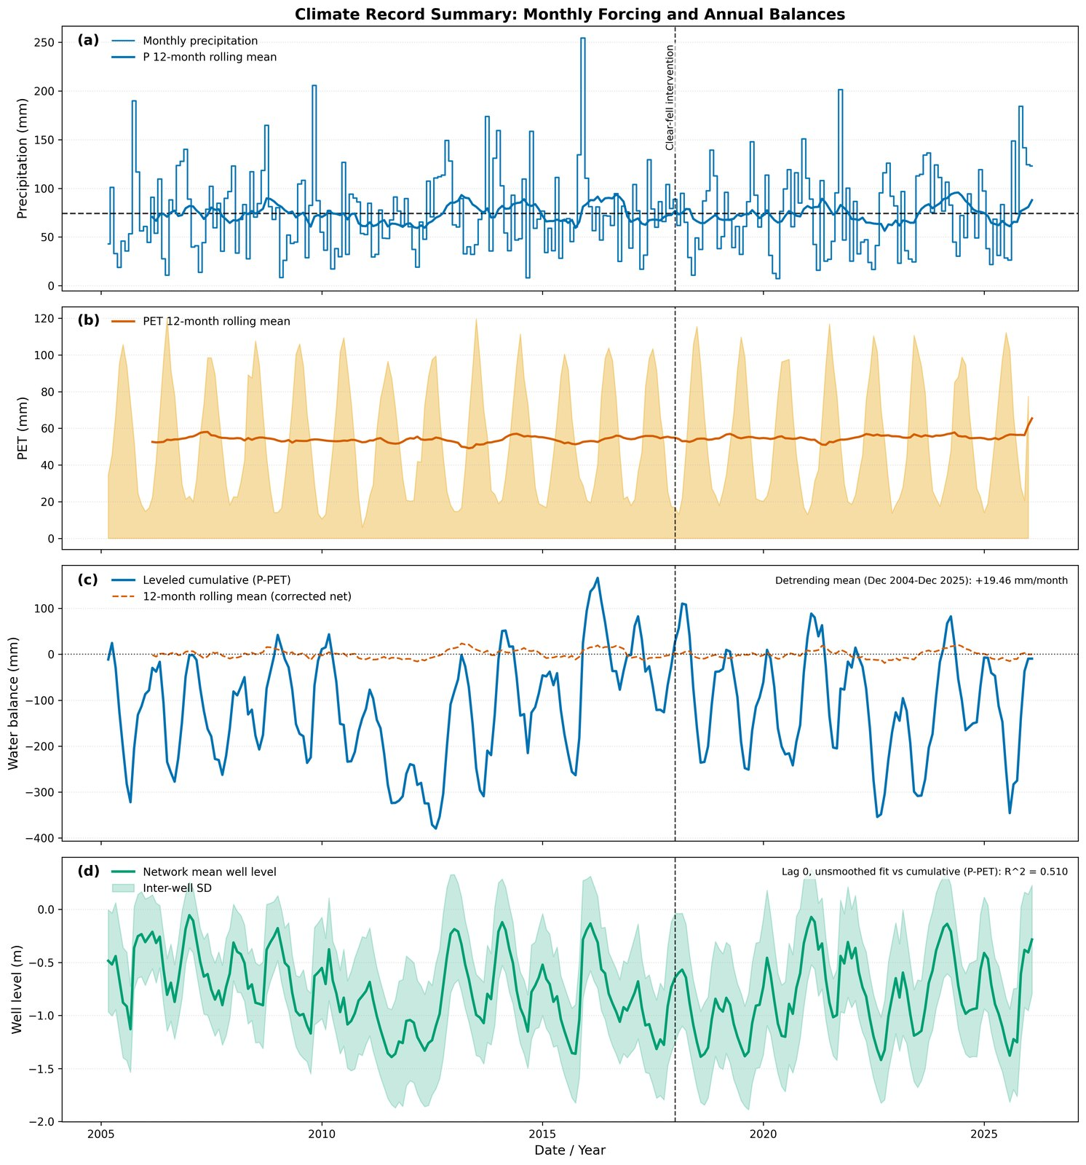
Figure 2. Climate forcing over the monitoring period (2005–2026) from RAF Valley: monthly precipitation and Thornthwaite PET, with cumulative water surplus. The full ~95-year station record is not shown here; the long-term warming context is given in Figure 3.
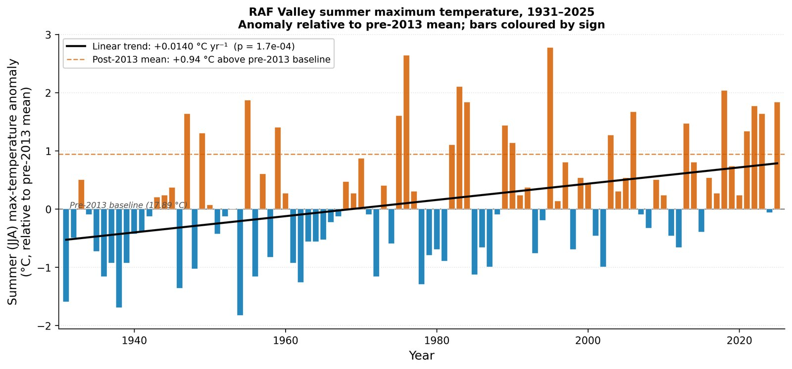
Figure 3. Summer-temperature record showing the post-2013 warming relative to the earlier baseline.

4.2 Network clustering and spatial architecture
Hierarchical clustering of the standardized hydrograph dynamics, using the Pearson correlation distance and Ward’s linkage, resolves five spatially coherent units under the dual-metric selection of k (Figure 4). The partition separates the network into a lake-margin unit (C1, Lake Edge), an open-dune unit (C2, Dune), a western unit on deeper sand (C3, Western Residual), and two units beneath the Corsican pine plantation distinguished by topographic position (C4, Main Forest, on the elevated ridge flank; C5, Coastal Forest, on the lower coastal fringe) (Figure 5). The cluster sizes are C1 = 7, C2 = 24, C3 = 21, C4 = 9 and C5 = 5 wells. The five units recover the broad substrate contrast between the responsive, storage-limited east and the buffered, deeper-sand south-west (Stratford et al., 2007), the latter (C3) gradational toward both the open dune and the forest rather than a sharply bounded block, with the two forested units segregating from this south-western dune despite their inferred substrate similarity. The cluster-centroid hydrographs and seasonal amplitudes are shown in Figure 6.

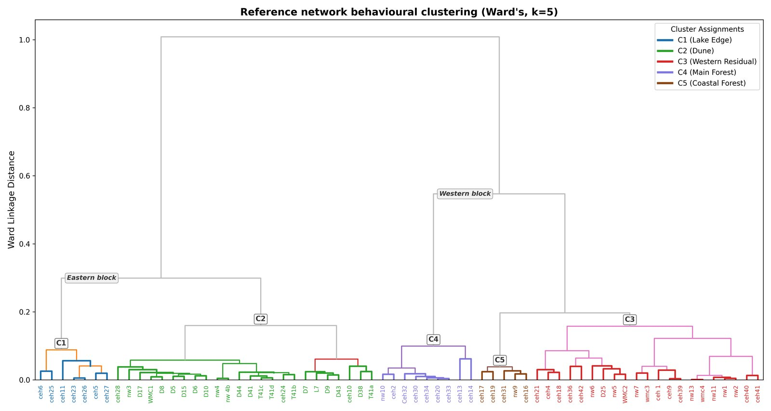
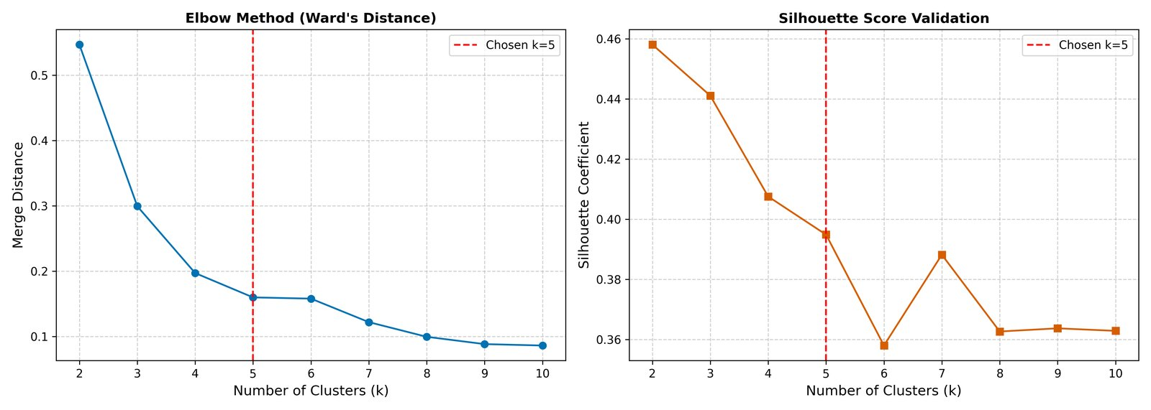
Figure 4. Hierarchical clustering of hydrograph dynamics: Ward’s dendrogram (upper) and the dual-metric cluster-number selection (lower).

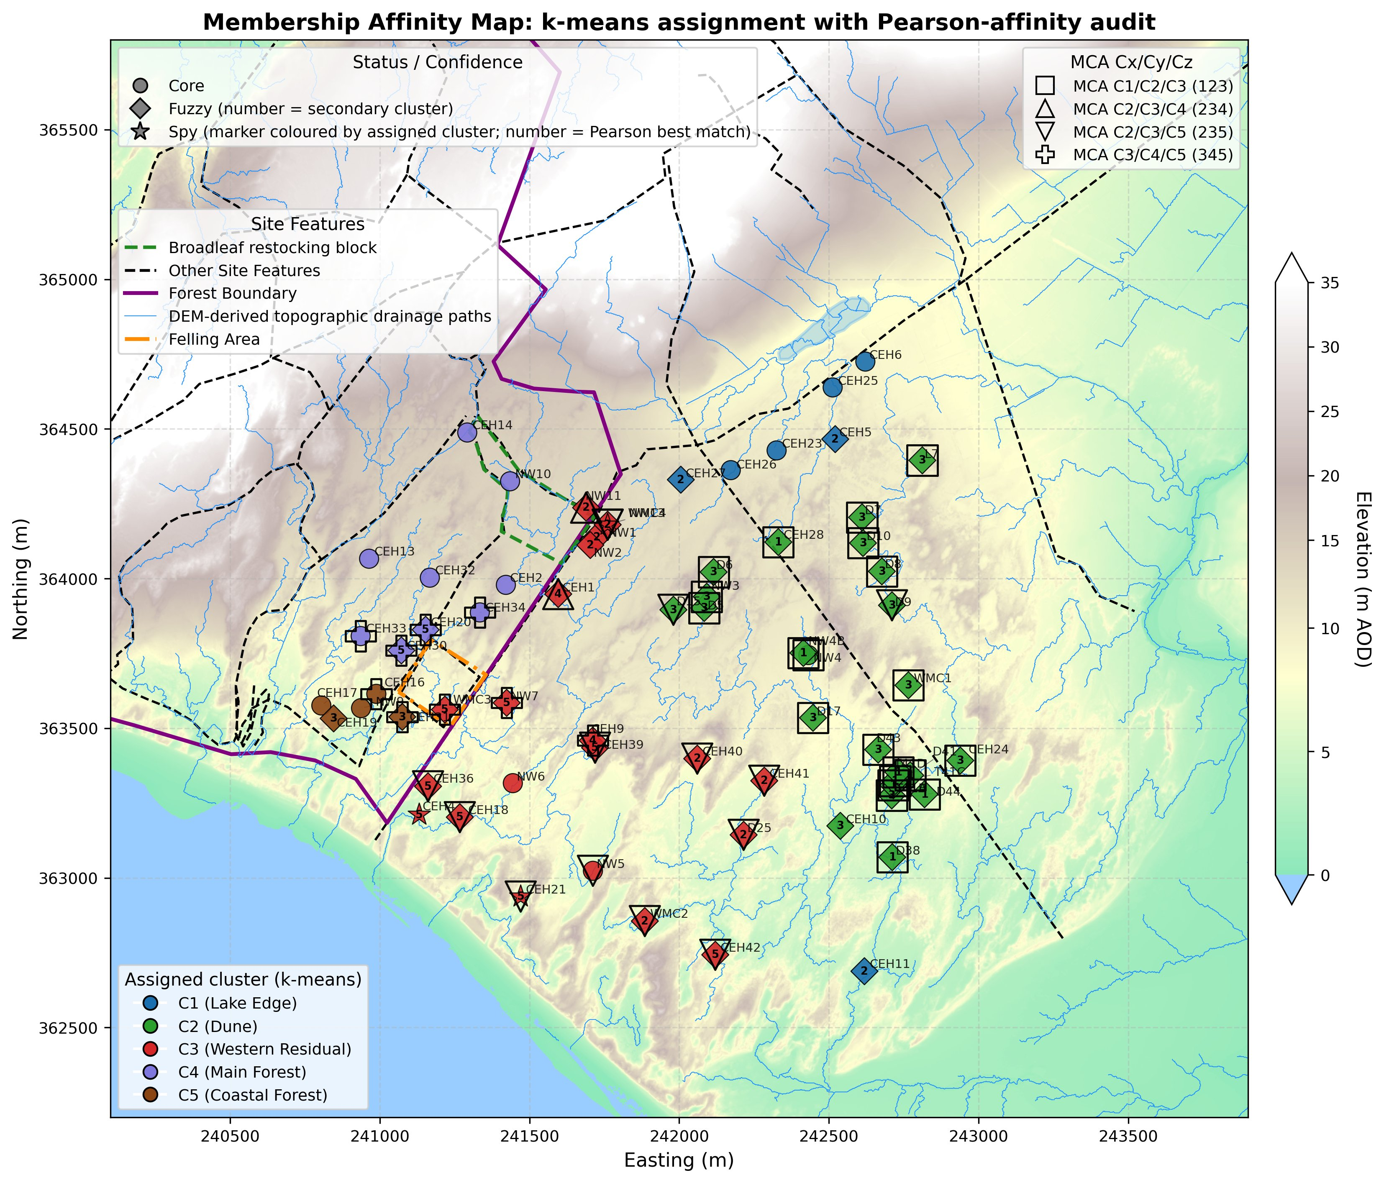
Figure 5. Spatial distribution of the five hydrogeological clusters (Pearson affinity validation), reference network (66 wells). Points coloured by k-means assignment; circles = Core (Δr > 0.05), diamonds = Fuzzy (Δr < 0.05; number inside diamond = secondary cluster), stars = Spy (Pearson best-match ≠ assigned; number inside star = best-match cluster). Hollow overlays = Multi-Cluster Affinity (r > 0.90 with ≥3 clusters). LiDAR: © NRW & OS.
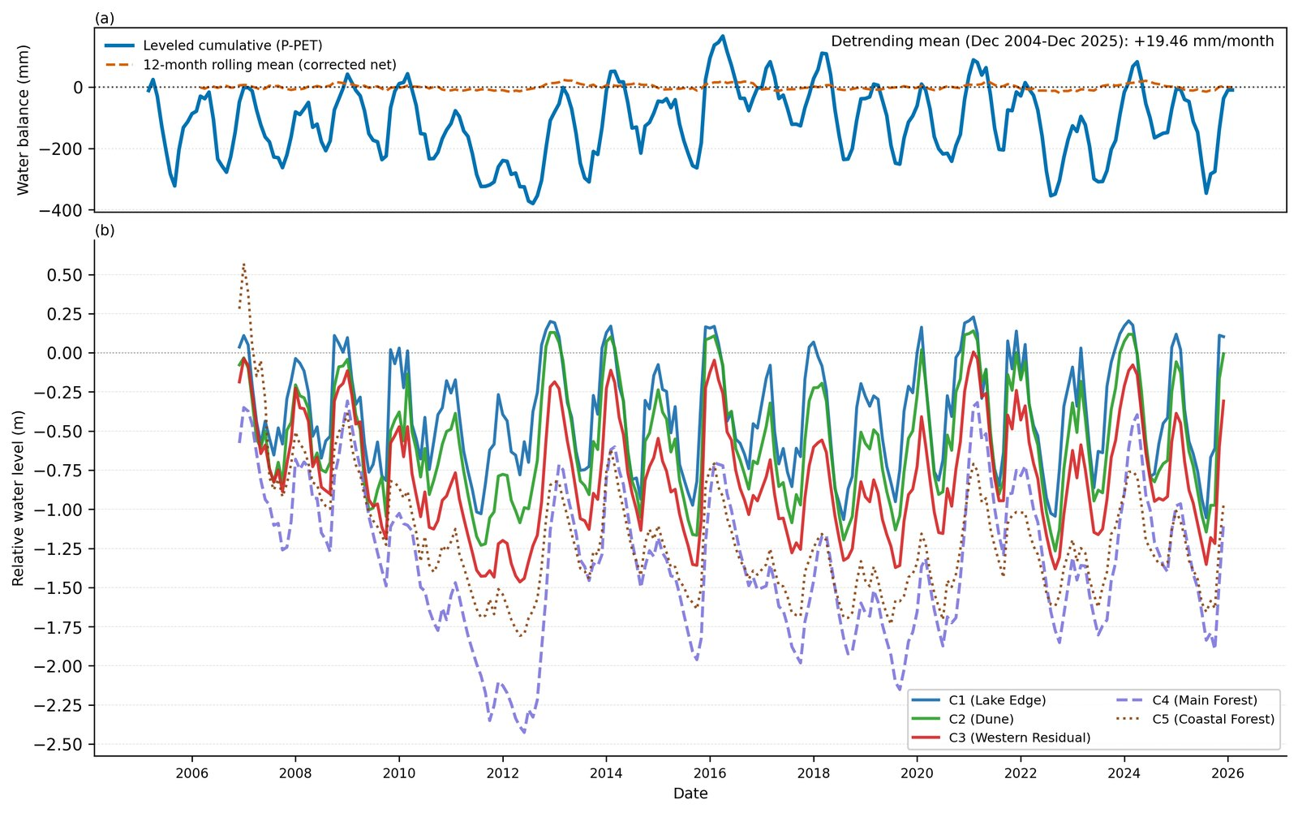
Figure 6. Cluster-centroid hydrographs and seasonal amplitudes, 2005–2026.

4.3 Affinity validation of the cluster structure
The Pearson affinity analysis confirms the primary membership of the great majority of reference wells. Membership separates into tiers by the correlation delta between the assigned and next-strongest cluster: a minority of wells are core members with an unambiguous dominant affinity, while many show closely competing affinities between neighbouring units, consistent with gradational rather than sharp boundaries in a contiguous, highly transmissive sand aquifer (Rao and Srinivas, 2006). The spatial concentration of multi-cluster-affinity flags along the C1/C2/C3 transition and the forest–dune margin identifies the zones where geological and vegetative controls overlap.

4.4 Cluster mechanistic coefficients
The five clusters are characterized mechanistically by the displacement-formulation SSM fitted to each cluster-centroid hydrograph (Table 1). All coefficients are statistically significant (p < 0.003) at every cluster.
Table 1. Cluster mechanistic characterization. β₁ = recharge sensitivity (mm rise per mm rainfall); β₂ = atmospheric draw (mm decline per mm PET); −β₃ = proportional drainage decay (fraction of displacement above the 3.7 m datum dissipated per month); LCSC = 100/β₁ (rainfall depth, as % per unit rise, required to raise the water table — lower is more efficient); R² = one-step diagnostic fit.
Cluster | n wells | β₁ | β₂ | −β₃ | LCSC (%) | R²
C1 Lake Edge | 7 | 4.58 | 0.96 | 0.090 | 21.8 | 0.73
C2 Dune | 24 | 3.98 | 1.77 | 0.066 | 25.1 | 0.75
C3 Western Residual | 21 | 3.57 | 1.85 | 0.058 | 28.0 | 0.81
C4 Main Forest | 9 | 2.52 | 2.55 | 0.020 | 39.7 | 0.68
C5 Coastal Forest | 5 | 2.41 | 1.32 | 0.045 | 41.5 | 0.68
Recharge sensitivity β₁ is highest at the Lake Edge (C1: 4.58), indicating that each millimetre of rainfall drives a proportionally larger water-table rise in the shallow-till eastern aquifer than in the Dune (C2: 3.98) or Western Residual (C3: 3.57). The two forested clusters return near-identical and substantially lower recharge sensitivities (C4: 2.52, C5: 2.41), consistent with canopy interception suppressing the rainfall signal reaching the water table. Expressed as LCSC, roughly 22–25% recharge efficiency at Lake Edge and Dune contrasts with 28% in the Western Residual and 40–41% beneath the plantation.
Atmospheric draw β₂ is highest at C4 (2.55) — where it is essentially equal to C4’s own β₁, so the Main Forest cluster loses as much water table per millimetre of PET as it gains per millimetre of rainfall — followed by C3 (1.85) and C2 (1.77), with C5 (1.32) and C1 (0.96) lowest. That C5 carries the same pine canopy as C4 yet returns less than half its atmospheric draw points to topographic position and water-table depth rather than canopy as the dominant control of the cluster-level β₂ contrast (Section 4.8). C1’s low β₂ reflects its shallow water table and rapid lateral drainage to the lake, where head-dependent drainage captures the dominant loss.
The drainage decay −β₃ shows the strongest contrast of the three coefficients: highest at C1 (0.090), where rapid lateral exchange with Llyn Rhos-Ddu drives fast recession, similar at C2 (0.066) and C3 (0.058), lower at C5 (0.045), and lowest at C4 (0.020), where a suppressed recharge pulse and weak lateral discharge produce the most sluggish drainage in the network.

4.5 Water balance and specific yield
The head-space water-balance decomposition (Table 2; Figure 7) closes to within 1.6% of total losses at every cluster, confirming that the three-term displacement SSM captures the principal fluxes without requiring an unmeasured boundary term at the cluster mean. Recharge declines systematically from C1 (0.341 m/month) to the forested clusters (≈0.18 m/month), and total losses track recharge closely at every cluster. The drainage partition varies markedly: drainage accounts for 85% of total losses at C1 but only 24% at C4, where atmospheric draw dominates.
Table 2. Mean monthly head-space water balance (m/month), 2005–2026. Identical climate forcing at every cluster (P̄ ≈ 74.4 mm/month, PET̄ ≈ 55.0 mm/month).
Cluster | Recharge | Atm. draw | Drainage | Total loss | Residual | Drain % / ET %
C1 Lake Edge | 0.341 | 0.053 | 0.292 | 0.345 | −0.004 | 85 / 15
C2 Dune | 0.296 | 0.097 | 0.203 | 0.299 | −0.004 | 68 / 32
C3 Western Residual | 0.265 | 0.101 | 0.164 | 0.265 | <0.001 | 62 / 38
C4 Main Forest | 0.187 | 0.140 | 0.045 | 0.186 | +0.002 | 24 / 76
C5 Coastal Forest | 0.179 | 0.073 | 0.111 | 0.183 | −0.004 | 60 / 40
The indicative volumetric conversion (Table 3) places all clusters under ≈893 mm/yr rainfall, with canopy interception removing ≈214 mm/yr at the forested clusters to leave ≈678 mm/yr of throughfall. The ET/drainage partition mid-point ranges from drainage-dominated at C1 (≈647 mm/yr drainage vs ≈246 mm/yr ET) to ET-dominated at C4 (≈250 vs ≈429 mm/yr).
Table 3. Indicative annual volumetric water balance (mm/yr). I = canopy interception (24% of P; Freeman, 2008), forested clusters only. ET/drainage are mid-points of two independent partitioning methods.
Cluster | P | I | P_net | ET (mid) | Drainage (mid)
C1 Lake Edge | 893 | 0 | 893 | 246 | 647
C2 Dune | 893 | 0 | 893 | 408 | 485
C3 Western Residual | 893 | 0 | 893 | 339 | 554
C4 Main Forest | 893 | 214 | 678 | 429 | 250
C5 Coastal Forest | 893 | 214 | 678 | 226 | 452
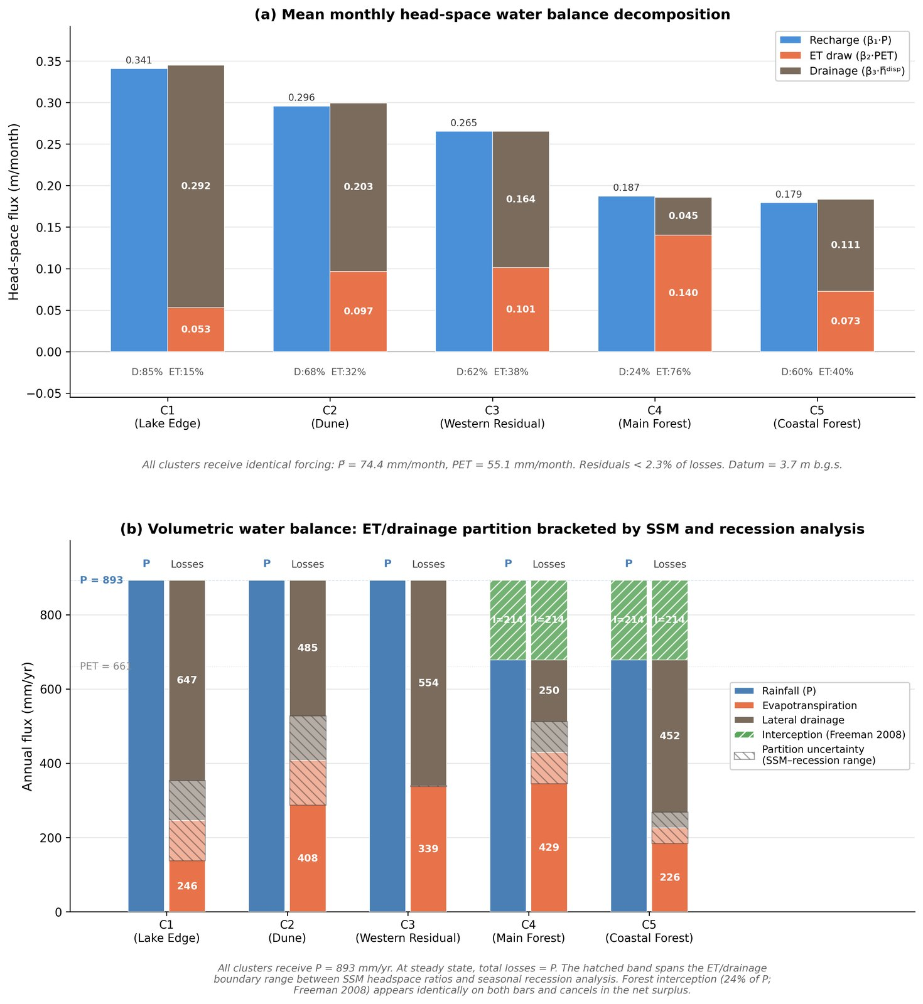
Figure 7. Water-balance decomposition by cluster: head-space (recharge versus atmospheric draw and drainage) and indicative volumetric partition. In (b), the hatched partition-uncertainty band spans the two independent estimates of the ET/drainage split — the SSM head-space ratio and the seasonal winter/summer recession ratio; it is negligible for C3, where the two methods coincide (both ≈0.60 drainage / 0.40 ET).
The water-table-fluctuation specific-yield estimates (Table 4; Figure 8) provide an independent test of whether the cluster contrasts reflect storage architecture or surface boundary conditions. Uncorrected forested-cluster medians (C4: 0.315, C5: 0.356) exceed the open-dune range, because gross rainfall overstates the recharge flux beneath the canopy. Applying the canopy-interception correction to the recharge term brings the forest medians down to 0.248 (C4) and 0.321 (C5): C4 falls cleanly into the open-dune range (0.210–0.325), while C5 sits at its upper edge. The C4 result indicates that the attenuated water-table response beneath the plantation reflects the surface canopy boundary condition rather than a fundamentally different substrate. The C5 estimate is the least reliable in the network — a majority of its rising-limb events imply an event-level Sy at or above the porosity of dune sand, so its median is constrained by the physical-plausibility limit rather than freely estimated — and it is reported as a weak corroborator only. All WTF medians exceed the assumed values used in the volumetric balance by a factor of two to three and are interpreted as upper bounds (Healy and Cook, 2002; Scanlon et al., 2002).
Table 4. Specific yield by cluster, water-table-fluctuation method. Event-median Sy; forested clusters reported uncorrected and interception-corrected.
Cluster | Sy assumed | Sy WTF median (uncorr.) | Sy WTF median (corrected)
C1 Lake Edge | 0.08 | 0.210 | —
C2 Dune | 0.12 | 0.268 | —
C3 Western Residual | 0.12 | 0.325 | —
C4 Main Forest | 0.12 | 0.315 | 0.248
C5 Coastal Forest | 0.12 | 0.356 | 0.321
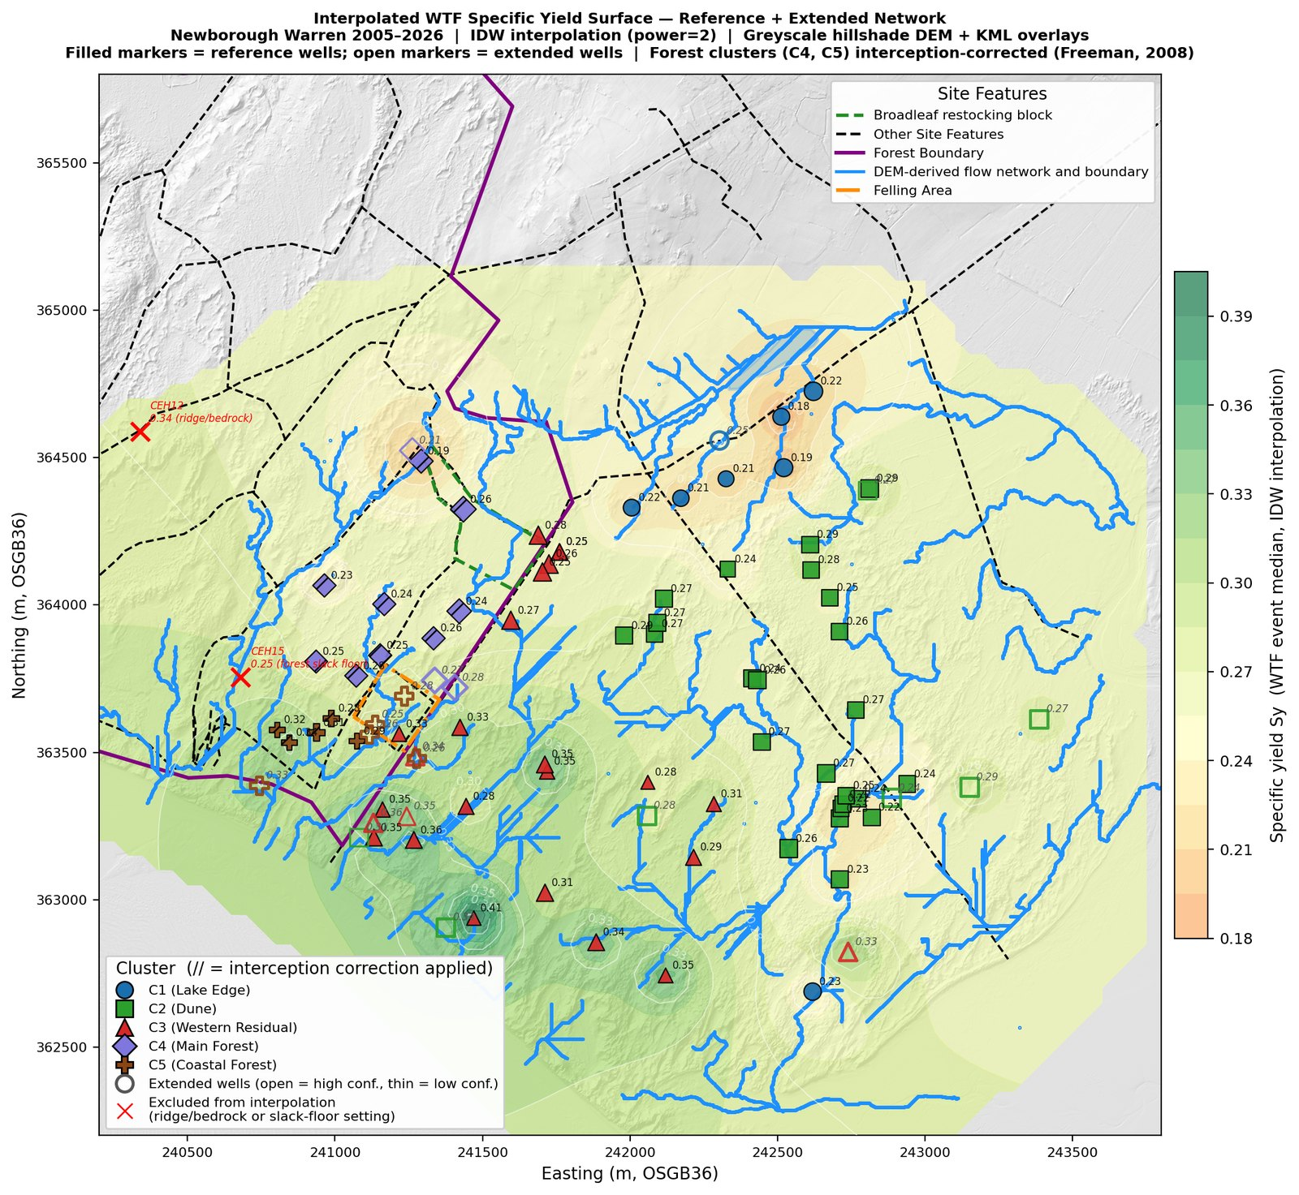
Figure 8. Interpolated water-table-fluctuation specific-yield surface; forest wells interception-corrected. The distribution is broadly uniform with no discontinuity at the cluster margins. The surface is a spatial diagnostic of a lumped-parameter model, not the output of a calibrated continuous-flow simulation. The interpolation extends over the rock-ridge bedrock outcrop on the northern boundary, which carries no monitoring wells; values shown there are extrapolations from the surrounding network and are not interpretable as model output on bedrock.

4.6 Model benchmarking: SSM versus traditional linear model
In one-step diagnostic mode the SSM and TLM are nearly indistinguishable (median R² 0.92 and 0.91), because each prediction is corrected by the previous observed level. The distinction emerges under iterative simulation, where the SSM achieves a median NSE of 0.75 against the TLM’s 0.13 — a median gain of +0.55 NSE units — and a positive iterative NSE at 65 of 66 wells against 43 of 66 for the TLM (Table 5; Figure 9). The explicit β₃ term captures storage-decay memory and prevents the cumulative drift that causes the TLM to diverge. The largest gains occur in the lake-proximal eastern aquifer (e.g. CEH25: TLM −1.47 → SSM 0.68; CEH6: −1.12 → 0.66), where head-dependent drainage is strongest; the smallest occur in the forest interior, where weak drainage makes the storage term nearly dispensable. The spatial pattern of the gain therefore serves as a non-invasive diagnostic of where nonlinear storage dynamics govern the aquifer.
Table 5. SSM (B) versus traditional linear model (A) benchmarking.
Metric | TLM (A) | SSM (B) | Δ (B−A)
Median one-step R² | 0.91 | 0.92 | +0.01
Median iterative R² | 0.66 | 0.80 | +0.13
Median iterative NSE | 0.13 | 0.75 | +0.55
Wells with iterative NSE > 0 | 43 / 66 | 65 / 66 | —
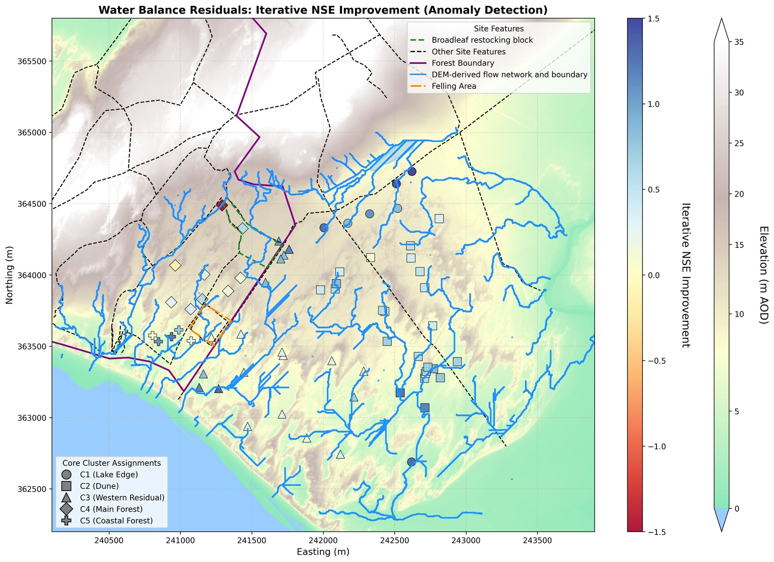
Figure 9. Spatial pattern of the SSM-over-TLM iterative Nash–Sutcliffe improvement across the reference network.

4.7 Spatial coefficient structure and drainage timescale
Per-well drainage-datum optimization shows the R²-maximizing datum varying systematically across the site, from shallow at the Lake Edge to deep in the western and forest interior, but the R² gain over the uniform 3.7 m value is negligible across most of the network (Figure 10), confirming the uniform-datum assumption. Interpolation of the per-well coefficients yields continuous surfaces whose broad structure aligns with the cluster boundaries while preserving substantial within-cluster variation (per-well ranges in Table 6; Figure 11). Recharge sensitivity β₁ is highest in the north-east around the Lake Edge wells (per-well up to 6.3) and declines across the open dune to its lowest values beneath the forest. Atmospheric draw β₂ peaks in the C4 forest interior and along the ridge-adjacent northern dune, and is lowest at the Lake Edge. Drainage rate β₃ shows the strongest spatial contrast of any coefficient, from the fast-draining Lake Edge (per-well up to 0.135 per month) to the near-stagnant forest interior, where one ridge-flank well (CEH14) records a negative value where the displacement formulation does not capture the boundary condition.
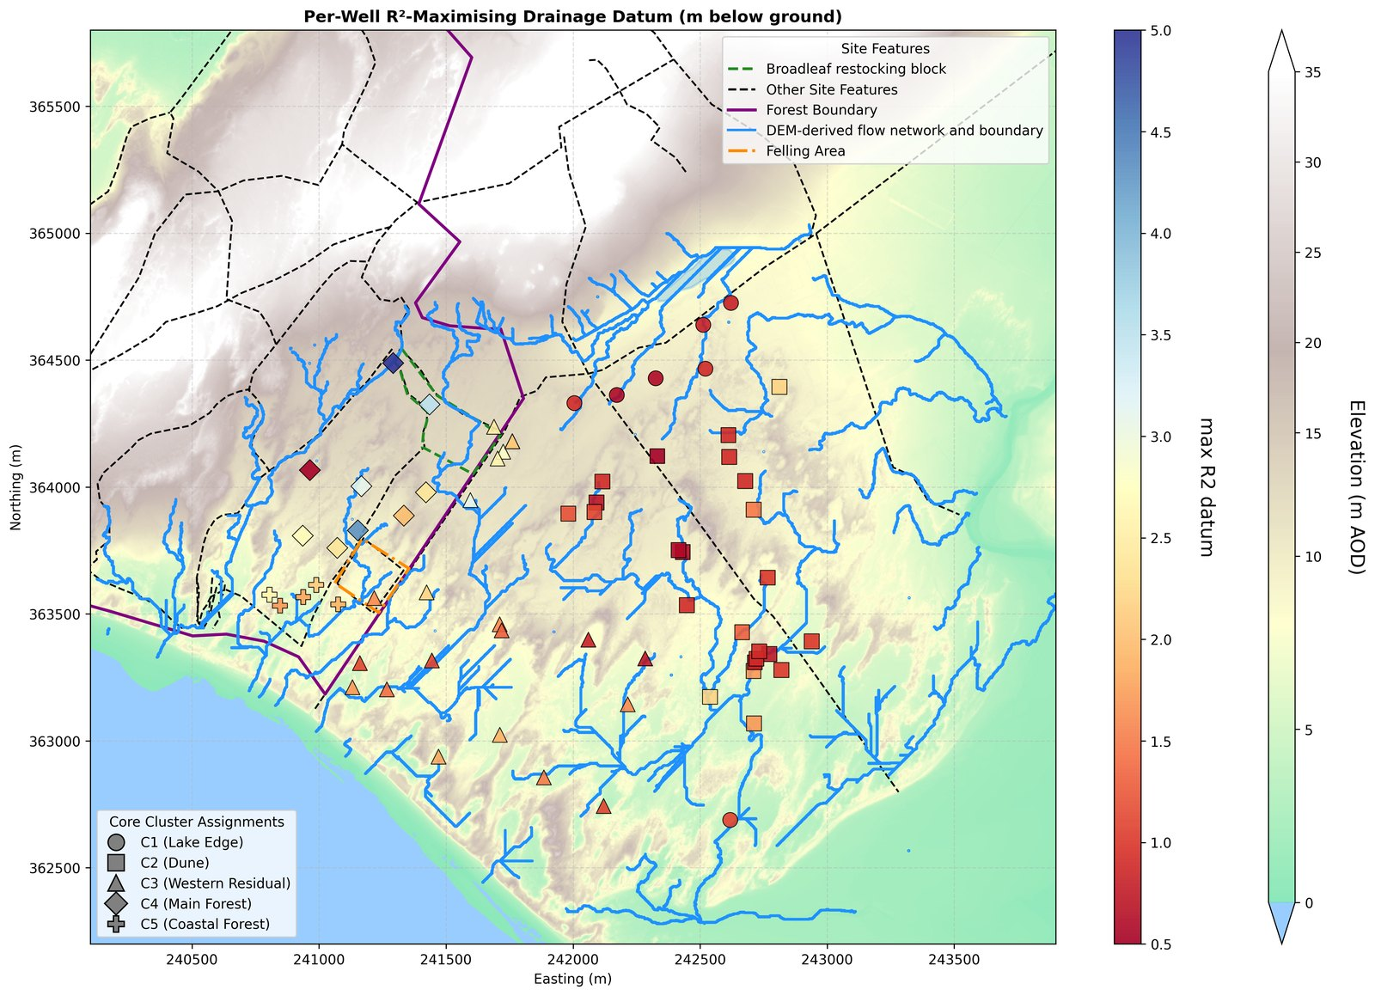
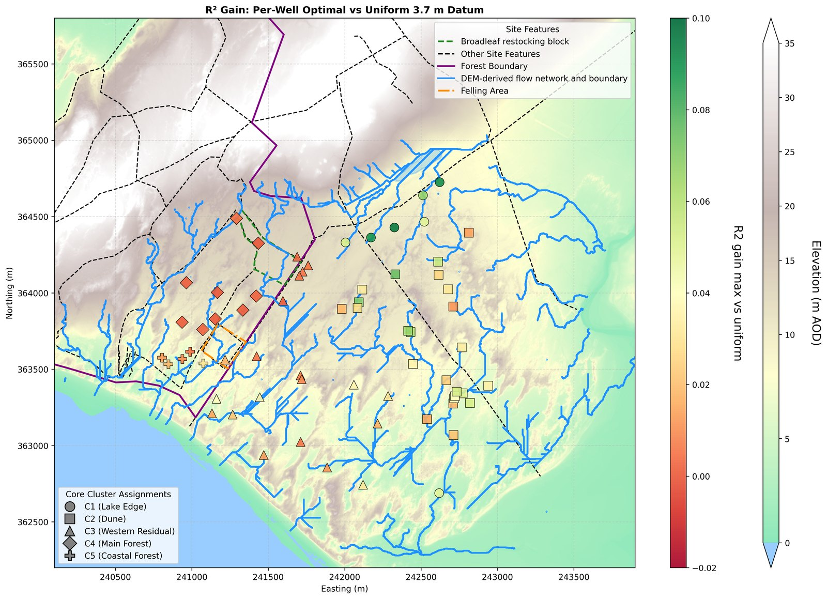
Figure 10. Per-well optimal drainage datum (left) and the R² gain over the uniform 3.7 m datum (right).

Table 6. Per-well SSM coefficient ranges by cluster.
Cluster | β₁ range | β₂ range | β₃ range
C1 Lake Edge | 4.31–6.27 | −0.20–1.34 | 0.088–0.135
C2 Dune | 3.36–5.46 | 1.20–2.61 | 0.055–0.112
C3 Western Residual | 2.32–4.83 | 1.08–2.28 | 0.031–0.111
C4 Main Forest | 2.06–3.48 | 2.17–3.72 | −0.016–0.043
C5 Coastal Forest | 2.03–2.73 | 0.88–1.47 | 0.037–0.057

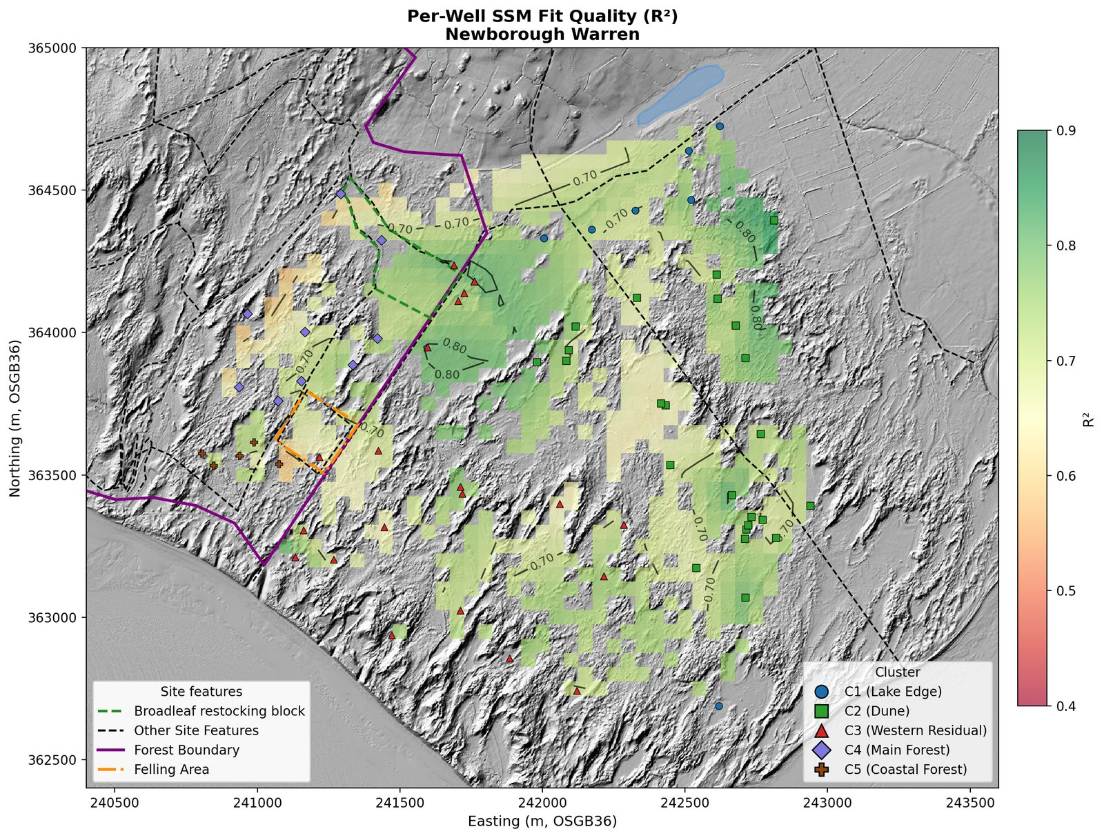

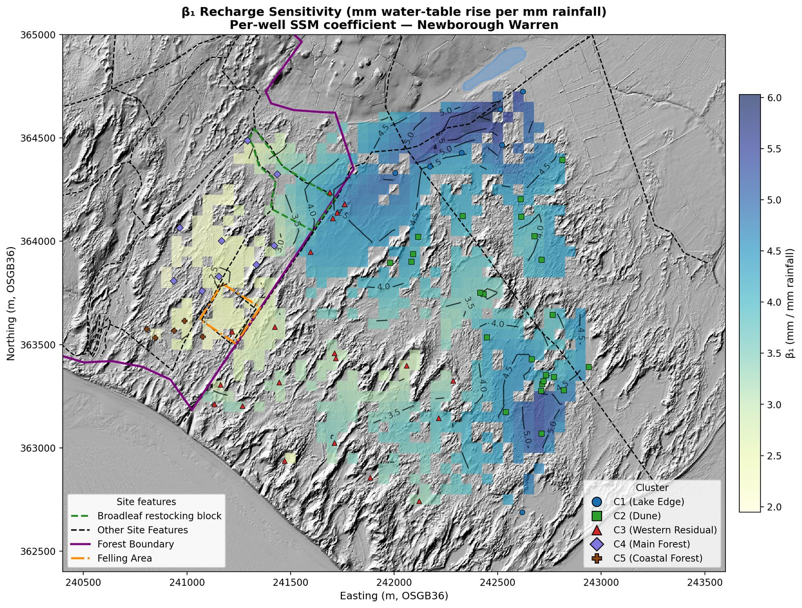
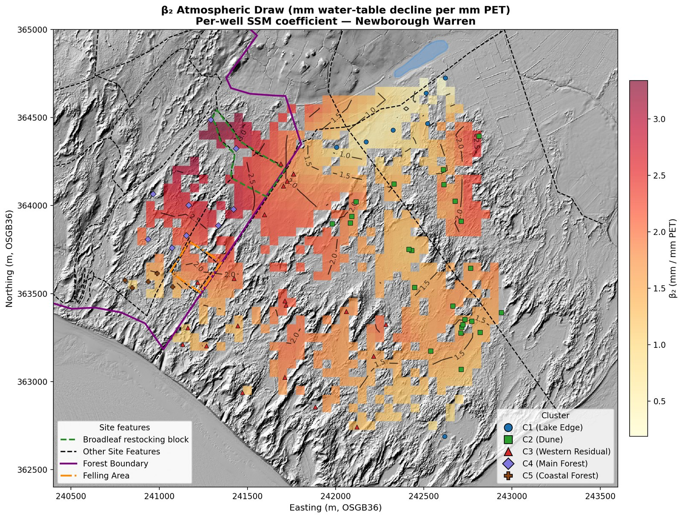
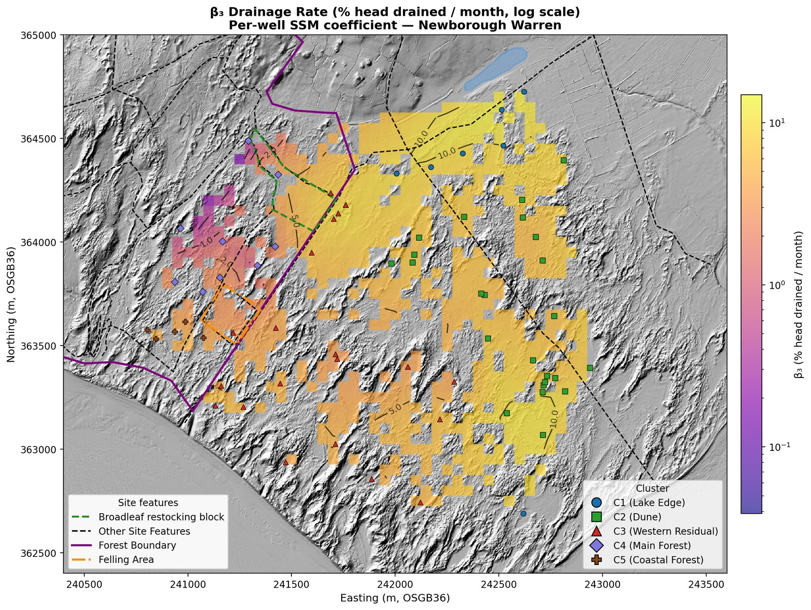
Figure 11. Spatial SSM coefficient atlas: (a) β₁ recharge sensitivity, (b) β₂ atmospheric draw, (c) β₃ drainage rate, (d) one-step R² fit quality. The interpolation extends over the rock-ridge bedrock outcrop on the northern boundary, which carries no monitoring wells; values shown there are extrapolations from the surrounding network and are not interpretable as model output on bedrock.
The characteristic drainage timescale τ = Sy/β₃ synthesizes the independently derived specific yield and drainage rate into a single measure of aquifer memory (Table 7; Figure 12). The eastern open dune turns over rapidly (C1 median 2.2 months, C2 3.7), the western dune is intermediate (C3 median 6.6 months), and the forest interior shows the longest memory in the network (C4 median 11.8 months, individual wells to 34). C5 Coastal Forest (median 7.1 months) resembles the western dune despite sharing the pine canopy, reinforcing the substrate and elevation control. Plotted together with the SSM-over-TLM gain and specific yield, the five clusters occupy distinct, non-overlapping regions of diagnostic space (Figure 13) — a model-based characterization of aquifer architecture consistent with, but derived independently of, the Ward’s clustering.
Table 7. Characteristic drainage timescale τ = Sy/β₃ (months) by cluster. Ridge-flank wells CEH14 (negative β₃) and CEH13 (near-zero β₃) excluded.
Cluster | τ min | τ median | τ max | n
C1 Lake Edge | 1.3 | 2.2 | 2.6 | 7
C2 Dune | 2.0 | 3.7 | 4.9 | 24
C3 Western Residual | 2.3 | 6.6 | 11.2 | 21
C4 Main Forest | 6.0 | 11.8 | 33.6 | 7
C5 Coastal Forest | 5.6 | 7.1 | 7.6 | 5
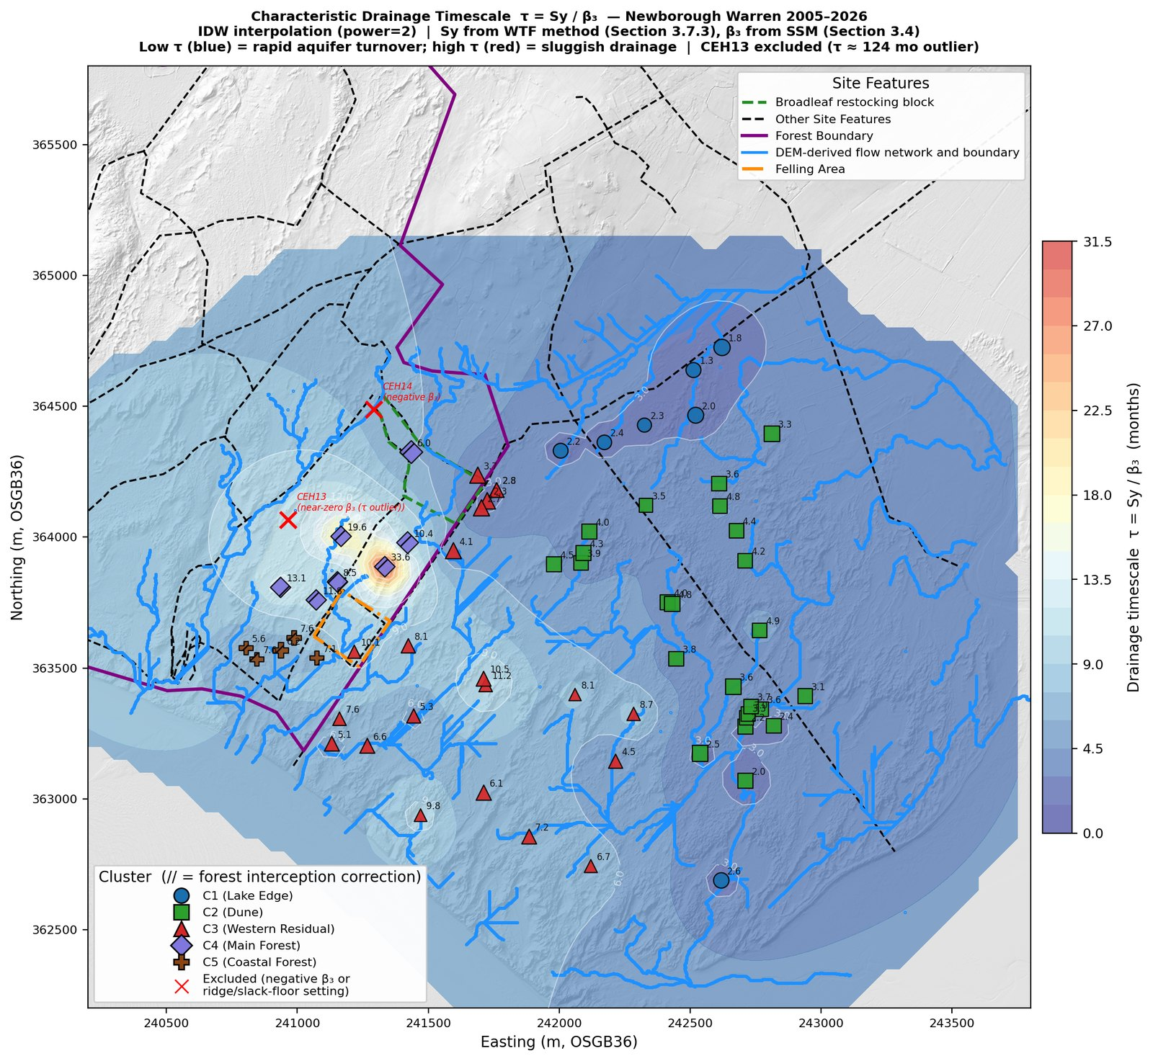
Figure 12. Characteristic drainage timescale τ = Sy/β₃ across the reference network. The interpolation extends over the rock-ridge bedrock outcrop on the northern boundary, which carries no monitoring wells; values shown there are extrapolations from the surrounding network and are not interpretable as model output on bedrock.
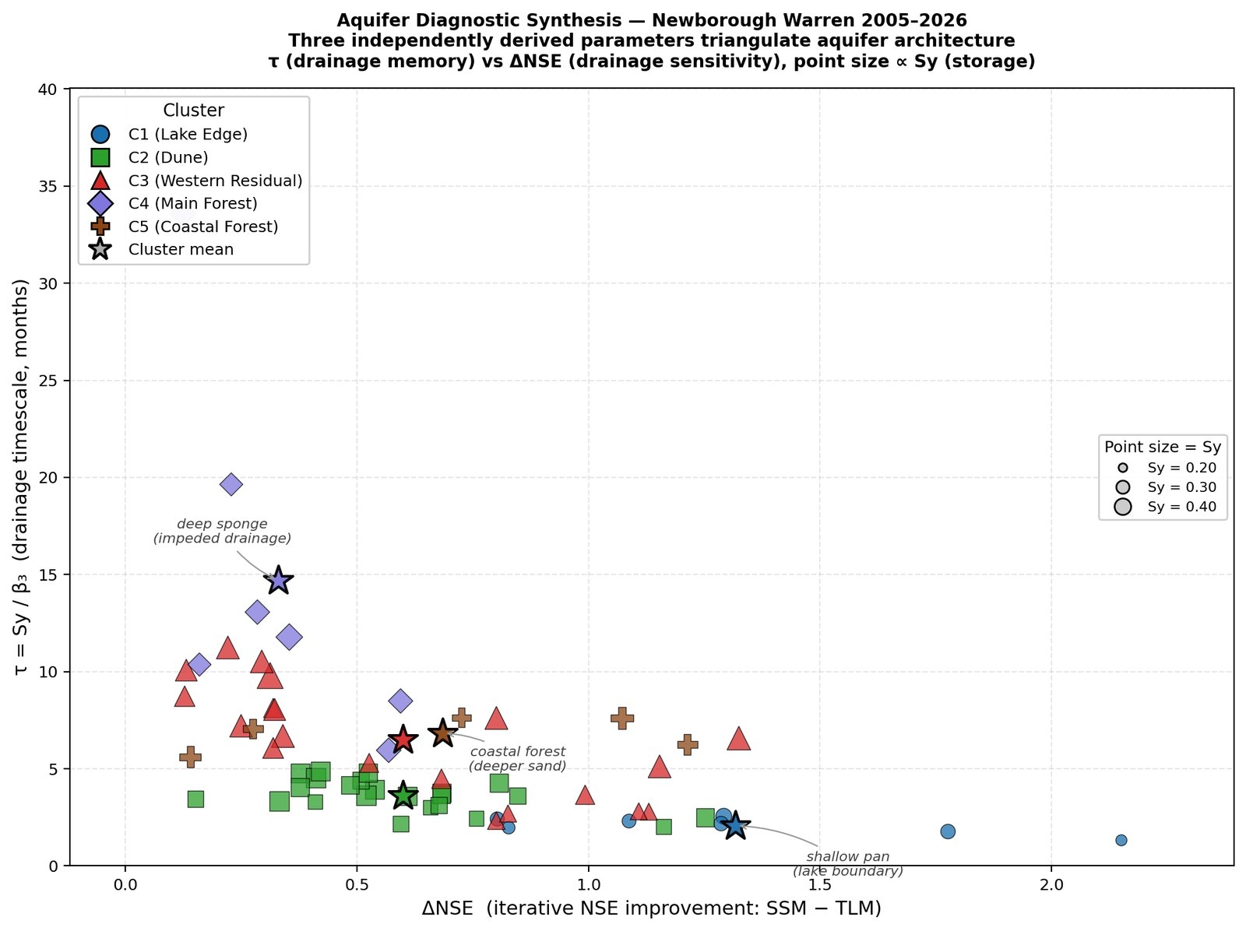
Figure 13. Aquifer diagnostic synthesis: drainage timescale τ versus SSM-over-TLM iterative NSE gain, points sized by specific yield and coloured by cluster.

4.8 Substrate control within the forested zone
Where the canopy is uniform but the per-well coefficients span much of the site-wide range, regression against elevation, distance from the ridge and easting identifies the underlying control (Table 8). Atmospheric draw β₂ is overwhelmingly governed by elevation (r = 0.981, p < 0.001; R² = 0.963): higher wells on the ridge return systematically higher β₂. Drainage β₃ shows a weaker but significant elevation dependence (r = −0.787, p < 0.001), with distance from the ridge adding information (combined R² = 0.739). Recharge β₁ shows no significant elevation relationship (p = 0.37); easting is its best single predictor (r = 0.62, p = 0.018).
β₂ does vary substantially across clusters (Table 1), but the cluster-level contrast is set by substrate, water-table depth and topographic position rather than by canopy maturation: the C4–C5 split — a 2.6-fold difference in atmospheric draw beneath a common pine canopy — is the cleanest evidence. C4 and C5 form two distinct groups rather than a continuum. They separate almost entirely on β₂ — C4 at 2.17–3.72, C5 at 0.88–1.47, with no overlap — and on mean elevation (C4: 10.7 m, C5: 5.7 m; p = 0.0001), corresponding to the transition from the elevated ridge flank, with its deeper water table and unsaturated zone, to the low coastal fringe, with a shallower water table. Both zones carry the same canopy, so the separation tracks elevation and water-table depth rather than canopy. The subsurface beneath the plantation is not cored; on the topographic and coefficient evidence the C4/C5 split is best read as a substrate-and-elevation discontinuity rather than an arbitrary division of a continuous canopy population.
Table 8. Within-forest spatial predictors of per-well SSM coefficients (n = 14). Pearson r (p).
Coefficient | vs Elevation | vs Dist. from ridge | vs Easting
β₁ recharge | 0.258 (0.37) | −0.561 (0.037) | 0.620 (0.018)
β₂ atm. draw | 0.981 (<0.001) | −0.900 (<0.001) | 0.749 (0.002)
β₃ drainage | −0.787 (<0.001) | 0.596 (0.024) | −0.419 (0.14)

4.9 Mean water-table surface and flow field
Interpolation of per-well mean elevations gives a head surface highest in the north-western forest zone adjacent to the bedrock ridge (≈14 m AOD), declining to 7–9 m AOD across the central dune and 2–3 m AOD at the southern and eastern coastal margins, with contours running approximately NE–SW (Figure 14). Normalized Darcy flow vectors computed from the head gradient diverge radially from the north-western high point: predominantly southward and south-westward in the western half of the site and south-eastward in the eastern half, broadly consistent with the DEM-derived flow network. The vectors are reported as directional context for the interpolated head field rather than as the output of a calibrated continuous-flow model.
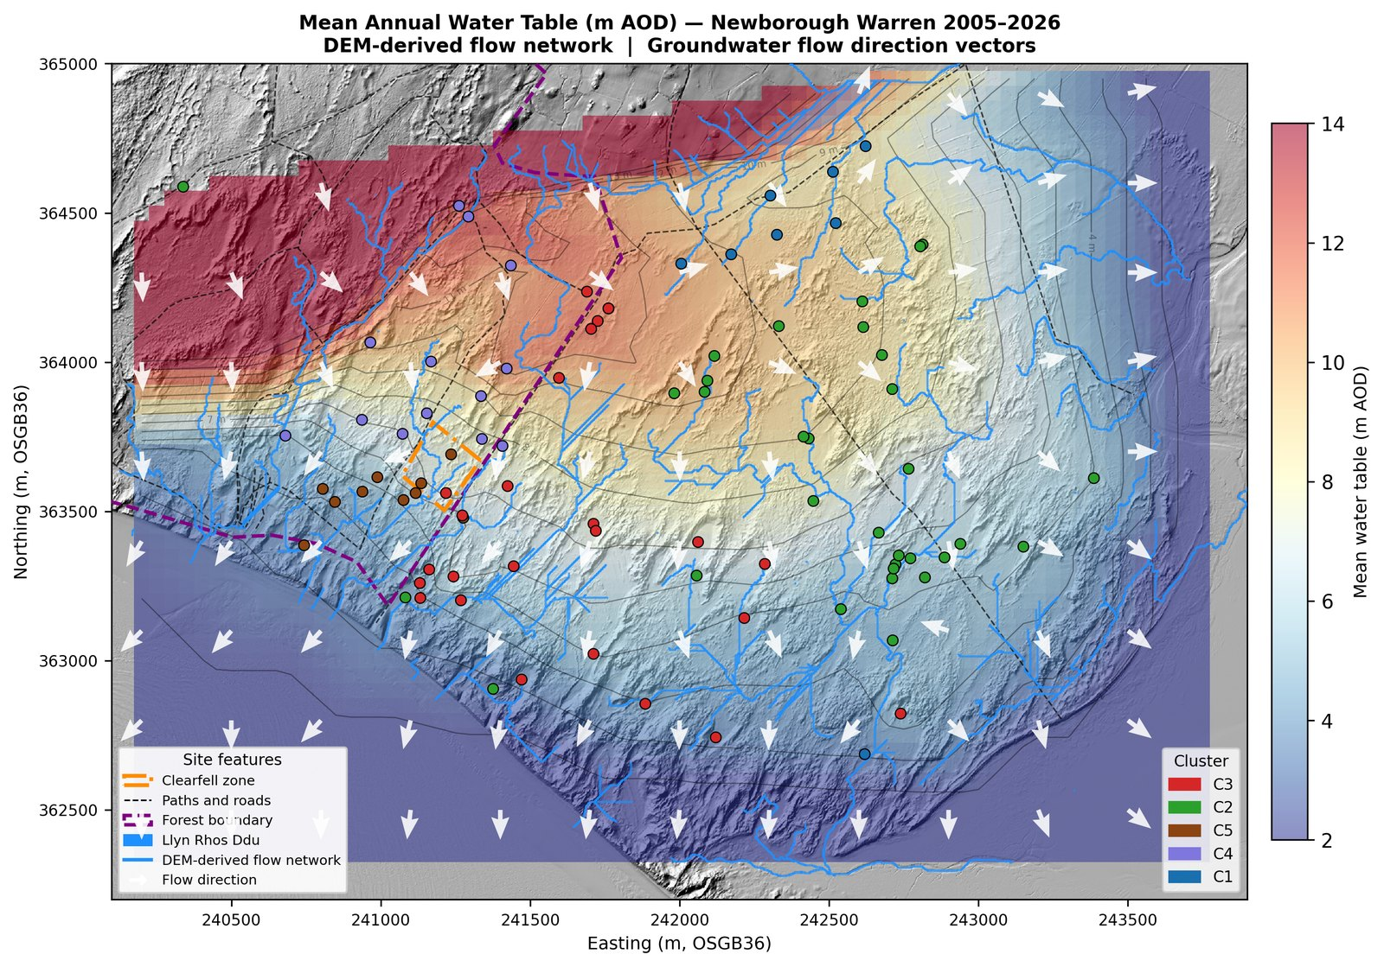
Figure 14. Mean annual water-table surface (m AOD) with normalized Darcy flow-direction vectors. The interpolation extends over the rock-ridge bedrock outcrop on the northern boundary, which carries no monitoring wells; values shown there are extrapolations from the surrounding network and are not interpretable as model output on bedrock.

4.10 Water-balance residual field
The residual field — modelled losses minus modelled recharge at each well, from the fitted coefficients — shows a broad north-west to south-east gradient (Figure 15). The strongest positive residuals concentrate along the northern forest margin and ridge flank, where measured rainfall-driven recharge alone does not account for observed water levels. The largest single positive residual, at CEH14, is treated as a candidate-attribution case rather than as a confirmed point-source artefact: the well sits about 50 m from the drainage field of a cottage in sporadic use, and intermittent septic-derived influx is one plausible explanation for its anomalous negative β₃ and its outlier residual. The attribution is not certain, but on this basis CEH14 is set aside from the broader ridge-margin pattern and treated separately. Residuals decline to near zero across the open dune, where the three-term balance closes, and become weakly negative at some south-eastern margin wells. The spatial coincidence of the largest positive residuals with the ridge boundary makes ridge-derived lateral input the most parsimonious candidate for the unmeasured flux, but the attribution is not resolved by the residual field alone: an independent cross-correlation lag test for distance-dependent transport from the ridge and a seasonal climatology test for unmodelled summer evaporative demand both returned null results. The residual pattern is real; its mechanistic attribution remains open and is taken up in the Discussion.
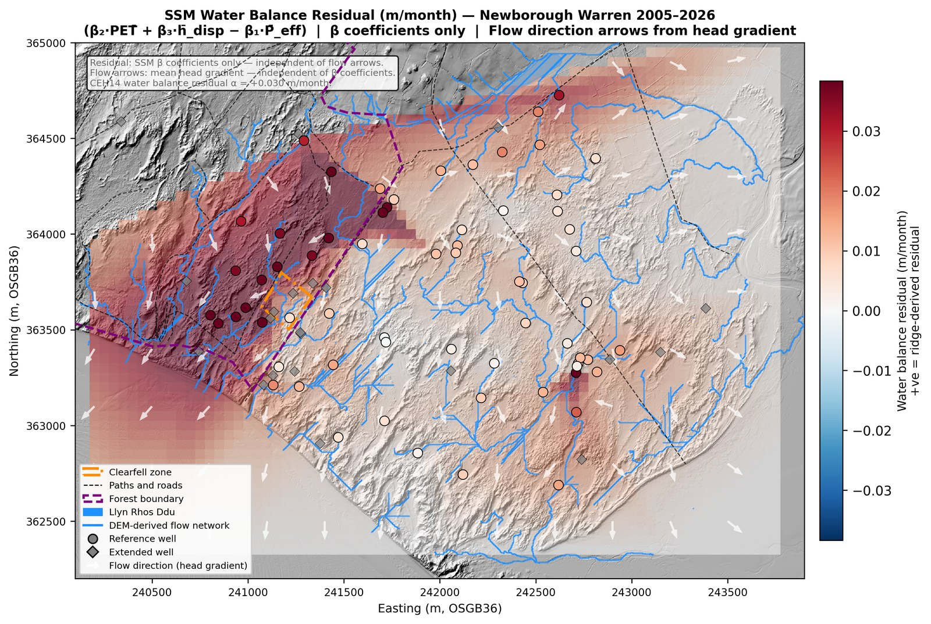
Figure 15. SSM water-balance residual field. Positive (red) indicates modelled losses exceeding modelled recharge; negative (blue) indicates over-prediction. The field is a spatial diagnostic of a lumped-parameter model, not the output of a calibrated continuous-flow simulation. The interpolation extends over the rock-ridge bedrock outcrop on the northern boundary, which carries no monitoring wells; values shown there are extrapolations from the surrounding network and are not interpretable as residuals on bedrock.

4.11 Coastal-retreat gradient and the partition of long-term decline
The network-scale regression of water-table trend against distance from the eroding Caernarfon Bay shoreline selects a linear-with-cutoff (Dupuit–Forchheimer) form in the forest-free headline specification, with a coast-edge deepening rate of −28.8 mm/yr above the climate background (95% CI −32.6 to −25.1), an inland reach of 894 m (792–995), and a far-field climate background of −6.4 mm/yr (Figure 16). The forest-free and full-network fits agree closely, and the C3-only specification returns a consistent coast-edge rate, confirming the gradient is not an artifact of forest-cover inclusion. The linear-with-cutoff and exponential-decay forms are statistically near-indistinguishable in the forest-free specification (ΔAIC ≈ 0.5); the linear-with-cutoff form is adopted as the headline on physical grounds, as it embodies the Dupuit–Forchheimer expectation of a finite inland reach beyond which the migrating seaward boundary exerts no influence, and the two forms agree to within about 1 mm/yr on the predicted coastal-retreat rate at the near-coast distances where it is largest.
Applying the headline fit to each cluster’s summer-minimum decline partitions the trend into a coastal-retreat component and a climate background (Table 9). The robust result is the network curve itself — fitted across thousands of well-months of the open-dune network and insensitive to functional form — together with the C3 Western Residual decomposition, which rests on 19 open-dune wells lying within the fitted inland reach: coastal retreat accounts for roughly a third of C3’s observed summer-minimum decline (mean 826 m from the coast), on top of the climate background. The inland clusters (C1, C2, and the two within-reach C4 wells retained after the clearfell-zone exclusion) lie beyond the fitted inland reach and carry no gradient component; their declines are climate-driven with an unexplained residual. This decomposition identifies coastal retreat as a distinct, spatially structured forcing on long-term summer minima that a climate-only attribution would fold into an apparent network-wide decline.
The C5 Coastal Forest row is reported for completeness but should not be read as a quantified cluster attribution. After the clearfell-zone exclusion and the requirement for a valid summer-minimum slope, only a single C5 well (nw9, 419 m from the coast) enters the gradient subset; its decline of −32.8 mm/yr is the steepest in the network and is statistically significant (p = 0.002), which is consistent with a strong near-coast retreat signal but cannot, from one well, support a quantified percentage. Because the forest-free curve is fitted on the open-dune wells and excludes the forested clusters entirely, an anomalous nw9 cannot bias the fit, and the choice of functional form does not bear on it: at nw9’s distance both forms predict a coastal-retreat deepening of about −15 mm/yr, leaving a large residual under either form. The single steep near-coast well is therefore treated as corroborating the gradient’s direction and magnitude rather than as an independent cluster-level estimate, and is cross-referenced to the substrate and coastal-position interpretation of C5 in Section 4.8.
Table 9. Decomposition of cluster summer-minimum decline into coastal-retreat and climate components (mm/yr). Well counts here are the gradient-analysis subset (clearfell-zone wells dropped; wells require a valid summer-minimum slope), not the cluster sizes of Table 1.
Cluster | mean dist. (m) | observed | coastal-retreat | climate | residual | coastal %
C1 Lake Edge | 1819 | −9.7 | 0.0 | −6.4 | −3.3 | 0%
C2 Dune | 1508 | −12.3 | 0.0 | −6.4 | −5.9 | 0%
C3 Western Residual | 826 | −6.8 | −2.2 | −6.4 | +1.8 | 32%
C4 Main Forest (n = 2) | 1142 | −11.5 | 0.0 | −6.4 | −5.1 | 0%
C5 Coastal Forest (n = 1) † | 419 | −37.7 | −15.3 | −6.4 | −16.0 | (41%) †
† C5 rests on a single open well (nw9) in the gradient subset; reported for completeness, not as a quantified attribution (see text). The observed decline shown is the cluster-centroid trend; nw9’s own per-well slope is −32.8 mm/yr.
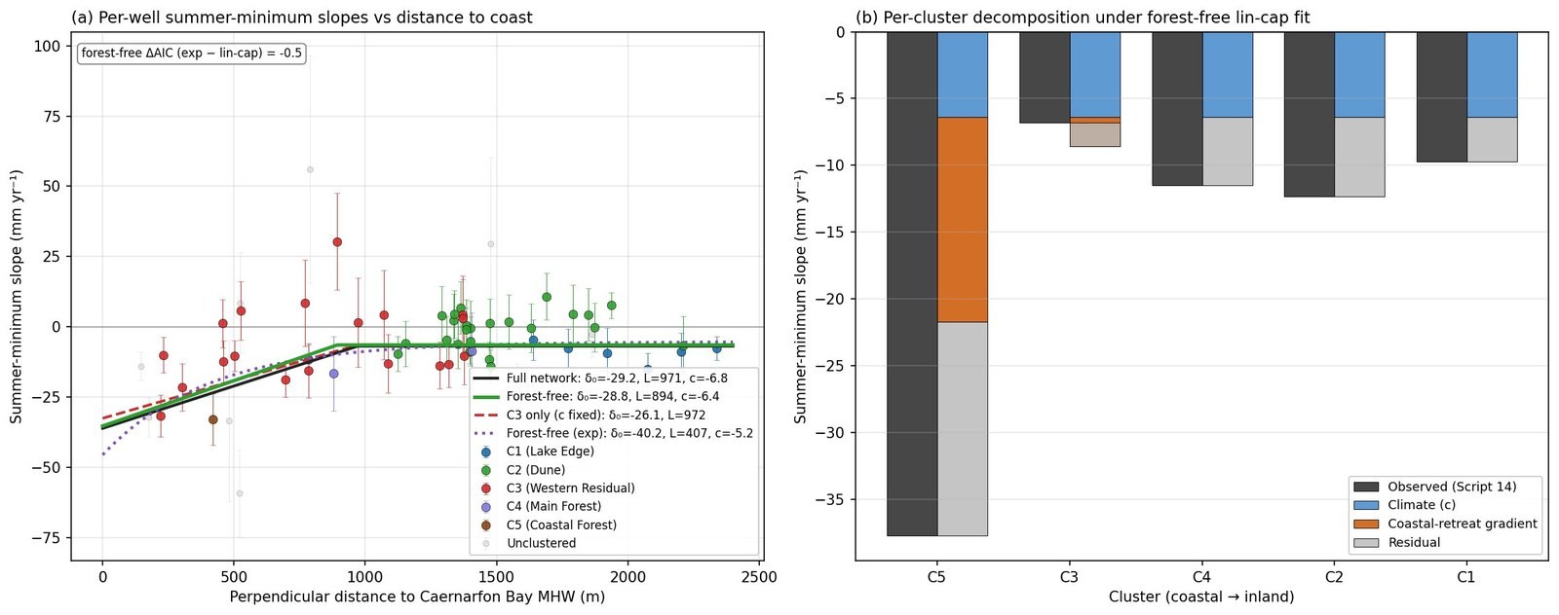
Figure 16. Coastal-retreat gradient. (a) Per-well summer-minimum slope versus distance to the eroding Caernarfon Bay shoreline, with the full-network, forest-free and C3-only linear-with-cutoff fits and the forest-free exponential fit overlaid; (b) per-cluster decomposition of the observed decline into climate, coastal-retreat gradient and residual.

5. Discussion

5.1 Geology, land cover and the cluster structure
The five hydrogeological clusters resolved by hierarchical clustering of hydrograph dynamics map onto the documented geological structure of the site. The broad contrast between the responsive eastern open dune (C1 Lake Edge, C2 Dune) and the buffered south-western dune (C3) reflects the difference in subsurface stratigraphy described by Stratford et al. (2007): shallow sand over till and estuarine deposits in the east constrains storage and drives flashy water-table responses, while a deeper sand column in the south-west supports a more buffered aquifer. The mechanistic coefficients recover this divide independently of the clustering that defined it, and they resolve a gradient running through the open dune rather than a simple binary. C1 Lake Edge is one extreme — the highest recharge sensitivity in the network (β₁ = 4.58) with the fastest head-dependent drainage (−β₃ = 0.090) and the fastest turnover in the network (τ ≈ 2.2 months), a fill-and-drain regime in which a shallow base promotes rapid lateral exchange directly with Llyn Rhos-Ddu. C2 Dune, the largest and most representative unit (24 wells), is the open-dune archetype between the end-members: a still-high recharge sensitivity (β₁ = 3.98) and a drainage-dominated loss partition (68% of losses), but a slower drainage decay (−β₃ = 0.066) and a longer turnover (τ ≈ 3.7 months) than the lake-coupled C1, reflecting open dune without a direct lake connection. C3 Western Residual is the buffered opposite — the lowest recharge sensitivity of the open clusters (β₁ = 3.57), the slowest open-system drainage (−β₃ = 0.058) and the longest open-dune memory (τ ≈ 6.6 months) — as the deep aeolian sand attenuates both the rainfall pulse and its release. The forested interior fills slowly and drains most sluggishly of all. C4 Main Forest is the cluster geographically nearest the rock ridge, with the metamorphic bedrock outcrop forming its northern margin — a setting reflected in the impeded drainage and the elevated atmospheric-draw coefficient (Section 5.2) and revisited in the residual-field discussion (Section 5.4).
This gradient also bears on how C3 is best understood. Its membership is the most diffuse in the network — the great majority of its wells are gradationally assigned, correlating almost as strongly with the C2 Dune centroid and with the coastal forest as with their own — and it is the open-dune cluster closest to both the plantation margin and the eroding Caernarfon Bay shoreline. Rather than a discrete western block, C3 is therefore better read as the transitional, more strongly buffered south-western continuation of the open dune, with a coherent central signature (the longest open-dune turnover and the lowest open recharge sensitivity) but boundaries that grade into both the dune and the forest. One parsimonious mechanism, consistent with the surface geology but not directly observed here, is a single estuarine-clay base that crops out on the higher eastern and southern ground — where a thin overlying sand column produces the flashy C2 response — and dips beneath the surface toward Caernarfon Bay, where a thickening sand column buffers the C3 response, making C2 and C3 one dipping system rather than two substrate blocks. The static buffering gradient is consistent with this: the characteristic drainage timescale lengthens from roughly 3.6 months in C2 to about 6 months in C3 as the coast is approached (Table 7), and the drainage coefficient slows in step (Table 1) — the opposite of the flashier response a discharge boundary alone would produce. Because coastal proximity, the plantation margin and the inferred clay dip all covary along the same south-western axis, this evidence supports the transitional reading without isolating the clay dip as its sole cause; a cored or geophysical transect would be needed to test it directly (Section 5.7). The two reaches responsible — the forest-interception drawdown propagating inland from the plantation, and the coastal-retreat drawdown extending inland from the eroding front — are mapped in Figures 17 and 18, which place the C3 wells within both reaches while the C2 wells lie largely beyond them.
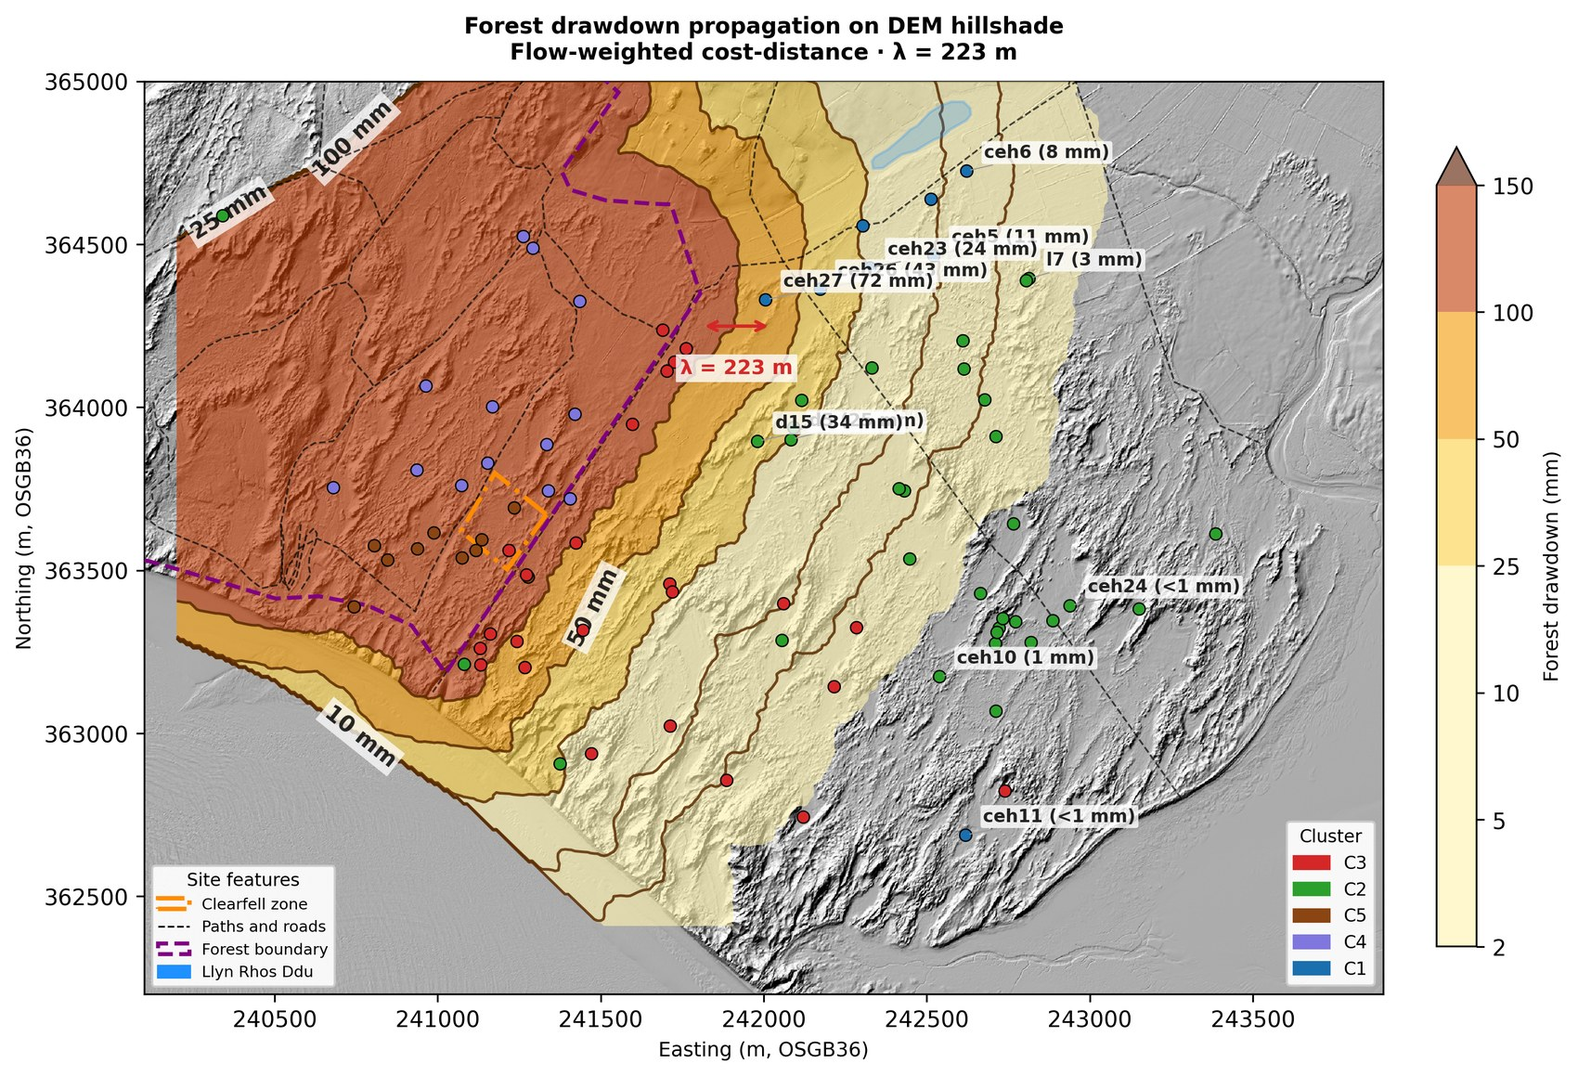
Figure 17. Illustrative forest reach. Forest-interception drawdown propagated inland from the plantation boundary by flow-weighted cost-distance (decay length λ ≈ 223 m, from C3's specific yield and drainage coefficient combined with an assumed hydraulic diffusivity — a literature conductivity, K = 6 m/day (Betson et al., 2002), and a nominal 5 m saturated thickness, the latter poorly constrained and plausibly larger; assumed edge deficit), over the DEM hillshade with per-well drawdown values labelled. The C3 wells fall within the forest reach while the C2 wells lie largely beyond it — drawdown falls from tens of millimetres near the plantation to under 1 mm at the easternmost C2 wells; the forest boundary, clearfell zone and Llyn Rhos-Ddu are marked. Drawdown magnitudes are illustrative of the reach rather than measured values.
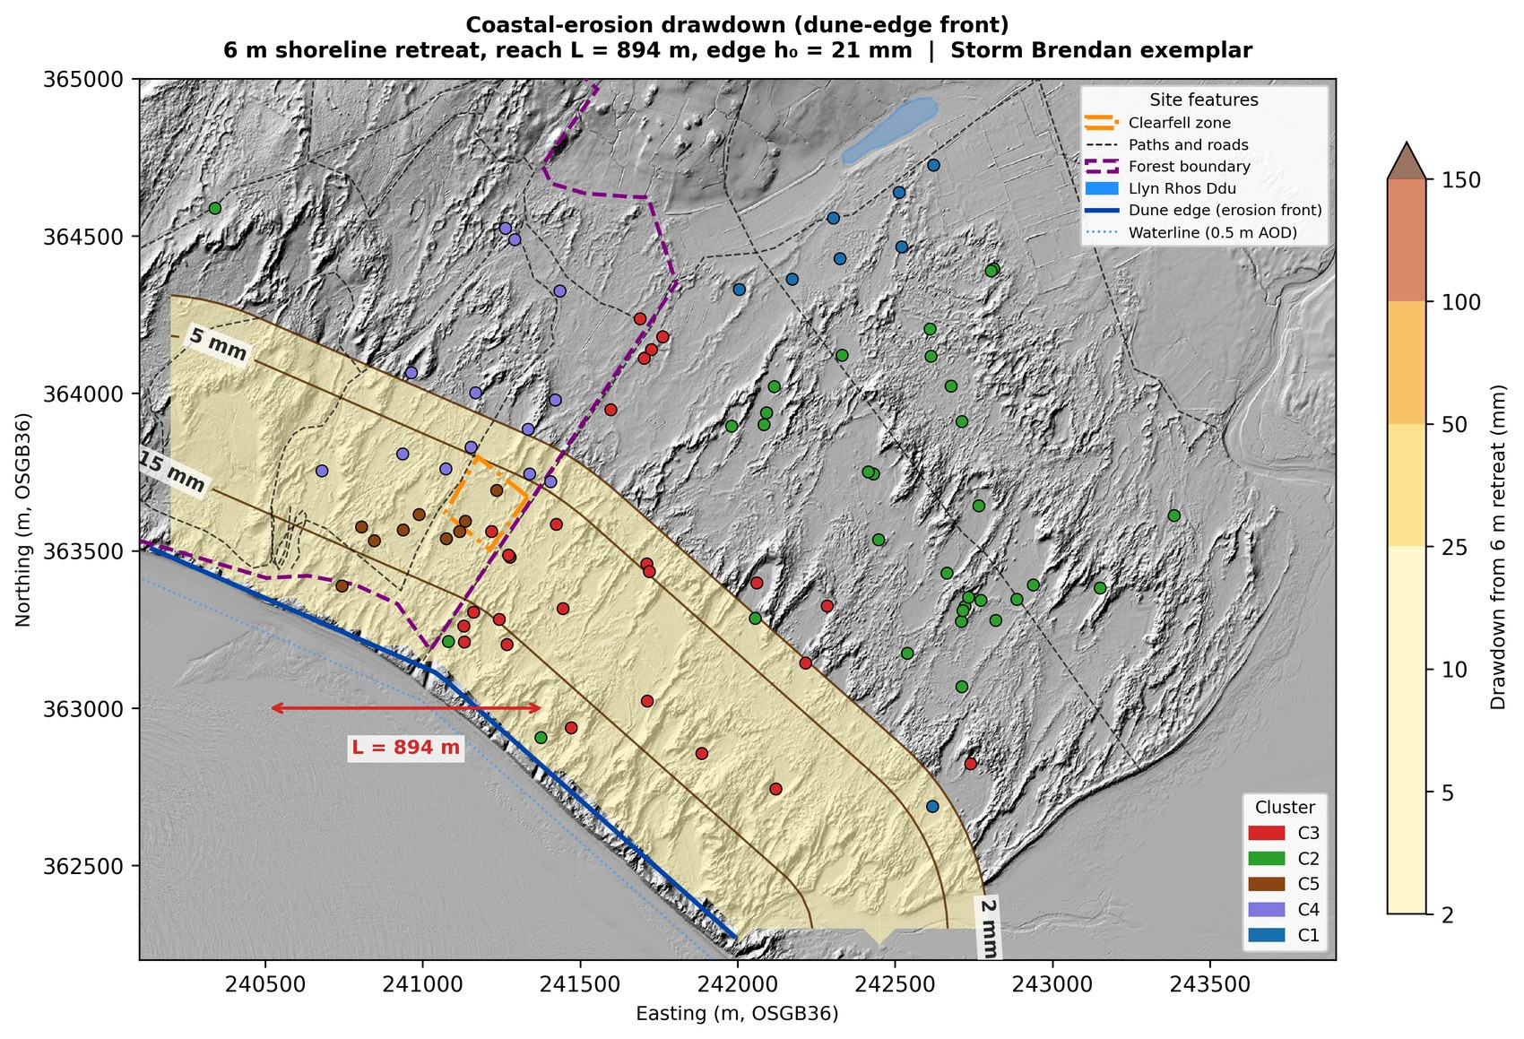
Figure 18. Episodic coastal-retreat reach. Water-table drawdown contoured inland from the eroding dune-edge front for a single Storm Brendan-scale retreat event (≈6 m at the front, early 2020), over the fitted inland reach (L = 894 m; §4.11). Coastal retreat at this shore is episodic, concentrated in storm events; the per-event edge drawdown is scaled from the chronic gradient through the long-term retreat rate (≈8 m/yr over 2014–2020, storm-inclusive; Forgrave, 2020). The C3 wells fall within the reach while the C2 wells lie largely east of it; the forest boundary and Llyn Rhos-Ddu are marked.
That the clustering (Figures 4 and 5), the mechanistic coefficients (Figure 11 and Table 1), and a third, fully independent diagnostic synthesis (Figure 13) all converge on the same structure is the strongest evidence that the partition is real rather than an artefact of the linkage method. When the characteristic drainage timescale (τ = Sy/β₃; Figure 12), the SSM forecasting gain over the linear benchmark (ΔNSE; Figure 9), and the water-table-fluctuation specific yield (Figure 8) — three parameters derived by separate routes — are plotted together (Figure 13), the five clusters occupy distinct, non-overlapping regions of diagnostic space. C1 Lake Edge sits at the shallow, fast-cycling, drainage-dominated extreme; C4 Main Forest at the sluggish, atmospheric-draw-dominated opposite; and C5 separates cleanly from C4 despite sharing the same canopy. This is a model-based characterization of aquifer architecture that is consistent with, but independent of, the Ward's clustering applied to the raw hydrographs.

5.2 Substrate versus surface control: interpreting the coefficients
The two forested clusters are inferred to share the deep sandy substrate of the western block, and carry the same Corsican pine canopy, yet segregate into distinct units — and resolving why is central to interpreting what the SSM coefficients measure. Within the forest zone, elevation alone explains 96% of the variance in atmospheric draw (β₂ versus elevation, r = 0.98), with C4 and C5 separating completely on this axis and on mean elevation (10.7 m versus 5.7 m). C4, on the elevated ridge flank, has a deeper water table and unsaturated zone — which we interpret as permitting stronger atmospheric draw — together with weaker drainage; C5, on the lower coastal fringe, has a shallower water table and faster drainage. The measured contrast in water-table depth and coefficient behaviour is unambiguous. The substrate explanation differs in confidence between the two clusters. For C4, the bedrock of the ridge outcrops within the forest, so the nature of the rock underlying the cluster is established; its depth and extent beneath C4 are not known without coring, but the impeded drainage there is consistent with a shallow, irregular bedrock base close beneath the wells — an inference supported by the proximity of the outcropping ridge. For C5, the proposed more-uniform, deeper coastal sand is the weaker inference, resting on the coefficients and topography alone. On that basis the split is best read as a substrate-and-topographic-position discontinuity beneath a constant canopy rather than an arbitrary division of a continuous population. One caveat attaches to this reading: the northern, high-ground C4 wells that carry the highest β₂ are also those where the ridge-derived lateral subsidy in the residual field is largest (Section 5.4). β₂ is the atmospheric-draw coefficient and is not the same quantity as that recharge subsidy, but the two share the same ridge-proximal corner of the site, so the deep-unsaturated-zone interpretation of the high forest β₂ should be read alongside the northern ridge boundary input rather than in isolation. The forest-interception drawdown footprint (Figure 17) occupies the same corner, so the high atmospheric draw, the positive water-balance residual and the modelled drawdown reach together describe one coherent forest signature; because all three are anchored to the same plantation-and-ridge zone, however, their spatial agreement is mutual consistency rather than independent corroboration.
This finding clarifies a potential misreading of the cluster contrasts. The forested clusters carry the highest LCSC values in the network, which might be read as low aquifer drainability. But LCSC is a recharge-efficiency descriptor, not a storage parameter: the fitted β₁ absorbs canopy interception alongside the true storage response, so part of the forest clusters’ elevated LCSC reflects the suppression of throughfall by the canopy rather than a difference in the aquifer itself. The water-table-fluctuation specific yields settle this directly. The uncorrected forest medians exceed the open-dune range, because the method attributes the full rainfall total to recharge when in reality the canopy intercepts roughly a quarter of it; once corrected for interception, C4’s forest median (0.248) falls within the open-dune range (0.210–0.325) and C5’s (0.321) sits at its upper edge, though C5’s estimate is constrained by the physical-plausibility limit and is only weakly corroborative. The interpolated specific-yield surface shows no discontinuity at the cluster margins. The effective storage inferred from the water-table response is therefore broadly uniform across the site — consistent with, though on these data not proof of, a well-mixed aeolian depositional history — with the C4 specific yield and the continuous Sy surface, rather than the ceiling-bound C5 estimate, carrying the argument that the forest clusters’ distinctive coefficient signature derives largely from a surface boundary condition (canopy interception) rather than from a different subsurface architecture.
A depth-dependent extension of the model, in which atmospheric draw declines as the capillary fringe retreats from the root zone with increasing water-table depth, confirms that a real depth-coupling effect is present at every cluster, strongest where the water table is shallowest (C1) and weakest where it is deepest (C4). Notably, C4 shows the weakest depth coupling despite carrying the highest atmospheric-draw coefficient, confirming that its high β₂ reflects low specific yield rather than a depth-dependent evapotranspiration pathway. The standard fixed-β₂ model absorbs the coupling as an effective depth-averaged parameter. The depth coupling and the lateral-drainage geometry together contribute to the within-forest β₂ variation alongside substrate, but the dominant control on the cluster-level contrast remains topographic position and substrate rather than canopy. These within- and cross-cluster comparisons rest on the ordering of β₂ rather than on its absolute magnitude: the fitted β₂ values are OLS estimates biased somewhat high in absolute terms, and are reliable as rankings rather than as quantitative atmospheric-draw rates.

5.3 Recharge, loss and the water balance
Decomposed under identical climate forcing, the clusters reveal markedly different recharge efficiencies and loss partitions while closing the monthly water balance to within 1.6% of total losses at every cluster. Recharge declines systematically from the Lake Edge through the open dune to the forested clusters, and total losses track recharge closely, but the partition between drainage and atmospheric draw varies sharply: drainage dominates at C1 (85% of losses), reflecting rapid lateral exchange with the lake, while atmospheric draw dominates at C4 (76%), where the suppressed recharge pulse never lifts the water table far enough above equilibrium to generate a strong drainage response and the irregular substrate impedes what drainage there is. The displacement formulation is what makes this contrast resolvable: under a ground-surface reference the C4 drainage term is borderline, but referencing drainage to a fixed sub-surface datum recovers a clearly significant coefficient at all five clusters, correctly specifying the hydraulic level against which drainage operates.
Two cautions attach to the recharge term. First, because the model is fitted without an intercept, in an open-boundary system the recharge coefficient can absorb unmeasured boundary fluxes (Young, 2011; Knotters and van Walsum, 1997); β₁·P should not be read as a direct measure of local precipitation reaching the water table. Second, the atmospheric-draw coefficient is an effective parameter: Thornthwaite PET is an energy-based demand index that does not define a reference surface in the manner of Penman–Monteith, so β₂ folds together transpiration, interception, specific yield and depth coupling into a single scaling between atmospheric demand and water-table response, and a formal crop-coefficient decomposition does not apply. Both cautions are consistent with the substrate interpretation above: the coefficients are diagnostic of behaviour, and their physical decomposition requires the independent specific-yield and depth-coupling evidence assembled here.

5.4 Boundary conditions and the water-balance residual field
The near-closure of the water balance at the cluster mean does not hold uniformly in space. The residual field — modelled losses minus modelled recharge, from the fitted coefficients — shows positive residuals concentrated along the northern forest margin and ridge flank, declining to near zero across the open dune and becoming weakly negative at some south-eastern wells. A positive residual marks a location where measured rainfall-driven recharge does not fully account for the observed water level, implying an unmodelled input. The spatial coincidence of the largest residuals with the bedrock ridge, together with the south-eastward Darcy flow field, makes ridge-derived lateral recharge the most parsimonious candidate. The single largest residual, at CEH14, is set aside from this interpretation on candidate-attribution grounds: the well sits about 50 m from the drainage field of a cottage in sporadic use, which is one plausible explanation for its anomalous negative β₃ and exceptionally large positive residual, though the attribution is not certain. The ridge-margin signal is therefore read on the surrounding wells rather than on CEH14 itself.
The framework is, however, deliberately honest about the limits of that inference. Two independent diagnostic tests — a cross-correlation lag analysis for distance-dependent transport from the ridge, and a seasonal climatology analysis for unmodelled summer evaporative demand — both returned null results. The cross-correlation null is itself qualified by sampling frequency: monthly observations are an order of magnitude coarser than the days-to-weeks transit times expected for fracture-flow input from a metamorphic bedrock ridge, so a real ridge-derived lag could be invisible at this resolution, and the null result bears on what the present record can resolve rather than on whether the mechanism is operative. The seasonal phase of the residual narrows the field further: it peaks in winter and early spring at the great majority of wells and at none in summer, which is inconsistent with any vertical-flux parameterization error — systematically underestimated summer PET, an incomplete canopy-interception correction, or any under-resolved summer evaporative demand, all of which would peak in summer when those fluxes are active — and consistent with either a winter-phased nonlinear recharge mechanism or ridge-derived lateral input arriving during the months of greatest rainfall. A cluster-stratified version of the same climatology shows mean winter-minus-summer residual contrasts of +7.4 mm in C3 (p<0.001), +6.2 mm in C4 (p=0.086, marginal) and −2.8 mm in C5 (not significant); the C3 > C4 > C5 ordering and the magnitude of the C3 signal together rule out canopy-interception over-estimation as the sole driver of the winter–summer contrast, since the largest signal sits in a cluster with no canopy. The residual pattern is real and reproducible; its mechanistic attribution is unresolved. This is the appropriate stance for a lumped-parameter framework: the residual field is a structural diagnostic of where the three-term balance is insufficient, not a quantified map of lateral flux, because it also absorbs nonlinear soil-moisture dynamics, coefficient sensitivity and any systematic PET bias.

5.5 Long-term forcing: coastal retreat and the partition of decline
The network-scale gradient regression isolates a forcing that a climate-only analysis would misattribute. Fitted across the open-dune network, the regression resolves a coast-edge water-table deepening of roughly 29 mm/yr above the climate background, declining over an inland reach of about 900 m to a far-field climate background of −6.4 mm/yr. Removing the ~29 mm/yr coastal artefact therefore isolates a clean far-field climate signal of about −6.4 mm/yr, which any climate-attribution analysis at this site should adopt as its baseline rather than the network-mean rate that conflates the two forcings. The result is robust to functional form at the network scale and to forest-cover inclusion, and it identifies coastal retreat as a spatially structured forcing distinct from climate: only the near-coast western clusters carry a gradient component, with coastal retreat accounting for about a third of the observed summer-minimum decline at C3, while the inland clusters lie beyond the fitted reach and decline at the climate background rate.
The aquifer’s characteristic drainage timescale τ = Sy/β₃, of order several months across the clusters (Table 7), exceeds the duration of individual storm-driven retreat events by an order of magnitude, so that the aquifer functions as a low-pass filter on the shoreline forcing — smoothing discrete event-scale shocks into a chronic gradient and validating the steady-state Dupuit–Forchheimer regression as the appropriate kinematic form. The chronic gradient resolved here is the time-averaged expression of a retreat process that, at this shore, is episodic rather than steady (Pye & Blott, 2024): shoreline loss is concentrated in storm events, of which the early-2020 Storm Brendan — a discrete retreat of order several metres at the dune front — is a recent example, set against a longer-term mean of roughly 50 m of retreat over 2014–2020 (about 8 m/yr, storm-inclusive; Forgrave, 2020) — well above the chronic background rate of order 1.5–2 m/yr at this frontage (Pye & Blott, 2024). Figure 18 maps the inland drawdown reach implied by a single Brendan-scale event; the steady-state regression averages many such events into the per-year deepening rate, so the gradient and the episodic map are two views of the same forcing rather than competing estimates.
This forcing also reframes the C5 Coastal Forest anomaly. C5 shows the steepest summer-minimum decline in the network — several times that of any other cluster — which, given that all clusters share the same climate forcing, argues against a purely climatic explanation. The position analysis (Section 5.2) and the coastal-gradient analysis converge on the same explanation: C5 occupies the lowest, most coast-proximal position in the network, where an inferred thin saturated thickness would amplify the head response to any forcing and where the eroding shoreline lies closest. The single C5 well that enters the gradient subset (nw9, 419 m from the coast) shows a decline of −32.8 mm/yr — the steepest and one of the most significant in the network — and the fitted gradient predicts a coastal-retreat deepening of roughly 15 mm/yr at that position under either functional form. Because nw9 is a forested well it is excluded from the open-dune (forest-free) regression and so functions as an out-of-sample sentinel: its observed decline tests the fitted gradient at a near-coast position without contributing to it. The agreement at that position — an observed −32.8 mm/yr against a fitted coastal contribution of about −15 mm/yr, the residual consistent with the climate background and with the substrate amplification developed in Section 5.2 — is the strongest single-well corroboration of the gradient available from the network. A single well cannot, however, carry a quantified cluster attribution, and the C5 figure should be treated as corroborating the gradient’s direction and magnitude rather than as an independent estimate; but the convergence of the substrate, position and gradient evidence makes coastal proximity, not canopy, the leading explanation for C5’s exceptional trajectory. The companion paper develops the management implication; here the point is characterization — that the framework distinguishes a coast-proximal, structurally amplified decline from the climate background, a distinction that bears directly on how network-wide summer-minimum trends should be attributed.
One boundary mechanism operates alongside the retreat gradient at the most coast-proximal wells: the discharging foreshore is a tidal boundary, so near-coast water tables couple to a constant-head sea boundary that buffers their short-term variability and holds their mean toward the shoreline. This tidal coupling and the multi-year shoreline retreat are complementary rather than competing — the former smooths event-scale fluctuation at a fixed boundary position, the latter migrates that boundary landward over years — and the C5 decline is read against the slower retreat process. The tidal coupling is noted here as the boundary condition that makes near-coast records intrinsically less climate-legible, not as an alternative explanation for the trend.
The far-field background itself — the decline that persists beyond the coastal reach — is a candidate for further mechanistic work, with at least two non-exclusive climate drivers. The deterioration is concentrated in the summer months, consistent with rising evaporative demand under the documented post-2013 summer warming (Figure 3) acting through the atmospheric-draw term as elevated potential evapotranspiration. A reduction in effective recharge is also plausible — for example a shift in the within-month distribution of rainfall… expressed as a declining recharge sensitivity. The two routes sit differently within the framework: the warming signal enters directly through the model's potential-evapotranspiration forcing, whereas a sub-monthly rainfall redistribution is invisible to a monthly model and would surface only as an apparent decline in recharge sensitivity. The framework makes the network-wide signal visible but does not, on the present analysis, resolve which dominates; it is noted as a forcing the characterization exposes rather than a result the paper establishes.

5.6 Predictive skill and transferability
The practical contribution of the framework rests on the benchmarking result. In one-step diagnostic mode the state-space and traditional linear models are nearly indistinguishable, because each prediction is corrected by the previous observation; the distinction emerges under iterative simulation, where the SSM achieves a median Nash–Sutcliffe efficiency of 0.75 against the linear model’s 0.13, and returns a positive iterative NSE at all but one of the 66 reference wells, against 43 for the linear model. The explicit head-dependent drainage term captures the storage-decay memory that prevents the cumulative drift to which the linear model is prone. The spatial pattern of the gain is itself a diagnostic: the largest improvements concentrate in the lake-proximal eastern aquifer where head-dependent drainage is strongest, and the smallest occur in the forest interior where weak drainage makes the storage term nearly dispensable. The improvement map therefore delineates which parts of the aquifer are governed by nonlinear storage dynamics and which approximate a linear climate response — a structural characterization obtained without any invasive measurement.
This is the basis for transferability. The framework requires only three fitted parameters per well, a uniform drainage datum, and monthly rainfall and temperature from a single climate station. It does not require hydraulic-conductivity measurements, aquifer-thickness surfaces, or lateral-flow modelling — precisely the parameter-sparsity constraints that produced calibration difficulties for an earlier distributed-model effort at this site (Betson et al., 2002). The displacement formulation is the methodological choice that enables this: by referencing drainage to a fixed sub-surface datum rather than to the ground surface, it captures the depth-dependence of the drainage response without site-specific calibration of the drainage geometry, and it resolves a physically meaningful drainage coefficient even in the low-gradient forest interior. Any coastal dune aquifer with a manual dipwell network and a nearby climate station can be parameterized in the same way, and the diagnostic syntheses demonstrated here — the τ/ΔNSE/Sy characterization, the coefficient atlas, the residual field — follow directly from that parameterization. One supplementary step reaches outside this core: rendering the forest-interception drawdown as a physical reach in metres (Figure 17) requires a hydraulic diffusivity, for which a single literature conductivity (K ≈ 6 m/day; Betson et al., 2002) and a nominal saturated thickness are assumed — the latter uncertain by a factor of two or more. These enter only that illustrative reach length; the core parameterization, the diagnostic syntheses above, and the empirically fitted coastal reach (Figure 18) all remain free of conductivity and thickness inputs. The forest reach is accordingly an order-of-magnitude diagnostic rather than a calibrated prediction.

5.7 Framework limitations
The framework’s strengths and its limits are two sides of the same design choice. Because it fits a lumped mass balance independently at each well and interpolates the results geometrically, it does not resolve lateral groundwater flow. The interpolated coefficient and head surfaces are aggregators of point responses, not a physical flow model, and cannot represent cluster-to-cluster hydraulic coupling, the lateral redistribution of localized recharge perturbations, or the diffusive response of the aquifer to a change in boundary flux. The affinity analysis and the Darcy field show that the clusters are connected along a continuous downslope drainage pathway, so whether a signal originating in one part of the aquifer propagates to another at magnitudes below the framework’s resolution cannot be answered here; that is a question for a calibrated continuous-flow model. The critical unknowns for such a model are the very quantities the present framework avoids — hydraulic conductivity, currently constrained by a single tracer test (6.0 m/day; Betson et al., 2002), and aquifer thickness, inferred from a handful of borehole logs across the site. A measured K would also tighten the only K-conditioned output of the present framework — the forest-drawdown reach length in Figure 17 — but, as noted in Section 5.6, all other framework outputs (SSM coefficients, WTF specific yields, substrate-gradient interpretation, coastal-retreat regression and residual field) are K-independent and would not change with a measured K. Slug tests at representative wells per cluster and a ground-penetrating-radar survey of aquifer thickness are the priority field measurements to enable a flow model, and would also support an independent vadose-zone test of the canopy-driven recharge-suppression signal. The same campaign would test the structural interpretation of the C3 transition (Section 5.1): a south-west to north-east transect resolving the depth to the estuarine-clay base, carrying the Caernarfon Bay coastal-retreat rate as a covariate, would establish whether the eastward-to-south-westward buffering gradient reflects a single dipping clay base — one thickening sand column — rather than two distinct substrate blocks, and would separate that structural control from the confounded coastal and plantation-margin influences.
Several further limitations qualify specific results. The monthly measurement resolution cannot isolate individual storm events, so the water-table-fluctuation specific yields conflate gravity drainage with capillary-fringe release and are upper bounds rather than point estimates (Healy and Cook, 2002; Scanlon et al., 2002). Thornthwaite PET is a temperature-and-daylength index whose absolute magnitude is uncertain; the framework’s internal consistency does not depend on it, but absolute flux estimates derived from it do. The coastal-retreat regression is a steady-state spatial model: it resolves the first-order distance gradient but not the multi-year transient over which an erosion signal propagates inland, and direct measurement of present-day retreat rates at the south-western dune front remains a monitoring priority. The water-balance residual field is spatially structured and reproducible but, as discussed, its attribution between a genuine lateral flux and a modelling artefact is unresolved. Finally, the close correspondence between DEM-derived drainage pathways and the cluster boundaries supports the use of surface topography as an operational proxy for subsurface flow divides, but the two are co-determined by the underlying till and bedrock architecture rather than one causing the other; the proxy is reliable for routing in the absence of high-resolution bedrock mapping, not a substitute for it.

6. Conclusions
This study sets out a parameter-sparse state-space framework for characterizing the hydrogeological architecture of a coastal dune aquifer from routine monitoring data, and demonstrates it across 88 dipwells and 21 years of monthly records at Newborough Warren. The principal conclusions are:
- Five hydrogeological clusters govern site hydrology. The Pearson affinity audit of hydrograph similarity independently confirms cluster assignment for 96% of reference-network wells (Section 4.3), and the cluster-level contrasts in SSM coefficients, drainage timescale and specific yield provide mechanistic substantiation. The five units resolve as — a responsive eastern block (C1 Lake Edge, C2 Dune), a buffered Western Residual (C3), and two forested clusters distinguished by topographic position and inferred substrate (C4 Main Forest, high atmospheric draw and weak drainage on the elevated ridge flank; C5 Coastal Forest, on the lower coastal ground). Within the forest zone, elevation alone explains 96% of the variance in atmospheric draw, identifying position and elevation rather than canopy as the dominant within-forest control.
- The aquifer’s storage is broadly uniform; the cluster contrasts are surface-mediated. Once corrected for canopy interception, the C4 forest specific yield falls within the open-dune range and the interpolated specific-yield surface shows no discontinuity at the cluster margins; the C5 estimate is consistent with this but is the least reliable in the network and is treated as weakly corroborative. The forest clusters’ distinctive coefficient signature therefore derives from a surface boundary condition — canopy interception suppressing recharge — rather than from a different subsurface architecture.
- The displacement-formulation SSM closes the water balance and substantially improves forecast skill. The three-term model closes the monthly water balance to within 1.6% of total losses at every cluster, and achieves a median iterative Nash–Sutcliffe efficiency of 0.75 against 0.13 for a traditional linear model, with a positive iterative NSE at 65 of 66 wells against 43 of 66. The spatial pattern of the improvement is itself a non-invasive diagnostic of where head-dependent drainage memory governs the aquifer.
- The water balance closes on average but its residual field is spatially structured. Positive residuals concentrate along the northern forest margin and ridge flank, consistent with a ridge-derived lateral subsidy (with the largest single outlier, at CEH14, set aside on candidate-attribution grounds linked to a nearby cottage's drainage field); the cross-correlation lag test and a seasonal climatology test return null results for the ridge-subsidy hypothesis, while a cluster-stratified climatology rules out canopy-interception over-estimation as the sole driver of the forest-zone winter residual; the attribution remains unresolved. The residual field is a structural diagnostic, not a quantified flux map.
- Coastal retreat is a distinct, spatially structured forcing on long-term water-table trends. A network-scale gradient regression resolves a coast-edge deepening of roughly 29 mm/yr declining over an inland reach of about 900 m, accounting for around a third of the observed summer-minimum decline at the near-coast Western Residual. The exceptional decline of the coast-proximal C5 cluster is best explained by coastal position and thin saturated thickness rather than by its canopy. Distinguishing this coastal forcing from the climate background is necessary for any correct attribution of network-wide summer-minimum trends.
- The framework is transferable. It characterizes aquifer architecture — storage, recharge efficiency, drainage memory and flow structure — from manual dipwell records and a single climate station, without coring, hydraulic testing or calibrated continuous-flow modelling. Its principal limitation is the converse of this strength: as a geometric aggregator of point responses it cannot resolve cluster-to-cluster hydraulic coupling, for which a calibrated flow model, and the hydraulic-conductivity and aquifer-thickness measurements it requires, would be needed.
The hydrological consequences of the dune-scraping and plantation-clearfell interventions undertaken at the site are quantified within a before-after-control-impact framework in the companion paper (Hollingham, 2026b).

References
Akaike, H. (1974) A new look at the statistical model identification. IEEE Transactions on Automatic Control 19(6), 716–723. doi:10.1109/TAC.1974.1100705
Bear, J. (1972) Dynamics of Fluids in Porous Media. New York: American Elsevier.
Betson, M., Connell, L. and Bristow, C. (2002) Groundwater Modelling of Newborough Warren. In: Bristow, C. (ed.) The Impact of Forestry on Coastal Geomorphology at Newborough Warren/Ynys Llanddwyn NNR, SSSI, pSAC. Volume 5: Hydrogeology. Report to the Countryside Council for Wales, Contract FC 73-05-18. Department of Geological Sciences, UCL, and School of Earth Sciences, Birkbeck, University of London, July 2002.
Curreli, A., Wallace, H., Freeman, C., Hollingham, M., Stratford, C., Johnson, H. and Jones, L. (2013) Eco-hydrological requirements of dune slack vegetation and the implications of climate change. Science of the Total Environment 443, 910–919. doi:10.1016/j.scitotenv.2012.11.035
Davy, A.J., Grootjans, A.P., Hiscock, K. and Petersen, J. (2006) Development of Eco-Hydrological Guidelines for Dune Habitats — Phase 1. English Nature Research Reports No. 696. Peterborough: English Nature.
Fetter, C.W. (2001) Applied Hydrogeology (4th ed.). Upper Saddle River, NJ: Prentice Hall.
Forgrave, A. (2020) Dramatic pictures show the beautiful little corner of North Wales that’s fast being lost to the sea. North Wales Live / Daily Post, 22 January 2020.
Freeman, S. (2008) The hydrological impact of Corsican pine plantation on the dune system at Newborough Warren, Anglesey. Unpublished BSc Honours dissertation, University of Wales, Bangor.
Freeze, R.A. and Cherry, J.A. (1979) Groundwater. Englewood Cliffs, NJ: Prentice-Hall.
Healy, R.W. and Cook, P.G. (2002) Using groundwater levels to estimate recharge. Hydrogeology Journal 10(1), 91–109. doi:10.1007/s10040-001-0178-0
Hollingham, M. (2026b) Hydrological response of a coastal dune aquifer to plantation clearfell and dune scraping: a BACI analysis of a 21-year manual record. In preparation.
Knotters, M. and van Walsum, P.E.V. (1997) Estimating fluctuation quantities from time series of water-table depths using models with a stochastic component. Journal of Hydrology 197(1–4), 25–46. doi:10.1016/S0022-1694(96)03278-7
Pye, K. and Blott, S.J. (2024) Dune rejuvenation AfterLIFE options for Twyni Penrhos, Newborough. NRW Evidence Report No. 787, 73 pp. Bangor: Natural Resources Wales.
Ranwell, D.S. (1958) Movement of vegetated sand dunes at Newborough Warren, Anglesey. Journal of Ecology 46, 83–100.
Rao, A.R. and Srinivas, V.V. (2006) Regionalization of watersheds by fuzzy cluster analysis. Journal of Hydrology 318(1–4), 57–79.
Rhind, P.M., Blackstock, T.H., Hardy, H.S., Jones, R.E. and Sandison, W. (2001) The evolution of Newborough Warren dune system with particular reference to the past four decades. In: Houston, J.A., Edmondson, S.E. and Rooney, P.J. (eds) Coastal Dune Management. Liverpool: Liverpool University Press, pp. 345–379.
Rousseeuw, P.J. (1987) Silhouettes: a graphical aid to the interpretation and validation of cluster analysis. Journal of Computational and Applied Mathematics 20(1), 53–65. doi:10.1016/0377-0427(87)90125-7
Scanlon, B.R., Healy, R.W. and Cook, P.G. (2002) Choosing appropriate techniques for quantifying groundwater recharge. Hydrogeology Journal 10(1), 18–39. doi:10.1007/s10040-001-0176-2
Stratford, C., Ratcliffe, J., Hughes, A.G., Roberts, J. and Robins, N.S. (2007) Complex interaction between shallow groundwater and changing woodland, surface water, grazing and other influences in partly wooded duneland in Anglesey, Wales. In: Ribeiro, L., Chambel, A. and Condesso de Melo, M.T. (eds) IAH 35th Congress, Groundwater and Ecosystems, Lisbon.
Ward, J.H. (1963) Hierarchical grouping to optimize an objective function. Journal of the American Statistical Association 58(301), 236–244.
Young, P.C. (2011) Recursive Estimation and Time-Series Analysis: An Introduction for the Student and Practitioner. Berlin: Springer.

