The Hydrogen Intensity and Real-time Analysis eXperiment (HIRAX) is a new 400–800 MHz radio interferometer under development for deployment in the Karoo Desert, South Africa. It will have 1024 6 m parabolic dishes on a compact grid, and will map the entire Southern sky over the course of 2 years. HIRAX has two primary science goals: to constrain Dark Energy and measure structure at high redshift, and to study radio transients and pulsars. HIRAX will measure unresolved sources of neutral hydrogen via their redshifted 21cm emission line (hydrogen intensity mapping). The resulting maps of large scale structure at redshifts 0.8–2.5 can be used to measure Baryon Acoustic Oscillations (BAO). BAO are a preferential scale in the matter distribution that we can use to chart the expansion history of the Universe and thus understand the nature of Dark Energy. BAO measurements with HIRAX will improve current error bars from galaxy surveys by observing a larger cosmological volume (both from increased survey area and redshift range), and will also measure BAO at high redshift when the expansion of the Universe transitioned to Dark Energy-dominated. HIRAX will complement CHIME, a hydrogen intensity mapping effort in the Northern Hemisphere, by completing the sky coverage in the same redshift range. The HIRAX location in the Southern Hemisphere also allows a variety of correlation measurements with surveys of structure at many wavelengths. Daily maps of 15,000 square degrees of the southern hemisphere will also be a new approach for discovering and monitoring radio transients. With access to the entire plane of the Milky way galaxy, HIRAX is building into its correlator the ability to rapidly and efficiently detect transients. The results will shed light on the poorly understood nature of Fast Radio Bursts (FRBs), have a critical monitoring role in pulsar timing arrays to detect long-wavelength gravitational waves, and find new radio transient phenomena. In this paper, I will discuss the HIRAX instrument, science goals, and current status.

Keywords: Cosmology, Dark Energy, Large Scale Structure, Intensity Mapping, 21cm

1. INTRODUCTION

Relatively recent measurements from SN1a [eg newest ref], Baryon Acoustic Oscillations (BAO) [eg Eisenstein ref], and the Cosmic Microwave Background (CMB) [eg Planck ref] have shown the Universe is dominated by Dark Energy, an unknown component causing the expansion rate of the Universe to accelerate. To better understand the nature of Dark Energy, we require measurements out to redshifts of z∼2, when Dark Energy began to influence the rate of expansion. Measurements of BAO are particularly extend-able to higher redshift; BAO are the imprints in the matter power spectrum of acoustic oscillations present when the Universe was ∼400,000 years old at photon-baryon decoupling. The resulting characteristic comoving 150Mpc scale is present as a feature in the large scale structure distribution: structure preferentially formed in the density peaks, and the physical size of that feature expands with the expansion of the Universe. Measurements of that char- acteristic scale are sensitive tracers of the expansion rate of the Universe, and hence of Dark Energy. This has been demonstrated most recently using galaxy surveys, presenting percent-level constraints on Dark Energy at redshift ∼0.6 [recent BOSS ref].

A promising technique for measuring BAO at higher redshift is a technique known as 21 cm intensity mapping, making low-resolution measurements of the integrated emission of many galaxies through the 21 cm emission of neutral Hydrogen. Neutral hydrogen is a natural redshift marker and is stored in galaxies, hence this emission traces the history of large scale structure and we can use the low resolution maps to resolve only the large (BAO) scales of interest. The Hydrogen Intensity and Real-time Analysis eXperiment (HIRAX)∗ is a 400–800 MHz radio interferometer planned for construction in the Karoo Desert, South Africa. HIRAX will map large scale structure between redshifts of 0.8–2.5 with 1024 6 m dishes. With Southern sky coverage, we will be complementary with CHIME [Kevin ref] in the Northern hemisphere, and also leverage correlator technology development for CHIME [Nolan ref]. We located HIRAX in the Southern hemisphere to take advantage of potential cross-correlations with additional wide-field surveys at other wavelengths (LSST, ACTPol, HST, DESI, DES, SPTPol). At minimum, cross-correlations with high-redshift galaxy surveys will provide an estimate for the neutral hydrogen bias and the neutral hydrogen fraction.

Can we use Mario’s/Amadeus’s plots here? do we have any number for wa?

Figure 1. Power spectra, credit Amadeus

Figure 2. Contours with lots of things held fixed, credit Amadeus

In addition to rich cross-correlation opportunities, observations of the Southern sky will provides access to the entire Galactic plane, enabling a wide variety of transient measurements with HIRAX. Current and future observatories are studying the transient sky, with detection capabilities in the optical (LSST [ref]) and the new ability to detect gravitational waves with LIGO [ref]. HIRAX will add radio transient monitoring to this suite of observations, and could be particularly useful for kilonova [ref]. In addition, Fast Radio Bursts (FRBs) are a source of enormous interest to the radio transient community because of their unique dispersion measures indicating possible cosmological distances [ref]. Their origin is unknown and the subject of ongoing study [ref ref ref]. Projecting from current discovery rates of FRBs, HIRAX will find NN per day and be able to measure properties associated with their spectra, timing, and distribution. In addition to FRBs, HIRAX can be used as

∗ http://www.acru.ukzn.ac.za/∼hirax

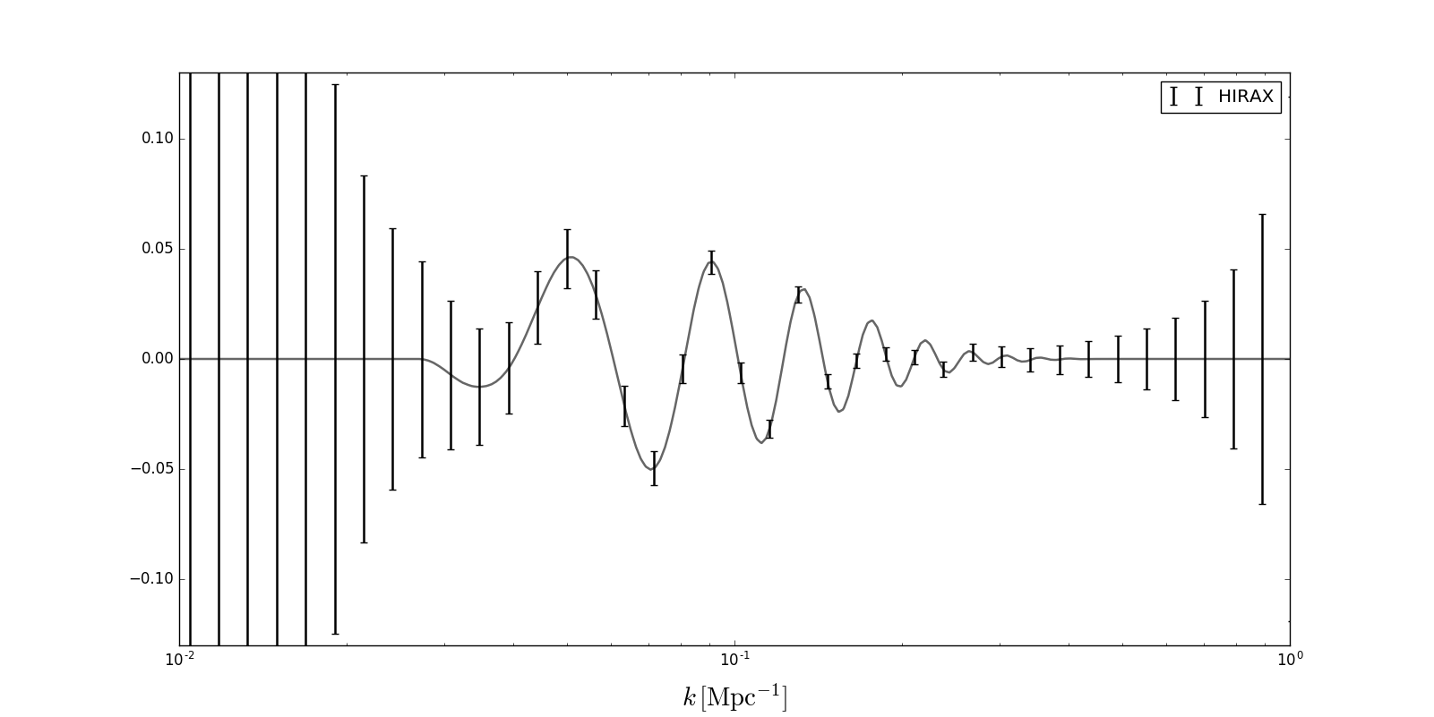 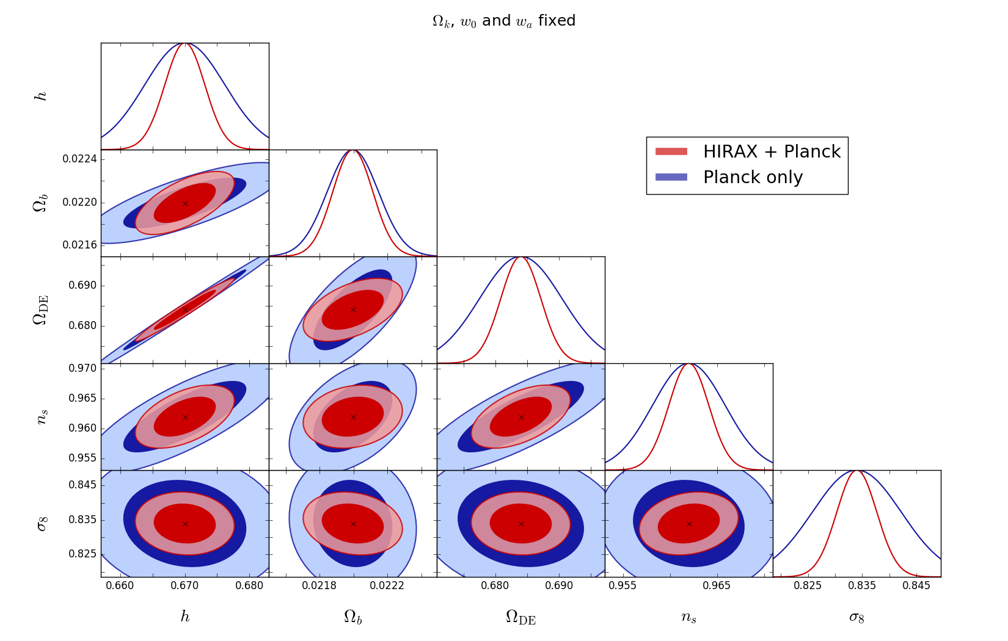 

a pulsar discovery engine and to monitor pulsar times. The former will increase the number of known pulsars by NN?, and the latter daily monitoring would be a natural partner in pulsar timing arrays, which can potentially map long-wavelength gravity waves inaccessible to other probes.

Currently we are building an 8-element prototype array (HIRAX-8) at the Hartebeesthoek Radio Astronomi- cal Observatory (HartRAO) to begin developing the analog system and analysis pipelines. After initial decisions on instrumentation informed by the prototype, we will build a 64-dish (HIRAX-64) instrument in the Karoo Desert from which we will build out to the final 1024-dish HIRAX array (HIRAX-1024).

In this paper we describe the instrument itself (Section 2) including its reflector design, analog chain, and digitization, and some of the known challenges to this technique (Section 3).

2. THE HIRAX INSTRUMENT

The main driver for the HIRAX design is the measurement of large scale structure at high redshift. The redshift- dependent 150Mpc BAO feature ranges from 1.35◦ at z=2.5 (400MHz) to 3◦ at z=0.8 (800MHz). To sample the third acoustic peak at high redshift would require a baseline distance of at least 80 m. To resolve the BAO feature along the line of sight (in the redshift direction), requires frequency resolution of at least 12 MHz. The signal level is also small, O(0.1 mK), requiring low system noise and large collecting area.

The HIRAX instrument will be comprised of 1024 6 m dishes deployed in a 32×32 grid with the square sides aligned on the celestial cardinal directions. HIRAX is a transit telescope: the dishes will be pointed at a given declination, and the sky will rotate overhead in a constant drift-scan. Thus each pointing of the dishes will give us access to a ∼ 6◦ wide stripe of the sky. To map the entire sky, the dishes will be re-pointed once every 3 months, to complete a full 15,000deg2 survey (40% of the sky) in ∼3 years. To map the sky to a depth of 1.2μJy in 3 months requires a system noise of 40K †. Its location in the Karoo desert provides for protection from Radio-frequency interference (RFI) in its operating bands.

Each of the 1024 signal chains is composed of one radio dish, one antenna feed, two amplifiers (one per polarization), Radio-frequency-over-Fiber (RFoF) to carry the signal to the correlator building, and the instru- ment correlator. The fiducial design would have noise temperature of 40K, collecting area of ∼ 29,000m2, for a daily sensitivity of ∼ 12μJy/pixel. A few key design parameters for HIRAX-1024 are given in Table 1.

2.1 Antennas: Dishes and Feeds

The antennas for HIRAX are still under development, and include the dishes, the feed itself, a choke for the feed, and possibly an active balun built into the feed. The primary consideration is to have fast mapping speed, requiring high sensitivity. This in turn drives us to have a large collecting area and extremely efficient antennas: high aperture efficiency (60%), low loss in the feed (< −15 dB), a low reflection coefficient at the feed (< −15 dB), and low spillover to the ground (< 10K ).

Dishes – The dishes will be 6m diameter parabolic reflectors with an f/D of 0.3. Because we image the sky in strips, changing the center declination every ∼3 months, the dishes must be able to tilt on one axis. We have initial dish designs for the HIRAX-8 prototype array and are in the process of re-designing the dishes based on experiences in the field and with the vendor, in particular building rockers into the frame for full access to all of our target declinations. Any design must be cost efficient and easy to assemble, as well as have repeatable surface shaping and reflector surface imperfections constrained to λ/50 = 7 mm [ref Ruze]. The dishes should also be rigid enough that the beam full-width-half-max does not change by more than 10−4 upon tilting up to 25◦. We would also like to minimize the reflections off of the support struts above the frame, for example by moving to a radio-transparent support. To reduce ground spillover and cross-talk, we are considering adding reflective collars to the dishes.

Feeds – The HIRAX feed will be a modified version of the feed used for CHIME [Meiling ref], a dual-polarized clover-leaf shaped dipole antenna which was based on a four-square antenna developed for Molonglo [ref]. The feed has impressive characteristics across a wide band and is composed of: (i) a FR4-dielectric printed circuit board (PCB) which has four metalized curved petals on the front to act as an antenna, (ii) a low-loss Teflon active balun for impedance matching, and (iii) a teflon support board. The signal current distribution, design parameters, and beam characteristics are described in detail elsewhere [ref Kevin,ref Meiling], here I will note just that the shape of the petals provides sensitivity to a wide bandwith and there is one output signal for each linear polarization.

The CHIME feed beam shape is designed for a cylindrical dish, and its impedance was chosen to minimize the noise of the low-noise amplifier at the feed output. For HIRAX, we would like circular beams with good impedance matching to the dish, and we are in the process of modifying the feed design accordingly. A prototype of the feed with the active balun is shown in Figure ?. To circular-ize the beam and aid in reducing cross-talk and ground spill, we will be adding a ring choke structure, which will also help us weather-proof the instrumentation at the focus. Various choke ring geometries are being simulated to optimize gain, reduce spillover, and reduce polarization artifacts. Optimization also included choke size. While wider chokes are more effective at reducing spillover, they also increase the blockage of the center of the dish.

2.2 Amplification – do we feel comfortable wtih a plot or picture of anything yet?

To achieve fast mapping speeds, we will need to ensure our system temperature is 40K or better. This will require not merely minimizing losses in the optical chain as described above, but also amplifying the signal either on or directly behind the feed with low noise amplifiers. The averaged sky signal is ∼50K and we would like to digitize that signal such that its level on the input to the digitizer is-21dBm across the 400MHz bandwidth. The total input power from the average 50 K sky would be -95 dBm across the entire band, leading us to require about 75 dB of total gain. In order for the noise to be dominated by the front-stage LNA, 50 dB of this total gain must come before the RFoF since they have relatively high noise (typically 27 dB ENR). We are investigating two routes for the amplification: including the amplification circuitry directly on the balun and backboard (an active balun), and attaching amplifiers at the SMA- connectorized outputs of the feeds. The benefits of amplifying directly on the feed is primarily a reduction in system noise by removing the distance between the petals and the LNA, a source of loss between the feed and the first active stage amounting to an extra ∼3 K in system noise (is this true?). We are currently planning to use Avago MGA-16116 GaAs MMIC low noise amplifiers since a 400-800 MHz prototype LNA built with the device produced a gain of ~18dB and a noise figure of ~0.4dB while also significantly reducing the expense of circuit board parts.

To carry signals from the dishes to the correlator, radio interferometers and telescopes have traditionally used coaxial cable. However, optical fiber is an attractive solution for long cable runs when the loss (and its steep frequency dependence) can be prohibitive. The HIRAX array is large (∼250 m x 250 m), and we are planning to use RFoF to send the signals from the dish to the correlator building. The RFoF modules were developed for radio telescopes [ref] and have two parts: a transmitter at the dish and a receiver at the correlator building, with optical fiber in between. They also contain the band-defining 400-800 MHz filter and can be designed to have the final amplification stages required in the HIRAX signal chain. This RFoF system has been developed for radio telescopes in general, tested in the lab, and a prototype set was deployed and tested on CHIME.

2.3 Digital Back End

The HIRAX digital backend is an FX correlator, and will leverage development for the correlator for CHIME. The correlator architecture and implementation has been described thoroughly in [ref, ref, ref], so here I will merely describe the general data processing steps. The F-engine performs frequency channelization using a set of custom boards, each of which takes 16 sky channels. For HIRAX-8 we can use just one board, for HIRAX-64 we will require 8 boards, and for HIRAX-1024 we will require 128 boards. The signal from each input is digitized at 8-bit precision at 800 MHz. The signal is then sent through a customized poly-phase filter bank (PFB) and FFT algorithm, performed at 16-bit precision, developed from CASPER [ref] to channelize the signal into 1024 frequency channels between 400–800 MHz. The X-engine of the correlator will correlate all sky inputs for each of the 1024 frequency channels, and is implemented in an array of GPU nodes. To transfer the data between the FPGA F-engine and the GPU X-engine, the data is sent on a custom backplane which performs the quarter turn operation. The quarter turn takes the output from the FPGA, which is natively 1024 frequency channels for each sky input, and re-arranges and shuffles them into the format required for the X-engine, namely all sky inputs for a single frequency.

The quarter-turned data is sent to the GPU X-engine on 10 Gbps lines. The diskless nodes will contain two network cards and two GPUs [Fury?], and the GPUs run a custom kernel to efficiently calculate the per-frequency correlation matrix. Each GPU correlator node is responsible for 64 frequencies for all sky inputs. The data is accumulated and written to a separate storage system.

Should I add anything specific about real-time correlation? If so .... I don’t know much about it

2.4 Current Status

We are currently building HIRAX-8, a prototype array of 8 dishes, at Hartebeesthoek Radio Astronomical Observatory (HartRAO), located ∼ 100 km outside of Johannesburg. From an RFI perspective, its proximity to Johannesburg is not ideal (and so the full HIRAX array will not be deployed there), however it is easy to access and has a variety of resources which make it a useful site for building a small prototype array. The prototype dishes have been ordered, and some initial instrumentation has already been deployed on commercial dishes. HIRAX-8 will have 16 total inputs (two polarizations from each of the 8 dishes), for which we can use one FPGA board and an off-the-shelf computer for correlation and data storage. The correlator is in a faraday cage at HartRAO and we are currently building up to continuous operations with the small commercial dishes. When the prototype dishes arrive, we will upgrade the array to its full 8 elements, and continue using the array to test newly developed hardware until we have a stable design. At that point we will build the 64-dish HIRAX-64, with 128 inputs and move to the Karoo desert site. HIRAX-8 and HIRAX-64 are currently funded, and will provide 3 × the collecting area already available on CHIME.

3. FOREGROUND REMOVAL CHALLENGES

The biggest challenge for all 21cm intensity mapping experiments is the presence of bright synchrotron fore- grounds from our own Milky Way galaxy, which can be as bright as 700 K. In theory these can be filtered due to their smooth spectral structure, as demonstrated in [ref]. As described in that paper, this removal hinges on the precise calibration of the instrument, primarily its beam (to 0.1%) and its gain (to 1%). This foreground filtering degrades our ability to measure large scale modes along the line of sight (because we filter smoothly in frequency), however it does not impact our ability to measure the matter power spectrum, which has features on smaller scales.

The current plan for calibrating the beam is to use a drone-based beam measurement technique. We will fly a broad-band antenna and source on a quadcopter drone in a known pattern to map out the near field beams, and extrapolate to the far field (or measure the far field directly, when possible). Using drones for beam mapping has been previously demonstrated [ref] and multiple groups are pursuing this method of beam calibration at a variety of wavelengths. The far field of the HIRAX 6 m dishes will be 96–192 m across the band, which is within range of commercially available drones. We are currently building up the drone measurement program, with testing starting this year.

We have chosen to place the HIRAX dishes on a grid to allow for maximum redundancy in baseline distances. Ultimately, this is to take advantage of redundancy for time-dependent gain calibration, as well as possible solutions for beam differences. The algorithm we are developing for HIRAX [ref sievers in prep] differs from traditional redundant calibration [ref liu] by using knowledge of the sky (whose prior can be incomplete and consist of basically just known bright point sources) to solve for gains only, and then recover the sky. This scheme allows the user to use knowledge of the array and partial sky knowledge to calibrate instrument gains and perhaps extract beam shapes.

4. CONCLUSION

HIRAX is a radio interferometer designed to measure 15,000 deg2 of the sky to a depth of 1.2μJy. The resulting maps of neutral hydrogen in 1024 frequency bins between 400–800 MHz will provide low-resolution measurements of large scale structure to better understand the nature of Dark Energy through its impact on the expansion rate of the Universe. HIRAX will also monitor the sky for radio transients, both fast irregular bursts (such as FRBs) and pulsars. The prototpye array, HIRAX-8, will be constructed this year at HartRAO and be used to finalize the design for the full instrument.

????

ACKNOWLEDGMENTS