1. 建立基本資料後，查詢DB: fiatCurrency/getFiatCurrency

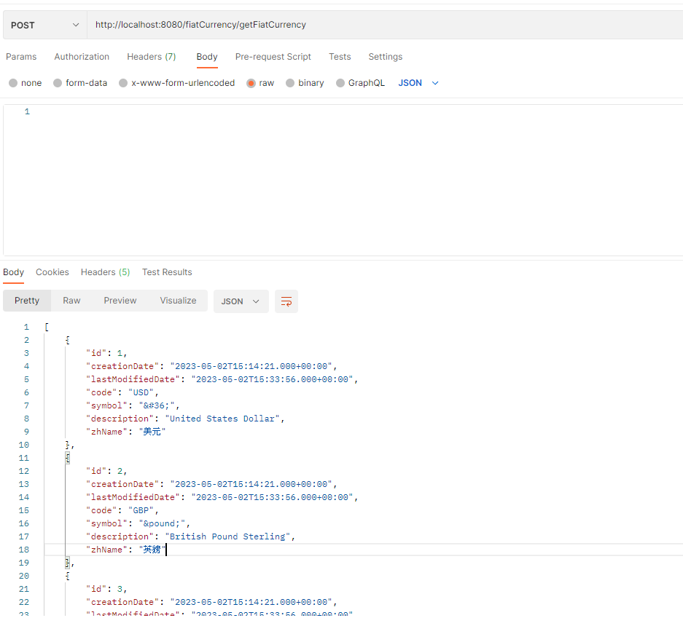

1. 新增fiat_currency
   1. 更新前DB:

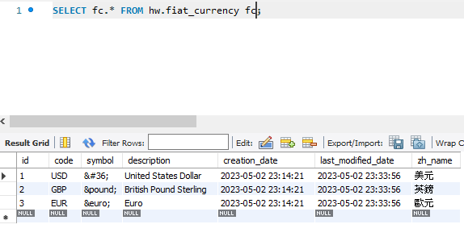

* 1. 更新payload: 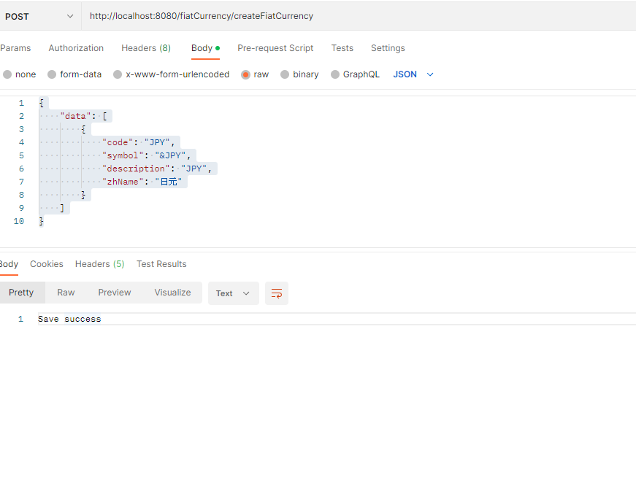
  2. 更新後:

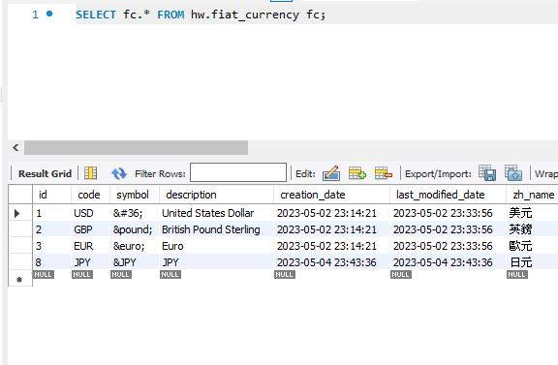

1. 更新fiat_currency
   1. 更新前DB:



* 1. 更新payload:

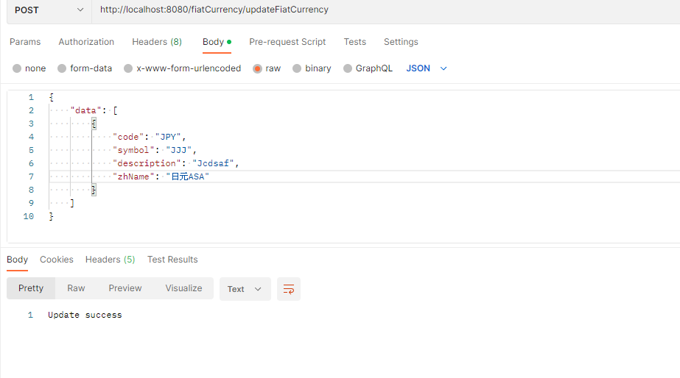

* 1. 更新後:

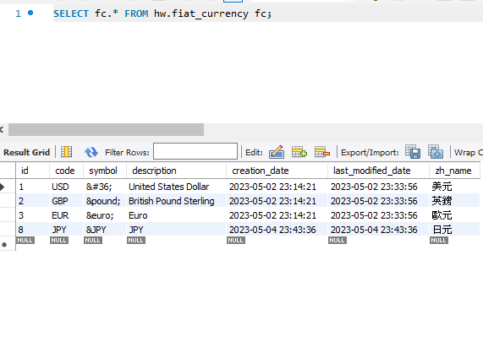

1. 刪除fiat_currency
   1. 更新前DB:



* 1. 更新payload:

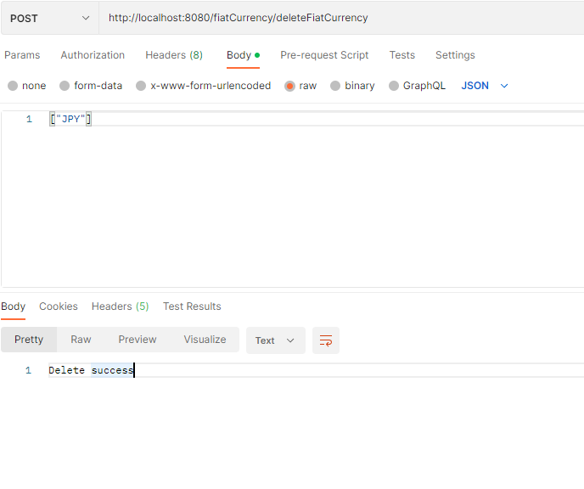

* 1. 更新後:

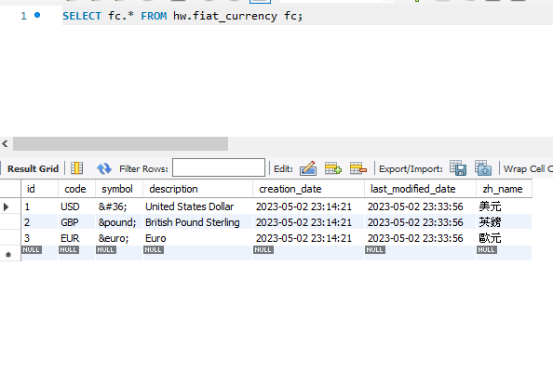

1. Coindesk API:題意我其實看不太懂，我把他解讀成要做匯率得更新
   1. 更新前DB:

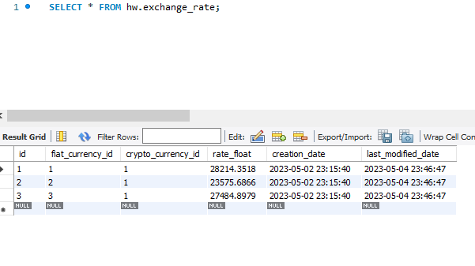

* 1. 更新payload:

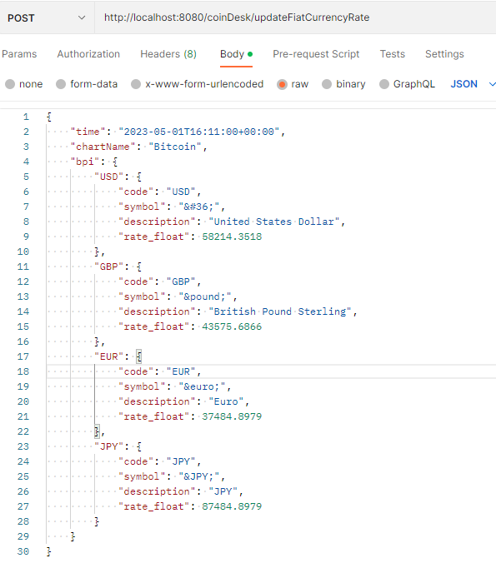

curl --location 'http://localhost:8080/coinDesk/updateFiatCurrencyRate' \

--header 'Content-Type: application/json' \

--**data** '{

    "time": "2023-05-01T16:11:00+00:00",

    "chartName": "Bitcoin",

    "bpi": {

        "USD": {

            "code": "USD",

            "symbol": "&#36;",

            "description": "United States Dollar",

            "rate_float": 58214.3518

        },

        "GBP": {

            "code": "GBP",

            "symbol": "&pound;",

            "description": "British Pound Sterling",

            "rate_float": 43575.6866

        },

        "EUR": {

            "code": "EUR",

            "symbol": "&euro;",

            "description": "Euro",

            "rate_float": 37484.8979

        },

        "JPY": {

            "code": "JPY",

            "symbol": "&JPY;",

            "description": "JPY",

            "rate_float": 87484.8979

        }

    }

}'

* 1. 更新後:

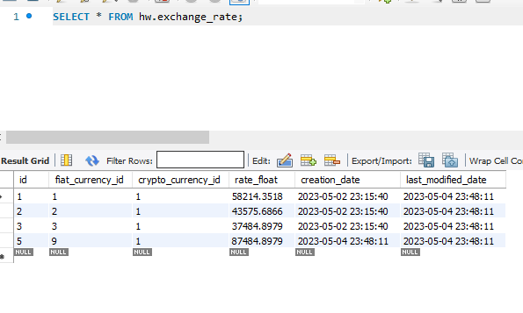

1. 更新匯率的結果
   1. 更新前DB:



* 1. 更新: coinDesk/getFiatCurrencyRate
  2. 更新後結果:

