Canadian Digital Soil Mapping Workshop

##### Prepared by Daniel Saurette and Brandon Heung

Canadian Digital Soil Mapping Working Group

Pedology Committee

Canadian Society of Soil Science

# Pre-Workshop Preparation Instructions

To get the most out of the Digital Soil Mapping workshop, it is recommended that you download and install several software packages. The workshop is split about 50/50 between theory and practice, therefore following along with the exercises during the workshop is ideal. The following will provide detailed instructions to prepare for the workshop. We ask that you please prepare this well in advance to ensure you are ready; it can take 2-3 hours to properly download and install all the software and the workshop materials

# Step 1: Download Workshop Materials

A large repository with all the necessary software and workshop materials has been prepared and posted to OneDrive site for download. The repository is quite large, approximately 1.2GB, and can be accessed using the following link:

[CDSM Workshop 2022](https://dalu-my.sharepoint.com/:f:/g/personal/br671675_dal_ca/Epm20dANX39Ek9QYod2lxh8Bpb8sHAta3f-qbpl5cc-R6A?e=wvMw3p)

The link will open in your default browser (Figure 1). In the upper left of the webpage, there is a download button. Click the button and the entire repository will be downloaded to a ZIP file called “CDSM.zip”.

Once downloaded, the folder should be unzipped directly on the C: drive. The main reason for this will become obvious during the practical exercises – R uses scripts or code to process data, and the sample code for the workshop includes paths to data in the folders, therefore it is important to save this directly to the C drive. You will need Admin privileges to read/write to your C: drive. The folder CDSM should be on the C: drive, with subfolders as shown in Figure 2.

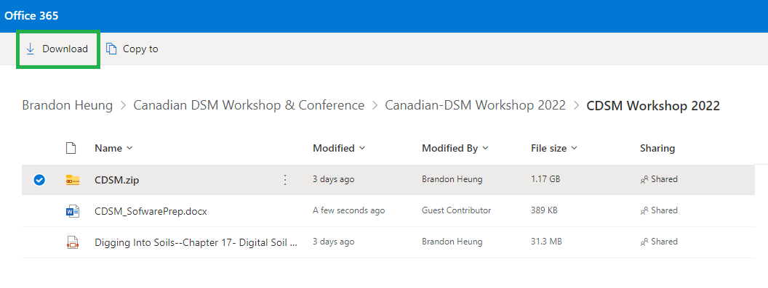

**Figure 1. Data repository screen capture with download button highlighted with green box in upper left**

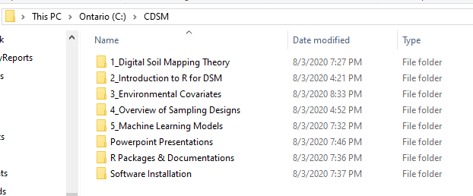

**Figure 2. Folder structure when properly unzipped to C: drive**

# Step 2: Install Required Software

There are four required software packages for the DSM Workshop (Figure 3):

1. R: this is the workhorse for DSM and enables all the analysis and computations
2. R Studio: This is a friendlier user interface for R
3. Rtools: these tools allow for proper R package installations
4. SAGA GIS: specialized software for terrain analysis

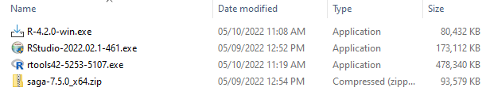

**Figure 3. Software packages for installation**

## Step 2.1: Install R

The R software can be installed directly by double-clicking the “R-4.2.0-win.exe” provided in the Software Installation folder of the repository. **NOTE: The executable provided is for Windows operating systems.** If you use an operating system other than Windows, or if you wish to install directly from the CRAN website, you can do so by following this link and selecting the appropriate version (Windows, Mac or Linux):

<https://cran.r-project.org/>

R will create a folder and install to C:\Program Files\R by default.

## Step 2.2: Install R Studio

The R Studio software can be installed directly by double-clicking the “RStudio-2022.02.1-461.exe” file provided in the Software Installation folder of the repository. **NOTE: The executable provided is for Windows operating systems.** If you use an operating system other than Windows, or if you wish to install directly from the RStudio website, you can do so by following this link and selecting the appropriate version:

<https://rstudio.com/products/rstudio/download/#download>

RStudio will create a folder and install to C:\Program Files\RStudio by default. During installation, allow RStudio setup to add a shortcut to the Desktop is prompted. If not, the RStudio.exe file is located at: C:\Program Files\RStudio\bin, and you can create a shortcut on the desktop manually.

## Step 2.3: Install Rtools (Windows Only)

The Rtools software can be installed directly by double-clicking the “rtools42-5253-5107.exe” provided in the Software Installation folder of the repository. If you wish to install directly from the CRAN website, you can do so by following this link:

<https://cran.r-project.org/bin/windows/Rtools/>

Rtools will create a folder and install to C:\rtools42 by default.

## Step 2.4: Install SAGA GIS

The SAGA GIS software requires no installation and simply needs to be extracted from the Software Installation folder of the repository. Unzip the file “saga-7.5.0_x64.zip” directly to the C: drive. It should place a folder on your C: drive called saga-7.5.0_x64. Once the extraction is complete, rename the folder “SAGA-GIS”. The file structure should look the same as Figure 4. When using SAGA in R, the R software will search a few default locations for the SAGA-GIS files; if you do not rename the folder as shown, every time you use SAGA through R scripts, it will take a long time to find the software because it will search your entire hard drive.

SAGA-GIS can also be downloaded directly from Source Forge using the link below. The current version of SAGA-GIS available for download is Version 7.7. We have provided Version 7.5 in the repository because the older version has been tested with our workshop material and therefore, we recommend using the version provided.

<https://sourceforge.net/projects/saga-gis/>

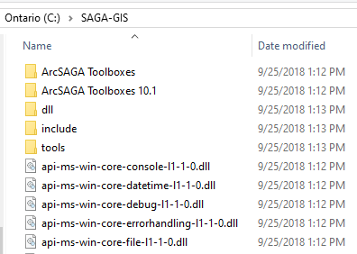

**Figure 4. Proper folder naming and location for SAGA-GIS**

# Step 3: Prepare R

We will review the basics of using RStudio and executing scripts or code during the DSM workshop; however, if a few preparations are done ahead of time, things will run much more smoothly during the workshop.

As mentioned, the R software works by writing code or scripts, which are just commands that instruct the software to do certain operations. In our case, we will be working on data manipulation and modelling towards the end of the workshop. To make certain routine tasks much easier, users of R write “packages” that can be downloaded and then used in an R session. The packages are really just pre-packaged code or scripts that allow us to complete tasks efficiently. We will use quite a few of these during the workshop. The following steps will walk you though the process of opening RStudio, then opening a script, and running a few lines of code. We will go through all of this during the workshop, but to avoid delays, it is preferable to have this done ahead of time.

First, we need open RStudio. You will see 3 windows when you first open the software (Figure 5). Once open, in the upper left corner click on the File, then on Open File (Figure 6).

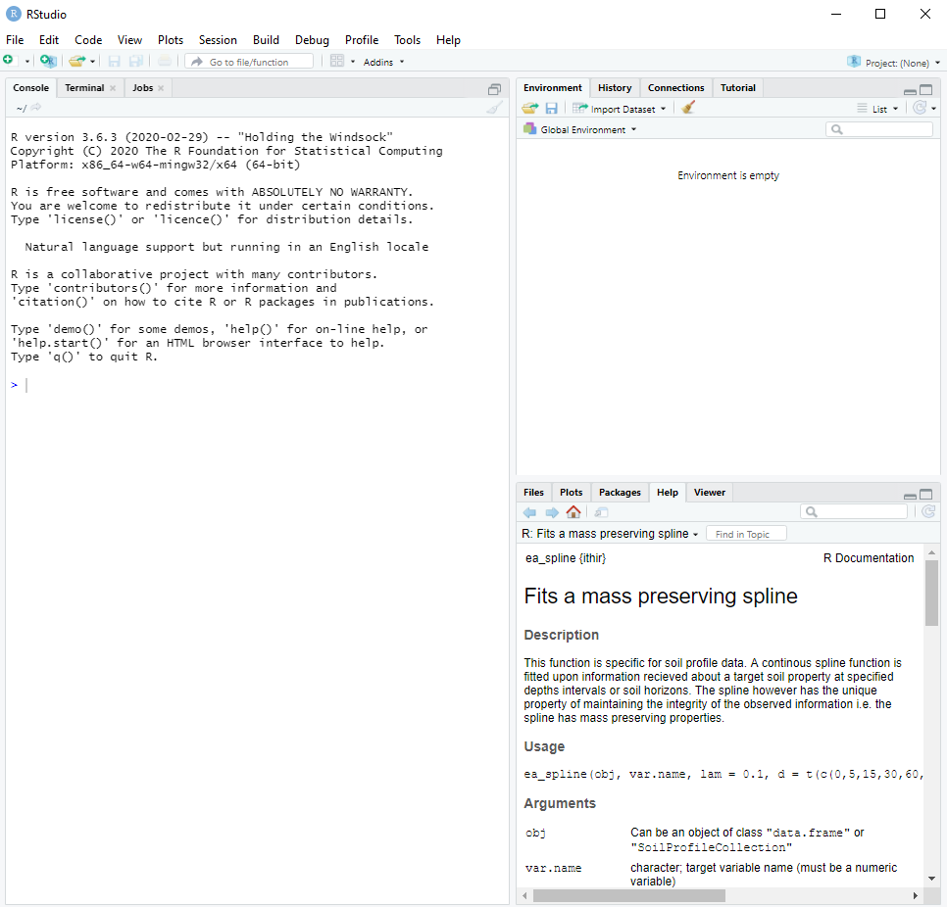

**Figure 5. RStudio upon first opening the software**

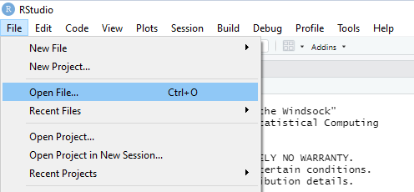

**Figure 6. Using the File menu to open a file**

A new window opens up to navigate through your folder directory and select the file that needs to be opened. Locate the CDSM folder on the C: drive and select the C:\CDSM|2_Introduction to R for DSM\R-Scripts\StartingR.R file (Figure 7).

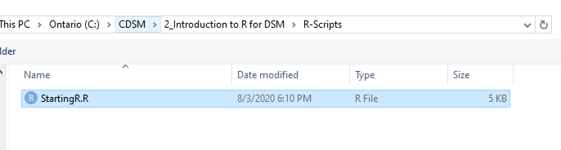

**Figure 7. Location of the StartingR.R file for preparing R for the workshop**

When the file opens in R Studio, it will do so in a new 4th window (Figure 8). To install the required packages for the workshop, simply place your cursor at the beginning of line 18. Now, press the Run button in the upper right corner of the scripting window (highlighted in red box on Figure 8) to execute this line of code (RStudio will run only one line of code at a time this way). There will be a progress bar show up as the package is downloaded from the CRAN website. It will then install the package. In the lower left window of the RStudio, you will see a message once the package is successfully installed (Figure 9).

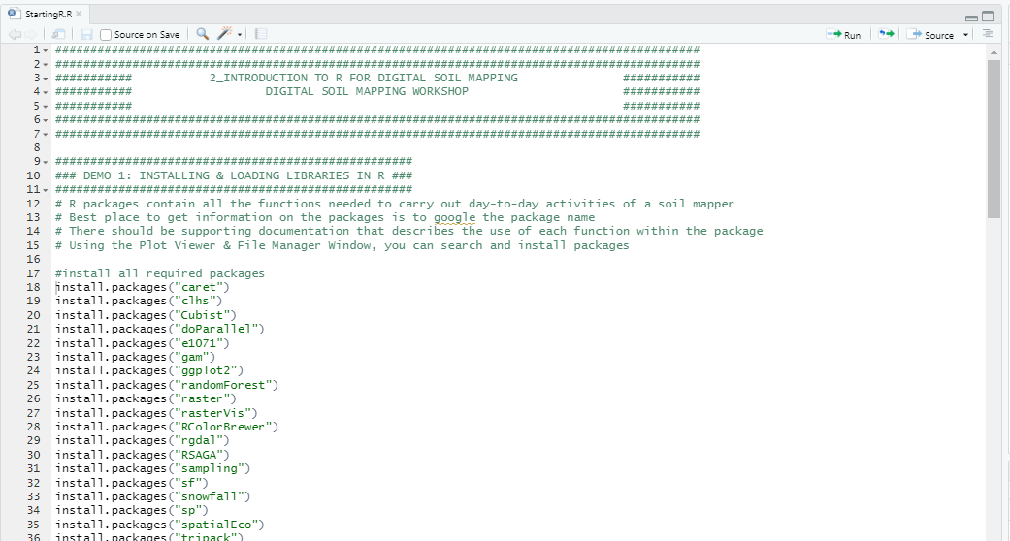

**Figure 8. Scripting window in RStudio with Starting R script open, and the Run button highlighted**

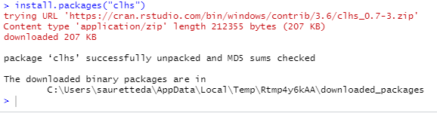

**Figure 9. Successfully installed “clhs” package.**

Please step through each line of the StartingR script by pressing the Run button until the end of the lines that start with “install.packages”. Some packages might ask you to “Install form Source” (Figure 10). Just choose yes.

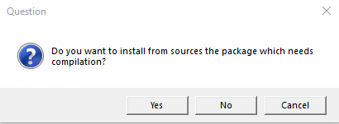

**Figure 10. Install from Source message**

Once this is done, you are ready for the DSM workshop. If you have any issues with the installation of the software, downloads, or preparations in RStudio, we would prefer to sort it out ahead of the workshop. Please contact Daniel Saurette ([daniel.saurette@ontario.ca](mailto:daniel.saurette@ontario.ca)) or Brandon Heung ([brandon.heung@dal.ca](mailto:brandon.heung@dal.ca)) and we would be more than happy to help you sort out any issues.