Haproxy（负载均衡安装文档）
一： 修改/etc/sysconfig/rsyslog文件
vi /etc/sysconfig/rsyslog
# Options for rsyslogd
# Syslogd options are deprecated since rsyslog v3.
# If you want to use them, switch to compatibility mode 2 by "-c 2" # See rsyslogd(8) for more details
SYSLOGD_OPTIONS="-r -m 0 -c 2"
– 配置Haproxy打开日志服务
vi /etc/haproxy/haproxy.cfg
global
log 127.0.0.1 local0
– 重启rsyslog与Haproxy服务
service rsyslog restart
service haproxy restart
– 查看haproxy的日志
cat /var/log/haproxy.log
二：关闭SELinux

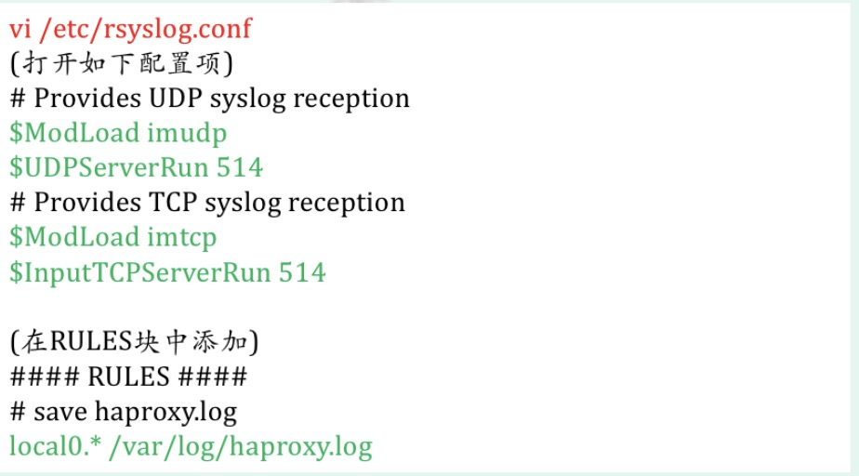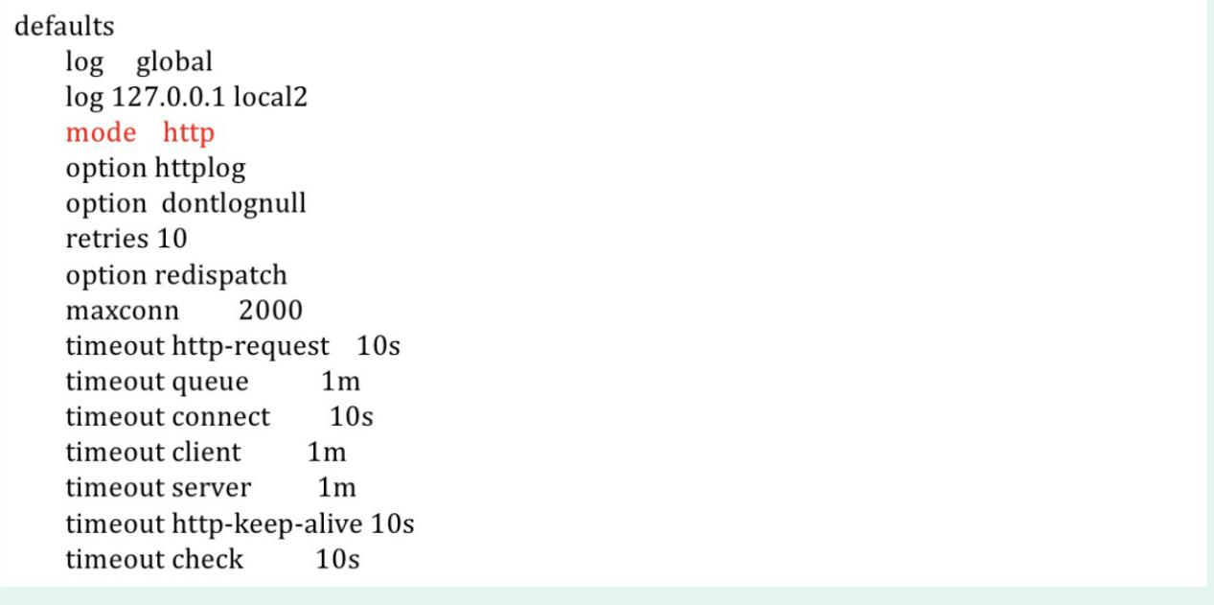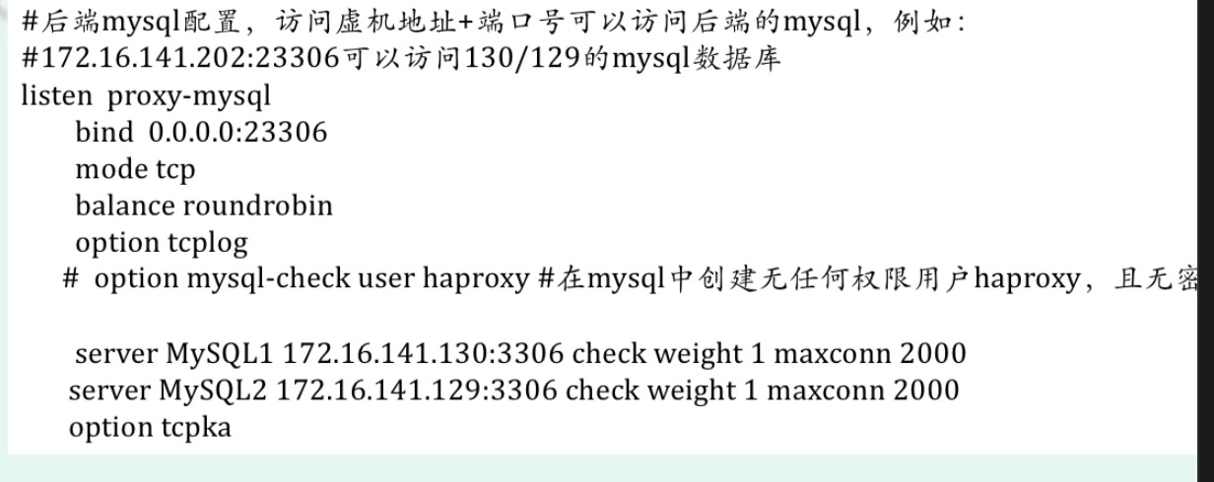

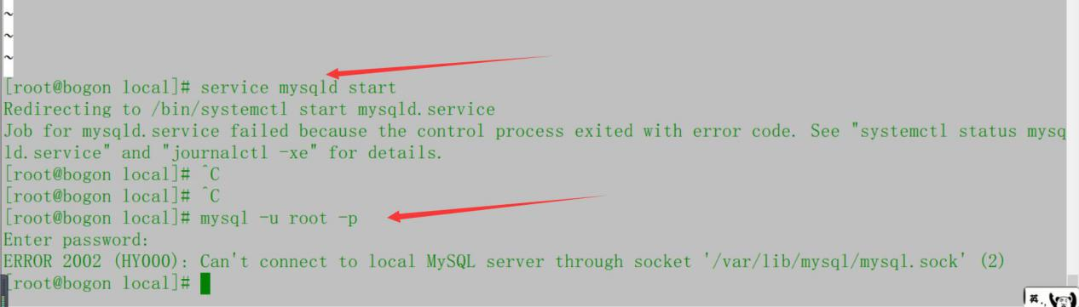
打开浏览器：http://172.16.141.202:1080/stats
(测试)


