# 安装keepalived

下载keepalived地址：

<http://www.keepalived.org/download.html>

将其放到路径 /usr/local/src下面

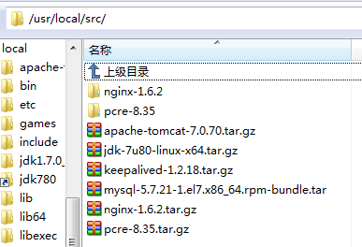

解压安装：

tar -zxvf keepalived-1.2.18.tar.gz -C /usr/local/ 注意路径

安装一个安装包

yum install -y openssl openssl-devel（需要安装一个软件包）



cd keepalived-1.2.18/ && ./configure --prefix=/usr/local/keepalived



make && make install 安装



将keepalived安装成Linux系统服务

将keepalived安装成Linux系统服务，因为没有使用keepalived的默认安装路径（默认路径：/usr/local）,安装完成之后，需要做一些修改工作

首先创建文件夹，将keepalived配置文件进行复制：

mkdir /etc/keepalived

cp/usr/local/keepalived/etc/keepalived/keepalived.conf /etc/keepalived/



如果执行无效，请回到根目录执行

然后复制keepalived脚本文件：

– cp /usr/local/keepalived/etc/rc.d/init.d/keepalived /etc/init.d/

– cp /usr/local/keepalived/etc/sysconfig/keepalived /etc/sysconfig/

– ln -s /usr/local/sbin/keepalived /usr/sbin/

– ln -s /usr/local/keepalived/sbin/keepalived /sbin/

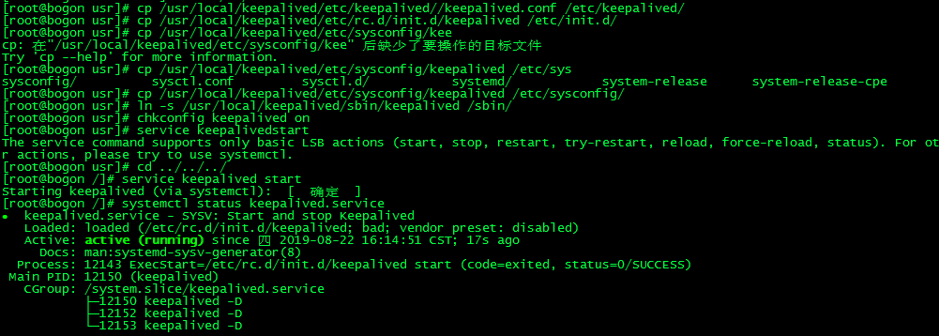

可以设置开机启动：执行代码chkconfig keepalived on，到此我们安装完毕!

开启或关闭keepalived

查看是否开启成功，用代码：

查看keepalive服务的状态：systemctl status keepalived.service

如果active的状态为running就证明连接上了

