Haproxy（负载均衡安装文档）

一： 修改/etc/sysconfig/rsyslog文件

vi /etc/sysconfig/rsyslog

# Options for rsyslogd

# Syslogd options are deprecated since rsyslog v3.

# If you want to use them, switch to compatibility mode 2 by "-c 2" # See rsyslogd(8) for more details

SYSLOGD_OPTIONS="-r -m 0 -c 2"

– 配置Haproxy打开日志服务

vi /etc/haproxy/haproxy.cfg

global

log 127.0.0.1 local0

– 重启rsyslog与Haproxy服务

service rsyslog restart

service haproxy restart

– 查看haproxy的日志

cat /var/log/haproxy.log

二：关闭SELinux



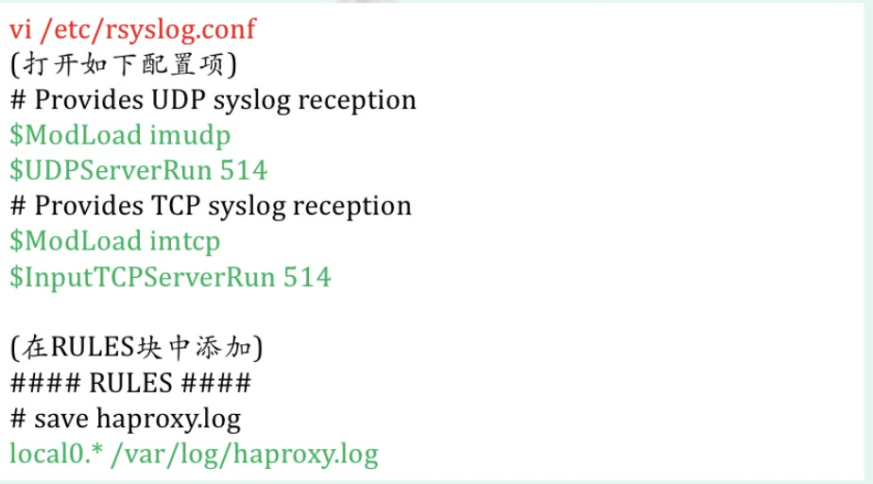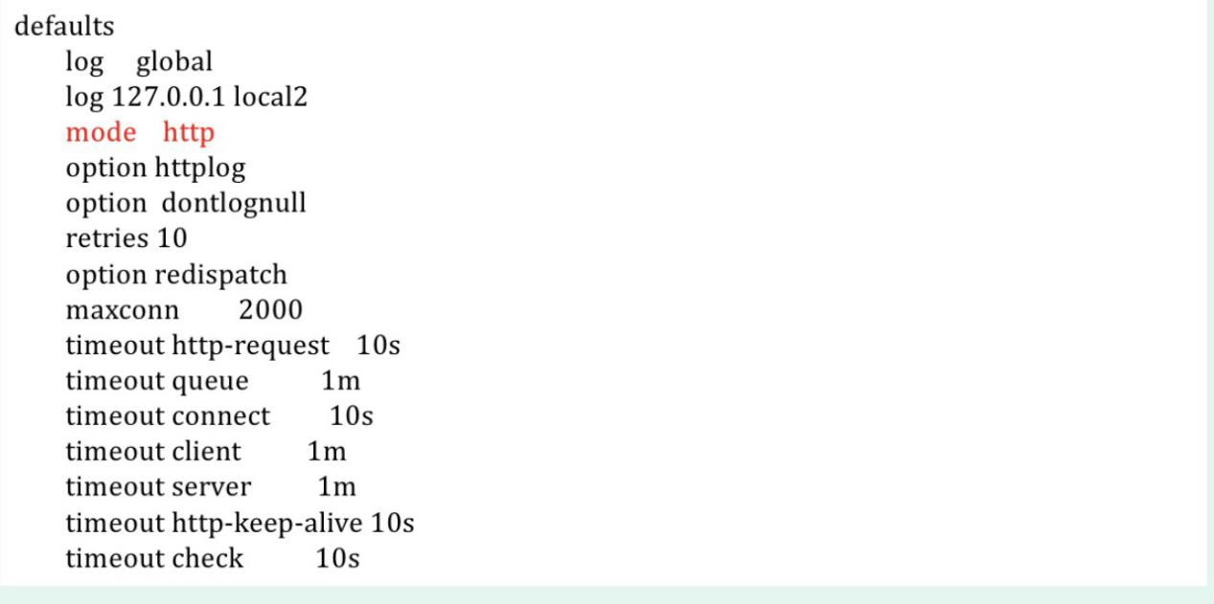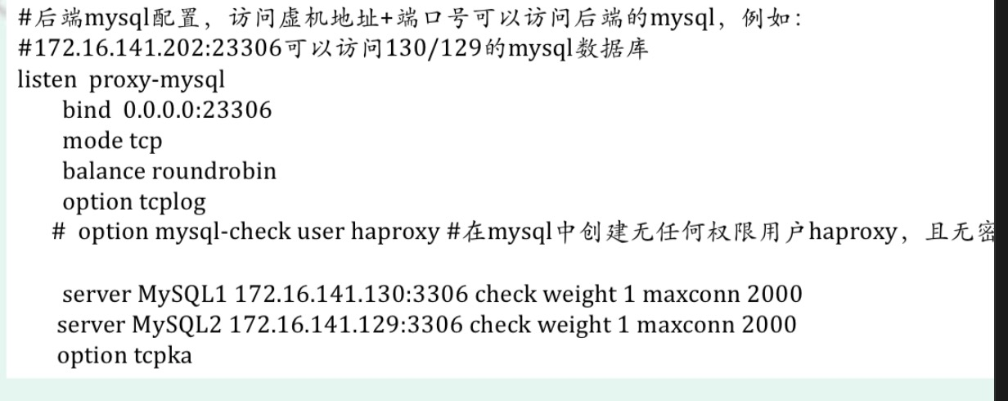

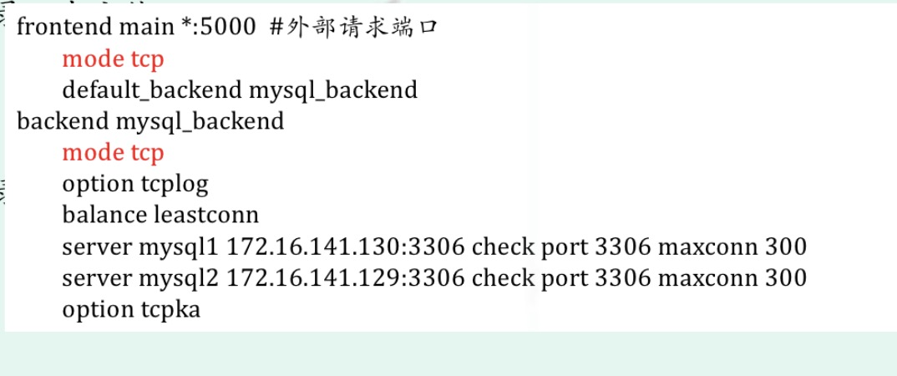

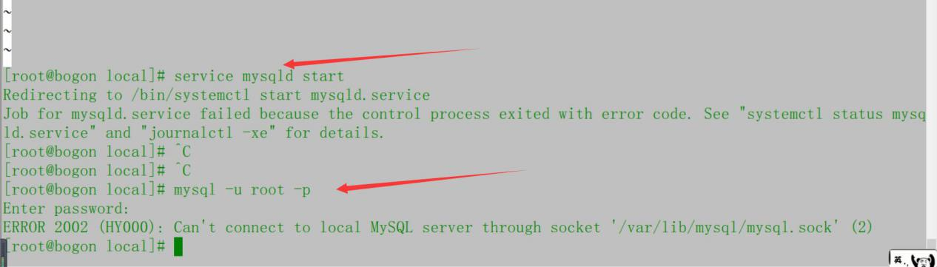

打开浏览器：http://172.16.141.202:1080/stats

(测试)

