SpendTracker
Design, development process and controls
Multi-layer spend tracking for a developer stack: Claude Code, the Claude API, GitHub, GitHub Copilot, CodeRabbit, MCP servers and any layer added later. Built by two kinds of Claude Code sessions that check and gate each other’s work.
Generated 2026-09-03 from repository commit a9c87ad by docs/exports/build-export.js. Every diagram and most tables are read from the markdown documents under docs/; the documents remain the source of truth.

Contents

1. Summary
What it is. SpendTracker records what every tool in a developer stack consumes, in that tool’s own unit (tokens, minutes, requests, sessions, actions, credits, reviews), and translates it into money. Everything runs locally first: collectors write usage events into a per-user SQLite database, a pricer turns events into cost lines using effective-dated rate cards and subscriptions, and a local web UI shows trends by app, by measure type and in real currency after subscriptions and budgets are applied. Each user can export append-only files to a shared git repository where a rollup job builds a team view.
How it is built. The repository is worked on by short Claude Code sessions in two roles. The Fable session (the most capable model) is architect, reviewer and gate: it answers questions, curates the ledgers, writes one task packet per builder session, verifies CI and acceptance criteria, and is the only session that merges. Builder sessions (other models) each take one packet, build it end to end on their own branch and draft PR, and stop. Only Fable holds the full context; a builder sees its packet and what the packet lists. Hooks enforce the roles inside Claude Code, CI enforces the PR-author rule and runs tiered tests scoped by blast radius, and branch protection on main is the backstop.
What this document contains. Sections 2 to 8 describe the system design (architecture, data model, cost model, collectors, rollup, web UI, security). Sections 9 to 12 describe the delivery plan, the development process, the controls and the testing and CI strategy. Section 13 describes the work packages and what is expected of every session from start to end. Section 14 records the alignment review that produced this revision.

1.1 Design decisions at a glance
ADR | Decision
ADR-0001 | Local-first SQLite as the system of record per user
ADR-0002 | One canonical usage-event fact table with a measure catalogue
ADR-0003 | Keep list cost, reported cost and effective (allocated) cost as separate cost kinds
ADR-0004 | Append-only file export rolled up through a git repository
ADR-0005 | Adapters are the only per-app code, bound by a conformance suite
ADR-0006 | Python, SQLite, FastAPI, htmx and Chart.js as the reference stack
ADR-0007 | Session roles bound to the model and enforced by hooks
ADR-0008 | CI runs tiered tests by blast radius and feeds a known-issues ledger
ADR-0009 | Session role from the observed model, else by declaration; undeclared sessions fail closed
ADR-0010 | Builder sessions work from a task packet; only the Fable session holds the full context

1.2 The one-paragraph design
Every app is a layer. Every layer emits usage events in its native measure. Events land in one canonical fact table in a local SQLite file. A pricer turns events into cost lines using effective-dated rate cards and subscriptions, producing both a list cost (pay-as-you-go price) and an effective cost (the share of a flat subscription the usage actually consumed, plus any overage). Budgets compare effective cost against allocations. A local web UI renders all of it. Adapters are the only per-app code; adding a layer means adding an adapter and a rate card. Export produces append-only files that a shared repository rolls up across users.

2. System architecture

2.1 Goals and how the architecture meets them
Goal | How the architecture meets it
Capture each layer's native measure (tokens, minutes, requests, sessions, actions, credits, reviews) | One fact table keyed by a measure catalogue (ADR-0002).
Translate to money including subscriptions and budgets | Pricer with rate cards, subscriptions, allocation and budgets (ADR-0003, COST-MODEL.md).
Store locally in SQLite | Per-node database, WAL, spool-based ingest (ADR-0001).
Local web UI for trends, by app, by type, by currency | FastAPI + htmx pages over SQL views (WEB-UI.md).
Roll up many local users to a repository | Append-only JSONL export, git-based rollup, CI-built aggregate (ADR-0004, AGGREGATION.md).
Add layers incrementally | Adapter contract and conformance suite (ADR-0005, ADAPTER-SPEC.md).
Iterate without losing context | Context ledger, ADRs, phase playbook (PHASE-PLAYBOOK.md); two session roles that gate each other and a packet per builder session (PROCESS.md, SESSION-PROTOCOL.md).

Non-goals for the first releases: real-time streaming dashboards, enforcing spend limits inside the tools, and scraping vendor invoices from web portals.

2.2 System context
A SpendTracker node runs on each developer machine. Push sources (Claude Code hooks and OpenTelemetry export, MCP hooks or proxy) write into it within seconds; pull sources (vendor billing APIs) are collected on a schedule; CSV and manual entries cover everything else. The node exports to a rollup repository that a team lead browses.
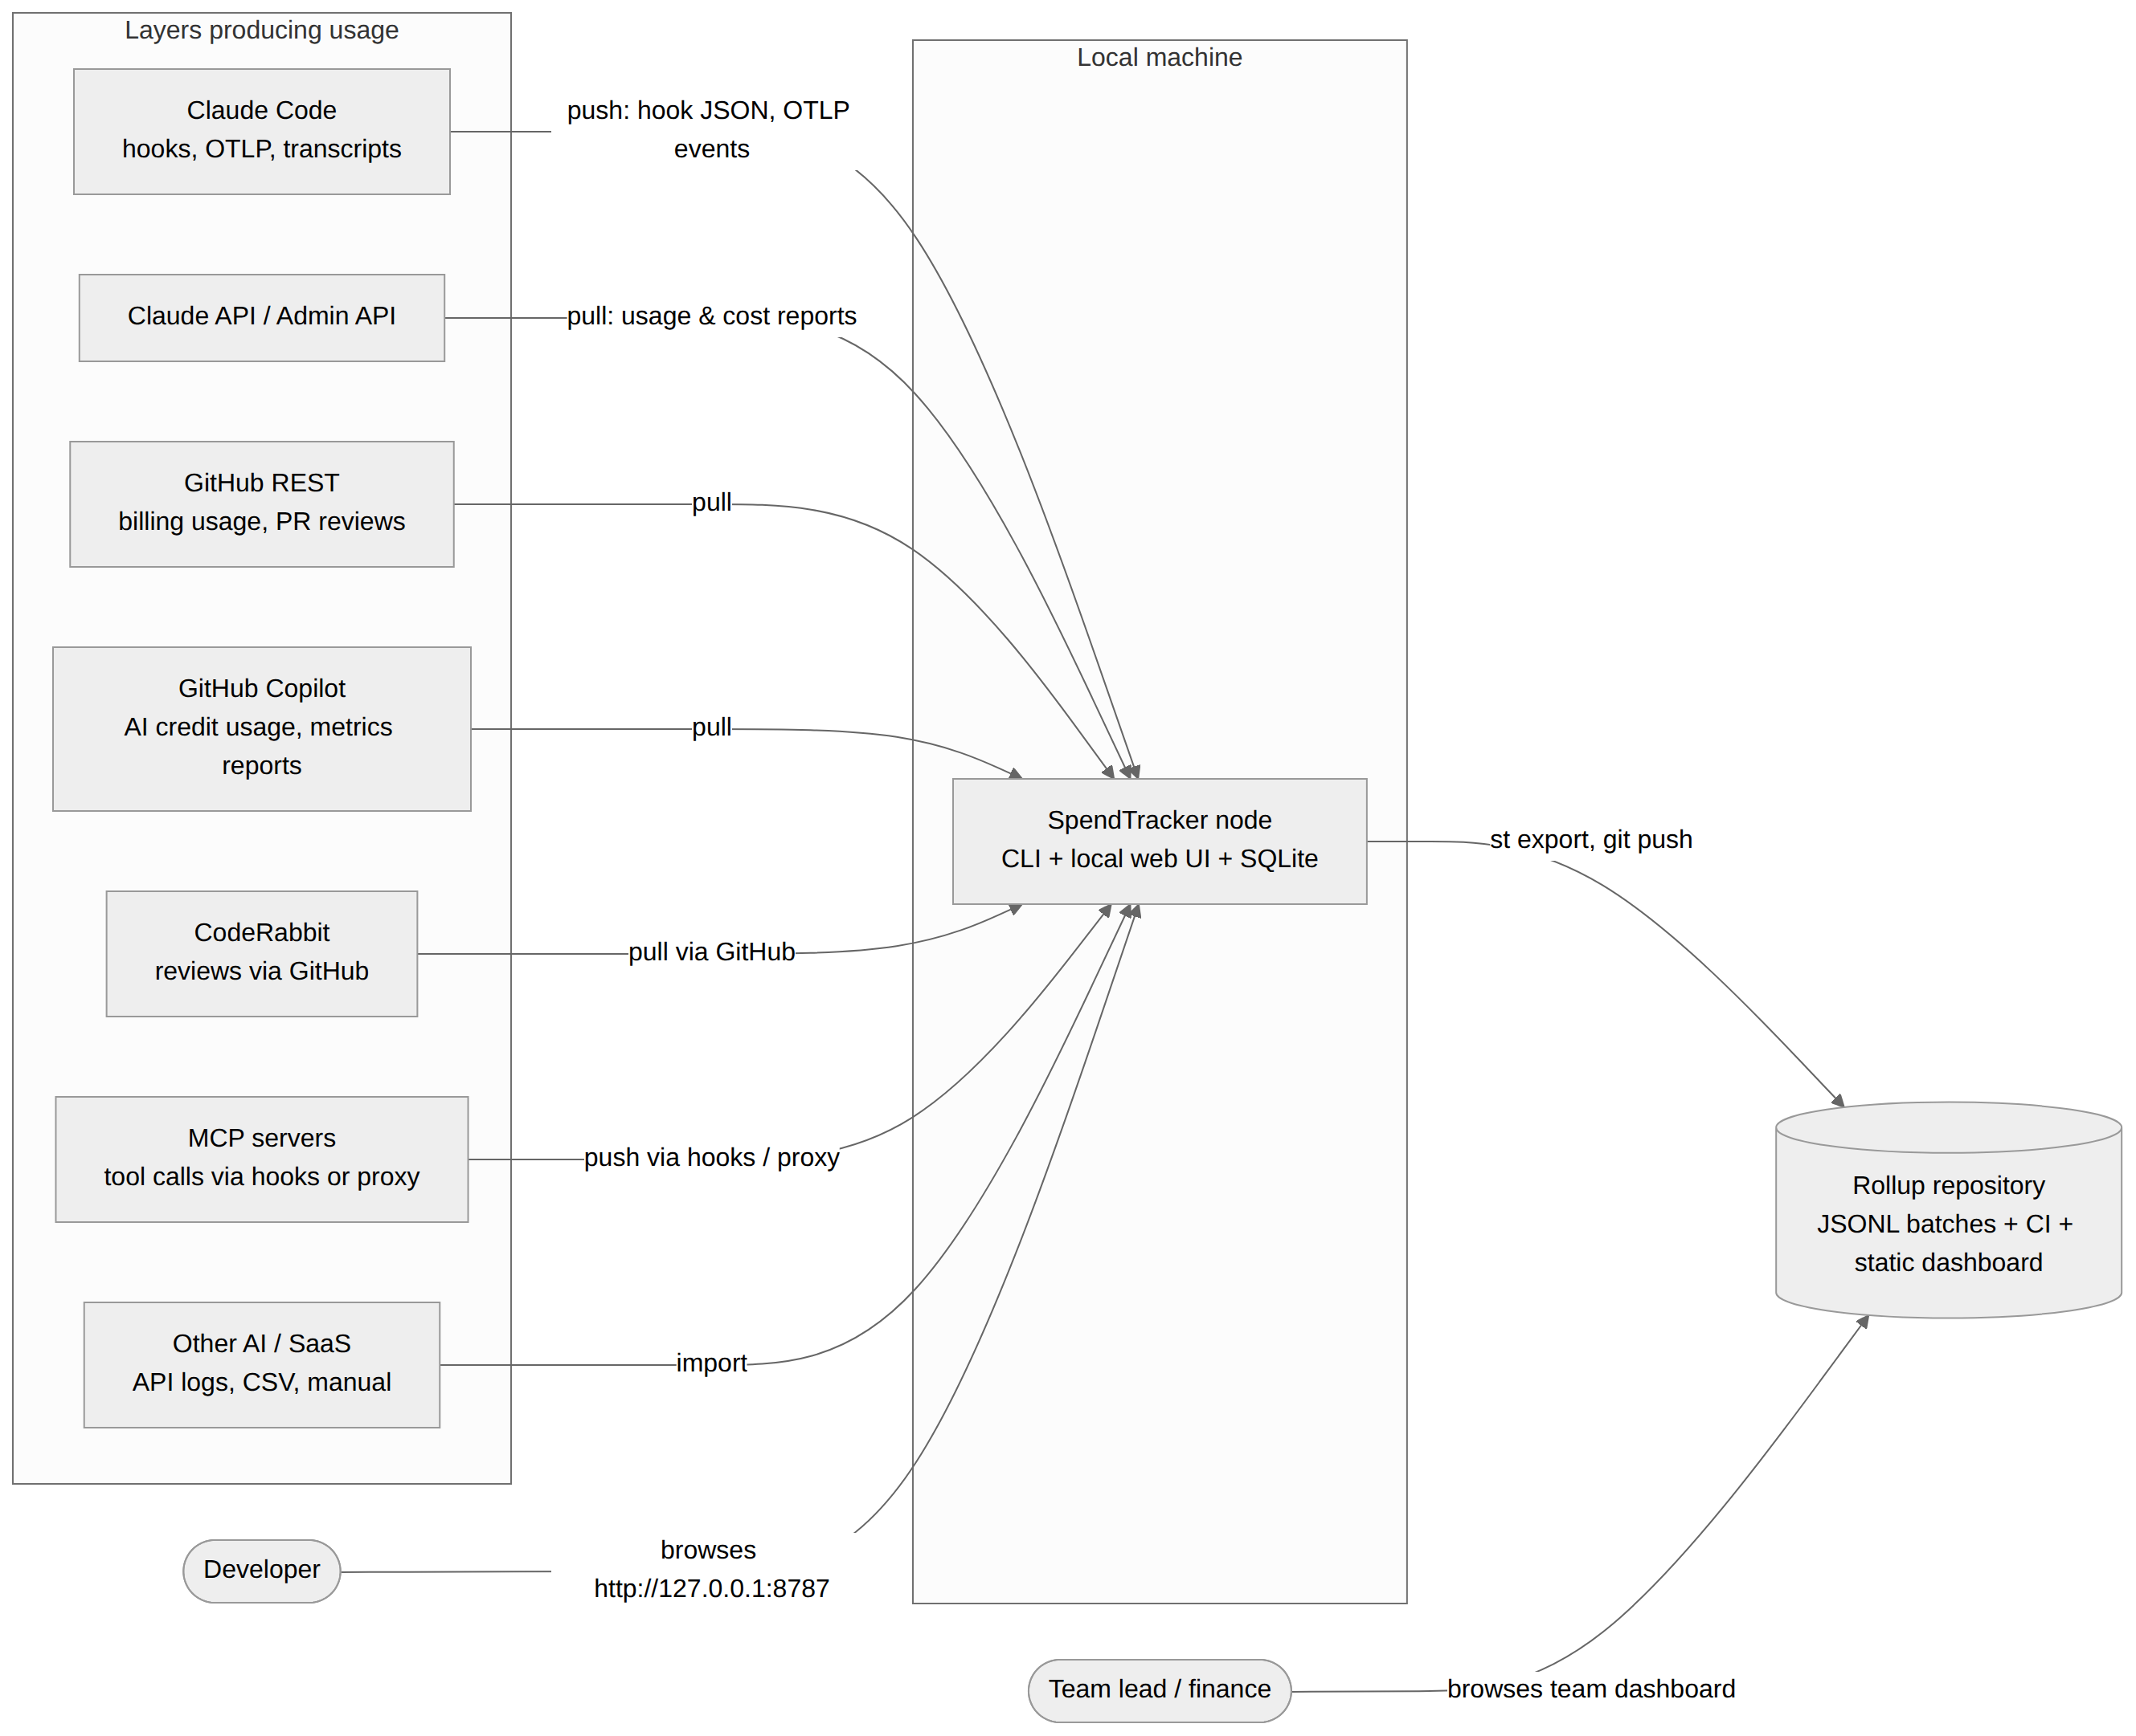
D-CTX: System context (source: docs/01-architecture/ARCHITECTURE.md)

2.3 Containers
st serve is one process hosting the web UI, the OTLP receiver, the spool watcher and, optionally, the scheduler. Every other command is a short-lived process that opens the same SQLite file. Hooks are shell scripts that only write files; they finish in milliseconds and never block Claude Code.

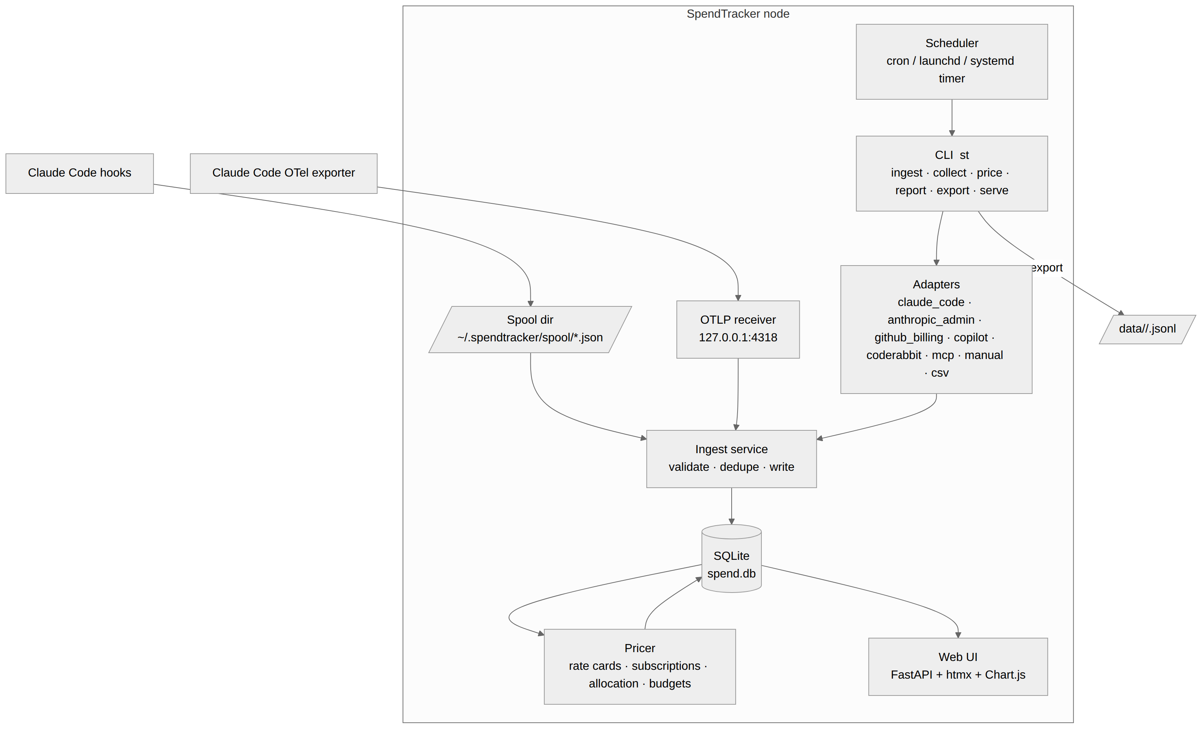
D-CONT: Container view (source: docs/01-architecture/ARCHITECTURE.md)

2.4 The data path
Every mechanism ends in the same place: a raw payload is normalized by adapter code into usage-event DTOs, validated (registered measure, UTC time, non-negative quantity, stable source reference), de-duplicated on app + source + source reference + measure, written, priced into cost lines, and read by SQL views that feed the JSON API and the pages.

D-COMP: Component view of the data path (source: docs/01-architecture/ARCHITECTURE.md)

2.5 Domain model

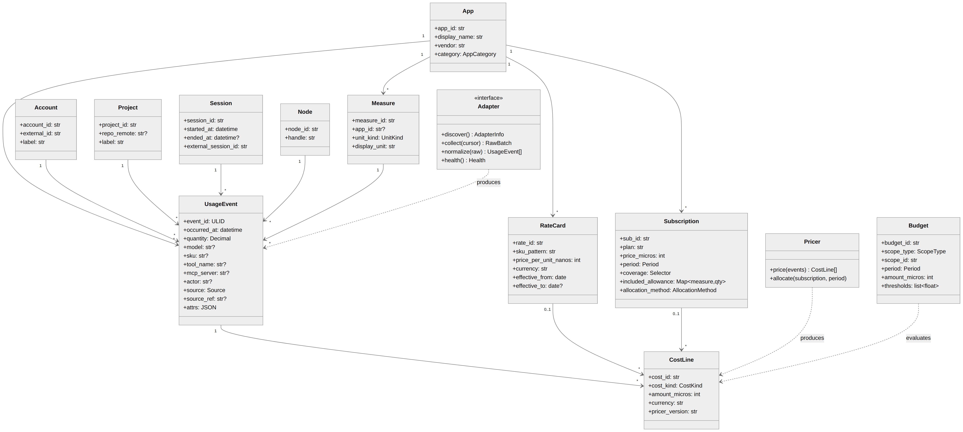
D-CLASS: UML class model of the domain (source: docs/01-architecture/ARCHITECTURE.md)

2.6 Key flows
The Claude Code hook path shows the decoupling that keeps hooks fast: the hook writes a spool file and exits; the ingester drains the spool, normalizes, inserts with duplicates ignored, and the pricer and UI read from the database.

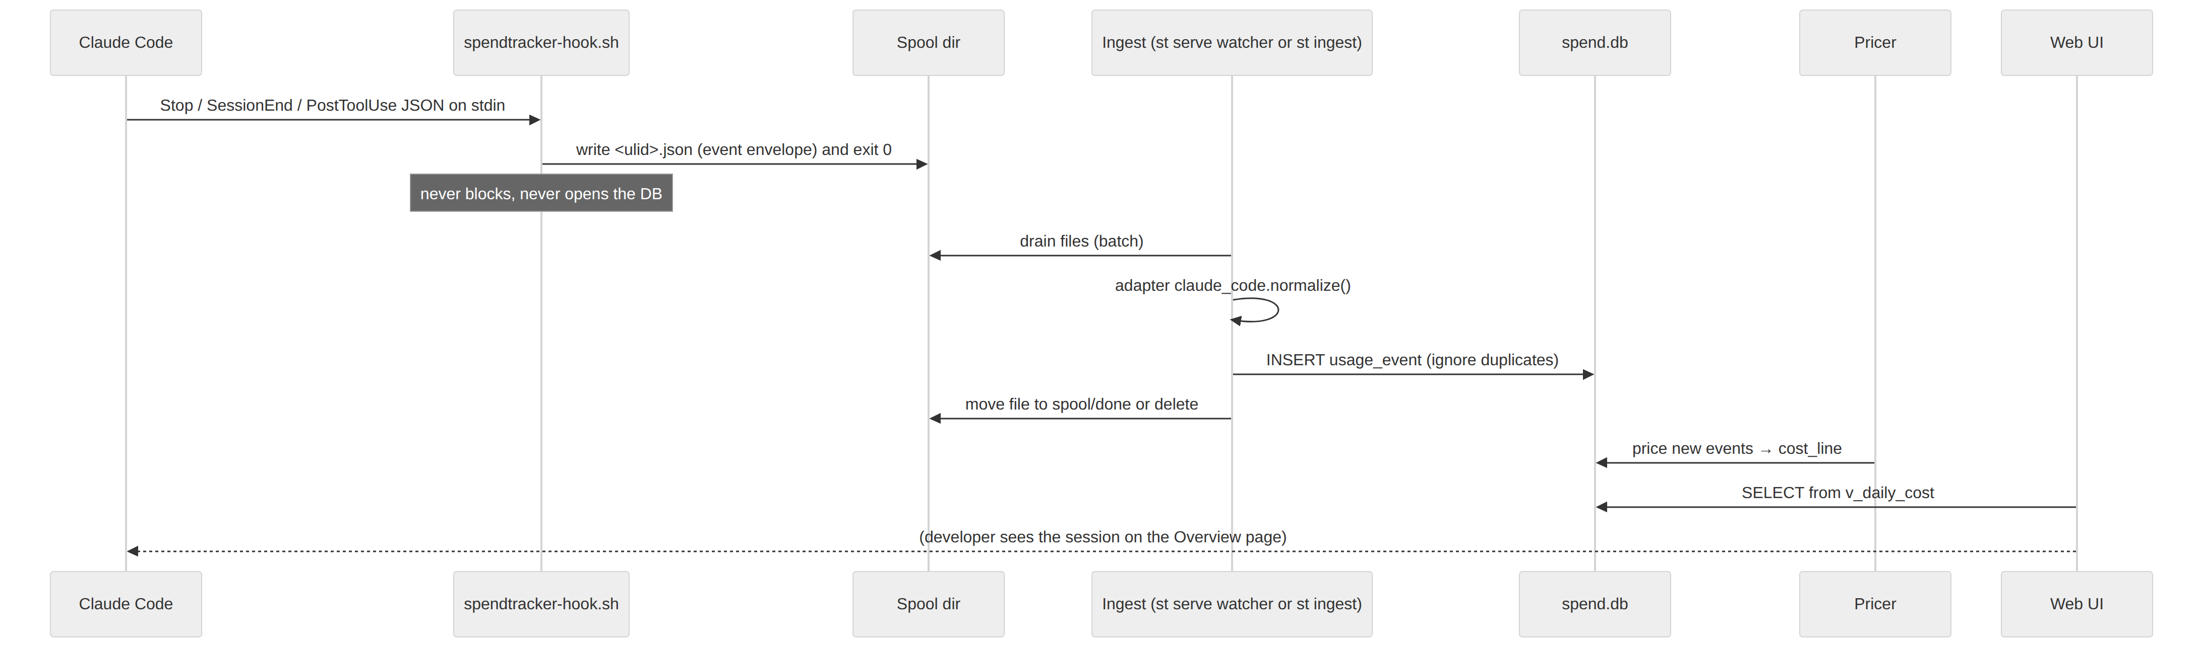
D-SEQ-HOOK: Claude Code hook to dashboard (source: docs/01-architecture/ARCHITECTURE.md)

Scheduled API pulls keep a cursor per adapter in adapter_state, insert with de-duplication on the source reference, record a collector_run row and price the new events.

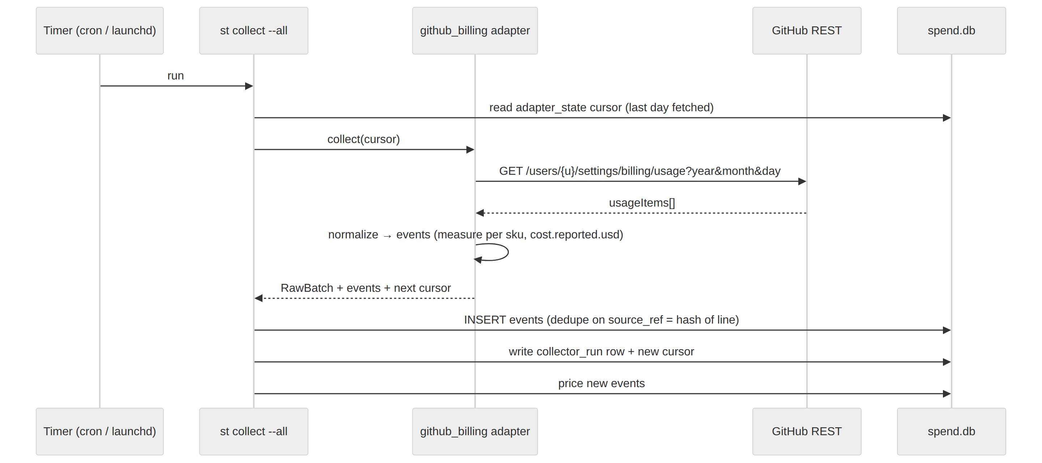
D-SEQ-PULL: Scheduled API pull (source: docs/01-architecture/ARCHITECTURE.md)

A collector run moves through a fixed lifecycle; failures retry with backoff and never advance the cursor.
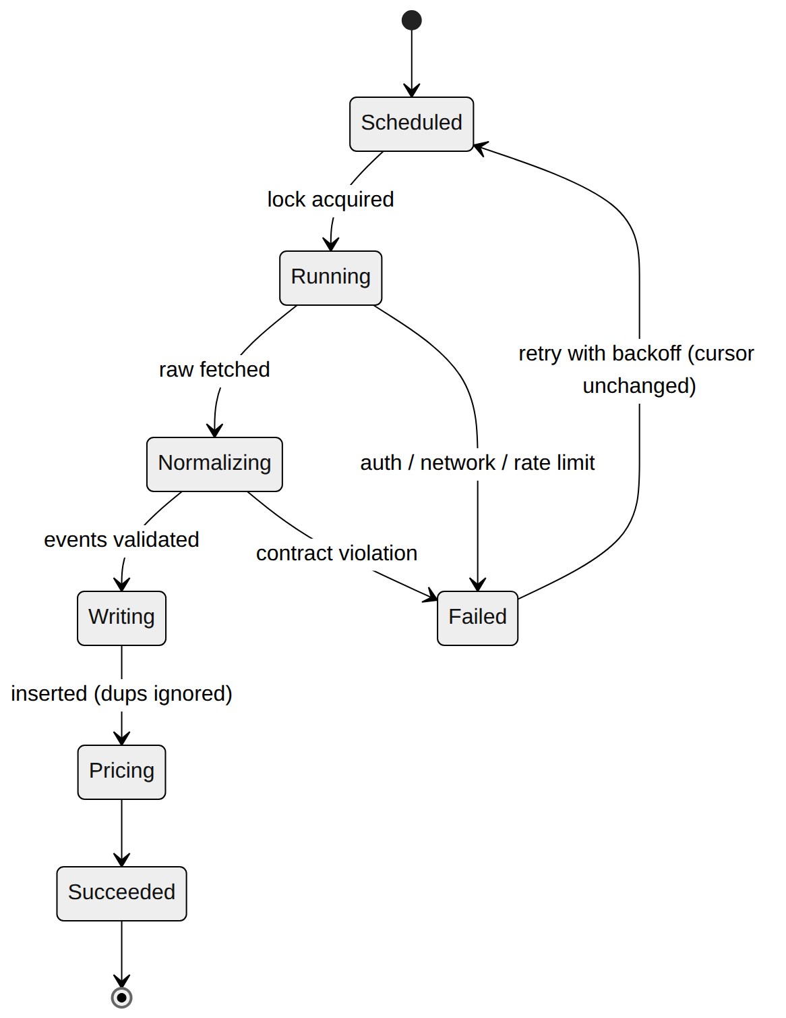
D-STATE: Collector run lifecycle (source: docs/01-architecture/ARCHITECTURE.md)

2.7 Layering rules
- core (schema, ingest, pricer, views) knows nothing about any app.
- adapters/* depend on core.api only, never on each other.
- web depends on SQL views and core.api; it never calls adapters.
- cli orchestrates; it contains no business logic.
- rollup reuses core to import batches into a second database with the same schema.

2.8 Cross-cutting concerns
Concern | Approach
Idempotency | Stable source_ref per adapter; unique index; ULID event_id.
Time | Store UTC; the UI converts with the node's timezone. Daily buckets are computed in the reporting timezone chosen in config.
Money | Integer micros + currency code; FX table for reporting currency.
Secrets | Tokens are referenced by environment variable name in config.toml; never stored in the DB or exports.
Privacy | Redaction levels applied at export (SECURITY-PRIVACY.md). Transcripts never leave the machine.
Observability of the tracker | collector_run table, /health endpoint, st doctor.
Versioning | Schema version in schema_migration; pricer_version on cost lines; adapter_api_version in manifests.

3. Data model
The DDL in schema/001_core.sql is the source of truth; docs/01-architecture/DATA-MODEL.md explains it. Every table exists in both the local database and the rollup database. Money is stored as integer micro-units with a currency code, prices as integer nano-units per unit; timestamps are UTC ISO-8601.
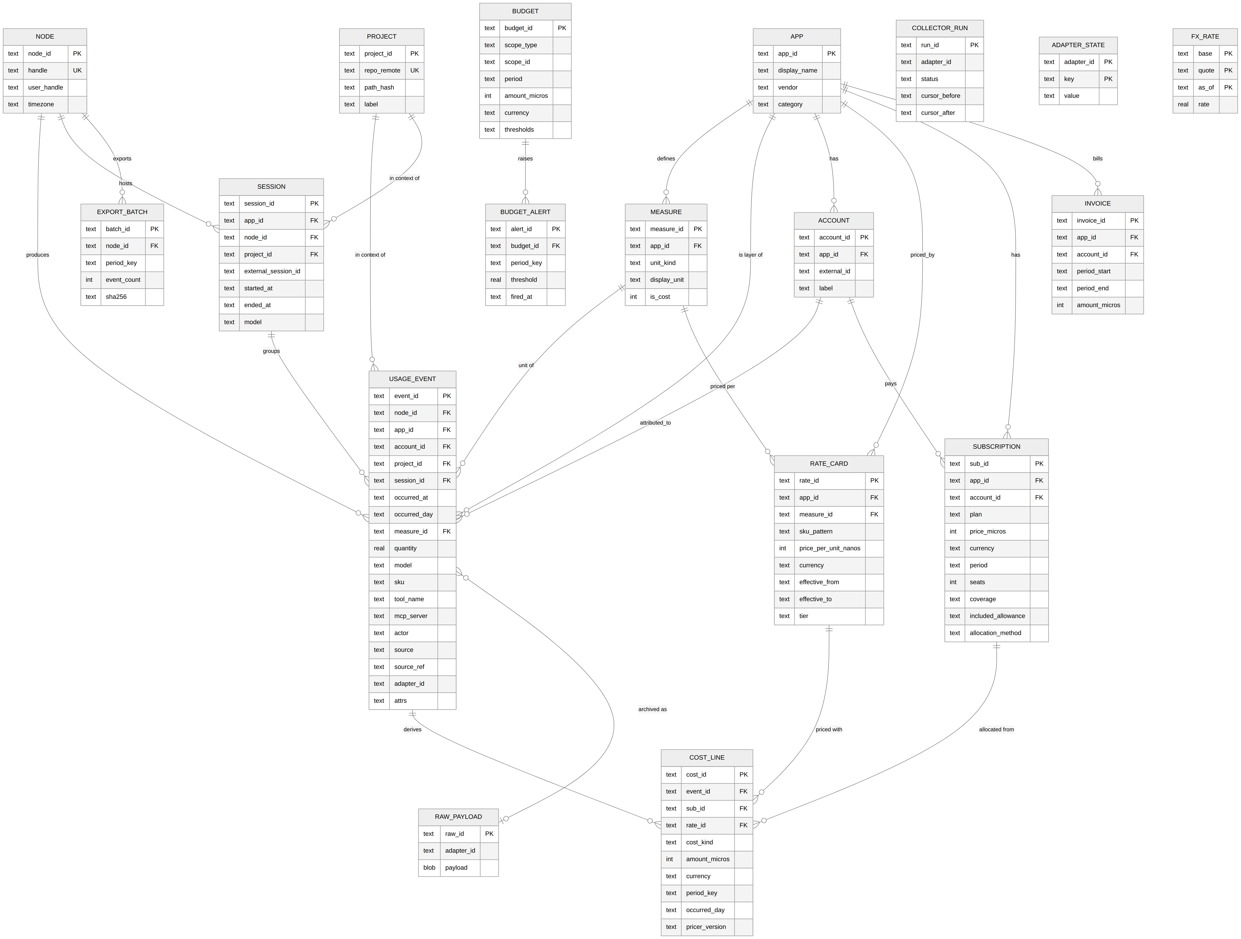
D-ERD: Entity relationship diagram (source: docs/01-architecture/DATA-MODEL.md)

3.1 Reference tables, facts and pricing
Table | Purpose | Notes
node | One installation. | handle appears in export paths, so keep it short and stable. hostname_hash only.
app | A layer. | Seeded by adapters on first run. category drives the "by type" grouping in the UI alongside measure.unit_kind.
measure | Unit catalogue. | Generic measures have app_id = NULL (token.input, session.count). App-specific ones are prefixed (copilot.ai_credit, action.minute.linux).
account | The vendor-side identity the usage is billed to. | One user can have several (personal GitHub, org GitHub).
project | Repository or directory the usage happened in. | Resolved from cwd by the hook (git remote get-url origin), else path_hash.
session | A grouping the layer itself defines. | Claude Code session, CI workflow run, Copilot day (synthetic).

Table | Purpose | Notes
usage_event | Immutable observations. | Never updated; corrections are new events with attrs.corrects = <event_id> and a negative-quantity counterpart is not allowed (quantity ≥ 0). Instead, delete-and-reinsert by source_ref inside a transaction when a source re-sends a corrected line.
raw_payload | Optional archive. | Enables re-normalization after an adapter bug fix. Keyed by content hash.

Table | Purpose | Notes
rate_card | Price per unit, effective-dated. | Lookup: most specific sku_pattern match, then latest effective_from ≤ occurred_at. Prices are stored per unit in nano-currency (Opus 5 input $5/MTok → 5000 nano-USD per token); cost lines round to micros.
subscription | Flat fees and allowances. | coverage JSON selects events; included_allowance maps measure to quantity per period; allocation_method picks the spreading rule.
cost_line | Derived money rows. | One row per (event, cost_kind). idle rows have event_id = NULL and carry unattributed subscription cost per day. Fully recomputable.
fx_rate | Conversion to reporting currency. | Applied in views by joining on currency and the latest as_of ≤ occurred_day.
budget / budget_alert | Allocations and threshold crossings. | Scopes: global, app, project, account, user, category.

3.2 Initial measure catalogue
measure_id | app_id | unit_kind | Emitted by
token.input | NULL | count | claude_code, claude_api, copilot (post June 2026), any LLM adapter
token.output | NULL | count | same
token.cache_read | NULL | count | claude_code, claude_api
token.cache_write | NULL | count | claude_code, claude_api (5m and 1h are distinguished by sku)
session.count | NULL | count | claude_code (SessionStart), any
active_time.s | NULL | duration_s | claude_code (claude_code.active_time.total)
request.count | NULL | count | claude_api, any API-style adapter
tool_call.count | NULL | count | claude_code (PostToolUse, non-MCP tools)
mcp.tool_call | mcp | count | claude_code hooks with mcp__* matcher, MCP proxy
mcp.duration_ms | mcp | duration_s (stored in seconds) | same
loc.added / loc.removed | claude_code | count | OTel claude_code.lines_of_code.count
commit.count / pr.count | claude_code | count | OTel
action.minute.<os> | github | duration_s (stored as minutes × 60) | github_billing (sku keeps the exact runner SKU)
storage.gb_month | github | count | github_billing (Actions storage, Packages, LFS)
codespaces.core_hour | github | count | github_billing
seat.count | NULL | count | github_billing, copilot, coderabbit (seat snapshots per day)
copilot.ai_credit | copilot | count | copilot adapter, /settings/billing/ai_credit/usage
copilot.premium_request | copilot | count | copilot adapter, legacy endpoint (pre June 2026 history)
copilot.suggestion.accepted / .shown | copilot | count | copilot metrics reports (org/enterprise only)
review.count | coderabbit | count | coderabbit adapter (reviews by coderabbitai[bot])
review.comment | coderabbit | count | same
cost.reported.usd | NULL | currency | any adapter whose source supplies a money amount

3.3 Attribution and migration policy
- Project: from cwd at hook time (git remote normalized to host/org/repo), from repositoryName on GitHub billing lines, from the PR's repository for CodeRabbit, otherwise NULL.
- Account: from the credential used to collect (GitHub login, Anthropic org) or from the OTel user.account_uuid / organization.id attributes.
- Actor: the person the usage is for. Defaults to node.user_handle; GitHub per-user billing lines and Copilot reports carry explicit logins.
- Session: Claude Code session_id; GitHub Actions run_id when present in attrs; otherwise NULL.
- Numbered files schema/NNN_<name>.sql, forward-only, idempotent where SQLite allows.
- A migration that adds a dimension column to usage_event must also add it to the export schema (AGGREGATION.md) and bump export_schema_version.
- st migrate refuses to run if the database version is newer than the binary.

4. Cost model
Three cost kinds are kept apart (ADR-0003): list (quantity times the rate-card price), reported (an amount the source itself supplied) and effective (allocated share of a subscription fee plus overage where a subscription covers the event, otherwise reported if present, otherwise list). Cost lines are derived data and can be recomputed at any time; usage events are never touched.

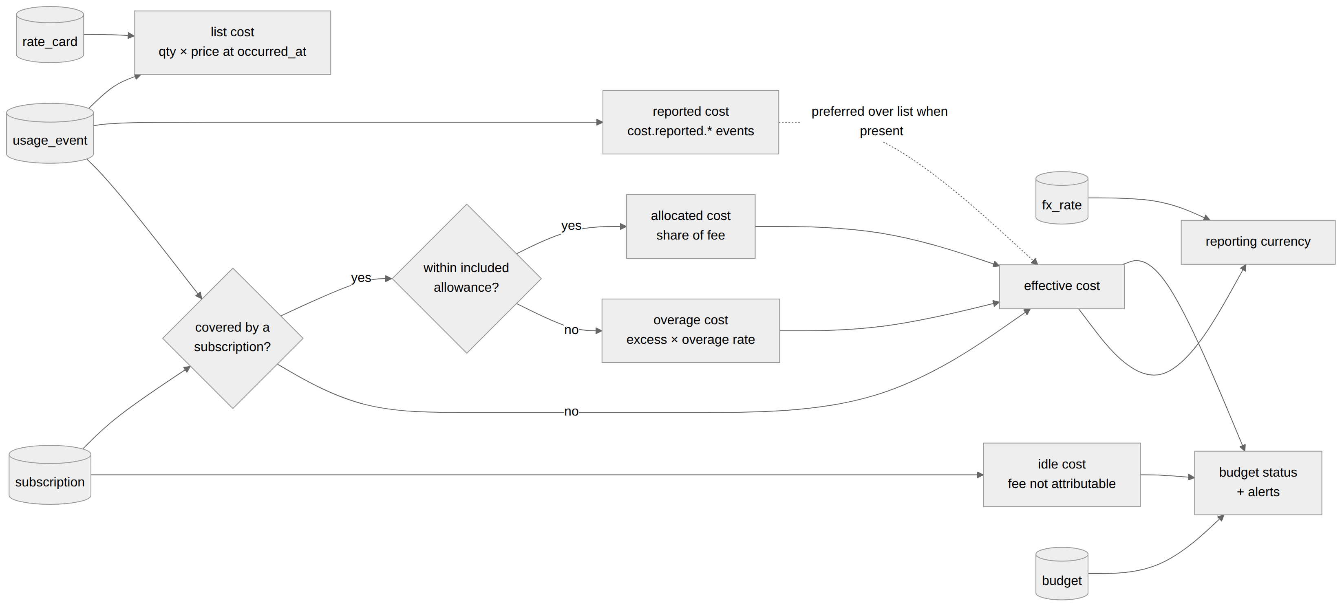
D-COST: Cost derivation pipeline (source: docs/01-architecture/COST-MODEL.md)

4.1 Definitions
Quantity | Definition
rate(a, m, d, t) | price per unit from the most specific rate_card whose sku_pattern matches d.model or d.sku, with the latest effective_from ≤ t and (effective_to null or > t). Tier defaults to standard; sku values like fast or batch select the matching tier.
list(e) | q × rate. If no rate exists, list is NULL and the event is flagged unpriced (visible in the UI).
reported(e) | sum of cost.reported.* events that share the event's source_ref group. Stored per group, attached to the request.count event of the group when one exists, otherwise to the first event.
covered(e, s) | true when subscription s is active at t and its coverage selector matches a, m, account. When several match, the most specific one (most selector fields) wins; ties go to the earliest starts_at.
allowance(s, m, P) | included quantity of m in period P (included_allowance[m] × seats).
overage(e) | for covered events: the part of q that exceeds the remaining allowance for m in P, in event time order, × the overage tier rate. If no allowance is defined for m, overage is 0 (unlimited plan).
allocated(e) | the share of fee(s, P) assigned to e by the allocation method (below).
idle(s, P) | fee(s, P) − Σ allocated when the method leaves part of the fee unassigned (no usage that period). Written as daily idle cost lines with event_id NULL.
effective(e) | allocated + overage if covered; else reported if present; else list.
savings(e) | list − effective (shown on the Apps page; it is the argument for or against the subscription).

4.2 Allocation methods
Method | Rule | Use when
usage_share (default) | allocated(e) = fee × list(e) / Σ list(covered events in P); if the denominator is 0, all of the fee becomes idle | A flat plan whose usage has meaningful list prices (Claude Max, Copilot)
even_daily | fee / days assigned to each day as an idle line regardless of usage; events get allocated = 0 | Seats where usage is not the cost driver (GitHub Team seat)
weights | fee × w(scope) per project or user from allocation_weights; inside a scope, split by usage_share | Chargeback to teams or clients
none | subscription tracked for budget totals only; events keep list cost | Temporary, until a coverage rule is defined

4.3 Worked example: Claude Max under usage share
Subscription | claude_max_5x, $100/month, coverage apps: [claude_code]
September usage | 120 requests; Σ list cost at Opus 5 rates = $260.00
One request r | list $4.00 (400k cache-read tokens at $0.50/MTok plus output)
allocated(r) | 100 × 4 / 260 = $1.538
effective(r) | $1.54 (no allowance defined, so no overage)
savings(r) | $2.46
Month totals | list $260, effective $100, savings $160, idle $0

If the same month had only two requests totalling $3 of list cost, effective cost would still sum to the $100 fee and the Apps page would show a utilization ratio of 3 %, the signal to downgrade. Budgets compare effective cost (including idle lines) against an amount per scope and period; thresholds fire once per period; budgets are informational and never block a tool.

5. Collectors and adapters
Each layer is integrated by an adapter, the only code that knows about a specific app. The mechanisms below all end in the same envelope in the spool or a direct call to the ingest layer.
Mechanism | Direction | Latency | Used by
Hook — the tool runs our script on an event; the script writes a spool file | push | seconds | Claude Code, any tool with lifecycle hooks
OTLP receiver — the tool exports OpenTelemetry logs/metrics to 127.0.0.1:4318 | push | seconds | Claude Code (richest source), other OTel-instrumented tools
Transcript / log parsing — read local files the tool already writes | pull (local) | minutes | Claude Code fallback, any CLI with JSONL logs
Vendor API pull — scheduled REST calls with the user's token | pull | hours to a day (vendor reporting lag) | GitHub billing, Copilot, Anthropic Admin API
Derived from a neighbour — count another system's records | pull | hours | CodeRabbit via GitHub PR reviews
Proxy / shim — wrap a process and count what passes through | push | seconds | MCP servers on hosts without hooks
Import — CSV/JSON files or manual entries via UI/CLI | manual | n/a | invoices, vendors without APIs

5.1 The adapter contract
An adapter is a directory with a manifest (adapter.yaml), a module implementing discover, collect, normalize and health, recorded fixtures and the events they must produce. A shared conformance suite (st adapter test) replays the fixtures and enforces the contract (ADR-0005). Push adapters (hooks, OTLP, proxy) implement only normalize and health.
Rule | Check
Every emitted measure_id is declared in the manifest or is a generic measure | static + runtime
occurred_at is timezone-aware UTC | runtime
quantity ≥ 0 and finite | runtime
source_ref is non-null for source ∈ {hook, otlp, api, transcript} and is stable across two normalizations of the same raw payload | fixtures replayed twice, diff must be empty
normalize performs no I/O | run under a socket-less sandbox
collect with the returned cursor yields no already-seen events | recorded HTTP fixtures (respx / VCR)
Money supplied by the source is emitted as cost.reported.<currency> events, never converted by the adapter | static check on measure ids
Manifest validates against schema/adapter-manifest.schema.json | CI
README documents required scopes and known gaps | CI checks headings exist

Out-of-process adapters in other languages write envelopes to the spool or POST /api/v1/ingest; they still ship a manifest and fixtures. The target for slice S7 is a new pull adapter in under one hour from the scaffold.

6. Multi-user rollup
Each node exports append-only JSONL batches per month with a manifest (event count, first and last event id, SHA-256, redaction level). Batches are committed to a rollup repository by pull request or by direct push to a per-node branch; CI validates on PR and, on merge, rebuilds rollup.db with the same schema and re-prices every period with the team’s rate cards, subscriptions and budgets so everyone is priced consistently (ADR-0004). Cost lines are not exported; raw payloads and transcripts never are.

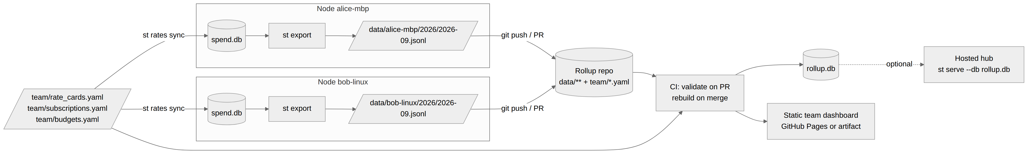
D-ROLLUP: Multi-user rollup flow (source: docs/01-architecture/AGGREGATION.md)

6.1 Redaction levels applied at export
Level | Effect
full | as stored locally (still no transcripts or raw payloads)
standard (default) | actor replaced by the node's user handle; attrs limited to an allowlist (effort, speed, agent_id, success); tool_name for non-MCP tools dropped
minimal | additionally drops session, project becomes the repo host+org only, events pre-aggregated to daily totals per (app, measure, model)

The rollup adds team-level views: by user, by project (chargeback with weights), subscription utilization (seats paid versus active versus usage) and node freshness. Per-event rows older than 13 months are compacted to daily aggregates.

7. Local web interface
st serve binds to 127.0.0.1:8787 only, with no authentication. Pages are server-rendered with htmx partials and Chart.js; all numbers come from SQL views. The same page templates render the static team site for the rollup repository.

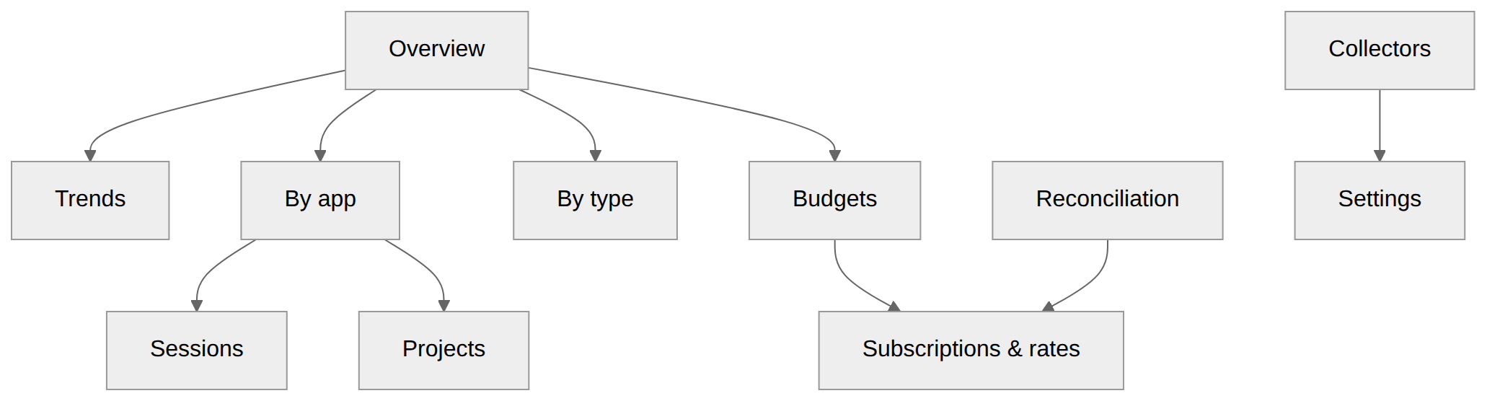
D-UI: UI navigation map (source: docs/01-architecture/WEB-UI.md)

Page | Question it answers | Main widgets | Source view
Overview | Where am I this month? | Effective spend vs budget (all budgets as progress bars with forecast marker); stacked daily area by app; "savings vs list" tile; top 5 projects; unpriced-events warning; stale collectors warning | v_daily_cost, v_budget_status, collector_run
Trends | How is it moving? | Line/area per app or measure over day/week/month buckets; period comparison (this vs last); moving average; toggle effective / list / reported | v_daily_cost, v_daily_usage
By app | Which layer costs what, in its own units and in money? | One card per app: native measures (tokens by type, minutes by runner, credits, reviews, MCP calls), effective vs list, utilization of its subscription, drill into model/sku breakdown | v_daily_usage, v_daily_cost, subscription
By type | Which kind of unit drives spend? | Grouping by measure.unit_kind and by app.category: tokens vs minutes vs actions vs seats; treemap of effective cost | v_daily_usage joined to measure
Sessions | What did a session cost? | Table of sessions (app, project, model, tokens, MCP calls, list, effective); session detail timeline of events | v_session_summary
Projects | Which repo consumes what? | Per-project cost across apps (Claude Code tokens + Actions minutes + CodeRabbit reviews on the same repo) | v_daily_cost grouped by project
Budgets | Am I on track? | Budget list with period, spent, forecast, alerts; create/edit form | v_budget_status, budget_alert
Subscriptions & rates | What are my plans and prices? | Subscription editor (coverage, allowance, allocation method); rate card table with effective dates; "apply seed" and "sync from team" buttons | subscription, rate_card
Collectors | Is data flowing? | Adapter status cards: last run, lag, events inserted, errors, next run; "run now" | collector_run, adapter_state
Reconciliation | Does computed match invoiced? | Per app/period: invoiced vs computed, delta, suspected causes; invoice entry form | invoice, cost_line
Settings | Node config | Handle, timezone, reporting currency, redaction default, enabled adapters, token env var names (values never shown) | config.toml

All money in the JSON API is { "micros": n, "currency": "USD" }; the UI formats. Effective cost is always the solid series, list cost dashed, reported dotted. No external network requests are made from the UI: fonts, scripts and Chart.js are vendored.

8. Security and privacy
The threat model is local-first tooling on developer machines holding usage metadata, vendor tokens by reference and, optionally, raw API payloads. The main risks are tokens leaking into the database or exports, prompt or code content leaking through attributes or raw payloads, and the local UI being exposed to the network.
Area | Rule
Tokens | config.toml stores the name of an environment variable, never the value. st doctor warns if a value looks like a token. Exports and the DB never contain tokens; CI runs a secret scan on every rollup PR.
Prompts and code | Never stored. Claude Code hooks read only ids, counts and timestamps. OTEL_LOG_USER_PROMPTS, OTEL_LOG_ASSISTANT_RESPONSES, OTEL_LOG_TOOL_CONTENT and OTEL_LOG_RAW_API_BODIES must stay unset for the SpendTracker exporter; the receiver drops prompt, response, body, tool_input attributes if they arrive.
Raw payload archive | Off by default. When on, it holds vendor billing lines and OTel records already stripped of content attributes. Not exported.
Transcripts | Parsed in place; only usage numbers are stored.
Identity | Hostnames and emails are stored hashed unless the node opts in. Export standard redaction replaces actor with the node's user handle.
Network | The UI and OTLP receiver bind to 127.0.0.1 only. --host 0.0.0.0 requires --allow-remote and prints a warning; there is no authentication layer, so remote exposure is for trusted networks with a reverse proxy in front.
Rollup repo | Private repository. Branch protection on main; CI validation required. Redaction minimums per node enforced by CI.
Dependencies | Pinned lockfile; pip-audit in CI; no runtime downloads (Chart.js and fonts vendored).
Hooks | Scripts are shipped with a checksum; st hooks install writes them to ~/.spendtracker/hooks/ and prints the diff to any existing file before overwriting.
MCP proxy | Forwards JSON-RPC byte-for-byte; records method names, tool names, sizes and latency; never records arguments or results.

8.1 Data classification
Data | Class | Leaves the machine?
Usage counts, timestamps, model names, SKUs | internal | yes, in exports
Project keys (repo remotes) | internal | yes (standard), org-only (minimal)
Session ids | internal | yes (standard), no (minimal)
Actor identity | personal | handle only
Tokens | secret | never
Prompt/response/tool content | confidential | never stored

9. Delivery plan

9.1 Capabilities
Each capability is independently buildable, testable and shippable behind its own CLI command, page or adapter. Vertical slices pick a thin path through several of them. No two capabilities write the same table except through the ingest layer and the pricer.

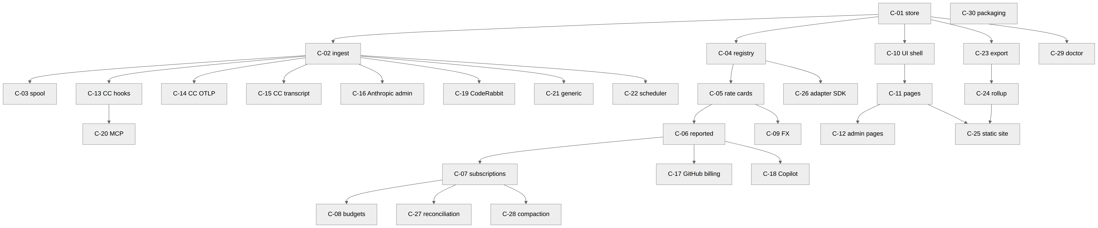
D-CAPDEP: Capability dependency graph (source: docs/02-delivery/CAPABILITIES.md)

Id | Capability | Deliverable | Depends on | Tests that prove it
C-01 | Core store and migrations | st init, st migrate, schema/*.sql, DB helpers | — | migration up on empty and populated DB; schema snapshot test
C-02 | Canonical ingest | core.ingest, st ingest (stdin/JSON/spool), POST /api/v1/ingest | C-01 | validator unit tests; idempotency property test
C-03 | Spool and watcher | spool dir, atomic writes, failed/ quarantine, watcher in st serve | C-02 | crash-mid-write test; duplicate file test
C-04 | Measure and app registry | seed loading from manifests, st measures list | C-01 | unknown-measure rejection
C-05 | Rate cards and list pricing | rate_card, pricer list kind, st rates apply/check/sync, seed YAML | C-01, C-04 | rate lookup precedence tests; nano→micro rounding tests
C-06 | Reported cost | cost.reported.* measures → reported cost lines | C-05 | GitHub netAmount fixture
C-07 | Subscriptions and allocation | subscription, coverage selectors, usage_share/even_daily/weights, idle lines, st reprice | C-05 | worked example from COST-MODEL §4 as a golden test; conservation test (Σ allocated + idle = fee)
C-08 | Budgets and alerts | budget, v_budget_status, forecast, thresholds, notifications, st budget status | C-07 | threshold-once-per-period test; forecast math
C-09 | Currency and FX | fx_rate, reporting currency conversion in views, st fx set | C-05 | conversion picks latest rate ≤ day
C-10 | Web UI shell and Overview | st serve, layout, filters, Overview page, /api/v1/series, /breakdown | C-01, C-05 | Playwright smoke; API contract tests
C-11 | Trends, By app, By type, Sessions, Projects pages | pages and partials | C-10 | snapshot tests of rendered partials with fixture DB
C-12 | Budgets, Subscriptions & rates, Collectors, Reconciliation, Settings pages | admin pages | C-10, C-07, C-08 | form round-trip tests
C-13 | Claude Code adapter: hooks | hook script, settings snippet, st hooks install, session/project attribution, MCP call parsing | C-02, C-03 | fixture replay; hook timing test (< 50 ms)
C-14 | Claude Code adapter: OTLP receiver | /otlp/v1/logs, /v1/metrics, cumulative→delta, content-attribute dropping | C-02 | recorded OTLP JSON fixtures; double-count guard test
C-15 | Claude Code adapter: transcript parser and backfill | offset cursors per file, st backfill claude-code | C-02 | fixture transcripts; resume-from-offset test
C-16 | Anthropic Admin API adapter | usage_report + cost_report pull | C-02, C-05 | respx fixtures; cursor test
C-17 | GitHub billing adapter | usage report pull, sku→measure mapping, trailing-3-day refetch | C-02, C-06 | fixtures for Actions/Storage/Codespaces lines
C-18 | Copilot adapter | ai_credit + premium_request billing pull; metrics reports download | C-02, C-06 | fixtures both regimes
C-19 | CodeRabbit adapter | reviews/comments by bot login across configured repos | C-02 | fixtures; pagination cursor
C-20 | MCP adapter and proxy | hook-based counting, st mcp-proxy stdio/HTTP | C-13 | proxy passthrough byte-equality test; latency capture
C-21 | Generic adapters | csv_import with mapping YAML, manual, otlp_generic, sdk_usage_log | C-02 | mapping tests
C-22 | Scheduler integration | st schedule install (launchd/systemd/schtasks), st collect --all, collector_run audit | C-02 | dry-run tests per platform; lock test
C-23 | Export | st export, JSONL + manifest, redaction levels, export_batch | C-01 | JSON-schema validation; redaction snapshot per level
C-24 | Rollup build | st rollup build, team YAML application, idempotent import, compaction | C-23, C-07 | rebuild twice → identical DB; conservation across nodes
C-25 | Static site | st site build, pre-computed JSON, Pages workflow | C-11, C-24 | build in CI; link check
C-26 | Adapter SDK, conformance suite, scaffold | core.api, st adapter test/new, manifest schema | C-02, C-04 | suite runs on every built-in adapter
C-27 | Reconciliation | invoice, st invoice add, Reconciliation page causes | C-06, C-07, C-12 | delta and cause detection fixtures
C-28 | Retention and compaction | st compact, aggregate rows, cost recompute | C-07 | totals preserved before/after
C-29 | Tracker observability | st doctor, /health, structured logs | C-01 | doctor detects missing hooks, stale collectors, token-looking config values
C-30 | Packaging and self-update | wheel, pipx/uv tool, st upgrade, release workflow | — | install smoke on macOS/Linux/Windows runners

9.2 Vertical slices
Slices are ordered so that each is usable on its own and the riskiest assumptions (hooks work, allocation math is right, rollup is idempotent) are tested early. A slice is delivered as one or more builder session packets, each sized to one 40-prompt session.

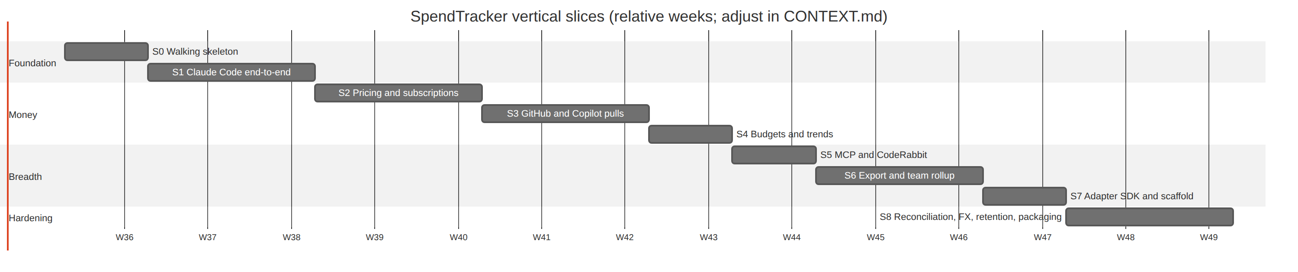
D-SLICES: Vertical slices timeline (source: docs/02-delivery/VERTICAL-SLICES.md)

Slice | Goal | Exit criteria
S0 Walking skeleton | prove the spine. One manual event goes in, is priced, and shows on a page. | pipx install from a wheel built in CI; st add --app claude_api --measure token.output --qty 1000 --model claude-opus-5 then st report prints $0.025. The full list is AC-1 to AC-17 in the packet docs/tasks/BS-001-s0-walking-skeleton.md.
S1 Claude Code end-to-end | a real session shows up with tokens, model, project, MCP calls and reported cost within seconds. | after a 10-minute Claude Code session, Sessions page shows the session with tokens matching /cost within 2 %, and MCP calls per server.
S2 Pricing and subscriptions | list vs effective is correct under a Claude Max subscription; savings are visible. | month with mixed usage shows effective = subscription fee to the cent; toggling the subscription off makes effective = list.
S3 GitHub and Copilot pulls | minutes, storage, seats and Copilot credits flow in on a schedule with reported cost. | scheduled run every hour for 3 days with zero failed collector_run; GitHub page totals match the GitHub billing page for the month.
S4 Budgets and trends | "am I on track" for every scope, with forecast and alerts. | a budget at 80 % triggers a desktop notification and a SessionStart context line in Claude Code.
S5 MCP and CodeRabbit | actions and reviews are first-class layers. | a PR reviewed by CodeRabbit appears under the project with review count; MCP calls per server per day chart.
S6 Export and team rollup | two nodes roll up into one team dashboard through a git repo. | two people export September, CI publishes a dashboard showing both, totals match the sum of their local Overview pages.
S7 Adapter SDK and scaffold | a new layer in under an hour by someone who has not read the core. | a timed exercise: build an adapter for a simple CSV usage export (e.g. an OpenAI usage CSV) from the scaffold in under 60 minutes, with fixtures, passing CI.
S8 Reconciliation, FX, retention, packaging | trustworthy month-end numbers and painless upgrades. | an invoice entered for August reconciles within tolerance or the page names the cause; pipx upgrade from S0 build to S8 build migrates a populated DB without loss.

9.3 The phase playbook
A phase is one pass through a slice, or a research, redesign or update effort. Context does not survive between sessions unless it is written down in known places, so every phase follows the same nine steps and ends with the Fable session updating CONTEXT.md and writing the next packet.

D-PHASE: Phase steps (source: docs/02-delivery/PHASE-PLAYBOOK.md)

Artifact | Purpose | Updated when
docs/00-context/CONTEXT.md | Current state, next actions, decisions log, open questions, phase history | End of every phase, and mid-phase when a decision is made
docs/00-context/adr/ADR-NNNN-*.md | Decisions with rationale and alternatives | Any time a design choice is made or reversed
docs/00-context/research/<slice>-<topic>.md | Findings from research with dates and sources | During research steps
docs/01-architecture/*.md | The design | When the design changes; never left describing a different system than the code
docs/02-delivery/*.md | The plan | When scope or order changes
Code comments # CONTEXT: | Pointers from code to the ADR or doc section that explains a non-obvious choice | While building
Commit messages | S<slice>/<capability>: <what> prefix, body links to the ADR or research note | Every commit

10. Development process: two roles that gate each other
Work is divided between the Fable session (lead: architect, project manager, designer, the owner’s delegate) and builder sessions (developer and tester for one packet). The division exists so that the model that designs and reviews is not the model that builds, and so that every piece of work passes through a reviewer with the full context before it reaches main. The mechanics are decided in ADR-0007, ADR-0008, ADR-0009 and ADR-0010, specified in docs/02-delivery/SESSION-PROTOCOL.md and enforced by the hooks in .claude/hooks/; docs/PROCESS.md adds the division of labour and the packet contract.

10.1 Roles

 | Fable session (lead) | Builder session (developer)
Role source (ADR-0009) | model matches fable|mythos (policy.json), or SPENDTRACKER_ROLE=fable, or ROLE: fable declared when no model was reported | any other model, or SPENDTRACKER_ROLE=builder, or ROLE: builder
Is | architect, project manager, designer, product owner's delegate | developer and tester for one packet
Context (ADR-0010) | full: design, ADRs, phases, all ledgers, all packets, all builder close logs | docs/PROCESS.md, its packet, the documents the packet lists, plus what the start hook injects: the current-state table, its own queue entry, open issues, answered questions on its branch, its own log entries. Nothing else unless the packet names it
Writes code | never | yes, inside the packet's file list
Writes tests | acceptance criteria in the packet; may add acceptance fixtures under schema/seed/ | unit, integration and system tests for its own code
Runs CI and verification | yes, independently, on every PR head | locally before every push
Reviews | code and architecture; issues action items to the builder through the queue entry | may review any PR and comment
Marks a PR ready | yes | yes; any session may
Merges | yes, when green, author-compliant, questions answered, issues recorded | never (hook-denied)
May edit | docs/, .claude/, README.md, CHANGELOG.md, schema/seed/ (fable_editable_paths) | the packet's "Files you may touch"; never the ledger files, CONTEXT.md or another packet (hook-denied)
Ledger writes | answers (answer.sh), issue curation, CONTEXT.md, log entries | questions (ask.sh), issues (issue.sh), log entries (log.sh)
Ends with | /fable-review checklist, log.sh close | /close-out

10.2 Session lifecycle, start to end
A builder session starts with the role bound by the hook and its own queue entry injected, reads its packet, builds one checkpoint at a time (each ending green and pushed), asks when something is missing, and ends with the close-out before its 40th prompt. A Fable session starts with the full context, answers, curates, reviews each PR against its packet, merges or sends it back, updates the ledger and writes the next packet.

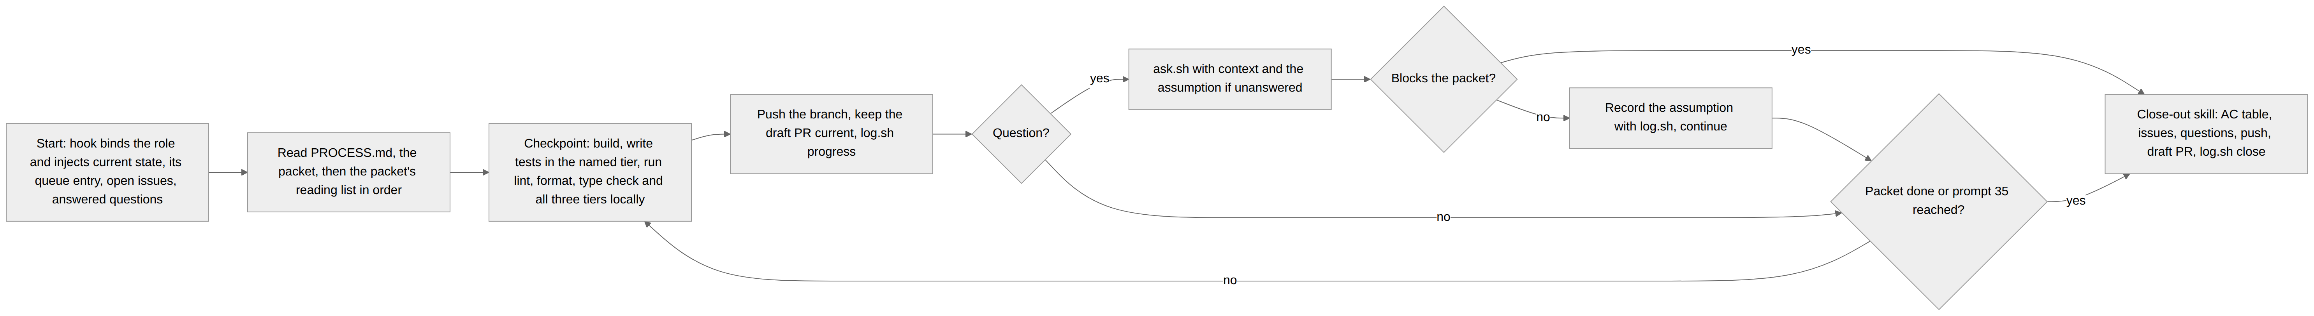
D-LIFECYCLE-BUILDER: Builder session lifecycle (source: docs/02-delivery/SESSION-PROTOCOL.md)

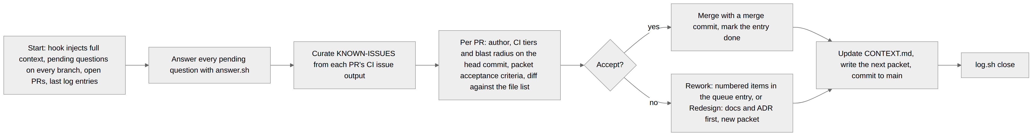
D-LIFECYCLE-FABLE: Fable session lifecycle (source: docs/02-delivery/SESSION-PROTOCOL.md)

10.3 What each session must produce

 | Builder session | Fable session
Starts from | its queue entry and packet, injected and named by the start hook | the whole ledger set, injected by the start hook
First action | log.sh start naming the entry; read PROCESS.md, the packet, its reading list | log.sh start; if the role was declared, confirm the model with get_session
During | one checkpoint at a time, each pushed green; log.sh progress per checkpoint; ask.sh per question; issue.sh per defect or failing check | answer.sh per question; issue.sh or edits to curate issues; acceptance criteria run on each PR head
Ends with | /close-out: summary with an AC table (MET / NOT MET / UNVERIFIED with evidence), deviations, assumptions, spend; questions and issues filed; branch pushed; draft PR under the owner's username; log.sh close | merges recorded in the log; CONTEXT.md updated (state, next actions, queue, decisions, questions, history); the next packet written; log.sh close
Never | merges, pushes to main, edits a ledger or CONTEXT.md, reads another packet, starts a second entry, answers a question | writes application code or tests, merges a red, unanswered, unrecorded or wrongly-authored PR, patches main forward (revert instead)

10.4 Interaction between owner, Fable, builder, CI and the ledgers

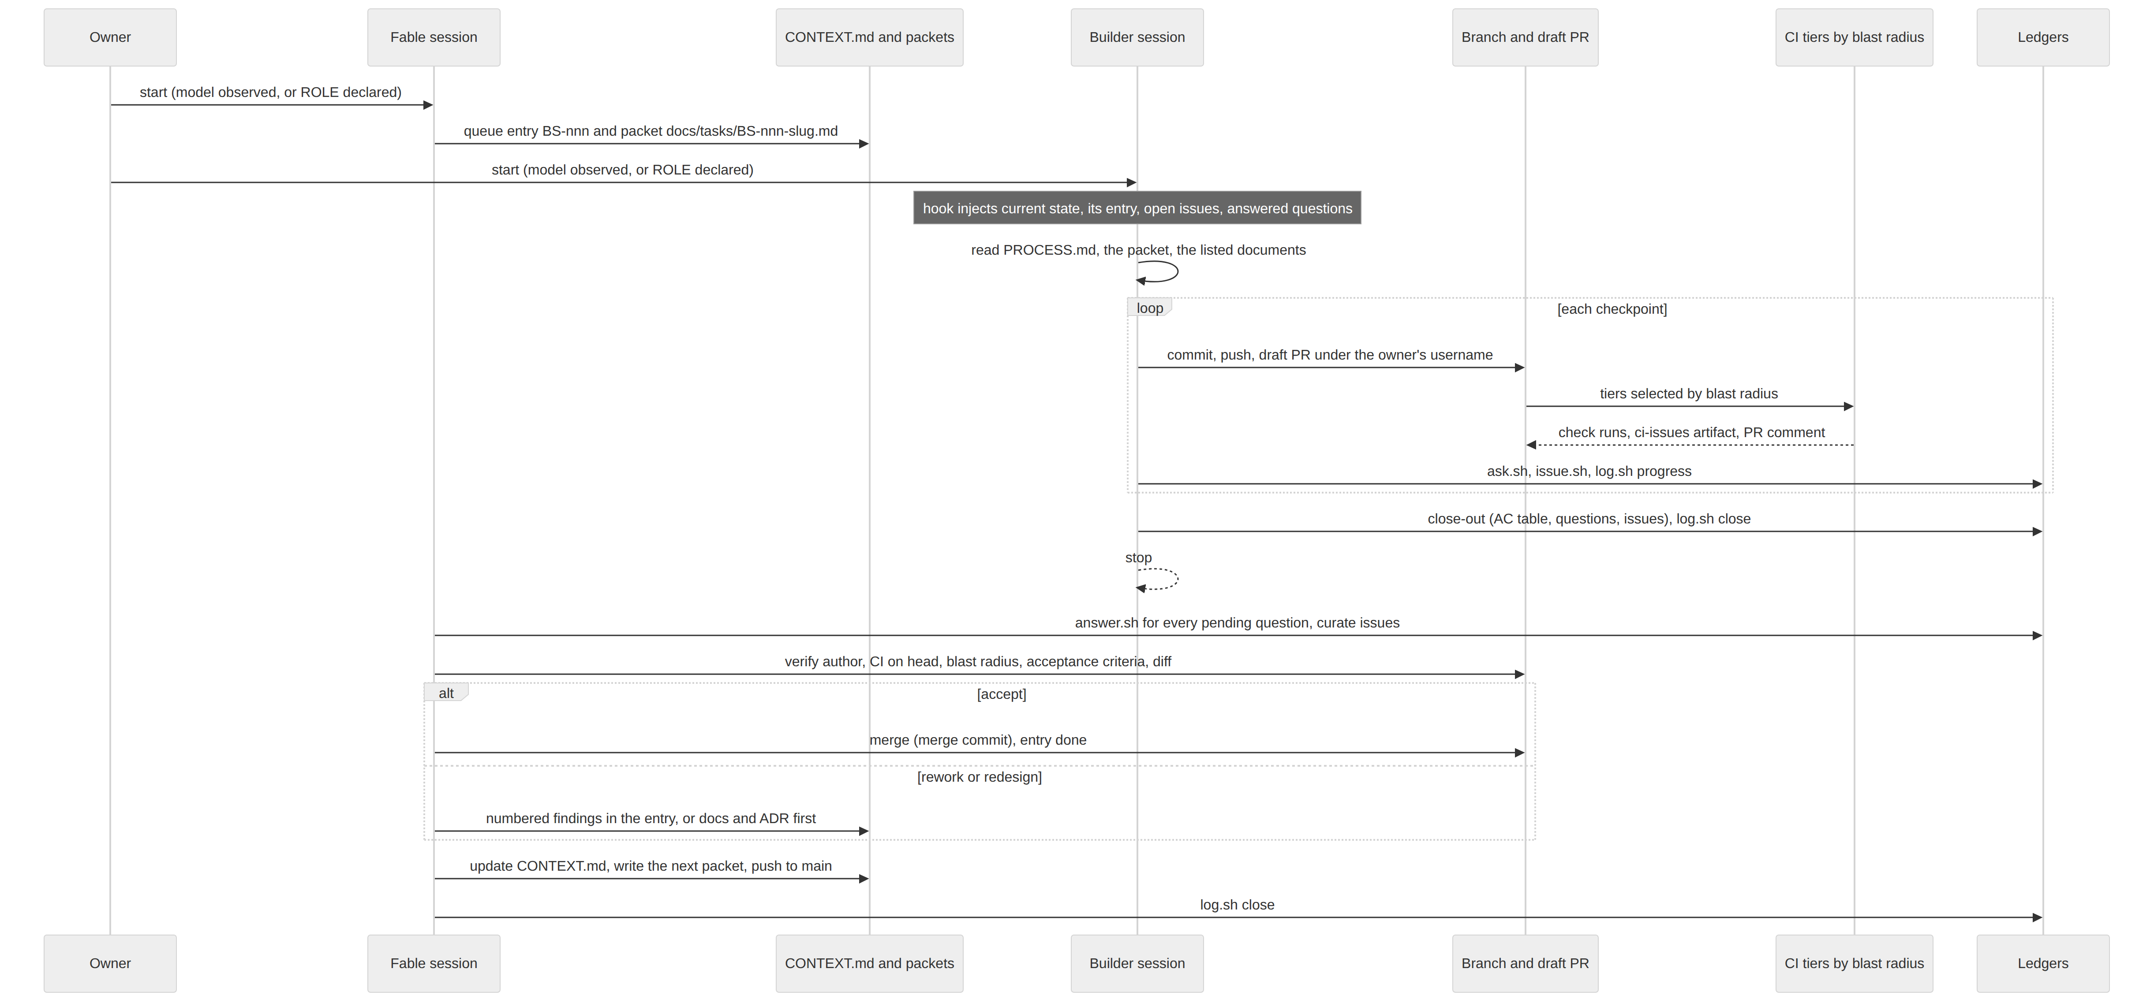
D-SESSION: Session interaction (source: docs/02-delivery/SESSION-PROTOCOL.md)

10.5 The task packet
Fable writes one packet per builder session. A builder starts with no memory of anything, so the packet stands alone with the documents it lists. Its sections, in order:
# BS-nnn · <short name>
ROLE / AUTHOR · SPEC-COMMIT (the main commit the packet was cut from) · PHASE / SLICE · BRANCH ·
CAPABILITIES · STATUS
0. How to use this packet the builder's operating instructions
1. Goal one paragraph: what exists when this is done
2. Read, in this order the only documents the builder needs, and why each
3. Acceptance criteria numbered AC-n, each testable; Fable runs them all
4. Interfaces to honor names, signatures, shapes, conventions later work builds on
5. Files you may touch explicit list; anything else is out of scope
6. Build order with checkpoints ordered steps, each ending green, each a resume point
7. Out of scope what not to build even when cheap
8. Tests required path, tier, what it proves
9. Known constraints limits, environment, hygiene
10. Close log what the builder must report beyond /close-out
11. Fable's standing items Fix issues · Act on answers · Changes requested by Fable
Packets in flight at the same time have disjoint file lists. A packet is sized to one session; its checkpoints make it resumable by the next session when the prompt limit is reached.

10.6 Questions, close log and Fable’s verification
- Ask with ask.sh, one question per call, with --context saying what depends on the answer and the assumption you will proceed under if no answer arrives.
- If the answer blocks the packet: log.sh progress why, /close-out, stop. The queue entry becomes blocked.
- If it does not block: record the assumption with log.sh progress, continue, and list the assumption in the close log.
- Only Fable answers (answer.sh). An answer is an instruction; the builder acts on it. Fable marks a question needs-human when only the owner can decide, and mirrors it into the CONTEXT.md open-questions table.
The close log carries an acceptance-criteria table (MET, NOT MET or UNVERIFIED with evidence), deviations, assumptions and spend. Fable treats it as a report to verify, not as truth: it checks out the PR head, runs lint, type check and all three tiers itself, runs every acceptance criterion, reads the diff against the file list and for architectural fit, and confirms the CI blast radius, the PR author, answered questions and recorded issues. Outcomes are Accept (merge with a merge commit, entry done), Rework (numbered findings in the queue entry, same branch) or Redesign (docs and ADR first, new packet). Fable advises and directs; it never makes the code change itself.

10.7 Human decision rights
Fable stops and asks the owner for:
- closing a phase or slice and opening the next;
- any change to architecture, interfaces or scope that needs a new or superseded ADR;
- adding a dependency outside ADR-0006, or an external service;
- anything that changes the cost profile of the project;
- a builder disagreement with a packet that the design does not settle;
- applying branch protection or repository settings (cannot be done from a session);
- changing this document or SESSION-PROTOCOL.md.

11. Context separation and controls

11.1 The context boundary
Only the Fable session holds the full context (ADR-0010). A builder’s context is PROCESS.md, its packet, the documents the packet lists, and the excerpt the start hook injects. This is deliberate: for quality, a builder that reads a packet builds to acceptance criteria instead of reinterpreting the design; for security, builder sessions run on less capable models and act under the owner’s identity, so limiting what they can see and act on (other builders’ unreviewed branches, the decisions log, owner next actions, other packets) limits what a confused or misdirected session can do, and keeps unreviewed content on one branch out of another session’s context.
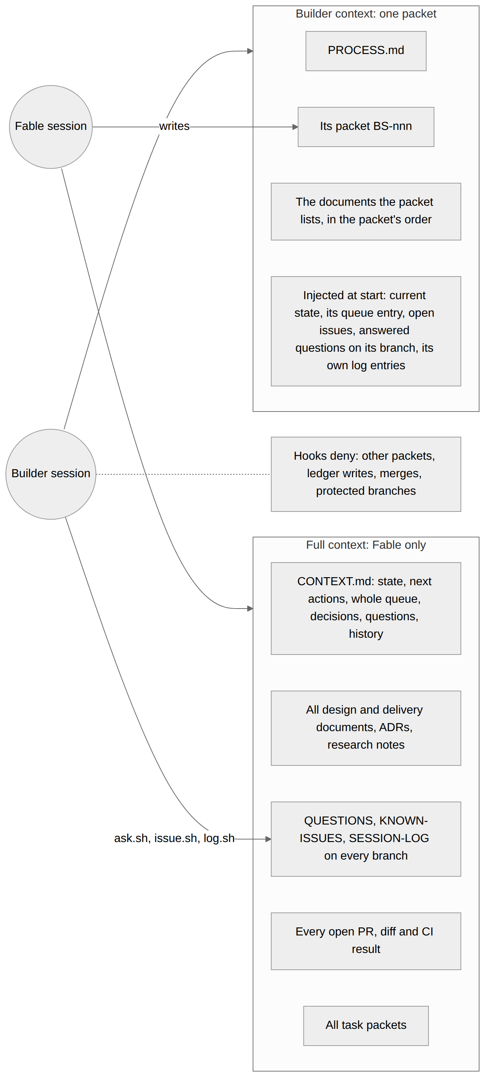
D-CONTEXT: Context boundary between the roles (source: docs/02-delivery/SESSION-PROTOCOL.md)
Material | Fable | Builder
CONTEXT.md | all of it, and writes it | current-state table and its own queue entry, injected
Task packets | all, and writes them | its own only (other packets are hook-denied)
Design and delivery documents | all | the sections its packet lists
QUESTIONS.md | all branches, answers | questions answered on its branch (injected); appends with ask.sh
KNOWN-ISSUES.md | all, curates | open entries (injected); appends with issue.sh
SESSION-LOG.md | all | its own branch's entries (injected); appends with log.sh
Other branches and PRs | all | none
Research notes, decisions log, owner next actions | all | none

11.2 How a session gets its role
ADR-0009 fixes the order of precedence. A role observed from the model or set by the owner is never changed by a prompt; a session that the platform reports no model for is undeclared and fails closed until a prompt states its role; the first declaration binds for the whole session and is marked in the log for audit.
Precedence | Source | Rule
1 | SPENDTRACKER_ROLE in the process environment | owner override for one session (env)
2 | the model reported at SessionStart | matches fable_model_pattern (fable|mythos) → Fable, any other model → builder (model)
3 | no model reported | undeclared until the first prompt containing ROLE: fable or ROLE: builder (prompt)

11.3 Gates between a builder branch and main

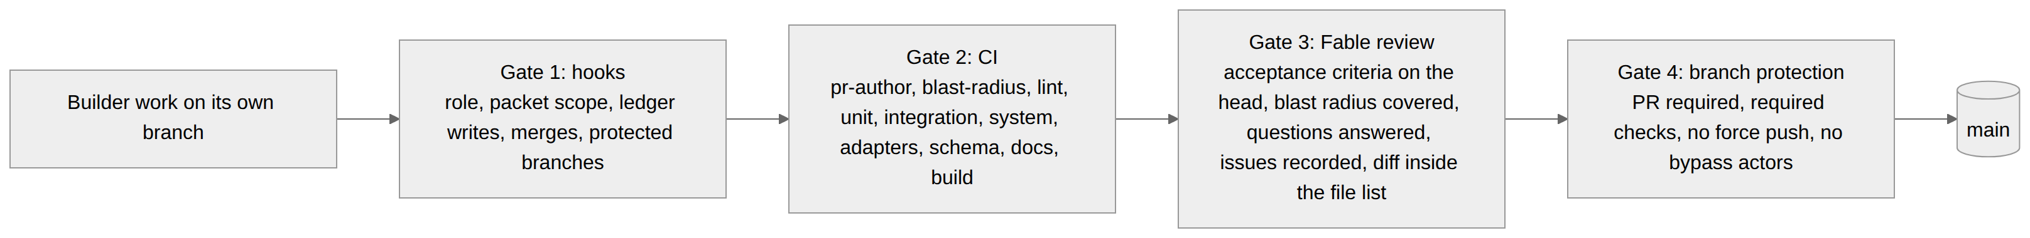
D-GATES: Gates between a builder branch and main (source: docs/02-delivery/SESSION-PROTOCOL.md)

Gate 1, hooks (inside Claude Code): role binding, the packet boundary, ledger writes, merges and protected branches. Gate 2, CI: the PR-author job, tiered tests selected by blast radius, adapter conformance, schema snapshot, docs checks and an installable build. Gate 3, the Fable review: acceptance criteria on the head commit, blast radius covered, questions answered, issues recorded, diff inside the file list. Gate 4, branch protection: pull request required, required checks, no force push, no bypass actors (.github/rulesets/).

11.4 Enforcement map

Rule | Hook | Mechanism
Role from the observed model, else declared, else undeclared | SessionStart → session-start.sh, UserPromptSubmit → prompt-submit.sh | SPENDTRACKER_ROLE, else the model field against fable_model_pattern, else undeclared until the first `ROLE: fable | builder in a prompt; role and role_source stored in .claude/state/sessions/<id>.json` (gitignored); a prompt never changes an observed role
Undeclared sessions fail closed | PreToolUse → pre-tool.sh | every builder restriction applies while the role is undeclared, so a session that never gets a role can never merge or write a ledger
Context per role | SessionStart → session-start.sh | Fable: role brief, CONTEXT.md through the queue, open issues, pending questions on this and other branches, open branches/PRs, last log entries. Builder: brief, current-state table, its own queue entry and packet path, open issues, answered and pending questions on its branch, its own log entries. Undeclared: brief and current state
Builder reads only its packet | PreToolUse → pre-tool.sh | the start hook stores the builder's entry and packet in its state; Read/Edit/Write on any other file under packet_dir is denied for non-Fable roles
40-prompt limit | UserPromptSubmit → prompt-submit.sh | counter per session; warning at 35, forced close-out instruction at 40, prompts blocked (exit 2) at 41+ or after close-out
Close-out before ending at the limit | Stop → stop.sh | blocks the stop (exit 2) with instructions when prompts ≥ 40 and no close entry
Unfinished sessions are visible | SessionEnd → session-end.sh | appends an auto close entry when no close-out was logged
Only Fable merges or touches main | PreToolUse → pre-tool.sh | for every non-Fable role: denies git merge, gh pr merge, pushes to protected branches or force pushes, git checkout main, GitHub MCP merge/auto-merge tools, MCP file writes to main
Only Fable answers or edits ledgers directly | same | denies Edit/Write to the ledger files and shell writes to them; denies running answer.sh
Fable does not build | same | denies Edit/Write outside the Fable-editable paths
PR author is the owner | same + CI pr-author job | gh api user check when gh exists; reminder on the MCP tool; CI fails any other author
Roles cannot be swapped by switching model | PreModelSwitch → pre-model-switch.sh | blocks the switch
Declared roles are visible | log.sh | log lines read fable (declared) when the role came from a prompt; the Fable review compares the model on the line with the pattern

11.5 The ledgers

File | Written by | Entry shape
QUESTIONS.md | builders via ask.sh; Fable via answer.sh | Q-YYYYMMDD-xxxx, Status pending/answered/needs-human, Asked, Question, Context, Answer (Fable), Answered
KNOWN-ISSUES.md | any session via issue.sh; Fable curates status and assignment | I-YYYYMMDD-xxxx, Status open/fixed/wontfix, Title, Signature (hash of check+title, used for de-duplication), Check tier, Blast radius paths, Detail, Ref, Recorded, Assigned
SESSION-LOG.md | any session via log.sh | start / progress / close with session id, model, role (fable (declared) when the role came from a prompt), branch, prompt count; auto when written by the SessionEnd hook
CONTEXT.md | Fable only | current state, owner/Fable next actions, builder session queue (BS-nnn entries: packet, slice, branch, goal, read list, scope, exit criteria, issues to fix, answers to act on, changes requested by Fable; status open/in progress/blocked/done), decisions, open questions, phase history
docs/tasks/BS-nnn-<slug>.md | Fable only | the task packet (PROCESS.md § 3): goal, reading list, acceptance criteria, interfaces, file list, checkpoints, out of scope, tests, constraints, close-log additions, Fable's standing items

11.6 What the hooks cannot enforce
- Anything done outside Claude Code (the GitHub web UI, a plain terminal). Branch protection on main is the backstop; the importable rulesets are in .github/rulesets/. Enable it.
- A declared role is self-reported. When the platform reports no model, a session that states ROLE: fable gets Fable's rights, including merge. The hooks make that explicit, recorded and hard to do by accident; they cannot prove it. Branch protection stops an unwanted merge; the session log shows fable (declared) so a Fable review can audit it.
- Prompt counting is per session id. /clear starts a new id and a new count; a session that clears to dodge the limit is visible in the log as an auto close entry without a real close-out.
- The builder context boundary is a hard rule only for other packets and the ledgers. Design documents live in the same repository and a builder can open them; the brief tells it not to, and a PR that strays outside its packet's file list is a Fable review finding.
- Hooks apply to the session that authored them: a session editing .claude/hooks/ is bound by the version already on disk, not the one it is writing.
- The Fable "no building" rule is a path allowlist over Edit/Write; it does not stop shell commands that write code. It is a guardrail, not a sandbox.
- The pre-tool PR-author check needs gh; the MCP path is enforced by CI only.
- CI verification depends on CI existing. Until slice S0 lands ci.yml, PRs are not mergeable unless the owner overrides, and the override is logged.

11.7 Branch protection
Rulesets cannot be created from a Claude Code session, so the owner applies .github/rulesets/main-protection.json now (pull request required, no direct pushes, no force pushes, no deletion) and switches the same ruleset to main-protection-with-checks.json once slice S0 has installed ci.yml and one PR has run it green. Required approving reviews stay at zero because every PR is opened under the owner’s username and GitHub does not let an author approve their own PR; the bypass list is empty because builder sessions act as the owner.

12. Testing and CI

12.1 The test pyramid

Level | Scope | Tooling | Runs
Unit | pricer math, rate lookup, validators, cursor logic, redaction | pytest, hypothesis | every push
Contract (adapter conformance) | each adapter: fixtures → expected events, stability, no I/O in normalize | st adapter test, respx for HTTP | every push, nightly CT
Integration | hook script → spool → ingest → DB → pricer → view | pytest with a temp DB and real hook scripts | every push
Data invariants | SQL assertions over a populated DB | pytest + sqlite3 | every push and nightly against a synthetic 4M-row DB
UI | one Playwright smoke per page; API contract tests | Playwright (pre-installed Chromium), schemathesis for /api/v1 | every push (Linux), nightly (matrix)
Migration | apply every migration from every historical snapshot | pytest, snapshots in tests/schema_snapshots/ | every push, nightly
Performance | view latency at 4M events; rollup build at 5M | pytest-benchmark | nightly, warn on regression > 20 %
Install | build wheel, install with pipx on macOS, Linux, Windows, run st doctor | GitHub Actions matrix | release and nightly
Live vendor (optional) | read-only calls to vendor APIs with a personal token, assert response shape | pytest with --live, skipped without tokens | nightly on a runner that has tokens

12.2 Tiers and blast radius
Every test carries exactly one tier marker (unit, integration, system). CI runs the tiers as separate named checks and selects tests by blast radius (ADR-0008): a map from changed paths to tiers and selectors; a change to schema, core, workflows or dependency manifests forces the full matrix, as does a push to main, the full-ci label or nightly CT.
Pyramid level | Tier marker | Runs in
Unit | unit | unit check
Contract (adapter conformance) | integration | adapters check (st adapter test), nightly ct-replay
Integration | integration | integration check
Data invariants | integration | integration check; nightly against the synthetic DB
UI and API contract | system | system check (Playwright)
Migration | integration | integration check and schema check; nightly ct-migrations
Performance | no tier marker (tests/perf) | nightly ct-perf only
Install | none (workflow step) | build check; nightly ct-install
Live vendor | none (--live) | nightly ct-live on the runner that has tokens

Changed path | Tiers run | Selectors
src/spendtracker/adapters/<x>/** | unit, integration | tests/adapters/<x>, tests/integration/test_ingest*.py
src/spendtracker/pricer/** | unit, integration, system | tests/pricer, tests/integration, tests/system/test_overview.py
src/spendtracker/web/** | unit, system | tests/web, tests/system
src/spendtracker/rollup/** | unit, integration | tests/rollup, tests/integration/test_export*.py
src/spendtracker/cli/** | unit, system | tests/cli, tests/system/test_cli_smoke.py
.claude/hooks/** | integration | tests/integration/test_session_hooks.py
tests/** | its own tier | the changed test file
schema/**, src/spendtracker/core/**, workflows, pyproject.toml, uv.lock | all (full run) | everything
docs/**, examples/** only | none (docs job only) | —
anything unmapped | all (full run) with a warning | everything

12.3 The CI pipeline

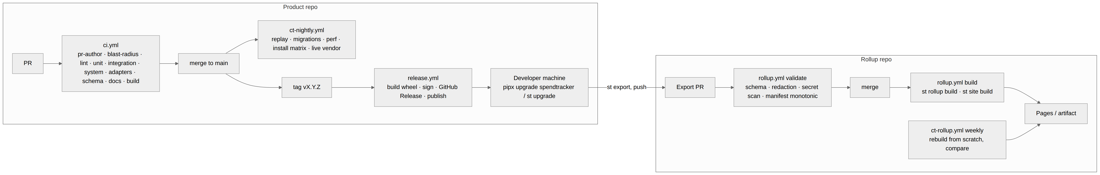
D-PIPE: CI, CD and CT pipeline (source: docs/02-delivery/CI-CD.md)

Job | Steps
pr-author | Fail unless github.event.pull_request.user.login equals the repository variable PR_AUTHOR_LOGIN (the owner's username). Hard rule. Skipped on pushes to main.
blast-radius | Diff the PR against its base; apply examples/ci/blast-radius.yaml; output tiers (subset of unit, integration, system) and selectors; force full=true when a ci_full_run_paths entry changed, on pushes to main, on label full-ci or [full-ci] in a commit message; write the selection to the job summary. Unmapped paths select the full matrix and add a warning.
lint | uv sync, ruff check, ruff format --check, mypy src
unit | pytest -m unit <selectors> (or everything when full); JUnit XML
integration | pytest -m integration <selectors>; JUnit XML
system | pytest -m system <selectors> (hook → spool → ingest → pricer → UI on a temp DB; Playwright smoke with Chromium); JUnit XML
adapters | st adapter test --all; runs on a full run or when an adapter test path is selected
schema | apply schema/*.sql to an empty DB; diff the sorted .schema output against tests/schema_snapshots/head.sql
docs | offline markdown link check (lychee) over docs/**/*.md and README.md; ensure every ADR is listed in docs/README.md. Planned, not in the template yet: mermaid parse check; fail if CONTEXT.md was not modified on a PR labelled phase-close
build | needs lint, unit, integration, system: uv build; upload the wheel; pipx install dist/*.whl && st doctor
ci-issues (composite action) | On any tier failure: examples/ci/ci-issues.py converts JUnit reports into ci-issues.jsonl (check, test id, signature, message, paths), uploads the artifact, posts one PR comment listing the signatures with the issue.sh command to record each

12.4 CI failures feed the known-issues ledger
A failing tier produces ci-issues.jsonl (check, test id, signature, message, paths) as an artifact plus one PR comment. Each signature must appear in KNOWN-ISSUES.md, recorded with issue.sh, before the PR can merge; the Fable review checks this. The start hook injects open issues into every session so they are not reintroduced, and only the session whose entry is assigned an issue fixes it.

12.5 Continuous testing
Job | Schedule | What it checks
ct-replay | nightly | All adapter fixtures against the current main build
ct-migrations | nightly | Every schema snapshot migrates to head; populated-DB migration keeps sums
ct-perf | nightly | View and rollup benchmarks
ct-live | nightly (opt-in runner) | Vendor endpoint shapes; rate card staleness
ct-rollup | weekly (rollup repo) | Full rebuild from scratch equals incremental build
ct-install | nightly | Fresh install on three OSes

12.6 Data invariants
Invariant | Query sketch
Every automatic event has a source_ref | SELECT COUNT(*) FROM usage_event WHERE source IN ('hook','otlp','api','transcript') AND source_ref IS NULL = 0
No unknown measures | usage_event.measure_id ⊆ measure.measure_id (FK)
Cost conservation per subscription period | Σ allocated + Σ idle = fee within 1 micro per period
Effective ≤ list for covered events in aggregate | per subscription period, unless overage exists
No cost line without an event except idle | cost_line.event_id IS NULL ⇒ cost_kind = 'idle'
Daily view equals event sum | Σ v_daily_cost.effective = Σ v_event_cost.effective
Export round-trip | export → import into fresh DB → same event count and same per-day sums
Re-price idempotent | run pricer twice → identical cost_line content hash

13. Work packages and the expectation per session
Work is queued as builder session entries (BS-nnn) in CONTEXT.md, each expanded by Fable into a standalone packet under docs/tasks/. Entries are never deleted; their status moves through open, in progress, blocked and done.

13.1 BS-001: S0 walking skeleton
Field | Value
ROLE / AUTHOR | fable · session ac98103e-96d1-5342-b6b7-982cd19f151f (claude-fable-5-1) · 2026-09-03
SPEC-COMMIT | main at 7fcb45b (docs, schema/, examples/ as of that commit)
PHASE / SLICE | Phase 1 (first build phase) · S0 (docs/02-delivery/VERTICAL-SLICES.md)
BRANCH | work/s0-skeleton for a local session; a cloud session pushes to the claude/<slug> branch the harness assigned it (PROCESS.md § 8)
CAPABILITIES | C-01, C-02 (stdin only), C-04, C-05 (list only), C-10 (Overview, one total), C-29 (minimal), C-30 (wheel)
STATUS | open (queue entry BS-001 in docs/00-context/CONTEXT.md)

Prove the spine. After this packet a user can install SpendTracker from a wheel, initialise a local SQLite database, put one usage event in from the command line or from stdin, see its list cost on the CLI, and see the same number on one web page. CI runs on every PR from this point on.

Acceptance criteria (Fable runs every one on the PR head)

Id | Criterion
AC-1 | Install. uv build produces a wheel. pipx install dist/*.whl (or uv tool install) puts st on PATH. st --help lists init, migrate, add, ingest, report, serve, doctor, adapter, version.
AC-2 | Init. With SPENDTRACKER_DB unset and a fresh HOME, st init --handle test-node --user-handle tester creates ~/.spendtracker/spend.db in WAL mode, applies schema/001_core.sql, leaves schema_migration at version 1, seeds every app in apps.yaml and every measure in measures.yaml, applies every rate card in rate_cards.example.yaml, and inserts exactly one node row (node_id a ULID, hostname_hash a sha256, never the hostname). A second st init changes nothing and exits 0.
AC-3 | Migrate. st migrate on an empty database applies 001. On the AC-2 database it reports nothing to apply and exits 0. On a database whose schema_migration version is higher than the binary's newest migration it exits 1 with a message naming both versions.
AC-4 | Slice exit criterion. After AC-2, st add --app claude_api --measure token.output --qty 1000 --model claude-opus-5 exits 0, and st report prints exactly $0.025 on stdout.
AC-5 | Ingest. st ingest < envelopes.json, where the file is a JSON array of two valid envelopes with distinct source_ref, inserts two usage_event rows, prices them, and prints ingested 2, skipped 0, rejected 0. Running the same command again prints ingested 0, skipped 2, rejected 0 and the row count is unchanged. Newline-delimited objects on stdin are accepted the same way.
AC-6 | Validation. An envelope with an unregistered measure, an unregistered app, a negative or non-finite quantity, an occurred_at that is not ISO 8601 UTC ending in Z, or a source in {hook,otlp,api,transcript} with no source_ref is rejected: nothing from that envelope is inserted, the reason and the envelope index go to stderr, valid envelopes in the same batch are still inserted, and the exit code is 2.
AC-7 | List pricing. For each new event, the rate card is the most specific sku_pattern match (glob against model, then sku; * is least specific) among cards with the same app_id and measure_id, tier = 'standard', latest effective_from <= occurred_at, and effective_to null or > occurred_at. amount_micros = round_half_up(quantity × price_per_unit_nanos / 1000). The cost line has cost_kind = 'list', period_key = occurred_at[0:7], pricer_version = '1'. An event with no matching card gets no cost line, and st report prints unpriced: N on stderr when N > 0.
AC-8 | Report. st report prints the sum of effective_micros from v_daily_cost for the current UTC month as $ followed by the amount with at most 6 decimals, trailing zeros trimmed, never fewer than 2 decimals: 25000 → $0.025, 1000000 → $1.00, 0 → $0.00. --month YYYY-MM selects another month.
AC-9 | Serve. st serve binds 127.0.0.1:8787 only. GET / returns 200 HTML that shows the same total as st report under the label "Effective this month" and a Chart.js daily series for the month. GET /health returns JSON with status, schema_version, db_path. GET /api/v1/series?metric=effective&bucket=day&from=YYYY-MM-DD&to=YYYY-MM-DD returns the daily series with money as {"micros": n, "currency": "USD"}. Chart.js and any CSS are vendored under the package; the page makes no request to any other host.
AC-10 | Doctor. st doctor prints the database path, schema version and node handle and exits 0 on a healthy install. When the database does not exist it prints a warning naming st init and still exits 0 (the CI build job runs it right after pipx install). It exits 1 only when the database exists but cannot be opened or its schema version is ahead of the binary.
AC-11 | Local checks. Every test carries exactly one of the markers unit, integration, system, registered with --strict-markers. Each of uv run pytest -m unit, -m integration, -m system collects at least one test and passes. uv run ruff check ., uv run ruff format --check . and uv run mypy src pass.
AC-12 | CI. .github/workflows/ci.yml is examples/ci/ci.yml with only the edits section 5 allows, and .github/actions/ci-issues/action.yml exists (the composite action ci.yml references; it wraps examples/ci/ci-issues.py as described in the comment at the bottom of ci.yml). On the PR, the checks pr-author, blast-radius, lint, unit, integration, system, adapters, schema, docs and build all succeed on the head commit.
AC-13 | Schema snapshot. tests/schema_snapshots/head.sql is the .schema output of a database built by applying schema/*.sql with the sqlite3 CLI, generated by the tool, not typed by hand. The schema CI job compares the sorted files.
AC-14 | Blast radius. Every file under src/spendtracker/ matches a rule in examples/ci/blast-radius.yaml. A change touching only package files produces no "unmapped paths" warning in the blast-radius job summary.
AC-15 | Layering. core and pricer import nothing from cli, web or adapters. cli calls core/pricer/web functions and holds no business logic. web reads SQL views and core.api only.
AC-16 | Demo. README.md gains a "Quick start" section with exactly the five commands: install, st init, st add, st report, st serve. The Status paragraph is updated to say S0 is built.
AC-17 | Docs describe what was built. Any deviation from the DDL, the envelope shape or the design is written into the relevant document in the same PR (PHASE-PLAYBOOK step 4) and listed under Deviations in the close log.

Build order with checkpoints
- Scaffold and CI. pyproject.toml (hatchling, src layout, script st, ruff, mypy strict for src/spendtracker/core and pricer, pytest markers with --strict-markers), .python-version, st version, one trivial test in each tier so no tier collects zero tests (pytest exits 5 on an empty selection and the job goes red), .github/workflows/ci.yml, the ci-issues composite action. Push, open the draft PR. Checkpoint: lint green, tiers green, blast-radius summary shows a full run (pyproject and workflows are full-run paths).
- Store. core.db, core.ids, st migrate, tests/schema_snapshots/head.sql. Tests: unit migrate on empty DB; integration migrate twice and refuse a newer DB (AC-3). Checkpoint: schema job green.
- Registry and init. core.registry, st init, st doctor. Tests: unit seed counts equal the YAML counts; unit rate card conversion (per_million 25.00 → 25000 nanos; per_unit 0.006 → 6_000_000 nanos); integration st init twice (AC-2). Checkpoint: build job green (pipx install then st doctor).
- Ingest. core.api, core.ingest, st ingest, st add. Tests: unit validator per AC-6 rule; integration idempotency (AC-5); a hypothesis property test that any valid envelope round-trips once and only once is welcome but optional. Checkpoint: integration green.
- Pricer and report. pricer.list_price, st report. Tests: unit rate lookup precedence (specific pattern beats *; later effective_from beats earlier; effective_to excludes), unit rounding half-up at the micro boundary, system tests/system/test_cli_smoke.py (init → add → report prints $0.025, AC-4, AC-8). Checkpoint: system green.
- Web. web.app, Overview template, vendored Chart.js, /health, /api/v1/series, st serve. Tests: unit API contract with httpx TestClient; system tests/system/test_overview.py Playwright smoke that the page shows the report total. Checkpoint: system green with Playwright.
- Finish. README Quick start, CHANGELOG, # CONTEXT: comments, AC-17 doc deltas, run the full local check list (AC-11), then /close-out.

Tests required
Path | Tier | Proves
tests/unit/test_migrate.py | unit | 001 applies on an empty DB; schema_migration has version 1
tests/integration/test_migrate_twice.py | integration | second run applies nothing; newer DB refused with exit 1
tests/unit/test_registry.py | unit | seed counts match YAML; rate conversions; node row shape
tests/integration/test_init.py | integration | AC-2, including idempotent second run and WAL mode
tests/unit/test_validator.py | unit | one test per AC-6 rule, plus the manual-without-source_ref success case
tests/integration/test_ingest_idempotent.py | integration | AC-5, array and newline-delimited input
tests/pricer/test_lookup.py | unit | AC-7 precedence and date rules; no-rate → no line
tests/pricer/test_rounding.py | unit | half-up at the micro boundary; 1000 × 25000 nanos → 25000 micros
tests/cli/test_report_format.py | unit | AC-8 formatting table
tests/system/test_cli_smoke.py | system | init → add → report prints $0.025 in a temp HOME
tests/web/test_api.py | unit | /health shape; /api/v1/series money shape and day buckets
tests/system/test_overview.py | system | Playwright: page shows "Effective this month" and the same total as st report

13.2 BS-002: CT and rollup workflows
Blocked until BS-001 merges. Goal: nightly continuous testing and the rollup workflow run from the repository rather than from examples/, with ci-issues.py wired so failing tiers upload the artifact and post the PR comment. Exit criteria: a deliberately failing test on a throwaway branch produces the artifact and the comment; the nightly runs green on main. Fable writes its packet after BS-001 merges because its interfaces depend on the S0 package layout.

13.3 The expectation of every session, start to end
Both roles stop at 40 prompts; the hook warns at 35, forces the close-out at 40 and blocks prompts after it. Every session ends with a log.sh close entry; a session that ends without one is marked auto in the log so the next Fable session inspects its branch. The table in section 10.3 is the contract; in short:
- Builder, start: the hook binds the role and injects the current state, its queue entry and packet path, open issues and answered questions; the session logs a start entry and reads PROCESS.md, the packet and the packet’s reading list, nothing else.
- Builder, middle: one checkpoint at a time, each ending green locally (lint, format, type check, all three tiers) and pushed; progress logged per checkpoint; every question through ask.sh, every defect or failing check through issue.sh; never a merge, a ledger edit, another packet or a second entry.
- Builder, end: /close-out before prompt 40: AC table with evidence, deviations, assumptions, spend; questions and issues filed; branch pushed; draft PR under the owner’s username; log.sh close; stop.
- Fable, start: the hook injects the full context; the session logs a start entry (confirming the model with get_session when the role was declared) and answers every pending question on every branch.
- Fable, middle: curates the known-issues ledger from CI output; for each builder PR runs the checks and the packet’s acceptance criteria on the head, verifies author, blast radius, questions and issues, reads the diff against the file list; merges with a merge commit or writes rework or redesign items.
- Fable, end: updates CONTEXT.md (state, next actions, queue, decisions, questions, history), writes or refreshes the next packet, pushes to main, log.sh close.

14. Alignment review of 2026-09-03
This revision of the documents comes from a Fable session review of every design, delivery and process document, the hooks, the skills, the CI templates and the first task packet, checked against each other and against what the sessions so far actually experienced. Findings and resolutions:

Finding | Resolution
The SessionStart hook receives no model in cloud sessions, so every session was classed as a builder and Fable sessions corrected their own state by hand (three times). PR #6 proposed replacing inference with self-declared roles. | ADR-0009: role from the observed model when the platform reports one, SPENDTRACKER_ROLE as owner override, otherwise undeclared and fail-closed until a ROLE: declaration; declarations cannot override an observed role; declared Fable roles are marked in the log and audited. Hooks implemented; self-test extended to 89 checks; issue I-20260903-f7d2 recorded as fixed; PR #6 superseded.
Q-6 (how much context a builder receives) was open while the owner had asked twice for separation. | ADR-0010: builder context is PROCESS.md, its packet and what it lists; the start hook injects only its own entry; other packets are hook-denied. Brief, protocol, process document, playbook and skills changed together.
docs/PROCESS.md on main described a different system (STATUS.md, DECISIONS.md, per-task question files, task/T- branches, prompt-declared roles). | PR #5’s reconciled version adopted as the base and aligned further (role source, context, branch naming, section 14 resolved).
Packets and the close-out skill named work/<slice>-<topic> branches, but cloud sessions must push to the claude/<slug> branch the harness assigns. | PROCESS.md section 8, the packet, the builder brief and the close-out skill now say: push to the branch the session was started on; the packet name applies to local sessions.
CI-CD.md still described a pre-tiering ci.yml (test-linux, test-macos, ui jobs) alongside the tiered one; the docs job listed checks the template does not run. | One job table matching examples/ci/ci.yml; unimplemented checks marked as planned; the pipeline diagram updated.
TESTING.md’s local commands used a ui marker although every test carries exactly one of unit, integration, system; the pyramid levels were not mapped to tiers; the blast-radius table lacked the rollup, cli, hooks and tests rules. | Commands rewritten per tier; a pyramid-to-tier mapping table added; the blast-radius table completed.
VERTICAL-SLICES S0 said CI runs on Linux and macOS and told builders to record DDL deviations as ADR-0007, a number now taken. | S0 now names the installed jobs and says a new ADR; slices are stated to be delivered as packets.
The phase playbook’s kickoff prompt told every session to read CONTEXT.md in full and finish by updating it, which builders cannot do. | Separate builder and Fable kickoff prompts with the role declaration; step 1 and the close checklist attribute the ledger update to Fable.
The Fable review skill said to squash; the repository history and PROCESS.md use merge commits; it did not run the packet’s acceptance criteria or write the next packet. | Merge commit, acceptance criteria on the head, file-list check, packet writing and the declared-role audit added to the checklist.
The diagram index lacked the session diagram and the playbook diagram had no id; the glossary lacked every process term; the root README did not mention the process, hooks or rulesets. | Index completed (D-PHASE, D-LIFECYCLE, D-SESSION, D-CONTEXT, D-GATES); thirteen glossary terms added; repository map extended.
BS-002 was open with a "Blocked by" line, while the brief tells builders to take the first open entry. | Status set to blocked; the hook resolves entries by status.
Two open PRs (#5 and #6) changed the same protocol in incompatible directions. | This branch is stacked on #5 and carries #6’s fail-closed mechanics inside ADR-0009; recommended merge order recorded in CONTEXT.md next actions.

Appendix A. Document map and diagram index
Reading order, from docs/README.md:
- 00-context/CONTEXT.md — the living ledger. Which slice is active, what has been decided, what is open. Read this first in every phase; the Fable session updates it last in every phase (ADR-0007).
- 00-context/GLOSSARY.md — the vocabulary used everywhere else.
- 01-architecture/ARCHITECTURE.md — system overview, C4 views, UML.
- 01-architecture/DATA-MODEL.md — ERD and table dictionary; DDL lives in ../schema/001_core.sql.
- 01-architecture/COLLECTORS.md — integration points and hooks for each app.
- 01-architecture/COST-MODEL.md — measures to money, subscriptions, budgets, currency.
- 01-architecture/AGGREGATION.md — multi-user rollup to a repository.
- 01-architecture/WEB-UI.md — local web interface and its API.
- 01-architecture/ADAPTER-SPEC.md — the contract for adding a new layer.
- 01-architecture/SECURITY-PRIVACY.md — secrets, PII, redaction.
- 02-delivery/CAPABILITIES.md — separable units of work.
- 02-delivery/VERTICAL-SLICES.md — the iterative build order.
- 02-delivery/PHASE-PLAYBOOK.md — how to run any phase without losing context.
- 02-delivery/TESTING.md and 02-delivery/CI-CD.md.
- 02-delivery/SESSION-PROTOCOL.md — hard rules, role determination, the session lifecycle and context boundary, prompt limits, the ledgers (QUESTIONS.md, KNOWN-ISSUES.md, SESSION-LOG.md), CI tiers and blast radius.
- PROCESS.md — division of labor between Fable and builder sessions and the task packet contract. Packets, one per builder session queue entry, live in tasks/ (first: BS-001).
- exports/ — the Word export of the design, process and controls, and the script that regenerates it from these documents.
Id | Kind | Where
D-CTX | C4 context | ARCHITECTURE.md
D-CONT | C4 container | ARCHITECTURE.md
D-COMP | Component (collector to UI) | ARCHITECTURE.md
D-CLASS | UML class model of the domain | ARCHITECTURE.md
D-SEQ-HOOK | Sequence: Claude Code hook to dashboard | ARCHITECTURE.md
D-SEQ-PULL | Sequence: scheduled API pull | ARCHITECTURE.md
D-STATE | State: collector run lifecycle | ARCHITECTURE.md
D-ERD | Entity relationship diagram | DATA-MODEL.md
D-COST | Cost derivation pipeline | COST-MODEL.md
D-ROLLUP | Multi-user rollup flow | AGGREGATION.md
D-UI | UI navigation map | WEB-UI.md
D-SLICES | Gantt of vertical slices | VERTICAL-SLICES.md
D-CAPDEP | Capability dependency graph | CAPABILITIES.md
D-PIPE | CI/CD/CT pipeline | CI-CD.md
D-PHASE | Phase steps | PHASE-PLAYBOOK.md
D-LIFECYCLE | Builder and Fable session lifecycle, start to end | SESSION-PROTOCOL.md
D-SESSION | Sequence: owner, Fable, builder, CI, ledgers | SESSION-PROTOCOL.md
D-CONTEXT | Context boundary between the roles | SESSION-PROTOCOL.md
D-GATES | Gates between a builder branch and main | SESSION-PROTOCOL.md

Appendix B. Decisions log
Date | Decision | Where
2026-09-03 | A session's role comes from the model the platform reports; when none is reported the session is undeclared and fails closed until it declares ROLE: fable or ROLE: builder; declared Fable roles are marked in the log and audited; model switches stay blocked | ADR-0009 (supersedes the role binding of ADR-0007 and PR #6)
2026-09-03 | Only the Fable session holds the full context; a builder session gets PROCESS.md, its packet, the documents the packet lists and the start-hook excerpt, reads only its own packet (hook-enforced), and asks for anything else. Resolves Q-6 | ADR-0010
2026-09-03 | Cloud builder sessions push to the claude/<slug> branch the harness assigns; the packet's branch name applies to local sessions; Fable records the actual branch when the entry goes in progress | PROCESS.md § 8
2026-09-03 | Accepted PRs merge with a merge commit, never squash or rebase, so builder checkpoints and ledger entries survive | /fable-review step 6
2026-09-03 | Builder session queue entries are expanded into standalone task packets under docs/tasks/; a packet's acceptance criteria are what Fable verifies on the PR head before merging | docs/PROCESS.md § 3, docs/tasks/BS-001-s0-walking-skeleton.md
2026-09-03 | docs/PROCESS.md (PR #3) records the division of labor between Fable and builder sessions; SESSION-PROTOCOL.md and the hooks keep precedence on mechanics until an ADR changes them | PR #3, reconciled by session ac98103e
2026-09-03 | Repository Actions variable PR_AUTHOR_LOGIN set to newellnarco; the CI pr-author job is the enforcement path for PRs opened through the GitHub MCP tools | Owner action, recorded by the Fable session; Q-20260903-2afc
2026-09-03 | CI runs tiered tests (unit, integration, system) selected by blast radius; failures feed KNOWN-ISSUES.md; full runs only for core, schema, workflow and dependency changes, main, full-ci and nightly | ADR-0008
2026-09-03 | Session roles are bound to the starting model and enforced by hooks: Fable reviews, answers, curates, merges and owns CONTEXT.md; other models build one piece per branch and PR; 40-prompt limit; PRs under the owner's username | ADR-0007
2026-09-02 | Reference stack is Python/SQLite/FastAPI/htmx | ADR-0006
2026-09-02 | Adapters are the only per-app code and must pass the conformance suite | ADR-0005
2026-09-02 | Multi-user rollup is append-only JSONL committed to a git repo, aggregated by CI | ADR-0004
2026-09-02 | Three cost kinds: list, reported, effective (allocated + overage) | ADR-0003
2026-09-02 | Single canonical usage_event fact table plus a measure catalogue | ADR-0002
2026-09-02 | Local-first SQLite per user is the system of record | ADR-0001

Appendix C. Glossary

Term | Meaning
Layer / app | One tool in the stack that costs money or consumes an allowance: Claude Code, Claude API, GitHub, GitHub Copilot, CodeRabbit, an MCP server, and so on. Stored in app.
Measure | The native unit a layer counts in. Examples: token.input, token.cache_read, action.minute.linux, copilot.ai_credit, review.count, mcp.tool_call, session.count, active_time.s. Stored in measure.
Usage event | One immutable fact: at time T, app A, under account X, in project P, session S, consumed quantity Q of measure M, with dimensions (model, sku, tool). Stored in usage_event.
Dimension | A tag on an event used for grouping: model, sku, tool_name, mcp_server, actor.
Source | Where an event came from: hook, otlp, api, transcript, manual, import.
Node | One installation of SpendTracker (one user on one machine). Provides provenance for rollups.
Rate card | Effective-dated price per unit of a measure for an app and optional sku/model.
Subscription | A flat-fee plan (Claude Max, Copilot Pro, CodeRabbit Pro seat, GitHub Team seat) with a period, price and optional included allowance.
Coverage | The selector on a subscription that says which events it pays for.
List cost | What an event would cost at pay-as-you-go rate-card prices. Always computable.
Reported cost | A currency amount the source itself supplied (Claude Code's cost_usd_micros, GitHub's netAmount).
Allocated cost | The share of a subscription's fee assigned to an event by an allocation method.
Overage | Usage beyond a subscription's included allowance, priced by the rate card.
Effective cost | The money the usage actually cost you: allocated + overage for covered events, list cost for uncovered events.
Budget | An amount per period for a scope (global, app, project, user, account) compared against effective cost.
Cost line | One derived money row per event per cost kind. Stored in cost_line. Recomputable at any time.
Adapter | The per-app module that discovers, collects and normalizes raw data into usage events.
Collector run | One execution of an adapter with a cursor before and after. Stored in collector_run.
Spool | A directory of small JSON files written by hooks; the ingester drains it. Decouples hooks from the DB.
Export batch | An append-only JSONL file of events from one node for one period, committed to the rollup repo.
Rollup | The aggregate database and dashboard built from all nodes' export batches.
Capability | A separately deliverable unit of functionality (C-xx in CAPABILITIES.md).
Vertical slice | An increment that cuts through collector, store, pricer, UI, tests and CI to deliver visible value (S-x in VERTICAL-SLICES.md).
CT | Continuous testing: scheduled test runs against recorded fixtures and live data invariants, independent of code pushes.
Fable session | The Claude Code session on the most capable model (fable|mythos). Architect, reviewer and gate: answers questions, curates the ledgers, writes packets and CONTEXT.md, verifies CI, merges. Never writes code. (ADR-0007, ADR-0009)
Builder session | A Claude Code session on any other model. Builds one task packet on its own branch and draft PR, then stops. Never merges. (ADR-0007, ADR-0010)
Undeclared session | A session the platform reported no model for and that has not yet stated ROLE: fable or ROLE: builder. Carries every builder restriction. (ADR-0009)
Task packet | The standalone specification for one builder session: goal, reading list, acceptance criteria, interfaces, file list, checkpoints, tests. docs/tasks/BS-nnn-<slug>.md, written by Fable. (PROCESS.md § 3)
Builder session queue | The list of BS-nnn entries in CONTEXT.md, one per builder session, with status open / in progress / blocked / done. Fable writes it.
Acceptance criterion (AC-n) | A numbered, testable statement in a packet. The builder reports MET / NOT MET / UNVERIFIED with evidence; Fable runs every one on the PR head before merging.
Checkpoint | A step in a packet's build order that ends green and pushed, so a session that hits the prompt limit can hand over and the next session resumes there.
Ledger | One of the append-only files in docs/00-context/: QUESTIONS.md, KNOWN-ISSUES.md, SESSION-LOG.md, plus CONTEXT.md. Written only through the helper scripts by role.
Close-out | The last act of a builder session (/close-out): AC table, deviations, assumptions, spend; questions and issues filed; branch pushed; draft PR; log.sh close.
Tier | One of unit, integration, system: the marker every test carries and the named CI check it runs in. (ADR-0008)
Blast radius | The set of tiers and test selectors a changed path can affect, from examples/ci/blast-radius.yaml; CI runs that set instead of everything. (ADR-0008)
Signature | A short hash of check name and failure title that de-duplicates CI failures between ci-issues.jsonl and KNOWN-ISSUES.md.
Context boundary | The rule that only Fable holds the full context and a builder sees its packet plus what it lists. (ADR-0010)

