1. Git Setup https://confluence.atlassian.com/bitbucket/set-up-git-744723531.html
sudo apt-get update
sudo apt-get install git

2. Initialize a Git Repository

3. Add files to the repository

4. Unstage 1 file

5. Commit the file


6. Add a remote
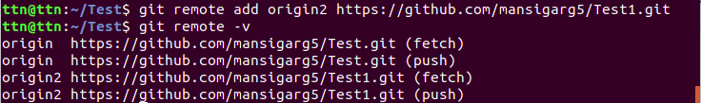

7. Undo changes to a particular file
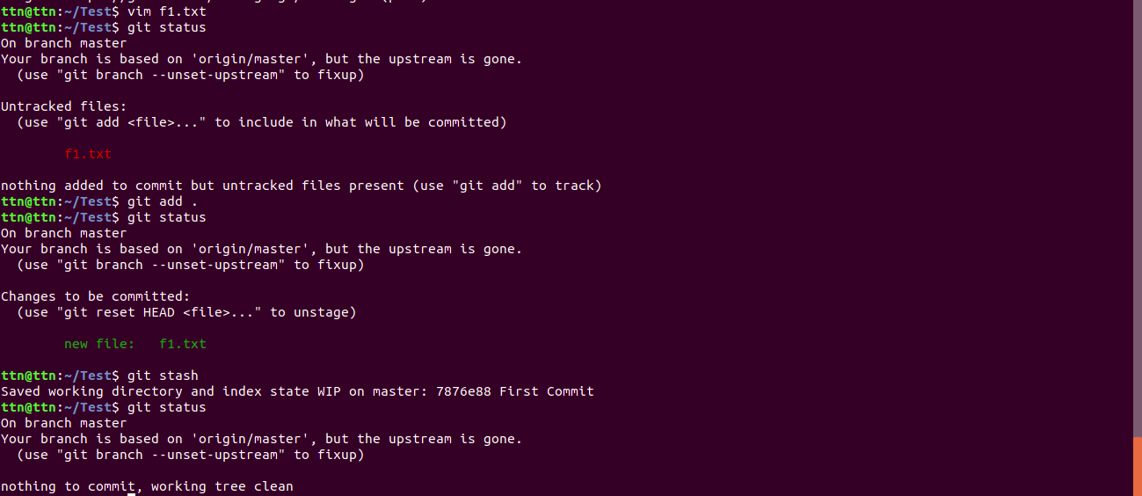

8. Push changes to Github
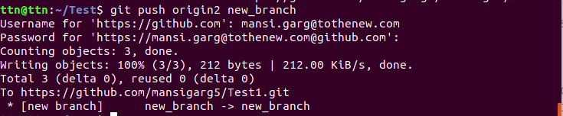

9. Clone the repository

11. Check differences between a file and its staged version
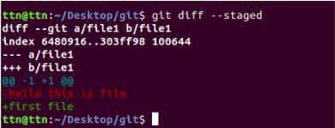

12. Ignore a few files to be checked in


13. Create a new branch.

14. Diverge them with commits

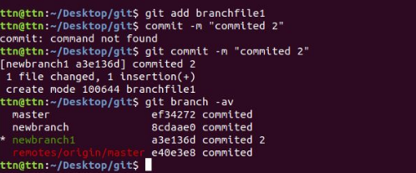

15. Edit the same file at the same line on both branches and commit
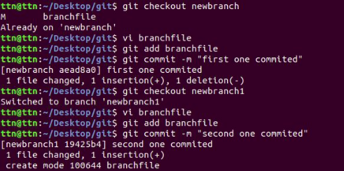

16. Try merging and resolve merge conflicts
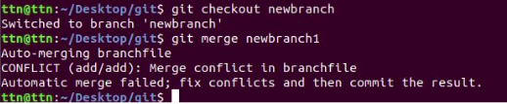
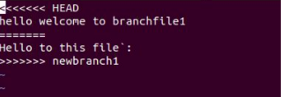
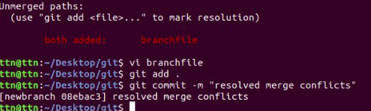

17. Stash the changes and pop them
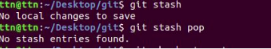
18. Add the following code to your .bashrc file
