# 

# INTRODUCTION

Emotion recognition involves detection of emotion in an image. This topic has received great deal of attention in computer vision because of its wide applications. To detect the emotion accurately, Fisherface algorithm is used. Fisher face is one of the popular algorithms used in face recognition, and is widely believed to be superior to other techniques, such as Eigen face because of the effort to maximize the separation between classes in the training process. The purpose of this research is to establish a program of face recognition application using fisher face method by utilizing GUI applications and databases that are used in the form of a Papuan facial image. Image recognition using fisher face method is based on the reduction of face space dimension using Principal Component Analysis (PCA) method, then applies Fisher's Linear Discriminant (FDL) method or also known as Linear Discriminant Analysis (LDA) method to obtain feature of image characteristic. The algorithm used in the process for image recognition is fisher faces algorithm while for identification or matching face image using minimum Euclidean.

In this project to teach the computer to recognize the emotion in image and classify them into one of the 5 categories such as angry, sad, happy, neutral, surprise. For example, system need to recognize the happy emotion in image. To do so, first need to teach the computer how a happy emotion looks like before it being able to recognize a new object. The more happy images the computer sees, the better it gets in recognizing happy emotion. With the help of fisher face algorithm, the computer will start recognizing the patterns present in happy pictures that are absent from other ones and will start building its own recognition.

Fisher face algorithm is one of the most popular techniques used in improving the accuracy of image classification. At the beginning it breaks the image into number of tiles, the machine then tries to predict what each tile is. Finally, the computer tries to predict what’s in the picture based on the prediction of all the tiles.

* 1. **Problem Definition**

To create a music player which will generate a playlist based on the facial expression extracted from captured image of the person and plays song according to user’s emotion.

## Objectives of Project

* + 1. To detect the emotion in image.
    2. To detect the category, type, attribute of emotion from an image.
    3. To classify the emotion categories and attribute using Fisher face algorithm.

## Scope of Project

Understanding the emotions in a single glance is one of the most accomplished feats. It takes only a few tens of milliseconds to recognize the category of an emotion, emphasizing an important role of feed forward processing in visual recognition.

* 1. **Timeline for Project**

|  |  |  |
| --- | --- | --- |
| **TOPIC** | **START DATE** | **END DATE** |
| Finalization of problem statement | 09/07/2019 | 10/07/2019 |
| Domain Selection | 16/07/2019 | 24/07/2019 |
| Domain Finalization | 16/07/2019 | 24/07/2019 |
| Selection of problem statement | 24/07/2019 | 04/08/2019 |
| Documentation of synopsis | 04/08/2019 | 03/09/2019 |
| Requirement Analysis | 03/09/2019 | 05/09/2019 |
| System Requirement | 03/09/2019 | 08/09/2019 |
| Module Identification | 08/09/2019 | 17/09/2019 |
| Architecture Module | 08/09/2019 | 17/09/2019 |
| Analysis Documentation | 22/09/2019 | 24/09/2019 |
| Design | 24/09/2019 | 05/10/2019 |
| Implementation | 05/10/2019 | 19/10/2019 |
| Testing ( For 2 k) | 05/02/2020 | 12/02/2020 |
| Testing ( For 3 k) | 20/02/2020 | 19/03/2020 |
| Report Making | 20/02/2020 | 02/03/2020 |
| Performance Analysis | 26/03/2020 | 29/03/2020 |

# LITERATURE REVIEW

* 1. **Technology review:**

Literature survey is the most important step in software development process. Before developing the tool, it is necessary to determine the time factor, economy. Once these things are satisfied, then next steps are to determine which operating system and language can be used to developing the tools. Once the programmer start building the tool the programmer needs lots of external support. This support can be obtained from senior friends, teachers, from book or from websites. Before building the system, the above considerations are taken into account for developing the proposed system.

## Literature review of related technologies:

Currently, there are many existing music player applications. Some of the interesting applications among them are:

* + 1. Saavan: This application gives good user accessibility features to play songs and recommends user with other songs of similar genre.
    2. Mood fuse: In this application, user should manually enter mood and genre that wants to be heard and mood fuse recommends the songs-list.
    3. Spotify: It features music from 21 languages, user friendly and it allows users to make their playlists public so that they can be seen by other users. Supports all OS.
    4. EmotiSphere: From emotions to music. Interactive sensor-based device to recognize mood of the user and generate song according to that. It consists of the sensors mainly: galvanic sensor and heart-rate sensor.
    5. Microsoft Oxford project is an API using which we can detect faces point like mouth corners, eye Locations, closed/open lids and determine relation between this element for each mood.

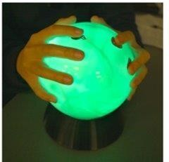

1. **REQUIREMENT ANALYSIS**
   1. **Functional requirements**

This project takes image as an input and from that images machine predict the emotion categories, emotion attributes. These kinds of applications are part of the deep learning. System need to train the images with different categories. For training the images Fisherface algorithm is used.

Why Fisherface Algorithm?

This algorithm follows the concept that all the parts of face are not equally important or useful for face recognition. When we look at a face we look at the places of maximum variation so that we can recognize that person. For example, from nose to eyes there is a huge variation in everyone's face. Eigenfaces algorithm works at the same principle.

Eigenfaces algorithm works at the same principle. It takes all training faces of all people at once and looks at them as a whole an then it keeps the most important components and discards the rest. These important components are known as principle components.

PCA method is less optimal in the separation between classes. Due to the useful features of faces this algorithm uses it's known as eigen faces. But this algorithm also considers illumination as an important factor. So, as it picks up light illuminations it considers it as a feature representing a face which is not true. This algorithm doesn't pay attention to the features that differentiate one individual from another. It just concentrates on the features that represent all the faces of all the people. So, to overcome problems of eigenfaces, Fisherfaces was introduced which is an improved version of eigenfaces algorithm.

## System Requirements

* + 1. Hardware requirement
       - ROM 500 GB
       - RAM 8 GB
    2. Operating system requirement
       - Windows 10

## Tools and technologies requirement

* + - Python 3.6.7
    - HTML,CSS
    - JavaScript
    - EEL(Python Library)

1. **SYSTEM DESIGN**
   1. **System Architecture**:

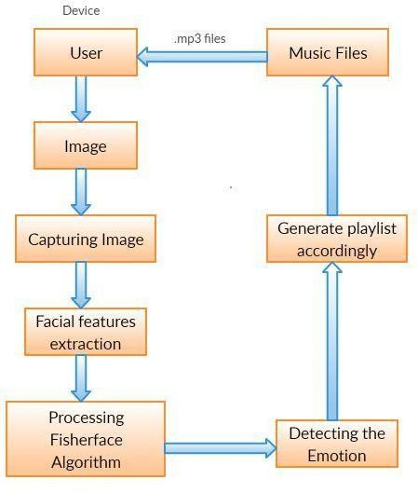

Fig 4.1 System Architecture

* + 1. Algorithm Description for each modules:

There are three modules. In **first module** uses the webcam will captures image of the user. As the system captures the image of user, then it will extract the facial features of the user from captured image using Fisherface algorithm. After Processing depending upon the output, the system will be categorized in respective class. The **second module** is audio extraction. According to emotion audio is extracted. The **last module** will combine all the intra scale features and depending upon the category, the system will play the music with respective to user’s mood.

Module 1: Emotion Extraction Module:

The general steps involved are:

1.Capturing

2.Feature extraction

3.Comparision

4.Detect the emotion

Module 2: Audio Extraction:

Depending upon the output of the emotion extracted module, the stored audio files are extracted to play the song depending upon the class identified.

Module 3: Emotion – Audio Extraction:

Emotions are extracted for the songs are stored as meta –data. According to the detected emotion the playlist will be generated.

* 1. **System Modeling Design**
     1. Dataflow Diagram:

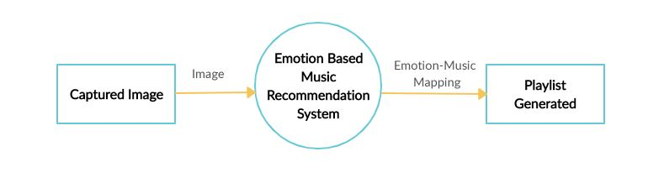

Fig 4.2.1.1 DFD Level-0

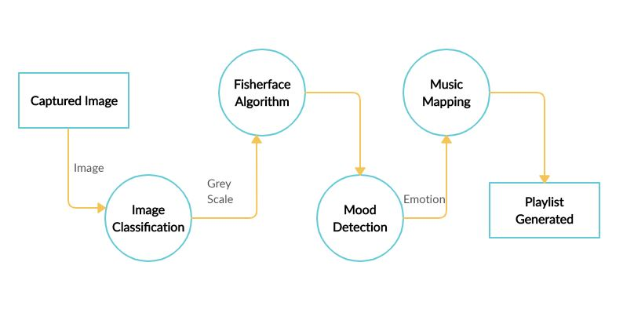

Fig 4.2.1.2 DFD Level-1

* + 1. Use-case Diagram

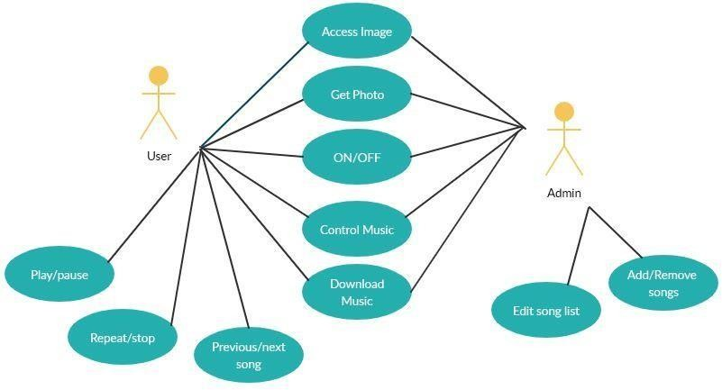

Fig 4.2.2 Use-case Diagram

* + 1. Flow chart

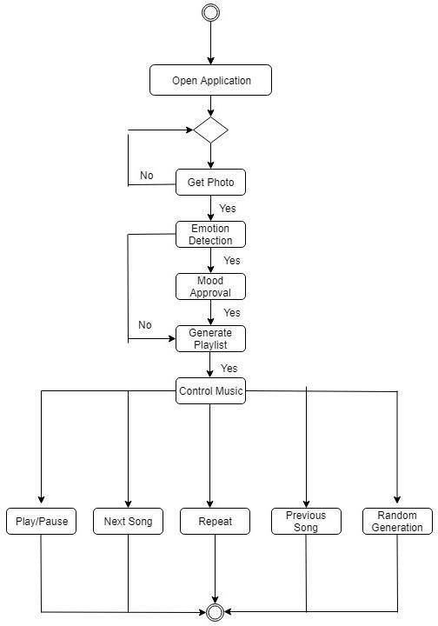

Fig 4.2.3 Flow chart

4.2.4 Activity diagram

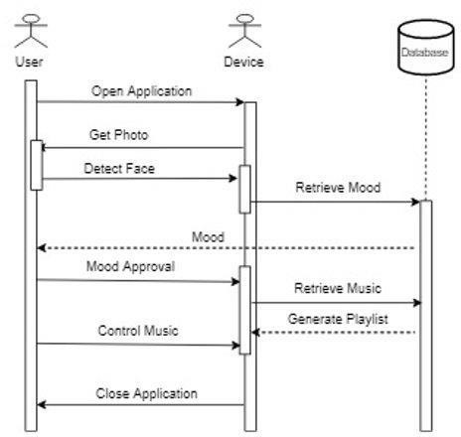

Fig 4.2.4 Activity diagram

1. **IMPLEMENTATION DETAILS**

Considering these illuminations as an important feature it may discard other people's features considering them less useful.

It can fix this by tuning eigenfaces such that it extracts features of all individuals separately instead of looking at them as a whole. So, now even if one person's face data has high illumination changes, it will not affect other people's features.

Fisherfaces algorithm extracts principle components that separates one individual from another. So, now an individual's features can't dominate another person's features. Image recognition using this algorithm is based on reduction of face space dimensions using PCA method and then applying LDA method also known as Fisher Linear Discriminant (FDL) method to obtain characteristic features of image.

LDA is used to find a linear combination of features that separates two or more classes or objects. It can be used for dimension reduction before further classification. It attempts to model the difference between classes of data.

This method doesn't capture illumination variations as obviously as Eigenfaces method.

* + Data is assumed to be uniformly distributed in each class.
  + Aim is to maximize the ratio of between-class scatter matrix and the within-class scatter matrix.
  + It can produce good results even in varying illumination.

# Algorithm of Fisherfaces

Let X be a random vector with samples drawn from c classes:



The scatter matrices S_{B} and S_{W} are calculated as:

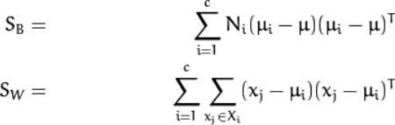

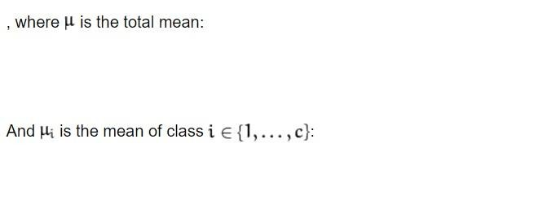Fisher’s classic algorithm now looks for a projection W, that maximizes the class separability criterion:



A solution for this optimization problem is given by solving the General Eigenvalue Problem:



The optimization problem can then be rewritten as:

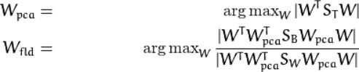

The transformation matrix W, that projects a sample into the (c-1)-dimensional space is then given by:



# Pseudocode of Fisherfaces

def Fisherfaces (X ,y , num_components =0) : y = np. asarray (y)

[n ,d] = X . shape

c = len ( np. unique (y ))

[ eigenvalues_pca , eigenvectors_pca , mu_pca ] = pca (X , y , (n -c ))

[ eigenvalues_lda, eigenvectors_lda ] = lda ( project ( eigenvectors_pca , X , mu_pca ) , y ,

num_components )

eigenvectors = np . dot ( eigenvectors_pca , eigenvectors_lda ) return [ eigenvalues_lda , eigenvectors , mu_pca ]

# Image data

'Yale face database' is used here for training. This database contains many grayscale images of different face poses of many individuals.

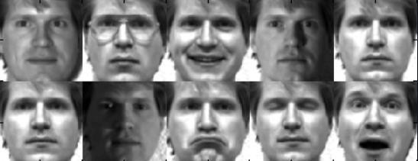

Here are the examples of testing data:

# Angry





**Happy**



**Sad**





**Neutral**





**5.1 Fisherfaces Process**

**Step 1**: Retrieve data

Collection of data is done in form of face images. Collection can be done using photographs already saved

or from a webcam. Face must be fully visible and must be facing forward.

**Step 2**: Image Processing

1. Preprocessing stage: Getting images using camera or saved images and conversion from RGB to grayscale. Image data is divided into training and test data.
2. Processing stage : Fisherface method will be applied to generate feature vector of facial image data used

by system and then to match vector of traits of training image with vector characteristic of test image using

Euclidean distance formula

**Step 3**: Feature generation Features of the faces are extracted.

# Recognition process

After the training is done, the next stage is image recognition process. The goal is to successfully recognize

the test images.

* If training image is the same as the testing image:

In this case system can successfully identify the test image correctly up to 100%.

* If training image is not the same as the testing image:

The test image and the training image must come from the image of the same person's face. System can now successfully identify the test image correctly up to 90%.

**Pseudocode:**

Module 1: Emotion Extraction

Step 1: Start

Step 2: Get input as an image from user

Step 3: The image is passed through the trainable module of fisherface algorithm.

Step 4: The output window predicts the emotion category

Step 5: End.

Module 2: Audio Extraction

Step 1: Start

Step 2: Songs are stored in folders by admin

Step 3: End.

Module 3: Emotion – Audio Integration

Step 1: Start

Step 2: Songs are stored in different folders according to their categories

Step 3: These songs are mapped with the emotion of the user.

Step 4: Song is played.

Step 5: End.

* 1. **Environmental Setup:**

Setup: Steps to follow:

* + 1. Harrcascade_frontalface.xml file is compulsory.
    2. Install Python.
    3. Install CV2.
    4. Install numpy.
    5. Install EEL.
    6. Then start Pycharm IDE.

## Screenshots:

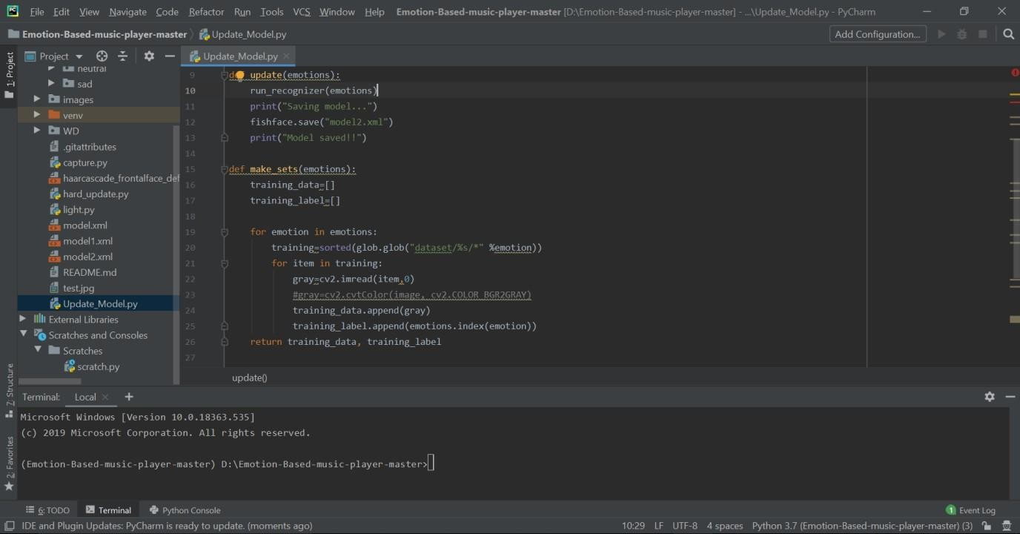

Above is the workspace (Pycharm Community edition) we used for developing our project.

1. **TESTING**

**6.1 Unit Testing**

|  |  |  |  |
| --- | --- | --- | --- |
| Date | No of Samples | Test accuracy | Validation accuracy |
| 15-1-2019 | 100 | 0.74 | 0.73 |
| 30-1-2019 | 500 | 0.77 | 0.75 |
| 1-2-2019 | 1500 | 0.82 | 0.81 |
| 4-2-2019 | 2000 | 0.80 | 0.78 |
| 8-2-2019 | 2500 | 0.84 | 0.73 |
| 12-2-2019 | 2700 | 0.88 | 0.85 |
| 14-2-2019 | 3000 | 0.94 | 0.91 |

During this testing following were occurred and solved:

1. No of samples:2000

Problem occurred: Memory error Solution: Increased RAM by 4 GB

1. No of samples:2700

Problem occurred: Batch size Solution: Batch size was reduced.

1. No of samples: 3000

Problem occurred: Accuracy problem Solution:

* 1. Increase the learning rate
  2. Data augmentation.

# PERFORMANCE ANALYSIS

The performance can be measured and understood by analyzing the below graphs drawn by considering the factors affecting the performance of the project.

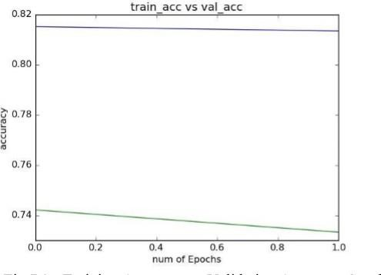

Fig 7.1 Training accuracy vs. Testing accuracy

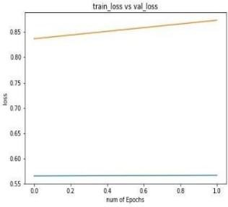

Fig 7.2 Training loss chart

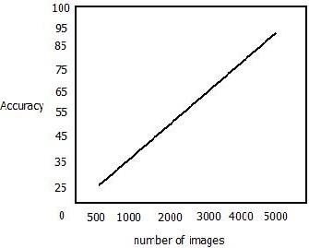

Fig 7.3 Image vs accuracy graph

# 

1. **APPLICATIONS**
   * Automatically plays song based on emotion of the user
   * Act as plugin for song website
   * Can be implemented on Android Smart TVs
   * Music therapy for patients
2. **PROJECT ETHICS**

As an Information Technology student, we believe it is unethical to,

* Surf the Internet for personal and non-class related purpose during classes.
* Make a copy of software for personal or commercial use.
* Make a copy of software for friend.
* Loan CDs of software to friend.
* Download pirated software from the internet.
* Distribute pirated software from internet.
* Buy software on single user license and then install it on multiple computers.
* Share a pirated copy of Software.
* Install a pirated copy of Software.

1. **SNAPSHOTS**

This is the UI for Emotion Based Music Recommendation System

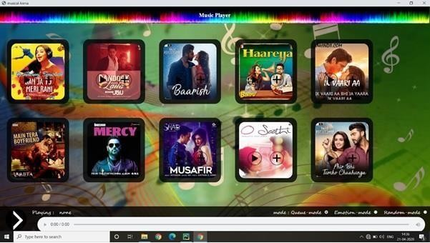

**Queue Mode –**

This is the first mode of system i.e. Queue mode. In this mode user have choice to play

song. according to his/her choice. This mode is like our normal music player.

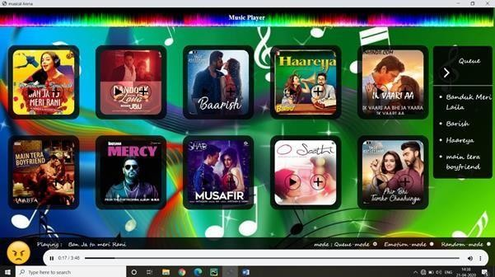

**Emotion Mode—**

This is the second mode of system. In emotion mode system will play song according to

emotion of the user. Below are snapshots for the emotion like happy, neutral, sad, angry.

1. Happy

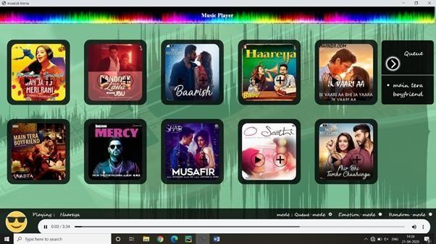

1. Neutral

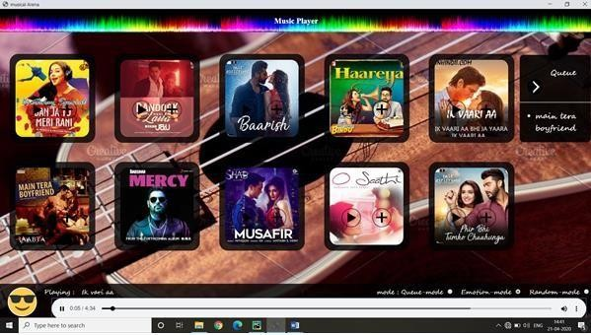

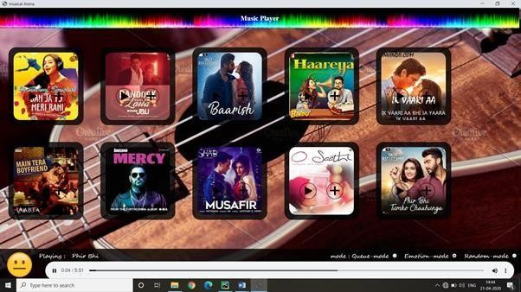3.Sad

1. Angry

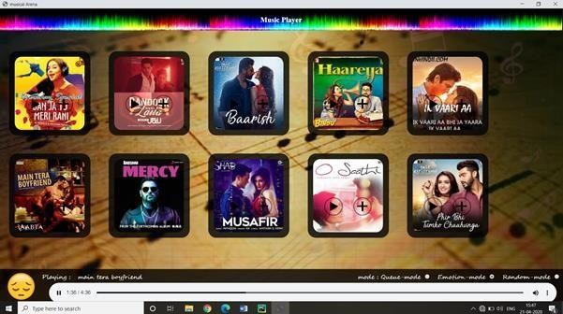

# Random mode—

This is the random mode of the system. In this mode system will play any random song

from the playlist. Below are some snapshots of random mode.

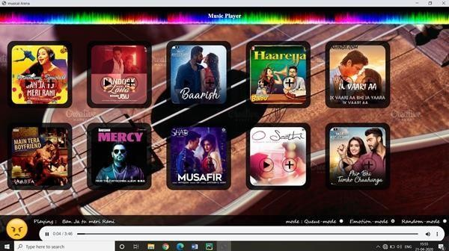

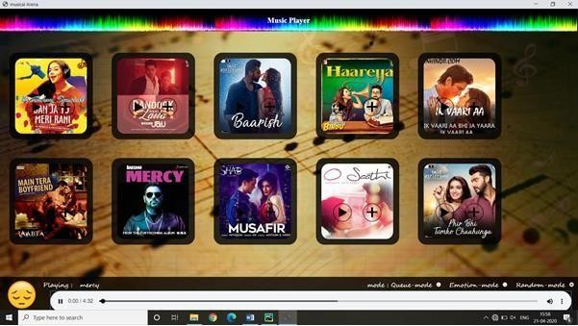

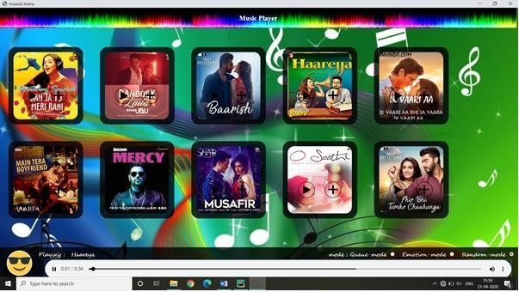

1. **Achievements**



We won second price at the Innovation 2k20, a national level technical event held at Sharad institute

and technology and college of engineering, Yadrav.





Above are the certificates of courses that we have completed related to project for study and

understanding purpose.

1. **REFERENCES**
   1. S. Casale, A. Russo, and G. Scebba, Speech emotion classification using machine learning algorithms, in Proc. IEEE Int. Conf. Semantic Comput., 2008, pp. 158165.
   2. JungHyun Kim, Seungjae Lee and WonYoung Yoo, “Implementation and analysis of mood- based music recommendation system,” 2013, 15th International Conference on Advanced Communications Technology (ICACT), PyeongChang, 2013, pp. 740-743., IEEE.
   3. M. Blondel, P. Prettenhofer, R. Weiss, V. Dubourg, J. Vanderplas, A. Passos, D. Cournapeau, M. Brucher, M. Perrot, E. Duchesnay, "Scikit -learn: Machine learning in Python", Journal of Machine Learning Research, vol. 12, pp. 2825-2830, 2011.