論文の内容の要旨
論文題目 Optimizing Annotation Guideline Refinements for LLM-Based Annotation
（LLMによるアノテーションに向けたガイドライン改善の最適化）
氏名 Hengyu Zhou
1. Introduction
Biomedical text mining depends on annotated corpora, and expert annotation is slow and costly. Large language models can annotate at scale, but only if they are told what counts as an entity. That instruction is carried by the annotation guideline, a human-readable document originally written for human annotators. In this setting the guideline, not the model, is the object being adjusted, which makes the result inspectable, reusable, and transferable across models.
Iterative guideline moderation automates that adjustment. An LLM annotates a small development set; its output is compared against gold annotations; the discrepancies are analyzed, explained as recurring patterns, condensed into a moderation principle, and written back into the guideline. The loop repeats until F1 reaches threshold or a round fails to improve. Across three datasets and three models, development F1 has been reported to rise from about 0.80 to 0.91^{[1]}.
The development set, however, is at once the target being optimized and the instrument by which improvement is judged. Two questions follow. Does the refined guideline encode general rules, or does it record the answers of the development set? And is development F1 stable enough to support the accept-or-revert decision taken each round? This work reproduces the method on the NCBI Disease corpus with GPT-5.4, obtaining a held-out gain consistent with the published figure, then audits the released implementation stage by stage, identifies six candidate issues, and defines two measurements that characterize the first two of them experimentally.
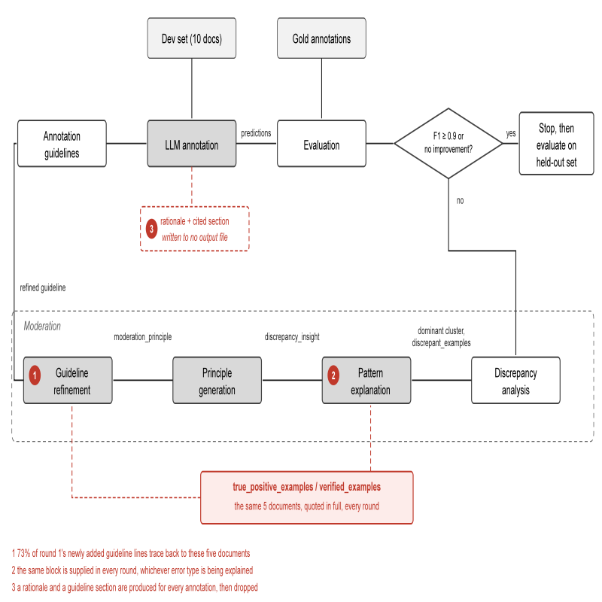
2. Methodology
Figure 1 shows the framework as implemented in the released code. An LLM annotates the development set under the current guideline; strict-match F1 against gold decides whether to stop; otherwise the discrepancies are clustered, the dominant cluster is explained as a pattern, condensed into a moderation principle, and written back into the guideline. We reproduce this on NCBI Disease with GPT-5.4 at high reasoning effort, ten development documents, and the published stopping threshold. Development F1 rises from 0.797 to 0.909 over four rounds. On the 100-document held-out set the refined guideline gains +0.009 over the original; with thirty development documents the gain is +0.026, against the +0.03 reported for NCBI with GPT-5.
Two quantities are measured throughout. The first is how much of the guideline is copied: of the lines a round adds, how many can be traced to the development documents quoted in its own prompt. The second is how unstable the signal is: the standard deviation of development F1 across repeated annotations of the same documents under an unchanged guideline, which is the noise floor beneath every accept-or-revert decision the loop makes.
3. Current Results and Issues
3.1 The guideline copies the development set
Section 3.4.4 of the method supplies the refinement prompt with verified examples: true positives listed together with the full text of five development documents. That block is 46% of the prompt. In round 1, 38 of the 52 lines newly added to the guideline trace back to those five documents.
Two structurally different interventions were run against this. The first removes the block. The second keeps it and adds one instruction: state the rule, do not transcribe the mention. Both eliminate the copying completely, and the second demonstrably obeys rather than paraphrases, inventing illustrative phrases that appear nowhere in the development documents. Both also stop the loop within one to three rounds, where the published configuration ran four (Table 1). The development gain therefore depends on writing development-specific content into the guideline; general rules do not produce it.
Table 1. Guideline refinement under three conditions, NCBI Disease with GPT-5.4. Copying counts distinct development mention strings appearing verbatim in the final guideline.
Condition | Runs | Rounds | Development F1 | Copying
Published, with verified examples | 2 | 1 and 4 | 0.797 to 0.909 | 15/37
Block removed | 3 | 1 to 3 | stalls | 0/37
Block kept, transcription forbidden | 2 | 1 to 2 | stalls | 0/37

3.2 The signal the loop stops on is noisier than the effects it decides
Annotating the same ten documents with the same unchanged guideline gives F1 between 0.739 and 0.859 across sixteen runs. Five consecutive repeats give a standard deviation of 0.0150, which is larger than the entire held-out gain reported for any model in the original work. Because the development splits are nested, one set of repeated annotations yields every size at once: the deviation falls as the inverse square root of the number of gold annotations, 0.0098 observed at twenty documents against 0.0102 predicted from ten. Resolving a difference of 0.02 would need roughly fifty documents.
The instability is not a sampling-temperature effect. Setting temperature to zero cuts the deviation 2.5-fold on a non-reasoning model but leaves it unchanged on reasoning models, whose reasoning traces are sampled independently of the output layer (Table 2). It cannot be switched off by a parameter, only averaged down. Two runs of the published configuration with identical settings illustrate the cost: one climbed four rounds to 0.909, the other stopped after one.
Table 2. Standard deviation of development F1 across five repeated annotations of the same ten documents under the same guideline.
Model | Reasoning | Temperature | Mean F1 | SD
GPT-4o | no | 0 | 0.365 | 0.0128
GPT-4o | no | default | 0.358 | 0.0318
DeepSeek-V4 | yes | 0 | 0.807 | 0.0261
DeepSeek-V4 | yes | default | TBD | TBD
GPT-5.4 | yes | not settable | 0.805 | 0.0150

4. Discussion and Future Work
Development F1 is thus neither a valid measure of guideline quality nor a reliable one. It is contaminated, because the gain depends on writing development-specific content into the guideline, and it is noisy, because its round-to-round variation is comparable to the differences it is asked to adjudicate. The published stopping rule, F1 at least 0.9 on the development set, therefore selects for memorisation rather than against it, and the reported gain should not be read as evidence of generalisation.
The audit identified six candidate improvements, four of which follow directly. Development documents should be chosen for error-type coverage rather than at random: mentions of type Modifier account for 41% of held-out errors but 10% of those in the ten-document set, and the largest single held-out error type never occurs there at all. Termination should tolerate noise, allowing several non-improving rounds and annotating each document k times with a majority vote per span. Contrastive examples should be selected to match the error type the round is explaining. The per-annotation rationale, currently discarded, should be stored and used to audit which guideline sections are actually cited. Evaluation should move to the held-out set and report intervals rather than point estimates. Replication on BC5CDR and BioRED will follow.
References
[1] Refining and Reusing Annotation Guidelines for LLM Annotation.
[2] R. I. Dogan, R. Leaman, Z. Lu. NCBI Disease Corpus. J. Biomed. Inform., 47:1-10, 2014.
[3] P. Koehn. Statistical Significance Tests for Machine Translation Evaluation. EMNLP, 2004.
[4] R. Dror et al. The Hitchhiker's Guide to Testing Statistical Significance in NLP. ACL, 2018.
[5] N. Reimers, I. Gurevych. Reporting Score Distributions Makes a Difference. EMNLP, 2017.

