修士論文内容の要旨
論文題目 Optimizing Annotation Guideline Refinements for LLM-Based Annotation
（LLMによるアノテーションに向けたガイドライン改善の最適化）
氏名 Hengyu Zhou
1. Introduction
Biomedical text mining depends on annotated corpora, and expert annotation is slow and costly. Large language models can annotate at scale, but only if they are told what counts as an entity. That instruction is carried by the annotation guideline, a human-readable document originally written for human annotators. In this setting the guideline, not the model, is the object being adjusted, which makes the result inspectable, reusable, and transferable across models.
Iterative guideline moderation automates that adjustment. An LLM annotates a small development set; its output is compared against gold annotations; the discrepancies are analyzed, explained as recurring patterns, condensed into a moderation principle, and written back into the guideline. The loop repeats until F1 reaches the threshold (e.g., 0.90) or a round fails to improve, which means F1^{(i)} < F1^{(i+1)}. Across three datasets and three models, development F1 has been reported to rise from about 0.80 to 0.91.
The development set, however, is at once the target being optimized and the instrument by which improvement is judged. This work reproduces the method on the NCBI Disease corpus with GPT-5.4, audits the released implementation stage by stage, and identifies six points where the evidence a stage receives does not match what that stage needs. One of the six, the copying of development-set content into the guideline, has been characterized experimentally and is reported in Section 3; the remaining five define the work plan.
2. Methodology
2.1 The moderation framework
Figure 1 shows the framework as implemented. An LLM annotates the development set under the current guideline, strict-match F1 against gold decides whether to stop, and otherwise the discrepancies are clustered, the dominant cluster is explained as a pattern, condensed into a moderation principle, and integrated back into the guideline. We reproduce this on NCBI Disease with GPT-5.4 at high reasoning effort, ten development documents and the published stopping threshold. Development F1 rises from 0.797 to 0.909 over four rounds. On the 100-document held-out valid set, the refined guideline gains +0.009 over the original; with thirty development documents, the gain is +0.026, compared with the +0.03 reported for NCBI with GPT-5.
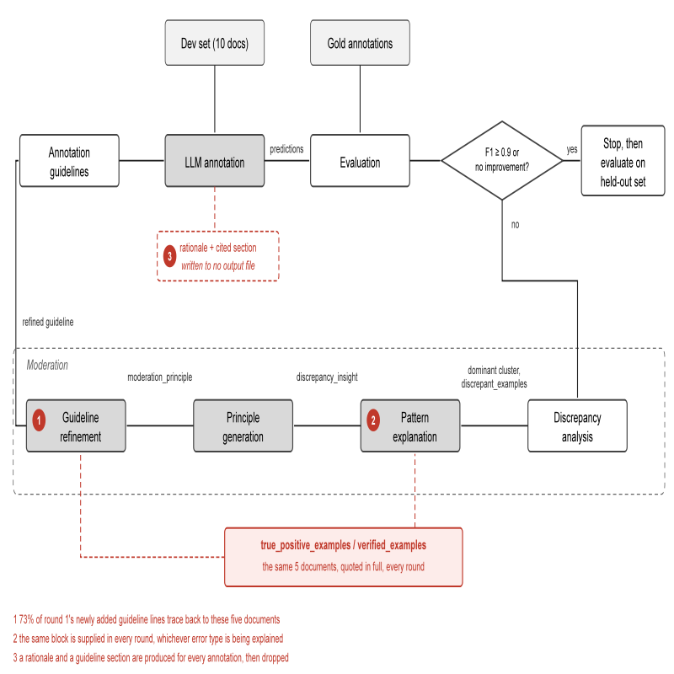
Figure 1. The iterative moderation framework as implemented. Markers 1 to 3 locate candidates from Table 1.
2.2 The audit
Table 1 lists the six candidates, the evidence that identified each, and the change it implies. They fall into three groups: what the guideline is permitted to absorb from the development documents (1), what evidence each moderation stage is given (2, 3), and how the loop decides whether to continue (4, 5, 6). Two measurements support them. The first is how much of the guideline is copied: of the lines a round adds, how many trace back to the development documents quoted in its own prompt. The second is how unstable the signal is: the deviation of development F1 across repeated annotations of the same documents under an unchanged guideline, which is the noise floor beneath every accept-or-revert decision.

# | Issue | Evidence | Change implied
1 | Verified examples are copied into the guideline | 38 of the 52 lines added in round 1 trace to the five documents quoted in the prompt | See Section 3
2 | Contrastive examples do not match the cluster | The block is byte-identical in rounds 1 to 3 while the target error type changes | Select true positives matching the current cluster
3 | The per-annotation rationale is discarded | Every annotation carries a rationale and a cited section; no output file contains either | Store both, and audit which sections are cited
4 | Development documents are sampled at random | Modifier accounts for 41% of held-out errors and 10% of the development set's; the largest held-out error type never occurs there | Choose documents for error-type coverage
5 | Termination rests on a single noisy comparison | F1 over 16 annotations of the same documents under the same guideline ranges 0.739 to 0.859 | Allow k non-improving rounds before stopping
6 | Each document is annotated once | Two annotations of the same documents return 59 and 56 true positives | Annotate k times and take a per-span majority vote

3. Current Results: Copying of the Development Set
Section 3.4.4 of the method supplies the refinement prompt with verified examples: true positives listed together with the full text of five development documents. That block occupies 46% of the prompt. In round 1, 38 of the 52 lines newly added to the guideline trace back to those five documents, and over four rounds 15 of the 37 distinct development mention strings appear in the guideline verbatim.
Two structurally different interventions were run against this. The first removes the block entirely. The second keeps it and adds a single instruction: state the rule, do not transcribe the mention. Both eliminate the copying completely, and the second demonstrably obeys rather than paraphrases, inventing illustrative phrases that appear nowhere in the development documents. Both also stop the loop within one to three rounds, where the published configuration ran four (Table 2).
The two interventions differ in mechanism yet agree in outcome, which locates the dependency: the development gain requires writing development-specific content into the guideline, and abstract rules do not produce it. The published run reaching the 0.9 threshold is therefore not evidence of generalisation, and consistently with that its held-out gain is +0.009. A second run of the same configuration, with identical settings, stopped after a single round.
Condition | Runs | Rounds | Development F1 | Copying
Published, with verified examples | 1 | 4 | 0.797 to 0.909 | 15/37
Block removed | 1 | 3 | stalls | 0/37
Block kept, transcription forbidden | 1 | 2 | stalls | 0/37
Table 2. Guideline refinement under three conditions, NCBI Disease with GPT-5.4. Copying counts distinct development mention strings appearing verbatim in the final guideline.

4. Discussion and Future Work
The first candidate is settled in the negative: the copying cannot simply be forbidden, because the loop's progress on the development set depends on it. Whether any progress is possible without it is the open question, and it is what the remaining five candidates are meant to test. Candidates 2 and 3 concern the evidence each stage receives, and are implementation fixes whose effect can be measured directly against the runs already reported. Candidates 4 to 6 concern the reliability of the loop's own decisions.
Preliminary measurements motivate that last group. Sixteen annotations of the same ten documents under the same unchanged guideline give F1 between 0.739 and 0.859. Setting temperature to zero does not remove the variation on reasoning models, whose reasoning traces are sampled independently of the output layer, so it can be averaged down but not switched off. Because the development splits are nested, one set of repeated annotations measures every size at once, and the deviation falls from 0.0150 at ten documents to 0.0092 at thirty. The immediate next steps are therefore to enlarge and coverage-balance the development set, to replace the single-comparison stopping rule, and to replicate on BC5CDR and BioRED.
References
[1] Refining and Reusing Annotation Guidelines for LLM Annotation.
[2] R. I. Dogan, R. Leaman, Z. Lu. NCBI Disease Corpus. J. Biomed. Inform., 47:1-10, 2014.
[3] P. Koehn. Statistical Significance Tests for Machine Translation Evaluation. EMNLP, 2004.
[4] R. Dror et al. The Hitchhiker's Guide to Testing Statistical Significance in NLP. ACL, 2018.
[5] N. Reimers, I. Gurevych. Reporting Score Distributions Makes a Difference. EMNLP, 2017.

