修士論文内容の要旨
論文題目 Optimizing Annotation Guideline Refinements for LLM-Based Annotation
（LLMによるアノテーションに向けたガイドライン改善の最適化）
氏名 Hengyu Zhou
1. Introduction
Biomedical text mining depends on annotated corpora, and expert annotation is slow and costly. Large language models can annotate at scale, but only if told what counts as an entity. That instruction is carried by the annotation guideline, a human-readable document written for human annotators. Here the guideline, not the model, is the object being adjusted, which makes the result inspectable and reusable across models.
Iterative guideline moderation automates that adjustment. An LLM annotates a small development set; its output is compared against gold annotations; the discrepancies are analyzed, explained as recurring patterns, condensed into a moderation principle, and integrated back into the guideline. The loop repeats until F1 reaches a threshold or a round fails to improve on the previous one. On NCBI Disease the published work reports held-out F1 of 0.46 without a guideline, 0.73 with the original guideline, and 0.76 after moderation: the guideline itself is worth +0.27, and moderating it a further +0.03^{[1]}.
That final increment is decided on a set the loop is also optimizing against: the development set is at once the target and the instrument. This work reproduces the method on NCBI Disease with GPT-5.4, examines each stage of the released implementation, and identifies the seven candidate improvements of Table 1. Candidate 1, the copying of development-set text into the guideline, is characterized experimentally in Section 3; the rest define the work plan.
2. Methodology
2.1 Task, framework and reproduction
NCBI Disease marks four entity types: SpecificDisease, DiseaseClass, CompositeMention and Modifier, the last being a disease name used to qualify another concept. A prediction counts as correct under strict match only if both its character span and its type equal a gold annotation's, and F1 below is always strict-match F1 over all annotations of the development set.
Figure 1 shows the framework as implemented. An LLM annotates the development set under the current guideline; F1 against gold decides whether to stop; otherwise the discrepancies are grouped by their (gold type, predicted type) pair, the largest group is explained as a linguistic pattern, condensed into a moderation principle, and integrated into the guideline. Two blocks of evidence travel with it. Discrepant examples show what is going wrong; verified examples, the true positives, serve the opposite purpose, the prompt requiring that the rewrite not break these already-correct cases. That block is the method's only guard against regression.
We reproduce this with GPT-5.4 at high reasoning effort on ten development documents. Development F1 rises from 0.797 to 0.909 over four rounds; held out on 100 documents the refined guideline gains +0.01.
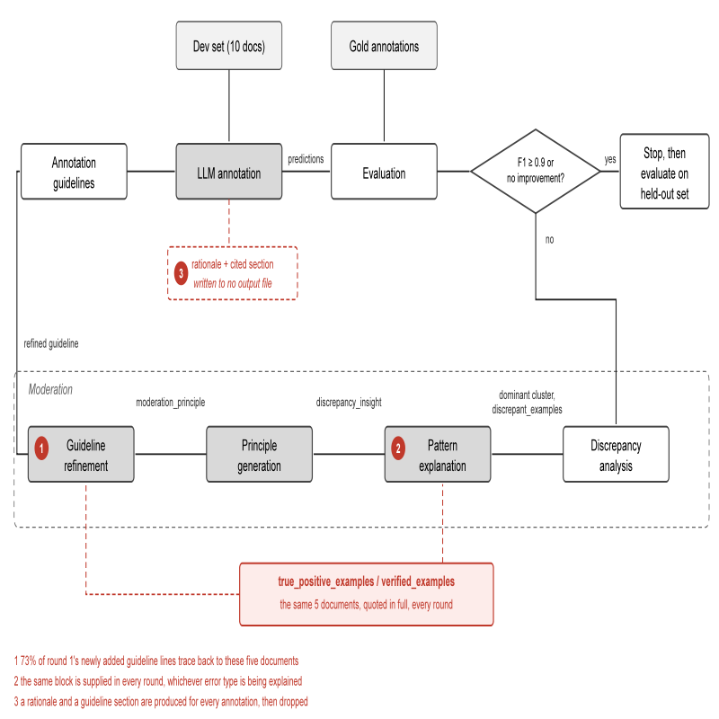
Figure 1. The framework as implemented. Markers 1 to 3 locate candidates 1, 2 and 3 of Table 1.
2.2 What is measured, and what the audit found
Two measurements are used throughout. For copying, let A be the lines a round adds and Q the development text quoted in that round's own prompt; the copied fraction is |{a in A : a traces to Q}| / |A|. For stability, annotating the same documents k times under one unchanged guideline gives k values of F1, whose standard deviation is the noise floor beneath every accept-or-revert decision, each of which compares two single annotations.
Table 1 lists the seven candidates and the evidence that identified each.
# | Candidate | Evidence
1 | Verified examples are copied into the guideline rather than used as a constraint | 38 of the 52 lines round 1 adds trace back to the five documents quoted（同样的问题，你不解释tps这里说这个想干什么？） in its prompt
2 | Contrastive evidence does not follow the error type being explained | The verified-example block （这是什么？你会不会提前解释？）is byte-identical in rounds 1 to 3 while the target error type changes from a label error to a boundary error to a missed mention
3 | The rationale each annotation carries is discarded | Every annotation names a rationale and the guideline section it applied; no output file records either
4 | Development documents are sampled at random rather than for coverage | M→O is 21% of held-out discrepancies（哪里的held-out？不会提前定义？） and 0% of the development set's
5 | Termination rests on a single noisy comparison | F1 over 16 annotations of the same documents under the same guideline ranges 0.739 to 0.859（和你的candidate有任何联系？你想说明什么？）
6 | Each document is annotated once, so every later stage rests on one draw（什么意思？和6应该可以整合？也就是说更稳定可靠的抗noise方式） | Two annotations of the same documents return 59 and 56 true positives
7 | One cluster is moderated per round, so repairs and regressions cancel | Discrepancies fall 18, 15, 13, 11 over three rounds; every round also adds errors elsewhere (Figure 2)（直接用errors regression）
Table 1. Seven candidate improvements. Only candidate 1 is characterized experimentally in this report.
3. Current Results: Verified Examples Are Copied Into the Guideline
The verified-example block reaches the rewriting stage as five development documents quoted in full, together with the true positives found in them. Its stated purpose is to prevent regression, but nothing distinguishes quoting a document as a constraint from quoting it as material, and the model does the latter: of the 52 lines round 1 adds to the guideline, 38 trace back to those five documents.
Two structurally different interventions were run against this. The first removes the block, so the rewriting stage never sees the documents. The second keeps it, letting the model still consult the true positives to see which cases must not break, but forbids transcription: rules inferred from them must be stated in abstract linguistic terms and any illustration must be the model's own invention.
Both eliminate the copying completely:
Condition | Development F1 | Threshold reached | Copying
Published, with verified examples | 0.797 → 0.909 | yes | 38/52 = 73%
Verified examples removed | 0.797 → 0.837 | no | 0/32 = 0%
Verified examples kept, transcription forbidden | 0.823 → 0.833 | no | 0/25 = 0%
Table 2. Development F1 and copied fraction under three conditions, NCBI Disease with GPT-5.4, ten development documents. Copying is the share of added guideline lines traceable to the documents quoted in the prompt, measured on round 1.

4. Discussion and Future Work
Candidate 1 is settled in the negative. The block cannot simply be forbidden, being the method's only protection against a rewrite that breaks working cases; removing it stops the loop rather than freeing it. Whether progress is possible without copying is the open question, and the remaining candidates divide into two kinds.
Candidates 2, 3 and 7 concern what each stage is given and how much it repairs per round. Figure 2 shows why the last matters: moderating one cluster at a time removes seven discrepancies over three rounds, 18 to 11, because every round also creates errors elsewhere. Round 1 cuts its target S→D from 6 to 2 but raises both D→O and the S boundary errors by one; round 2 cuts those boundary errors from 3 to 1 and pushes S→D back up to 3; round 3 repairs three cells and adds an S→O. Moderating the top k clusters jointly would let one rewrite be checked against several error types at once.
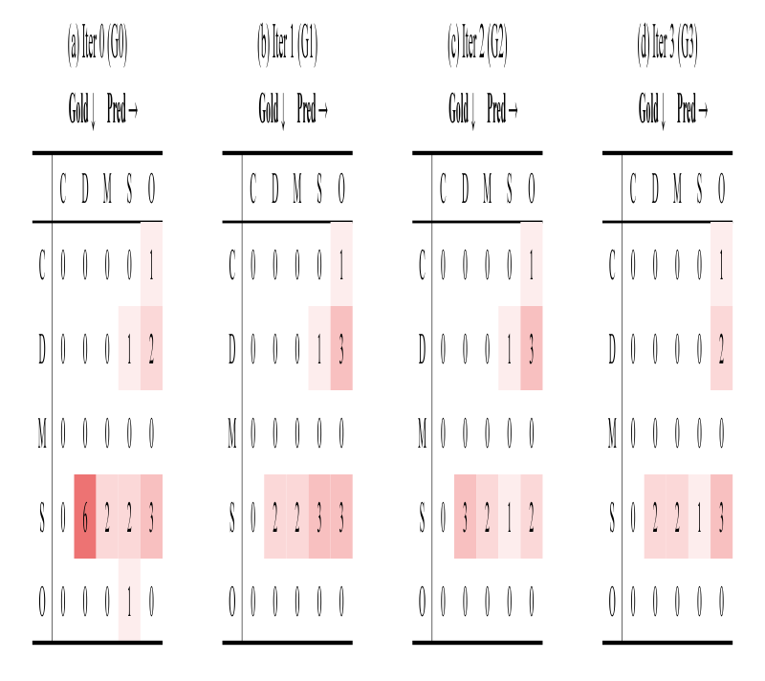
Figure 2. Confusion matrices over moderation iterations (k = 0, ..., 3), development set, published configuration. Rows correspond to the gold labels and columns to the model predictions. The cells of the same gold and prediction labels show the number of span boundary mismatches. The clusters targeted in rounds 1 to 4 are S→D (6), S→S (3), D→O (3) and S→O (3). C = CompositeMention, D = DiseaseClass, M = Modifier, S = SpecificDisease, O = No Entity.
Candidates 4, 5 and 6 concern the reliability of the loop's own decisions. Sixteen annotations of the same ten documents under one guideline give F1 between 0.739 and 0.859. Temperature does not remove this on reasoning models, whose traces are sampled independently of the output layer: DeepSeek-V4 over five repeats deviates by 0.0261 at temperature 0 against 0.0147 at the default. Set size does. The splits are nested, the ten documents lying inside the twenty and those inside the thirty, so one set of repeated annotations measures every size at once, and the deviation falls from 0.0150 at ten to 0.0092 at thirty. Enlarging and coverage-balancing the development set is the direction to explore next, then replication on BC5CDR and BioRED.
References
[1] Refining and Reusing Annotation Guidelines for LLM Annotation.
[2] R. I. Dogan, R. Leaman, Z. Lu. NCBI Disease Corpus. J. Biomed. Inform., 47:1-10, 2014.

