修士論文内容の要旨
Optimizing Annotation Guideline Refinements for LLM-Based Annotation
（LLMによるアノテーションに向けたガイドライン改善の最適化）
Hengyu Zhou
1. Introduction
Text annotation for biomedical named entity recognition (NER) follows annotation guidelines, the concrete labeling rules that regulate human annotators. Human annotators follow them well, but human annotation is slow and expensive, so transferring the guidelines to an LLM is an attractive alternative. A guideline that works for human annotators, however, is not guaranteed to work for an LLM. No written guideline can state every case, so gaps remain at entity scope, gray-zone cases, and span boundaries. Human annotators close these gaps with conventions settled into guidelines: annotators label the same documents, and wherever they disagree, the guideline is revised to remove the ambiguity that caused the disagreement. An LLM has no access to those conventions and closes the same gaps with its own reading of the text.
Prior work closes this gap by making the missing conventions explicit, running moderation with an LLM in place of the human annotator[1]. Each round, the LLM annotates a ten-document development set under the current guideline, and its predictions are scored against the gold annotations by F1. The disagreements are grouped, and the largest group becomes that round's target: it is explained as a linguistic pattern, condensed into one rule, and written back into the guideline for the next round annotation. The loop stops when development F1 reaches 0.9 or a round fails to improve it (Figure 1[1]). Evaluated on NCBI Disease with GPT-5, on a held-out set of 100 documents the loop never sees, prompting with no guideline gives an F1 of 0.46, adding the original human guideline raises it to 0.73, and running the moderation loop on top raises it to 0.76[1].
These two gains are very unequal, and the smaller one is the one that matters. Supplying the guideline is worth +0.27, but it is a one-time gain: once the guideline is in the prompt, it cannot be supplied again. Moderation is the only component that can push performance further, and it contributes just +0.03.
This work aims to optimize guideline refinement for LLM-Based annotation, so as to maximize what moderation can contribute. We examine the released implementation stage by stage against what each stage assumes. This diagnosis yields six points at which the implementation could be improved, together with a strategy for deciding which of them to address first.

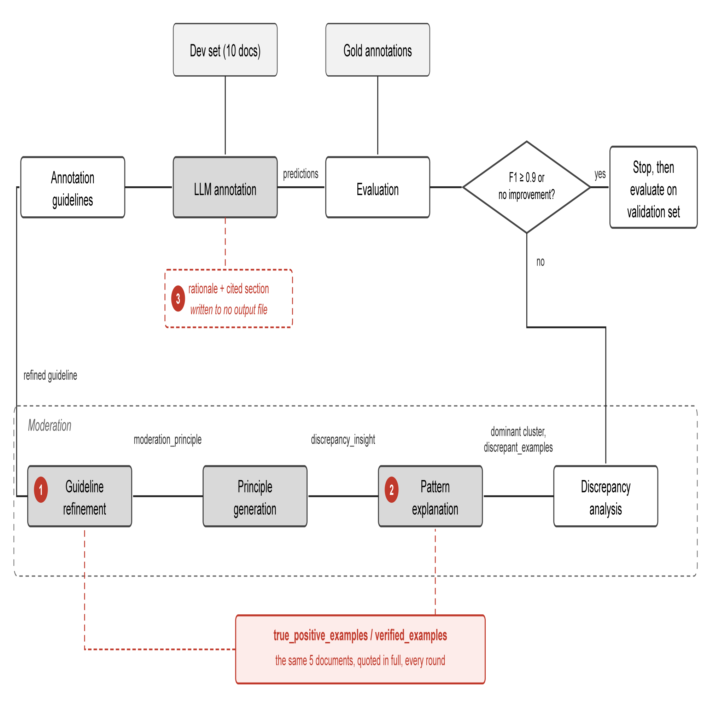
Figure 1. One round of iterative guideline moderation as implemented. Markers 1 to 3 locate points 1, 2 and 3 of Table 1.
2. Methodology
This work optimizes the guideline refinement process itself. Any optimization requires first locating what limits the current gain, so the released implementation was examined stage by stage. This examination found six points at which the implementation could be improved. Table 1 lists each point with the evidence for it.
# | Point | Evidence
1 | Verified examples, meant only to prevent regression, are copied into the guideline instead. | 38 of the 52 lines round 1 adds come from the five documents supplied as verified examples
2 | The verified examples do not change with the error type being analyzed | Identical in rounds 1 to 3, while the error type analyzed goes from a label error to a boundary error to a missed mention
3 | The rationale each annotation carries is not fully utilized | Every annotation names a rationale and the section it applied; neither is recorded, so neither can be analyzed
4 | Ten development documents do not cover the error types the guideline is judged on | Gold Modifier predicted as nothing: 21% of validation-set disagreements, 0% of the development set's
5 | Annotating the same documents twice does not give the same result | Two annotations of the same ten documents returned 59 and 56 correct annotations; over sixteen, development F1 ranged 0.739 to 0.859
6 | One group is moderated per round, so each repair causes regressions elsewhere | Each round repairs its target but adds errors of other types; the total falls only from 18 to 11 over three rounds (Figure 2)
Table 1. Six points at which the released implementation could be improved, with the evidence for each. The first is tested experimentally and the sixth analyzed from the same reproduction (Section 3); the remaining four are evidenced but not yet tested.
Restart from here
1. Copying. The gain a round makes on the development set does not reach the validation set, and point 1 of Table 1 shows where it comes from: most of what a round adds to the guideline is taken from the development documents themselves. We therefore test whether the loop can run without that, by withholding the verified examples and, separately, by supplying them under a rule against copying; Table 2 reports the copied share and both F1 scores for all three conditions.
2. Distribution. The error types of the development set and of the validation set differ (point 4), so the loop optimizes against errors it will not be judged on. Section 3 gives the two distributions, from which development documents can be selected to match.
3. Variance. A round is kept or discarded on a comparison whose spread exceeds the gains it decides (point 5). We narrow that spread three ways, by fixing the sampling temperature, by varying reasoning effort, and by enlarging the development set; Section 3 reports what each is worth.
4. Coverage per round. Each round repairs its own target group and regresses elsewhere, as Figure 2 shows. Moderating the top k groups in one rewrite would let it be checked against several error types at once.
Points 2 and 3 of Table 1 concern the evidence each stage receives and are not addressed here.
3. Current Results
The guideline copies what it was told to protect. The verified examples reach the rewriting call under the prompt heading DO NOT BREAK THESE EXAMPLES, and for each of the five documents they come from, the prompt prints that document's entire text before listing the annotations to preserve. Nothing marks the text as reference only, and the model writes from it: whole sentences move out of those documents and into the guideline as illustrations, one arriving almost unchanged as “Coats disease is characterized by abnormal retinal vascular development (so-called retinal telangiectasis)”. Of the 52 lines round 1 adds, 38 are traceable to those five documents; Table 2 reports this share as copying.
Two interventions were run against this. The first withholds the verified examples, so the rewriting call never sees the documents. The second still supplies them but forbids copying: a rule taken from them must be written in general terms, and any example must be one the model makes up.
Neither guideline copies anything, and the second does not evade the rule by paraphrasing either: every example in it is invented, and none appears in the five documents. Neither condition reaches the loop's stopping threshold of F1 ≥ 0.9 (Table 2). Withholding the documents and forbidding their use come to the same end, which shows what the gain in development F1 was resting on: in this method there is no way to limit regression except by copying. Because a single annotation is noisy — repeated annotation of the same ten documents under one unchanged guideline later gives development F1 between 0.739 and 0.859 (Section 4) — the gap between conditions here should be read as suggestive rather than exact; the qualitative pattern, that copying is what enables the gain, is more robust than any single F1 value in Table 2.
Condition | Development F1 | Threshold reached | Copied share | Validation F1
Verified examples supplied, as published | 0.797 → 0.909 | yes | 38/52 = 73%
Verified examples withheld | 0.797 → 0.837 | no | 0/32 = 0%
Verified examples supplied, copying forbidden | 0.823 → 0.833 | no | 0/25 = 0%
Table 2. Development F1 and copied share under three conditions, NCBI Disease with GPT-5.4, ten development documents. Copied share is defined above; both are measured on round 1.
Moderating one group at a time causes regressions in the others. Each round targets a single (gold type, predicted type) group, and Figure 2 shows what that costs: over three rounds the total disagreement count falls only from 18 to 11, because each round adds errors of a type it was not working on. Round 1 cuts its target, gold SpecificDisease predicted as DiseaseClass, from 6 to 2, but adds a missed DiseaseClass and a SpecificDisease boundary error. Round 2 halves those new boundary errors and pushes the previous target back up to 3. Moderating several groups within one rewrite, rather than one at a time, would let each round be checked against more than one error type before it is accepted.
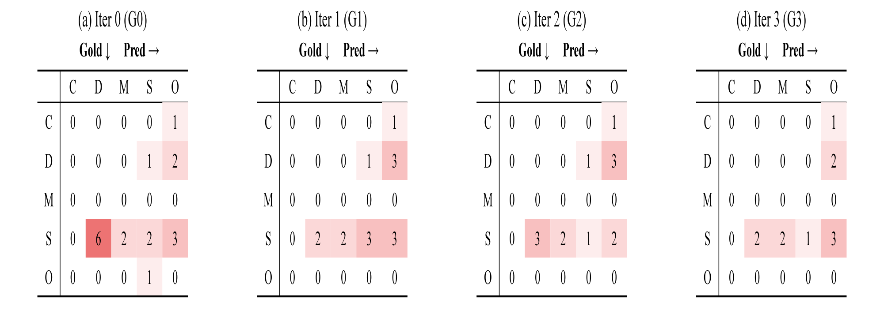
Figure 2. Disagreements between the LLM and the gold annotations on the development set, for the guideline in force at the start of each round. Rows are gold labels, columns are model predictions, and a cell on the diagonal counts span boundary mismatches. The groups targeted in rounds 1 to 4 are S→D (6), S→S (3), D→O (3) and S→O (3). C = CompositeMention, D = DiseaseClass, M = Modifier, S = SpecificDisease, O = no entity.
4. Discussion and Future Work
The first point cannot be fixed simply by removing the verified examples, because they are the only thing stopping a rewrite from breaking annotations that were already correct: without them the loop stops improving after one or two rounds. Copying has to be prevented some other way, and designs that limit regression without placing the source documents in the prompt at all are now being tested. Two further points remain untested: how the examples supplied at each stage are chosen (point 2), and whether the rationale each annotation carries could be used to guide the rewrite (point 3). Whether moderating several error groups within a single rewrite would reduce the regressions documented for point 6 is also untested.
The current loop keeps or discards each round by comparing development F1 before and after it, and both numbers come from a single annotation. Those numbers are not stable. Annotating the same ten documents sixteen times under one unchanged guideline gives development F1 anywhere between 0.739 and 0.859, a spread wider than the gains the loop is deciding on. The randomness cannot be switched off: on reasoning models, whose reasoning is sampled independently of the answer, DeepSeek-V4 deviated by 0.0261 at temperature 0 against 0.0147 at temperature 1. It can be reduced by averaging over more documents, the deviation falling from 0.0150 at ten to 0.0092 at thirty. Two directions follow, to enlarge the development set and to choose its documents so that the error types in it match the validation set's, and then to replicate on BC5CDR and BioRED.
References
[1] Refining and Reusing Annotation Guidelines for LLM Annotation (Kim et al., ACL 2026).

