修士論文内容の要旨
論文題目 Optimizing Annotation Guideline Refinements for LLM-Based Annotation
（LLMによるアノテーションに向けたガイドライン改善の最適化）
氏名 Hengyu Zhou
1. Introduction
Text annotation underlies much of biomedical text mining, most often as named entity recognition (NER): marking which spans of a document refer to entities of interest, and of what type. Large language models annotate at scale, but a generic task description does not tell them where an entity begins and ends, or which of two types a borderline case belongs to. Annotation guidelines exist for that. Written to regulate human annotators, they encode as concrete labeling rules the requirements the corpus was built to serve.
Guidelines are never complete at the outset. In a traditional corpus project a new annotator first works through a small set of documents, compares the result against the gold annotations, and either revises their own understanding or has the guideline clarified; this phase is called moderation. Iterative guideline moderation transfers it to the model. The LLM annotates that small set, now called the development set; the disagreements with gold are condensed into one rule, which is written into the guideline; and the loop repeats until agreement stops improving (Figure 1).
On NCBI Disease the published work reports F1 of 0.46 with no guideline, 0.73 with the original guideline and 0.76 after moderation^{[1]}, all measured on a validation set the loop never sees: having a guideline is worth far more than moderating one. This work asks what limits that +0.03. We reproduce the method with GPT-5.4, examine each stage of the released implementation, and make two contributions: six points at which it could be improved, each with its evidence (Table 1); and an experiment on the first of them, where the model copies the annotations it was told not to change straight into the new guideline (Section 3).
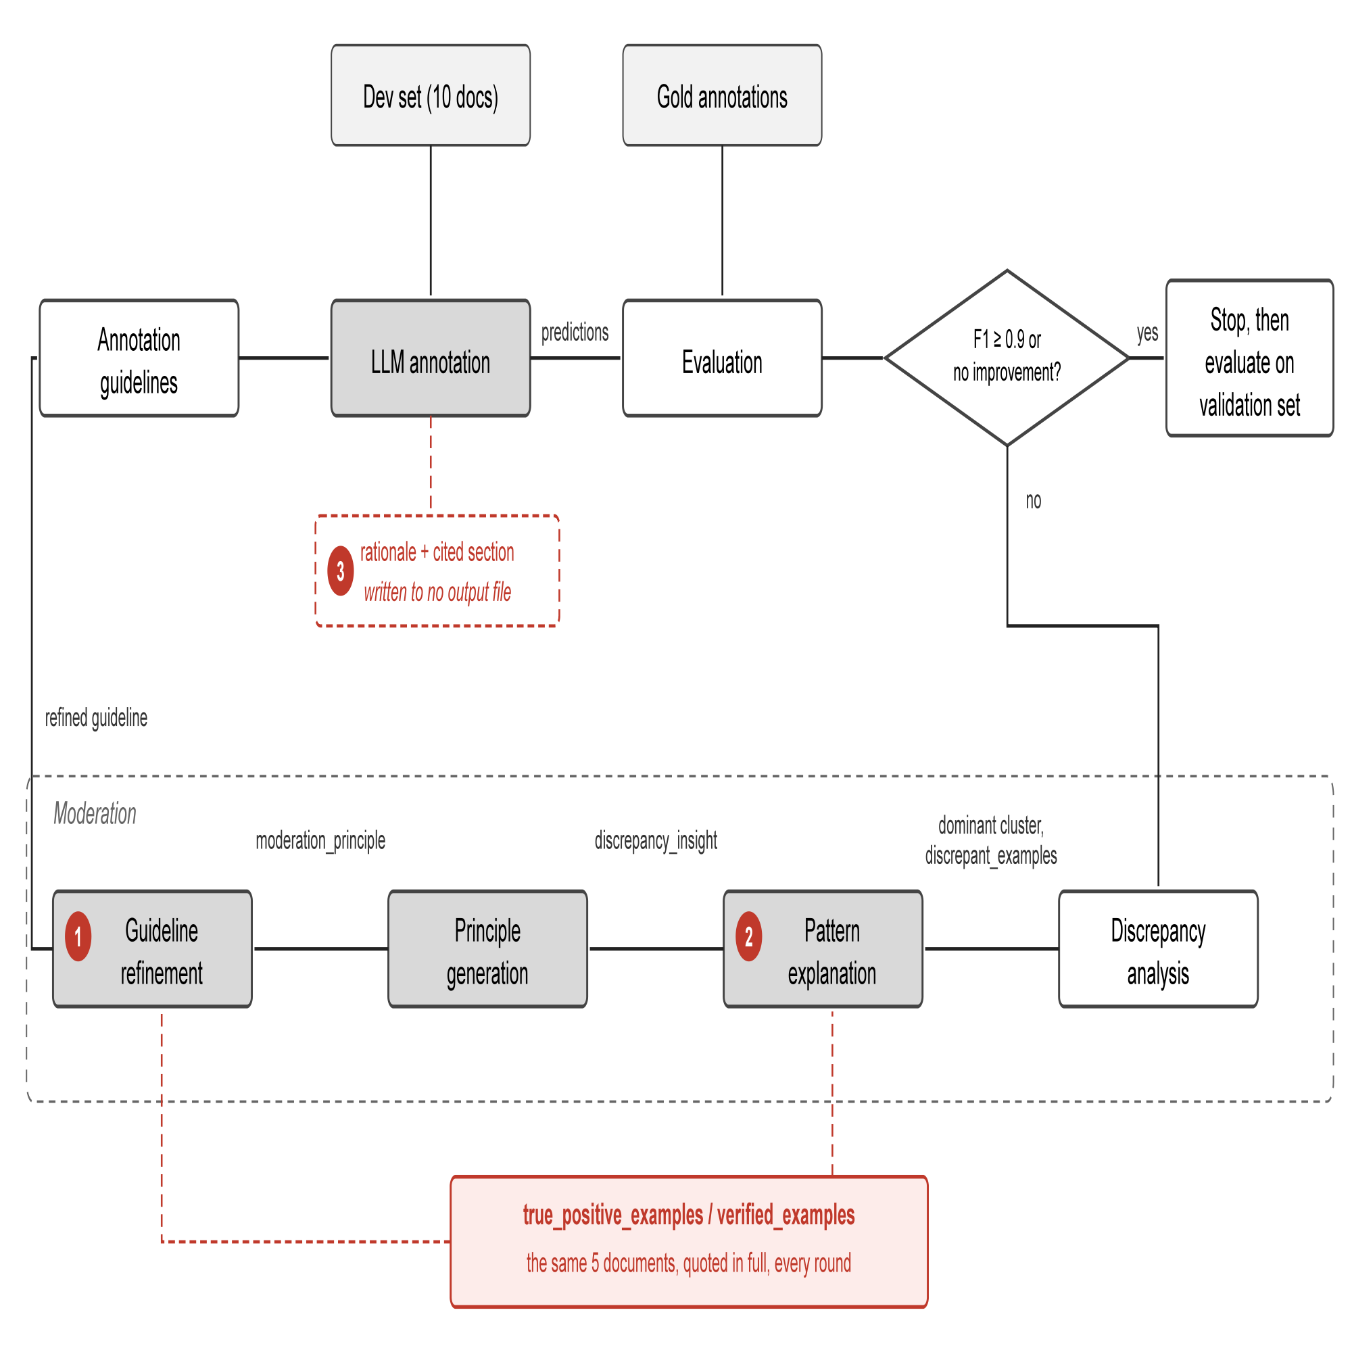
Figure 1. One round of iterative guideline moderation as implemented. Markers 1 to 3 locate points 1, 2 and 3 of Table 1.
2. Methodology
NCBI Disease marks four entity types: SpecificDisease, DiseaseClass, CompositeMention and Modifier, the last being a disease name qualifying another concept. A prediction is correct under strict match only if its span and its type both equal a gold annotation's. Development F1 below is strict-match F1 on the ten-document development set; validation F1 the same measure on a separate 100 documents the loop never sees.
Figure 1 fills in what the introduction left out. The disagreements are grouped by their (gold type, predicted type) pair; the largest group is explained as a linguistic pattern and condensed into one moderation principle; and a final call rewrites the whole guideline to include it. That call also receives two kinds of example. Discrepant examples are the cases the round is fixing. Verified examples are the opposite: annotations the model already got right, which the prompt tells the rewrite not to break. They are the method's only mechanism for limiting regression.
We reproduce this with GPT-5.4 at high reasoning effort. Development F1 rises from 0.797 to 0.909 over four rounds, and the refined guideline gains +0.01 on the validation set.

Table 1 lists six points at which the implementation could be improved, with the evidence for each.

# | Point | Evidence
1 | Annotations supplied to prevent regression are copied into the guideline | 38 of the 52 lines round 1 adds come from the five documents supplied as verified examples
2 | The verified examples do not change with the error type being analyzed | Identical in rounds 1 to 3, while the error type analyzed goes from a label error to a boundary error to a missed mention
3 | The rationale each annotation carries is not fully utilized | Every annotation names a rationale and the section it applied; neither is recorded, so neither can be analyzed
4 | Ten development documents do not cover the error types the guideline is judged on | Gold Modifier predicted as nothing: 21% of validation-set disagreements, 0% of the development set's
5 | Annotating the same documents twice does not give the same result | Two annotations of the same ten documents returned 59 and 56 correct annotations; over sixteen, development F1 ranged 0.739 to 0.859
6 | One group is moderated per round, so each repair causes regressions elsewhere | Each round repairs its target but adds errors of other types; the total falls only from 18 to 11 over three rounds (Figure 2)
Table 1. Six points at which the released implementation could be improved, with the evidence for each. Only the first is characterized experimentally here.
3. Current Results: The Guideline Copies What It Was Told to Protect
The verified examples reach the rewriting call under the prompt heading DO NOT BREAK THESE EXAMPLES, and for each of the five documents they come from, the prompt prints that document's entire text before listing the annotations to preserve. Nothing marks the text as reference only, and the model writes from it: whole sentences move out of those documents and into the guideline as illustrations, one arriving almost unchanged as "Coats disease is characterized by abnormal retinal vascular development (so-called retinal telangiectasis)". Of the 52 lines round 1 adds, 38 are traceable to those five documents, and that share is what Table 2 reports as copying.
Two interventions were run against this. The first withholds the verified examples, so the rewriting call never sees the documents. The second still supplies them but forbids copying: a rule taken from them must be written in general terms, and any example must be one the model makes up.
Neither guideline copies anything, and the second does not evade the rule by paraphrasing either: every example in it is invented, and none appears in the five documents. Neither reaches the threshold (Table 2). Withholding the documents and forbidding their use come to the same end, which shows what the gain in development F1 was resting on: in this method there is no way to limit regression except by copying.
Condition | Development F1 | Threshold reached | Copied share
Verified examples supplied, as published | 0.797 → 0.909 | yes | 38/52 = 73%
Verified examples withheld | 0.797 → 0.837 | no | 0/32 = 0%
Verified examples supplied, copying forbidden | 0.823 → 0.833 | no | 0/25 = 0%
Table 2. Development F1 and copied share under three conditions, NCBI Disease with GPT-5.4, ten development documents. The copied share is the proportion of added guideline lines traceable to the five documents supplied as verified examples, measured on round 1.
4. Discussion and Future Work
The first point cannot be fixed by removing the verified examples, because they are the only thing stopping a rewrite from breaking annotations that were already correct: without them the loop stops after one or two rounds. Copying has to be prevented some other way, and we are now testing designs that limit regression without putting the documents in the prompt at all.
One further point has been analyzed. Each round moderates a single group of disagreements, and Figure 2 shows what that costs: over three rounds the total falls only from 18 to 11, because each round adds errors of a type it was not working on. Round 1 cuts its target, gold SpecificDisease predicted as DiseaseClass, from 6 to 2, but adds a missed DiseaseClass and a SpecificDisease boundary error. Round 2 halves those boundary errors and pushes the previous target back up to 3. Moderating several groups in one rewrite would let it be checked against more than one error type at a time. The points on the examples each stage receives and on the unused rationale are untested.
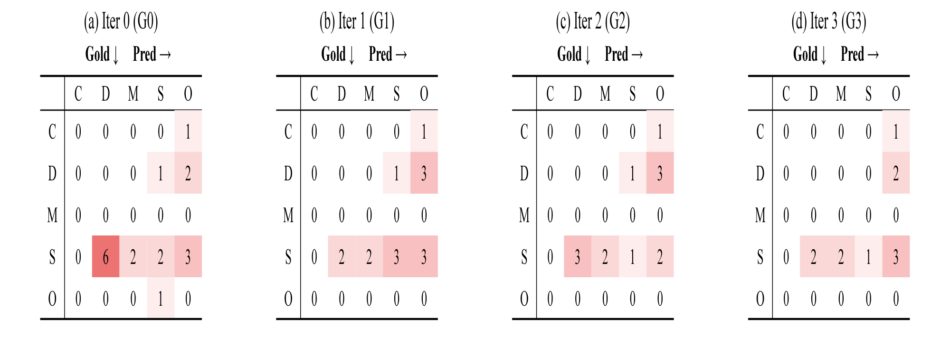
Figure 2. Disagreements between the LLM and the gold annotations on the development set, for the guideline in force at the start of each round. Rows are gold labels, columns are model predictions, and a cell on the diagonal counts span boundary mismatches. The groups targeted in rounds 1 to 4 are S→D (6), S→S (3), D→O (3) and S→O (3). C = CompositeMention, D = DiseaseClass, M = Modifier, S = SpecificDisease, O = no entity.
The current loop keeps or discards each round by comparing development F1 before and after it, and both numbers come from a single annotation. Those numbers are not stable. Annotating the same ten documents sixteen times under one unchanged guideline gives development F1 anywhere between 0.739 and 0.859, a spread wider than the gains the loop is deciding on. The randomness cannot be switched off: on reasoning models, whose reasoning is sampled independently of the answer, DeepSeek-V4 deviated by 0.0261 at temperature 0 against 0.0147 at temperature 1. It can be reduced by averaging over more documents, the deviation falling from 0.0150 at ten to 0.0092 at thirty. Two directions follow, to enlarge the development set and to choose its documents so that the error types in it match the validation set's, and then to replicate on BC5CDR and BioRED.
Reference
[1] Refining and Reusing Annotation Guidelines for LLM Annotation (Kim et al., ACL 2026).

